In Vuur en Bloed
Koos de la Rey and the Second Boer War
1899 - 1902
By
Urica
OpenGen-Kaiser General efile 2014

Intro
These are hard times for being a farmer in the Transvaal Republic. If the British want something, they take it. And now they want your land. All right then. If they desire it so badly, they will have to pay with fire and blood.

Follow the Boer general Koos de la Rey in his campaign against the British Empire and become a hero. Fight your enemies until the bitter end and, who knows? maybe you'll get a chance to earn your happy ending.
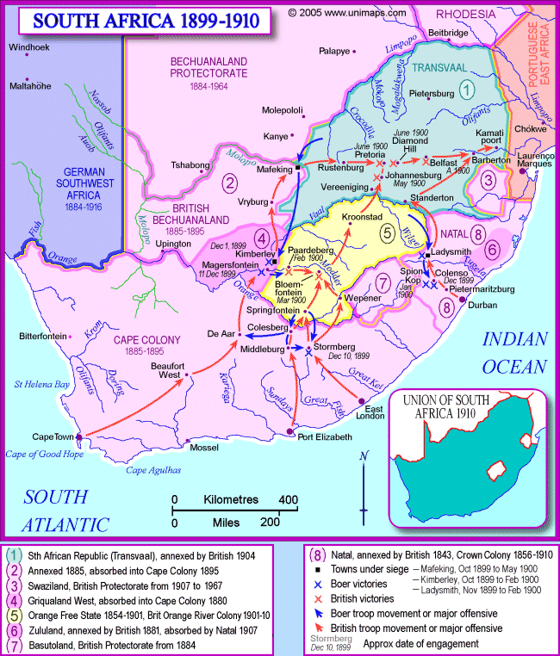

Historical Background
The Dutch settlers in South Africa and the British colonial administration had been in conflict since the end of the Napoleonic Wars, when the United Kingdom had officially bought the Dutch territories in the Cape area (they had taken them by force some years before, anyway).

Since 1834 some of those Dutch settlers, who were called “Boers”, decided to live free from British control and they migrated to the east and north east. Eventually, in the 1850s they founded two independent republics: the South African Republic (Transvaal) and the Orange Free State.

It didn’t take long before the British tried to annex the young republics, leading to the First Boer War (1877-1878). Surprisingly the Boer could defeat the British troops in some battles, and Transvaal and the Orange Free State could keep their independence, although becoming in practice British protectorates.

That agreement didn’t last long, either. The Boer republics were rich in gold and diamonds, and that attracted thousands of foreign immigrants (uitlanders), mainly British. Fearing that the number of uitlanders could surpass the number of Boer in a few years, the governments of the Boer republics denied the uitlanders most political rights, and naturally that enraged the British public opinion. Some British businessmen and politicians with imperialist ideas took advantage from that state of things, lobbying for the war.

In 1899 the situation had deteriorated so much that all the diplomatic negotiations failed. Paul Kruger, the president of the South African Republic, issued an ultimatum on 9 October, and two days later the Second Boer War started.

Boer soldiers, with a great knowledge of the terrain, amazing mobility (due to their use of horses) and excellent marksmanship, were a formidable foe for the British Army. But with the massive arrival of reinforcements in 1900 there was only one possible ending. The war lasted almost three years later, but it finished in 1902 with a total, although very costly, British victory. Under the conditions of the Treaty of Vereeniging the two Boer republics were annexed by the Britis Empire, although they obtained some limited self-government again in 1910, when the Union of South Africa was created.

Even though they lacked all kind of formal military education, some Boer leaders showed an extraordinary skill for strategy and guerrilla warfare. Names like Christiaaan de Wet, Christiaan Beyers, James Hertzog, Jan Smuts or Louis Botha became well known for their combat abilities. However, even today, the Boer leader who is considered to be the most capable is Jacobus “Koos” de la Rey, ”the lion of West Transvaal”. He is the protagonist of this campaign.

Note: I don’t support any kind of political movement or ideology. This campaign only tries to represent some of the main battles involving Koos de la Rey in the wargame OpenGen.

The campaign flow

This campaign has 19 scenarios in total, although the maximum number which can be played on a single run is 12. It can divided in three main sections:

a) Start: The first five scenarios are linear and historical. But if you have a BV in the fifth one (Colesberg) you’ll be allowed to choose if you want to stay on the historical path or you prefer to switch to a fictional path where you can have a chance to defeat the British.

b) Historical path: The next seven scenarios. Eventually you’ll lose your core and will play small, short, guerrilla-like scenarios with very few units. No matter what you do, you’ll have to surrender in 1902.

c) Fictional path: These are seven fictional or semi-fictional scenarios. The battles are bigger and longer. If everything goes well, they will end with a Boer victory.
Campaign scenario flow table.

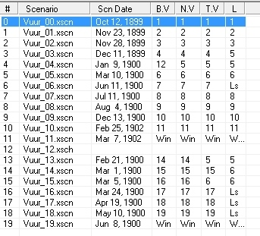

Scenario list.

Number | Scenario Name | Date | Map (number)
0 | Kraaipan | Oct 12th, 1899 | Railway (794)
1 | Belmont | Nov 23rd, 1899 | Belmont (1150)
2 | Modder River | Nov 28th, 1899 | Modder River (1151)
3 | Magersfontein | Dec 11th, 1899 | Modder River (1151)
4 | Colesberg | Jan 9th, 1900 | Colesberg (1207)
5 | Driefontein | Mar 10th, 1900 | Driefontein (1210)
6 | Donkerhoek | Jun 11th, 1900 | Diamond Hill (1152)
7 | Silkaatsnek | Jul 11th, 1900 | Silkaatsnek (1221)
8 | Elandsrivier | Aug 4th, 1900 | Elands River (1223)
9 | Nooitgedacht | Dec 13th, 1900 | Nooitgedacht (1225)
10 | Ysterspruit | Feb 25th, 1902 | Ysterspruit (1226)
Number | Scenario Name | Date | Map (number)
11 | Tweebosch | Mar 7th, 1902 | Tweebosch (1227)
12 | Choice | Feb 8th, 1900 | Included in .7z file
13 | Rescue at Paardeberg | Feb 21st, 1900 | Paardeberg (1208)
14 | Pursuing Roberts | Mar 1st, 1900 | Modder River (1151)
15 | Kimberley | Mar 5th, 1900 | Kimberley (1214)
16 | First Battle of Port Elizabeth | Mar 24th, 1900 | Port Elizabeth (1222)
17 | Second Battle of Colenso | Apr 19th, 1900 | Ladysmith (1224)
18 | Strangers in a strange land | May 10th, 1900 | Axona (1137)
19 | Second Battle of Port Elizabeth | Jun 8th, 1900 | Port Elizabeth (1222)

Setup

Create a Kaiser General folder into the main OpenGen folder (it usually is C:\OpenGen). Unzip the the newest Kaiser General efile into the Kaiser General folder (usually C:\OpenGen\KG2).
Then unzip the file Vuur_Campaign.7z into the Kaiser General efile´s scenario folder (usually C:\OpenGen\KG2\scenario).

You can download the efile from Kaiser General webpage:

http://sites.google.com/site/jkpanzer/graphics/efile

Requirements

OpenGen, at least the 0.90.32.9 version. You can download the OpenGen game from Luis Guzman´s webpage:

http://luis-guzman.com/

Soundup (sound files), at least the aug/2010 version. You can download it from Kaiser General webpage

http://sites.google.com/site/jkpanzer/graphics/efile

Openicons (icon files). They are really easy to install. Unzip the Datup into your main OpenGen folder, usually c:\OpenGen. You can find the latest Openicons here:

http://sourceforge.net/projects/opengeneral/files/DailyBuild/

Maps: The needed maps can be found on the next link: http://pg2mapfinder.gilestiel.eu/

The OG game can automatically download the maps you need from the OG repository, too. You just have to select that option in the game settings.

Acknowledgements

Special thanks to…

Juan Carlos Preciado, for being the author of the Kaiser General efile.

Luis Guzmán, creator of the OpenGen programme and the Suite.

Paqueo, for playtesting the campaign.

Musical note
The songs “de la Rey” and “Afrikanerhart”, performed by South African singer Bok Van Blerk, have inspired me during the design of the campaign. In fact, “In Vuur en Bloed” is the first verse of “Africanerhart”. You can listen to the songs here:

https://www.youtube.com/watch?v=nlHqKJyo3GQ

https://www.youtube.com/watch?v=0wdIiT16LV4

Finally...

These files are free; I made it only for fun. I hope you take fun too playing it. You are not allowed to modify or to sell the files of the campaign without permission of the author.
For any commentary about the campaign you can email at.

delmarec@gmail.com

The author is not responsible from any bad use or damaged caused by these files. I haven’t any political interest with this campaign; which is only made for historical and fun purposes for OpenGen.

