Kaiserlich und Königlich
Austro-Hungarian Weltkrieg campaign for KG
1914 - 1919
By
Urica
OpenGen-Kaiser General efile 2020

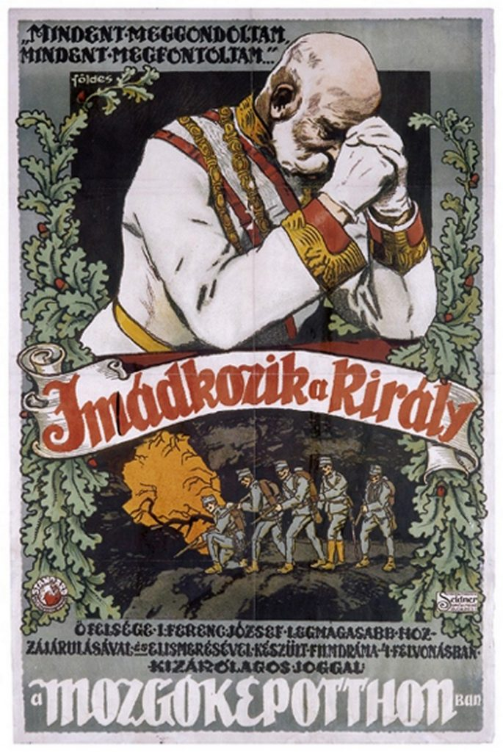

Intro

Enough is enough. A despicable terrorist has murdered our heir to the throne, and Serbia is to blame. They will pay for that. Those who sow the wind shall reap the whirlwind. It doesn't matter if Russia supports Serbia. We have powerful allies, too. If Serbia doesn't comply with all our demands, there will be war. If the world thinks that the Austro-Hungarian Empire is a weak, moribund kingdom, then we'll show them how wrong they are.

Some years ago, the campaign "Weltkrieg" gave the players of Open General the chance to win the First World War playing with the Imperial German Army. But, in the meantime, what were the Austro-Hungarians doing? This new campaign answers that question. You'll lead the K.u.K from Serbia to southern France, fighting against the enemies of the Central Powers. In the end, victory can be yours. The soldiers of the King Emperor deserve their fair share of glory, and they will have it. They will be heroes, too!

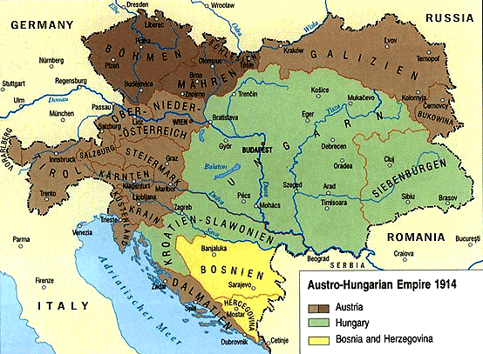

Historical Background
After having been defeated by Italy (1859) and Prussia (1866), Austria finally understood that she had lost her status as one of Europe’s dominant powers. The Empire wouldn’t survive without undergoing profound reforms, which should necessarily include the re-establishment of the sovereignty of the Kingdom of Hungary.

That’s why, after the approval of the Austro-Hungarian Compromise on 30 March 1867, the Austrian Empire ceased to exist and the Austro- Hungarian Empire was born. It was composed of two different countries (Austria and Hungary), both ruled by the Habsburg monarch. He would be the Emperor of Austria and the King of Hungary (Kaiserliche und königliche Monarchie, that is, Monarchy of the Emperor and the King, or k. u. k).

In practice, Austria and Hungary were almost independent countries, with the same Head of State and only a few common policies, mainly foreign affairs and defense. But there were two different parliaments, two fiscal policies, two budgets, and even two different citizenships. Besides, apart from Germans and Hungarians there were many other ethnic groups in the different regions of the Empire: Poles, Ruthenians, Czechs, Slovaks, Romanians, Italians, Slovenians, Croats, Jews and, after the occupation of Bosnia- Herzegovina in 1878, Serbians and Muslim Bosniaks. Most of these groups sought the recognition of their nations, either within the Empire or as fully independent states, so the Dual Monarchy found that working as a cohesive state was virtually impossible.

Those internal tensions finally exploded when, on 28 June 1914, Archduke Franz Ferdinand visited the Bosnian capital, Sarajevo, and was murdered by a group of Serbian nationalists, who supposedly had the support of the Kingdom of Serbia.

After some debate, and confident in the alliances that the Austro-Hungarian Empire had signed with Germany and Italy, the government sent an ultimatum to Serbia, which included one demand that was nearly impossible to accept. When, as expected, Serbia rejected part of the sixth demand (allowing the Austrian police to operate in Serbia during the course of the investigation), Austria-Hungary declared war on Serbia.

What happened next is well known: Russia supported Serbia, Germany supported the Dual Monarchy, France and Britain warned Germany and, in the end, the Great War started in August 1914. Italy, a theoretical ally of Austria- Hungary and Germany, initially remained neutral, and would actually switch sides in 1915.

The Austro- Hungarian army didn’t perform too well during the war. Poorly commanded and coordinated, many regiments lacked the motivation to fight a long war in two or even three different fronts at the same time, especially the ones with a large proportion of ethnic minorities. Despite all the efforts of Austria- Hungary and her allies, the war ended in 1918 with a catastrophic defeat, the partition of the empire and the end of the monarchy.

But, what if things had been different? What if the k.u.k army had a chance to win the war? This campaign answers those questions.

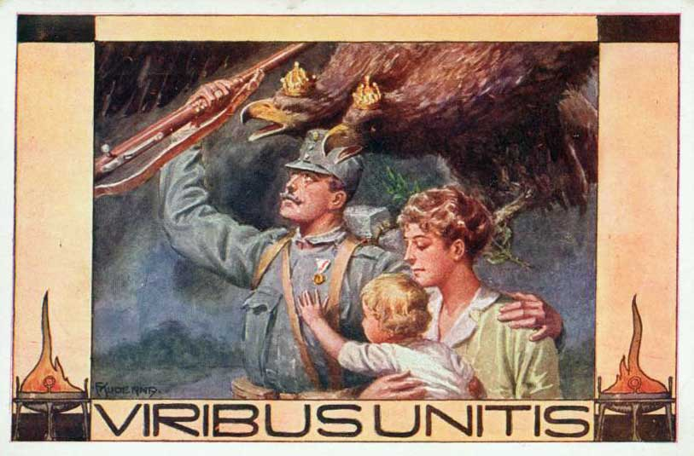

Note: I don’t support any kind of political movement or ideology. This campaign only tries to represent some battles involving the Austro- Hungarian Army during the WWI in the wargame OpenGen.

The campaign flow

This campaign is linear, and has 24 scenarios in total. However, since there are two different paths, which converge in 1917, the maximum number of scenarios is 17.
Any victory will take you to the next battle, and in most scenarios even a loss will be enough to go on.

All the scenarios are (mostly) historical until the end of 1917. The point of divergence takes place in 1918. It assumes that USA doesn’t enter the war so, instead of launching the Spring Offensive, Germany decides to crush the Entente armies in the secondary fronts (the Balkans, Italy and the Middle East), with the cooperation of the Austro- Hungarians. Then, in 1919, they can mobilize more troops for a final, and successful, offensive against France. With France defeated, Britain eventually accepts a negotiated peace.

Scenario list.

Number | Scenario Name | Date | Map (number)
0 | At the mountain of Cer | Aug 15th, 1914 | Cer (1513)
1 | Choice: east or west? |  | Strategic Europe (1215)
2 | The nightmare of Kolubara | Dec 3rd, 1914 | Kolubara (1514)
3 | The Isonzo valley: a place to stay | Jun 23rd, 1915 | Gorizia (1515)
4 | Serbia is falling | Oct 7th, 1915 | Kolubara (1514)
5 | Expedition against Montenegro | Jan 5th, 1916 | Sarykamysh (463)
6 | Die Strafexpedition | May 15th, 1916 | Verona (1518)
7 | Return to the Isonzo | Aug 6th, 1916 | Gorizia (1515)
8 | Raid in Albania | Jan 30th, 1917 | Col di Lana (1451)
9 | Rawa Ruska | Sep 9th, 1914 | Russian plains (279)
10 | Limanowa | Dec 6th, 1914 | Limanowa (1164)
11 | Duklapass | Jan 26th, 1915 | Dukla Pass (240)
12 | Görlitz-Tarnów | May 2nd, 1915 | Gorlice (704)
13 | Brussilow-Offensive: Luzk | Jun 4th, 1916 | Dubno (236)
14 | The Romanian front: Predeal Pass | Oct 8th, 1916 | Brasov (1519)
15 | The Romanian front: Marasesti | Aug 6th, 1917 | Jassy (336)
16 | Karfreit | Oct 24th, 1917 | Gorizia (1515)
17 | Unternehmen Teutoburg | Jun 4th, 1918 | Doiran Lake (982)
18 | Unternehmen Radowitz (I): Verona | Jun 15th, 1918 | Verona (1518)
19 | Unternehmen Radowitz (II): Florenz | Jul 14th, 1918 | Gothic Line (409)
20 | Beirut | Oct 10th, 1918 | Beirut (311)
21 | Jerusalem | Oct 31st, 1918 | Jerusalem 1917 (596)
22 | Gaza | Nov 16th, 1918 | Gaza (594)
23 | Toulon | Mar 6th, 1919 | Toulon (126)
24 | Malta | Aug 16th, 1919 | Malta 3K (1470)

Scenario flow.

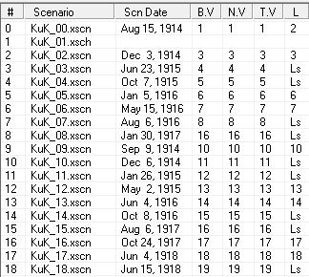
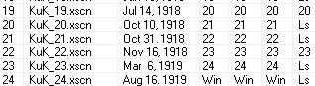

Setup

Create a Kaiser General folder into the main OpenGen folder (it usually is C:\OpenGen). Unzip the newest Kaiser General efile into the Kaiser General folder (usually C:\OpenGen\KAISER).
Then unzip the file KuK_Campaign.7z into the Kaiser General efile’s scenario folder (usually C:\OpenGen\KAISER\scenario).

You can download the efile from the Open General Installer webpage:

http://www.open-general.com/installer-efiles.php

Requirements

OpenGen, at least the 0.93.3.0 version. You can download the OpenGen game from Luis Guzman’s webpage:

http://luis-guzman.com/

Soundup (sound files). You can download it from Kaiser General webpage

http://sites.google.com/site/jkpanzer/graphics/efile

Or from the Open General Installer webpage:

http://www.open-general.com/installer-core.php

Openicons (icon files). They are really easy to install. Unzip the Datup into your main OpenGen folder, usually c:\OpenGen. You can find the latest Openicons here:

http://www.open-general.com/installer-core.php

Maps: The needed maps can be found on the next link: http://pg2mapfinder.gilestiel.eu/

The OG game can automatically download the maps you need from the OG repository, too. You just have to select that option in the game settings.

Acknowledgements

Special thanks to…

Juan Carlos Preciado, for being the author of the Kaiser General efile.

Luis Guzmán, creator of the OpenGen programme and the Suite.

Mark, for playtesting some of the scenarios of the campaign.

Toliy, for being the creator of the Baltic efile (a precursor to t he Kaiser General efile), and for being the author of the classical campaign “For God, Tsar and Motherland”. Some of the scenarios of this campaign are, actually, conversions of scenarios of FGTM.

Finally...

These files are free; I made them only for fun. I hope you take fun too playing the campaign. You are not allowed to modify or to sell the files of the campaign without permission of the author.
For any commentary about the campaign you can email at.

delmarec@gmail.com

The author is not responsible from any bad use or damaged caused by these files. I haven’t any political interest with this campaign; which is only made for historical and fun purposes for OpenGen.

