The Lion of Judah
Abyssinian campaign
1875 – 1896 (historical) and
1916-1919 (fictional)
By
Urica
OpenGen-Kaiser General efile 2016-2017
Intro
Not long ago Ethiopia, or Abyssinia, as it was called in the Western world until the end of the WW2, was a hermit kingdom that had fascinated the European explorers since the XVI century. A Christian enclave, completely surrounded by Muslim states and pagan tribes. A medieval state where life in the 1800’s resembled the one in Europe 1,000 years before. Noble families fighting and betraying each other in a seemingly endless civil war. A place where hunger, slavery, murder and torture coexisted with faith, mysticism and true devotion. A nation that, although still primitive, possessed the most advanced civilisation of all Black Africa.

Thanks to two outstanding emperors, who were also fierce rivals, Yohannes IV and Menelik II, Ethiopia survived and prospered during the years of the European colonialism. They fought terrible wars against the Egyptian, Mahdist and Italian invaders, but in the end the country survived, becoming the only African country that managed to win a war against a colonial power.

This campaign recreates the main battles that the Ethiopians fought during the second half of the XIX century. Besides, if you wish, you’ll be able to play a fictional mini campaign, assuming that, during the WWI, Ethiopia is attacked by Italy, forcing the African Empire to join the Central Powers. That fictional campaign will take place in the same timeline that my “Weltkrieg” campaign, so it will end with an Ethiopian victory in 1919.

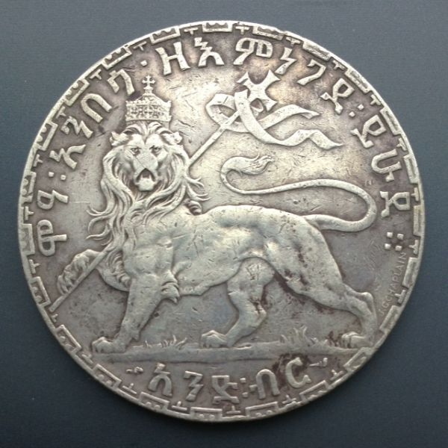

Background
After more than a century of anarchy, Emperor Tewodros II “the Mad” managed to reunify Ethiopia in the 1860’s. However, his cruelty and his increasingly erratic behaviour led to a series of rebellions, and to an useless confrontation with the British Empire. Finally defeated, Tewodros committed suicide in 1868. But his legacy lived on. The age of permanent warfare among the different noble families was over. Without the Mad Emperor, modern Ethiopia wouldn’t exist today.

In 1871, after a short civil war, one of the Ethiopian rebel leaders, Kassai Mercha, became the new Emperor Yohannes IV. Just as Tewodrod before him, Yohannes wished to modernize Ethiopia and his Army. He also longed for an open access to the Red Sea, free from the control of the Ottomans and the Egyptians. He tried hard, but he never could make those dreams become true.

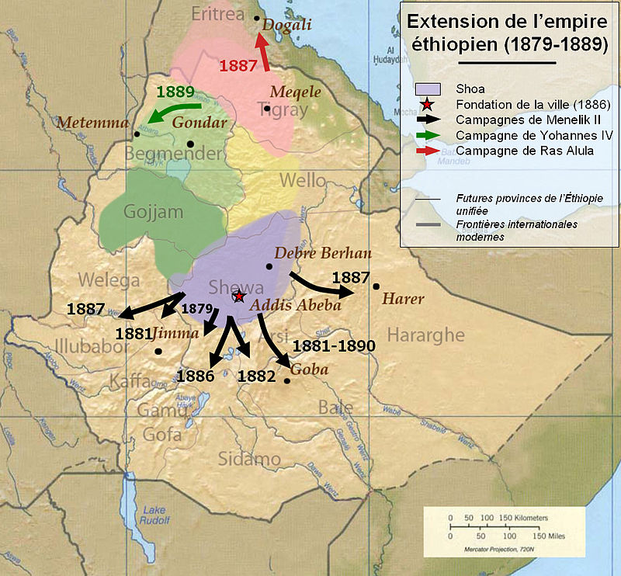

The problems started soon after Yohannes’s coronation. In the south, in Shewa, king Menelik, a former ally of Yohannes against Tewodros, quickly became the staunchest rival of the new emperor. Menelik didn’t care about the Red Sea, and just intended to increase his own kingdom and his own power, until one day he could defy the emperor and claim the title of King of Kings for himself. In the meantime, he wouldn’t openly challenge Yohannes’s authority, but he would give as little support to the emperor as possible.

So, when in 1875 the Egyptians invaded the northern Ethiopian lands of Bogos and Hamasien, Yohannes found himself without any kind of help. Fortunately, his old friend Alula Engida was an excellent military commander, despite being born in a peasant’s family. Against all odds, Yohannes defeated the Egyptians twice, in 1875 and 1876, although he couldn’t expel the from all the occupied lands and, much less, from the Red Sea ports.

Yohannes believed that his opportunity had arrived some years later, in 1884, when the British Empire asked him for help against the Sudanese Mahdists. In exchange for the Ethiopian assistance in evacuating some isolated Egyptian garrisons, saving them from the wrath of the Dervishes, Ethiopia would finally recover Bogos and, even more important, the emperor could use the port of Massawa, even for importing arms.

Naturally, as soon as the Egyptians were successfully evacuated, the United Kingdom betrayed Ethiopia, and encouraged Italy to take Massawa.

Due to that betrayal, Ethiopia didn’t gain any access to the Red Sea, and made two new powerful enemies. Now Yohannes had to deal with the Italians in the north, with the Dervishes in the west, and with Menelik’s passive resistance in the south.

The emperor knew that the Mahdist were the most dangerous enemies at that moment. Furious with the Ethiopians, the Sudanese started a campaign of periodical raids against border towns and villages, forcing the people to choose between conversion to Islam or death. Acting again as a champion of Christianity, Yohannes raised new armies, and Ras Alula defeated the Mahdists at Kufit in 1885. However, his troops had to face too many enemies at the same time. In 1887 Ras Alula defeated the Italians at Dogali, in a first, and futile, attempt to drive them out of the coast of the Red Sea. New Sudanese raids on Ethiopia forced Yohannes and Alula to seek peace with the Italians and concentrate their efforts on defeating the Mahdists. Meanwhile, Menelik negotiated with the Italians, expanded his own kingdom, and watched as the power of Yohannes apparently crumbled.

Overtaken by all of these events, Yohannes couldn’t prevent the sack of the old capital, Gondar, by the Sudanese, in 1888. Sensing a change in the Ethiopian balance of power, some noblemen allied with Menelik and openly rebelled against Yohannes.

Yohannes reacted in a most brutal way. He devastated the lands of the rebels, being even more cruel to them than the Dervishes had been, maybe more harsh and violent than anyone had been in Ethiopia since the last years of Tewodros. But it worked. The rebellion was defeated, and Yohannes was finally free to crush the Sudanese invaders.

Menelik was going to be the next one who would suffer the rage of the emperor, but the Ethiopian Orthodox Church convinced Yohannnes to launch a final campaign against the Dervishes. Menelik would have to wait.

Finally, in 1889 Yohannes launched a massive attack against the border town of Gallabat. Initially, it seemed that the Ethiopians would have a decisive victory. Their forces were massacring some of the best Sudanese units, and their enemies wouldn’t resist for much longer. But then, suddenly, a stray bullet mortally wounded Yohannes. The pious emperor died as he always had wished, in a battle against the Saracens.

Sadly, as soon as they discovered that their emperor had died, the Ethiopians panicked and fled, giving the Dervishes a victory that they didn’t expect. In fact, the Sudanese even managed to surprise, a few days later, the troops that carried the body of the emperor. The Sudanese got the body, decapitated it, and took the head to Omdurman as a trophy. However, their losses had been so staggering that they didn’t attack Ethiopia again.

With Yohannes’s death, Menelik II claimed the title of Emperor. He quickly signed a peace treaty with the Italians, giving them all the coast of the Red Sea and the Eritrean Highlands. What Menelik didn’t know was that those concessions it weren’t enough for the Italians, and that they were planning to betray them, just as the British had done with Yohannes. The Treaty of Wuchale was a scam from the start.

When Menelik realised that he had been cheated, he denounced the treaty, and a war started between Ethiopia and Italy. Russia was the only European country that supported the Ethiopians.

It seemed clear that the Italians would defeat Menelik’s army, but political meddling from the Italian Army forced the Italian commander to advance, against his will, to a mountain area full of Ethiopian warriors. In Adwa, in 1896, the Ethiopians achieved an unexpected, and decisive, victory, becoming the only African country that defeated a colonial power, assuring its independence.

Note: I don’t support any kind of political movement or ideology. This campaign only tries to represent some of the main battles involving Ethiopia during the last years of the XIX century in the wargame OpenGen.

Tips
Let’s face it. In this campaign, your units are really weak. If you aren’t careful, your enemies will beat you once and again, especially in the fictional scenarios.

What can you do? Well, here are some tips:

- Combat support is really useful. It will make your units a bit stronger. Try to buy units with that ability, or even better, upgrade some weak, experienced units.
- Don’t get rid of all your infantries with mountain movement. They are weak, but sometimes they’ll be able to go to places where your enemies, and your own stronger units, can’t go.
- Try to outflank your enemies and attack them from behind, in order to destroy their artilleries, especially if your own guns don’t obtain good leaders.
- Don’t hesitate to sacrifice your auxiliary units if necessary.
- Overstrength your best units, especially in the last scenarios.
- Have patience.

The campaign flow
This campaign has 15 scenarios in total (8 historical and 7 fictional), but if you don’t like fictional scenarios, it’s OK. You can choose to end the campaign after Adwa.

Scenario list.

Number | Scenario Name | Date | Map (number)
0 | Gundet | Nov 16th, 1875 | Gundet (960)
1 | Gura | Mar 7th, 1876 | Gura (961)
2 | Kufit | Sep 23th, 1885 | Paardeberg (1208)
3 | Dogali | Jan 26th, 1887 | Dogali (962)
4 | Sar Weha | Jan 18th, 1888 | Ramacca (633)
5 | Metemma | Mar 9th, 1889 | Gallabat (365)
6 | Amba Alagi | Dec 7th, 1895 | Amba Alagi (358)
7 | Adwa | Mar 1st, 1896 | Adwa (963)
8 | Choice scenario
9 | Tembien | Nov 16th, 1916 | Barentu (364)
10 | Shire | Dec 8th, 1916 | Kasserine Pass (62)
11 | Second battle of Gundet | Mar 23th, 1917 | Gundet (960)
12 | Keren | Sep 9th, 1917 | Keren (363)
13 | Dawa River | Jan 6th, 1918 | Tweebosch (1227)
14 | Bure | Jun 20th, 1918 | Tapline (259)
15 | Massawa | Aug 2nd, 1919 | Massawa (362)

Campaign scenario flow table.

Number | Scenario Name | BV | V | Tac V | Loss
0 | Gundet | 1 | 1 | 1 | 1
1 | Gura | 2 | 2 | 2 | 2
2 | Kufit | 3 | 3 | 3 | 3
3 | Dogali | 4 | 4 | 4 | 4
4 | Sar Weha | 5 | 5 | 5 | 5
5 | Metemma | 6 | 6 | 6 | 6
6 | Amba Alagi | 7 | 7 | 7 | 7
7 | Adwa | 8 | 8 | 8 | Loss
8 | Choice scenario | 9 or Win
9 | Tembien | 10 | 10 | 10 | 10
10 | Shire | 11 | 11 | 11 | 11
11 | Second battle of Gundet | 12 | 12 | 12 | 12
12 | Keren | 13 | 13 | 13 | 13
13 | Dawa River | 14 | 14 | 14 | 14
14 | Bure | 15 | 15 | 15 | Loss
15 | Massawa | Win | Win | Win | Loss

Setup

Create a Kaiser General folder into the main OpenGen folder (it usually is C:\OpenGen). Unzip the newest Kaiser General efile into the Kaiser General folder (usually C:\OpenGen\EFILE_KAISER).
Then unzip the file Lion_Campaign.7z into the Kaiser General efile´s scenario folder (usually C:\OpenGen\EFILE_KAISER\scenario).

You can download the efile from Kaiser General webpage:

http://sites.google.com/site/jkpanzer/graphics/efile

Lion_Campaign.7z also includes an audio file called camplion.mp3. You must paste it into the Kaiser General efile´s sound folder (usually C:\OpenGen\KG2\sound).

Requirements

OpenGen, at least the 0.90.54.0 version. You can download the OpenGen game from Luis Guzman’s webpage, where you’ll also find a complete install explanation and instructions:

http://luis-guzman.com/

Openicons (icon files). They are really easy to install. Unzip the Datup into your main OpenGen folder, usually c:\OpenGen. You can find the latest Openicons here:

http://sourceforge.net/projects/opengeneral/files/DailyBuild/

Maps: The needed maps can be found on the next link: http://pg2mapfinder.gilestiel.eu/

The OG game can automatically download the maps you need from the OG repository, too. You just have to select that option in the game settings.

Acknowledgements

Special thanks to…

Juan Carlos Preciado, for being the author of the Kaiser General efile.

Luis Guzmán, creator of the OpenGen programme and the Suite.

Patrice Gaudette, a.k.a “Arpitec”, for his campaign “The war of the Negus”. It has been a clear inspitation for this new project.

Finally...

These files are free; I made it only for fun. I hope you take fun too playing it. You are not allowed to modify or to sell the files of the campaign without permission of the author.
For any commentary about the campaign, you can email at:

delmarec@gmail.com

The author is not responsible from any bad use or damaged caused by these files. I haven’t any political interest with this campaign; which is only made for historical and fun purposes for OpenGen.

