Prussian campaign
1864-1871
By Urica
OpenGen-Kaiser General efile 2016

Intro
Since the beginning of the XIX century, and the rise of nationalist ideologies, the different German states had made great efforts to achieve some kind of economic and political union. However, it wasn't until the 1860's when Prussia, one of the most powerful German kingdoms, could lead the other states to unification. Through a skilled use of diplomacy and military power, and after winning three wars against Denmark, Austria and France, Prussia made possible, in just seven years, the transformation of Germany from a loose confederation into an Empire composed of 26 constituent states.

This campaign recreates the main battles that Prussia fought during that historical period.

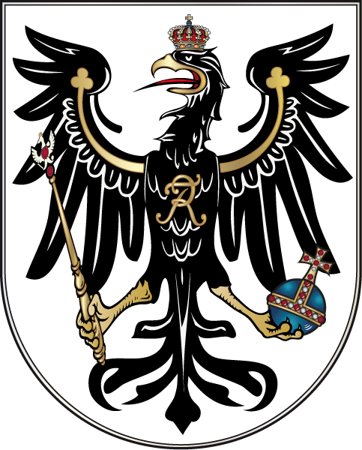

Historical map
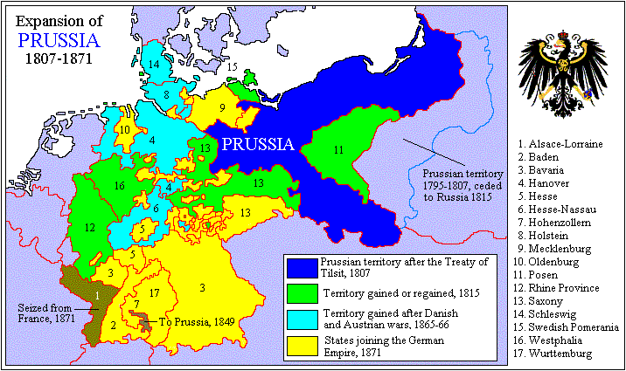
Disclaimer
I don’t support any kind of political movement or ideology. This campaign only tries to represent some of the main battles involving Prussia during the second half of the XIX century in the wargame OpenGen.

The campaign flow
This campaign has 15 scenarios in total. Every result, even a loss, will take you to the next scenario.

Scenario list.

Number | Scenario Name | Date | Map (number)
0 | Gefechte von Missunde | Feb 2nd, 1864 | Missunde 2 (1296)
1 | Düppeler Schanzen | Apr 18th, 1864 | Sonderborg 2 (1297)
2 | Alsen | Jun 29th, 1864 | Sonderborg 2 (1297)
3 | Langensalza | Jun 27th, 1866 | Prut River (832)
4 | Gitschin | Jun 29th, 1866 | Gitschin (1298)
5 | Königgrätz | Jul 3rd, 1866 | Königgrätz (1299)
6 | Schlacht bei Wörth | Aug 6th, 1870 | Bois des Caures (865)
7 | Mars-la-Tour | Aug 16th, 1870 | Gravelotte (1300)
8 | Gravelotte | Aug 18th, 1870 | Gravelotte (1300)
9 | Sedan | Sep 1st, 1870 | Sedan 1870 (1304)
10 | Belagerung von Paris: Chevilly | Sep 30th, 1870 | Paris South (1307)
11 | Amiens | Nov 27th, 1870 | Amiens 1870 (1308)
12 | Orléans | Dec 3rd, 1870 | Orleans (1309)
13 | Le Mans | Jan 11th, 1871 | Le Mans (1310)
14 | Saint Quentin | Jan 19th, 1871 | Saint Quentin (1315)

Setup

Create a Kaiser General folder into the main OpenGen folder (it usually is C:\OpenGen). Unzip the the newest Kaiser General efile into the Kaiser General folder (usually C:\OpenGen\KG2).
Then unzip the file Prussian_Campaign.7z and paste the content of the folder called “Campaign files” into the Kaiser General efile’s scenario folder (usually C:\OpenGen\KG2\scenario).

Prussian_Campaign.7z also includes an audio file called camprus.mp3. You must paste it into the Kaiser General efile´s sound folder (usually C:\OpenGen\KG2\sound).

You can download the efile from Kaiser General webpage:

http://sites.google.com/site/jkpanzer/graphics/efile

Requirements

OpenGen, at least the 0.90.53.0 version. You can download the OpenGen game from Luis Guzman’s webpage:

http://luis-guzman.com/

Soundup (sound files), at least the aug/2010 version. You can download it from Kaiser General webpage

http://sites.google.com/site/jkpanzer/graphics/efile

Openicons (icon files). They are really easy to install. Unzip the Datup into your main OpenGen folder, usually c:\OpenGen. You can find the latest Openicons here:

http://sourceforge.net/projects/opengeneral/files/DailyBuild/

Maps: The needed maps can be found on the next link: http://pg2mapfinder.gilestiel.eu/

The OG game can automatically download the maps you need from the OG repository, too. You just have to select that option in the game settings.

Acknowledgements

Special thanks to…

Juan Carlos Preciado, for being the author of the Kaiser General efile.

Luis Guzmán, creator of the OpenGen programme and the Suite.

Mark “Spasteur de Mont Tonnerre”, for his concept of the battle of Wörth, which I adapted for this campaign.

Finally...

These files are free; I made it only for fun. I hope you take fun too playing it. You are not allowed to modify or to sell the files of the campaign without permission of the author.
For any commentary about the campaign you can email at:

delmarec@gmail.com

The author is not responsible from any bad use or damaged caused by these files. I haven’t any political interest with this campaign; which is only made for historical and fun purposes for OpenGen.

