The Volunteer Army
The White forces during the Russian Civil War
1918 - 1920
By
Urica
OpenGen-Kaiser General efile 2015

Intro
The Red forces roam over most of Russia. All that you have learnt to love seems to be dying under the Bolshevik yoke. But you, along with a handfull of fellow officers, are determined to make a last stand and save your beloved motherland. You won't leave without a fight. In the end, the Communist hordes will be defeated, or you'll die trying.

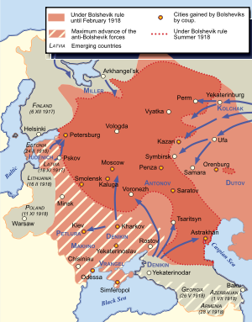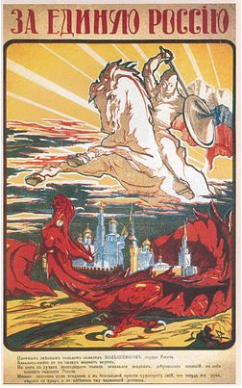

Historical Background
The Volunteer Army was an anti-Bolshevik army which was created in Southern Russia soon after the revolution, in december 1917, by generals Mikhail Alekseyev and Lavr Kornilov. Initially, the small Volunteer Army was composed almost entirely of former Tsarist officers and cadets. Although badly outnumbered, with few weapons and even less money, they were, however, a highly trained fighting force which included other prominent generals as Anton Denikin or Sergey Markov among their leaders.

The new army was on the verge of destruction very soon. In february, knowing that a huge Bolshevik offensive was imminent, the Volunteer Army had to retreat from Rostov-on-Don and left south, towards Kuban, across the frozen steppes. The withdrawal, known as the Ice March, continued day and night, avoiding the railways and hostile towns. The sick and the wounded were simply left behind.
In Kuban some Cossack troops joined the Volunteer Army. After receiving those reinforcements Kornilov tried to take Etaterinodar (today’s Krasnodar), but the well-defended town resisted, and Kornilov himself was killed in action.

With Kornilov dead and Alekseyev terminally ill, the Volunteer Army could have disappeared. General Denikin had to take command (something he never ambitioned), and directed his troops again to the north, where he was reinforced by
Colonel Mikhail Drozdovsky and his men, among them Vladimir May-Mayevsky.
Fortunately for the Volunteer Army, the German presence in Ukraine and the actions of Krasnov’s Cossack Don Army prevented the Red Army from attacking Denikin’s White forces, which had time to reorganize themselves. Besides, the Red forces in the Caucasus, although numerically superior, were virtually isolated and lacked any kind of discipline and formal military training.
Denikin managed to obtain the support of the Don and the Kuban Cossacks, too, and with their aid the Volunteer Army launched the Second Kuban Campaign in june, 1918. This time the white forces took Ekaterinodar and Novorossiysk, which allowed them to receive supplies from the United Kingdom and France, as well as the reinforcement of new volunteers, like General Piotr Wrangel. By then Alekseyev, Markov and Drozdovsky has already died, but the Whites managed to overcome those losses.
In the Autumn of 1918 the forces of the South Russian Whites were combined into the so-called Armed Forces of South Russia under the command of Denikin. In the late 1918 – early 1919, Denikin destroyed all of the Soviet forces in the area, and captured the North Caucasus region. Continuing its offensive, the Armed Forces of Southern Russia took Donbass, Tsaritsyn (today’s Volgograd) and Kharkov in the spring of 1919, and during the summer it began an advance towards Moscow.
Kiev, Odessa, Voronezh, Kursk, Orel…many towns fell under the attack of the White forces. But when october came, Denikin’s army was exhausted. The Red counter-offensive inflicted the Armed Forces of Southern Russia a decisive defeat at Orel, from which they never recovered. Denikin had to retreat to the south, losing all the territorial gains of the spring and the summer. In the early 1920 it retreated beyond the Don, and in march 1920 the remnants of the Volunteer Army were evacuated from Novorossiysk to Crimea, where they would fight under the command of Wrangel until his final defeat, in november 1920.

Note: I don’t support any kind of political movement or ideology. This campaign only tries to represent some of the main battles involving the Armed Forces of Southern Russia in the wargame OpenGen.

The campaign flow

This campaign has 19 scenarios in total, although the maximum number which can be played on a single run is 16. Even a loss will take you to the next scenario.

The first scenarios are linear and historical. If you lose any of the scenarios 10 to 14 (the ones that take place during the White offensive on Moscow) you’ll follow that historical path, until the final defeat of the White Army in Crimea. However, if you get victories in all of the scenarios of the offensive on Moscow, you’ll have a chance of winning the civil war.

Campaign scenario flow table.

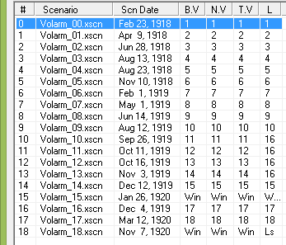

Scenario list.

Number | Scenario Name | Date | Map (number)
0 | The Ice March | Feb 23rd, 1918 | Rostov (347)
1 | Tragedy at Ekaterinodar | Apr 9th, 1918 | Mezy (650)
2 | Belaya Glina | Jun 28th, 1918 | Stalluponnen (1129)
3 | The liberation of Ekaterinodar | Aug 13th, 1918 | Mezy (650)
4 | Novorossiysk | Aug 23rd, 1918 | Novorossiysk (390)
5 | Stavropol | Nov 10th, 1918 | Szekesfehervar (495)
6 | Grozny | Feb 1st, 1919 | Grozny (696)
7 | Operation Manych | May 1st, 1919 | Vistula River (157)
8 | Tsaritsyn | Jun 14th, 1919 | Stalingrad (41)
9 | Oboyan | Aug 12th 1919 | Oboyan (270)
10 | Peregonovka | Sep 26th, 1919 | Lenino (867)
11 | Orel: White avalanche | Oct 11th, 1919 | Orel (438)
12 | Orel: Red storm | Oct 16th, 1919 | Orel (438)
13 | Tula | Nov 3rd, 1919 | Tula South (690)
14 | Moscow | Dec 12th, 1919 | Moscow (67)
15 | Petrograd | Jan 26th, 1920 | Leningrad Center (506)
16 | Kharkov | Dec 4th, 1919 | Kharkov (457)
17 | Last days in Novorossiysk | Mar 12th, 1920 | Novorossiysk (390)
18 | Perekop | Nov 7th, 1920 | Perekop (143)

Setup

Create a Kaiser General folder into the main OpenGen folder (it usually is C:\OpenGen). Unzip the the newest Kaiser General efile into the Kaiser General folder (usually C:\OpenGen\KG2).
Then unzip the file Volarm_Campaign.7z into the Kaiser General efile´s scenario folder (usually C:\OpenGen\KG2\scenario).

You can download the efile from Kaiser General webpage:

http://sites.google.com/site/jkpanzer/graphics/efile

Requirements

OpenGen, at least the 0.90.38.2 version. You can download the OpenGen game from Luis Guzman’s webpage:

http://luis-guzman.com/

Soundup (sound files), at least the aug/2010 version. You can download it from Kaiser General webpage

http://sites.google.com/site/jkpanzer/graphics/efile

Openicons (icon files). They are really easy to install. Unzip the Datup into your main OpenGen folder, usually c:\OpenGen. You can find the latest Openicons here:

http://sourceforge.net/projects/opengeneral/files/DailyBuild/

Maps: The needed maps can be found on the next link: http://pg2mapfinder.gilestiel.eu/

The OG game can automatically download the maps you need from the OG repository, too. You just have to select that option in the game settings.

Acknowledgements

Special thanks to…

Juan Carlos Preciado, for being the author of the Kaiser General efile.

Luis Guzmán, creator of the OpenGen programme and the Suite.

Finally...

These files are free; I made it only for fun. I hope you take fun too playing it. You are not allowed to modify or to sell the files of the campaign without permission of the author.
For any commentary about the campaign you can email at.

delmarec@gmail.com

The author is not responsible from any bad use or damaged caused by these files. I haven’t any political interest with this campaign; which is only made for historical and fun purposes for OpenGen.

