Turkish campaign
1897 - 1922
By
Blitzstoper, Guille, Juankar, Paqueo, REDrake, Spasteur de Mont Tonnerre, Urica and Wonderdoctor
OpenGen-Kaiser General efile, 2017

Intro
In the XIX Century it was undeniable that the once powerful Ottoman Empire was enduring a long period of decadence, and many European nations took advantage of it. Algeria and Tunisia were lost to the French, Egypt to the British, and in Europe most of the Turkish Balcanic possessions had to be handed over to new countries like Greece, Romania and Bulgaria. Decade after decade, the agony of the Ottomans didn't seem to end.

Intending to stop this, the Turkish authorities tried to modernize and strengthen their armies since the decade of 1890. In the following years they had to fight wars in Greece, in Lybia, in Macedonia and, finally, in the terrible Great War. Although they fought bravely, the Ottomans were eventually defeated, and the new Turkish Republic had to fight for its very survival until 1923, when the foreign invaders were finally expelled from the country.

Play this campaign and recreate some of the main battles of this historical period.

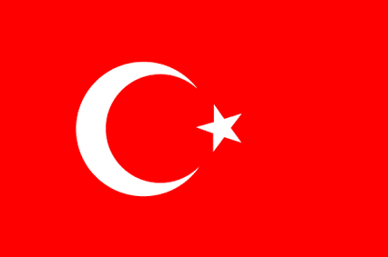

Ottoman flag
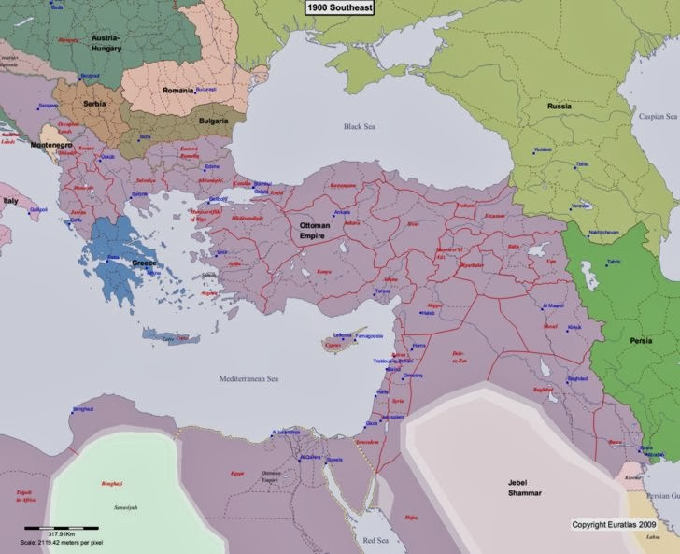

The Ottoman Empire, 1900

Historical background
There are six different wars that we have shown to you in this campaign:

Greco-Turkish War (1897): an Ottoman victory against a Greek invasion (2 scenarios).

Italo-Turkish War (1911-1912): an Ottoman defeat. The Empire lost Libya (2 scenarios).

First Balkan War (1912-1913): an Ottoman defeat against Bulgaria, Serbia and Greece. The Empire lost most of its remaining territories in Europe. (2 scenarios).

Second Balkan War (1913): a victory of the Ottomans, Greece, Serbia and Romania against Bulgaria. The Empire recovered parts of Eastern Thrace (1 scenario).

First World War (1915-1918): despite all the Ottoman efforts, and some fine victories like Gallipolli and Kut, fighting in several fronts against the Russians and British was too much for the Turks. In the end, the Empire was completely lost, and just a few years after the Ottoman defeat, a republic was proclaimed in Turkey (9 scenarios).

Turkish Independence War (1919-1923): the Republican uprising against the occupation of Anatolia by the foreign powers that had won the WWI. It ended with a Turkish victory (4 scenarios).

The story of this project
This campaign project started a long time ago, on February 2012, when Blitzstoper suggested that the OpenGen community should design a Turkish campaign, that would take place during the first years of the XX century. Naturally, it would use the KG efile, which is specially made for that historical period.
At that time there were already many campaigns with the Ottoman Empire as the enemy, so it shouldn’t be difficult to design new scenarios with the Turks as protagonists.

The very same day that Blitzstoper had the idea, Guille, Paqueo, Urica and Wonderdoctor volunteered to make some of the scenarios. And soon the team started to work. In just three months half of the scenarios were ready. Juankar had modified the efile to make the scenarios more fun and realistic, and he had joined the team of designers, too. 1-Terminator and REDrake promised to design some scenarios, too. The development of the project was incredibly fast, and it seemed that it would be finished soon.

Then the summer came, and everything became slower. The campaign just needed a final push, since thirteen scenarios had been completed. But that was the time when Luis Guzmán released the new formats for OG. The game became better, but more complicated, too. Some old-school players gradually lost interest in OG, and that included Blitzstoper, who had coordinated the project since the beginning. From September to December he didn’t work on the campaign, and when he came back the project was seriously damaged. 1-Terminator forgot about his design and, soon after that, he left the OG community. REDrake only sent an unfinished scenario, and focused on his own projects. In fact, that’s what all the other designers did.

Some days before Christmas, Blitzstoper disappeared again, and that was the end of the Turkish campaign for a very long time. Without his leadership, nothing was done for many, many months. Urica took care of the project in March 2013, but during that year and the following one, only one more scenario was finished: Velestino.

The battle of Domokos should be the next one, but Juankar didn’t have time for it. Two more years went by without any advance. The project was all but dead.

Then, in June 2016 Wonderdoctor asked about the campaign. Juankar allowed Urica to design the battle of Domokos, he did it, and that was a turning point. The prestige management, the AI, and other minor issues were updated, and in August 2016 the project resurrected.

Urica finished REDrake’s scenario in Romania and designed a couple of extra battles, too. Wonderdoctor made another one. And Spasteur de Mont Tonerre joined the team of designers, making two additional scenarios. In just a couple of months, the Turkish campaign was brought back to life, and was nearly finished. After a final, but fortunately short, development freeze, Guille made the last scenario in February of 2017. Finally, after five years, the campaign ended. It has been a long way, but at least you have it!!!

Note: we don’t support any kind of political movement or ideology. This campaign only tries to represent some of the main battles involving Turkey, during the last years of the XIX century and the beginning of the XX century, in the wargame OpenGen.

The campaign flow
This campaign has 20 scenarios in total. Every victory will take you to the next scenario, and except for the last two battles, even a loss will be enough.

Scenario list:

Number | Scenario Name | Author | Date | Map (number)
0 | Battle of Velestino | Juankar | May 5th, 1897 | Velestino (957)
1 | Domokos | Urica | May 5th, 1897 | Domokos (1316)
2 | Battle of El Hani and Bu Meliana | Wonderdoctor | Oct 23rd, 1911 | Trablus (945)
3 | The trenches at Janzour | Wonderdoctor | June 8th, 1912 | Janzour (947)
4 | Battle of Kirk Kilisse | Urica | Oct 22nd, 1912 | Amiens (140)
5 | Çatalca line | Urica | Nov 17th, 1912 | Çatalca (937)
6 | Liberation of Edirne | Urica | July 22nd, 1913 | Adrianople (941)
7 | Raid on Misir | Blitzstoper | Feb 3rd, 1915 | Kantara (563)
8 | Gelibolu (Gallipoli) | Paqueo | Apr 25th, 1915 | Helles (560)
9 | Fighting in Kafkasya: Arhavi- Findikli | Blitzstoper | Jan 23rd 1916 | Sicily North (332)
10 | Kut al Amara | Paqueo | Apr 17th, 1916 | El Kut (315)
11 | Supporting the allies: Kobadin | REDrake/Urica | Sep 17th, 1916 | Zborow (613)
12 | Supporting the allies: Galicia | Urica | Sep 30th, 1916 | Kishinev (729)
13 | Second Battle of Gaza | Wonderdoctor | Apr 19th, 1917 | Gaza (594)
14 | The Battle of Jerusalem | Spasteur de Mont Tonerre | Nov 17th, 1917 | Jerusalem 1917 (596)
15 | Transjordan Attack | Spasteur de Mont Tonerre | Apr 30th, 1918 | Golan (853)
16 | The insurgency at Marash | Urica | Jan 21st, 1920 | Ramacca (633)
17 | Second battle of Inonu | Guille | Mar 27th, 1921 | Inonu (829)
18 | Battle of Sakarya | Guille | Aug 23rd, 1921 | Polatli (740)
19 | Dumlupinar | Guille | Aug 26th, 1922 | Dumlupinar (1126)

Setup

Create a Kaiser General folder into the main OpenGen folder (it usually is C:\OpenGen). Unzip the the newest Kaiser General efile into the Kaiser General folder (usually C:\OpenGen\KG2).
Then unzip the file Turkish_Campaign_files.7z into the Kaiser General efile´s scenario folder (usually C:\OpenGen\KG2\scenario).

Turkish_Campaign.7z also includes an audio file called camturk.mp3. You must paste it into the Kaiser General efile’s sound folder (usually C:\OpenGen\KG2\sound).

You can download the efile from the OG DailyBuild webpage:

https://sourceforge.net/projects/opengeneral/files/DailyBuild/

Requirements

OpenGen, at least the 0.90.57.1 version. You can download the OpenGen game from Luis Guzman’s webpage:

http://luis-guzman.com/

Soundup (sound files). You can download it from Kaiser General webpage

http://sites.google.com/site/jkpanzer/graphics/efile

Openicons (icon files). They are really easy to install. Unzip the Datup into your main OpenGen folder, usually c:\OpenGen. You can find the latest Openicons here:

http://sourceforge.net/projects/opengeneral/files/DailyBuild/

Maps: The needed maps can be found on the next link: http://pg2mapfinder.gilestiel.eu/

The OG game can automatically download the maps you need from the OG repository, too. You just have to select that option in the game settings.

Acknowledgements

Special thanks to…

Luis Guzmán, creator of the OpenGen programme and the Suite.

Patrick Steinmann, for his campaigns “The last crusade” and “British Gallipolli campaign”, which were taken as a reference for designing some of the scenarios of this campaign.

Finally...

These files are free; we made it only for fun. We hope you take fun too playing it. You are not allowed to modify or to sell the files of the campaign without permission of the authors.
For any commentary about the campaign you can write in the JP’s panzers forum:

http://www.panzercentral.com/forum/index.php

The authors are not responsible from any bad use or damaged caused by these files. We haven’t any political interest with this campaign; which was only made for historical and fun purposes for OpenGen.

