Weltkrieg
German campaign during the First World War
1914 - 1919
By
Urica
OpenGen-Kaiser General efile 2015

Intro
Your country has been too ambitious, or too imprudent, in this fateful summer of 1914. Nobody thinks that Germany will be able to win a long war fighting on two separate fronts at the same time. Defeat seems inevitable. And that's what will happen, if one unexpected factor doesn't enter the scene: you.
Join the Deutsches Heer in its struggle against the Entente forces. Show your enemies that the German Empire has been underestimated, and that it has the will and the skill to become the main power in Europe...and the world.

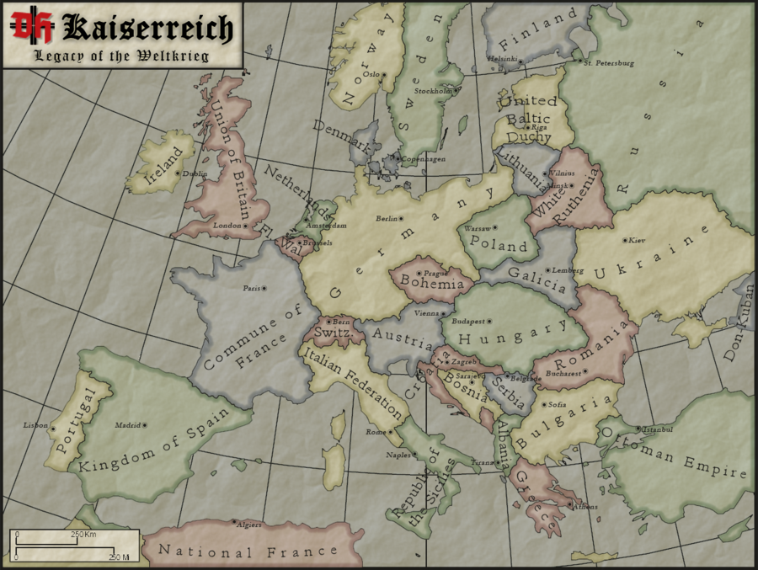

Background
This campaign is inspired on the “Kaiserreich” mod, developed for the game “Hearts of Iron II”. In this mod, set in 1936, Germany won the WWI and became the main power in the world.
In “Kaiserreich” the first years of the war don’t differ from reality. But in 1917 Germany manages to keep the USA neutral. So when 1918 starts, Germany doesn’t need to hurry and end the war in the west as soon as possible. The Kaiserschlacht doesn’t take place and, while the Germans hold their ground in Belgium and France, they are capable of sending troops to Italy and the Balkans, winning the war in those secondary fronts. Then, in 1919, after more than a year of planning, and with all their available resources, Germany launched its final offensive in the west, finally breaching the French lines. Then a Marxist revolution started in France, that had to sue for peace, and the British troops retired from the Continent. Unable to invade Great Britain, Germany offered the British a Peace with Honour, which was accepted, ending the war.
You can find more about the mod in these links:

https://forum.paradoxplaza.com/forum/index.php?threads/kaiserreich-legacy-of-the-weltkrieg-global-alternate-history-mod-for-hoi2.223176/

http://editthis.info/kaiserreich/Main_Page
Note: I don’t support any kind of political movement or ideology. This campaign only tries to represent some of the main battles involving Germany during the WWI in the wargame OpenGen.

The campaign flow
This campaign has 24 scenarios in total. Every victory will take you to the next scenario, and except for the last five scenarios even a loss will be enough.

Scenario list.

Number | Scenario Name | Date | Map (number)
0 | Mülhausen | Aug 7th, 1914 | Mulhouse (382)
1 | Schlacht in Lothringen | Aug 20th, 1914 | Arracourt (19)
2 | Hartmannsweilerkopf | Jan 19th, 1915 | Hartmannsweilerkopf (866)
3 | Neuve-Chapelle | Mar 10th, 1915 | Neuve Chapelle (1066)
4 | Zweite Flandernschlacht - St. Julien | Apr 24th, 1915 | Langemark (1073)
5 | Loos: Hohenzollern-Redoute | Sep 25th, 1915 | Hohenzollern-Redoubt (1074)
6 | Verdun: Unternehmen Gericht | Feb 21st, 1916 | East Bank Verdun (1081)
Number | Scenario Name | Date | Map (number)
7 | Verdun: Toter Mann (Mort- Homme) | Mar 6th, 1916 | Verdun “Le Mort Homme” (NW) (920)
8 | Brussilow Offensive: Kowel | Jul 24th, 1916 | Bzura River (147)
9 | The Romanian front: Hermannstadt | Sep 26th 1916 | Sibiu (451)
10 | Aisne 1917 | Apr 16th, 1917 | Aisne (1160)
11 | Kerenski Offensive | Jul 1st, 1917 | Zborow (613)
12 | Schlacht um Riga | Sep 1st, 1917 | Riga (337)
13 | Karfreit | Oct 24th, 1917 | Caporetto (450)
14 | Cambrai | Nov 30th, 1917 | Gouzeaucourt (1151)
15 | Estaires | Apr 9th, 1918 | Estaires (1186)
16 | Unternehmen Teutoburg | Jun 4th, 1918 | Tapline (259)
17 | Athen | Jun 20th, 1918 | Athens (471)
18 | Unternehmen Radowitz | Jul 14th, 1918 | Po Valley (406)
19 | To the Marne! | Mar 2nd, 1919 | Sedan North East (277)
20 | Reims | Jun 4th, 1919 | Laon (133)
21 | Dieppe | Jun 4th, 1919 | Dieppe (130)
22 | Closing the trap | Jun 4th, 1919 | Dessau (17)
23 | Port Said | Jun 4th, 1919 | Port Said (38)

Campaign scenario flow table.

Number | Scenario Name | BV | V | Tac V | Loss
0 | Mülhausen | 1 | 1 | 1 | 1
1 | Schlacht in Lothringen | 2 | 2 | 2 | 2
2 | Hartmannsweilerkopf | 3 | 3 | 3 | 3
3 | Neuve-Chapelle | 4 | 4 | 4 | 4
4 | Zweite Flandernschlacht - St. Julien | 5 | 5 | 5 | 5
Number | Scenario Name | BV | V | Tac V | Loss
5 | Loos: Hohenzollern-Redoute | 6 | 6 | 6 | 6
6 | Verdun: Unternehmen Gericht | 7 | 7 | 7 | 7
7 | Verdun: Toter Mann (Mort- Homme) | 8 | 8 | 8 | 8
8 | Brussilow Offensive: Kowel | 9 | 9 | 9 | 9
9 | The Romanian front: Hermannstadt | 10 | 10 | 10 | 10
10 | Aisne 1917 | 11 | 11 | 11 | 11
11 | Kerenski Offensive | 12 | 12 | 12 | 12
12 | Schlacht um Riga | 13 | 13 | 13 | 13
13 | Karfreit | 14 | 14 | 14 | 14
14 | Cambrai | 15 | 15 | 15 | 15
15 | Estaires | 16 | 16 | 16 | 16
16 | Unternehmen Teutoburg | 17 | 17 | 17 | 18
17 | Athen | 18 | 18 | 18 | 18
18 | Unternehmen Radowitz | 19 | 19 | 19 | 19
19 | To the Marne! | 20 | 20 | 20 | Loss
20 | Reims | 21 | 21 | 21 | Loss
21 | Dieppe | 22 | 22 | 22 | Loss
22 | Closing the trap | 23 | 23 | 23 | Loss
23 | Port Said | Win | Win | Win | Loss

Setup

Create a Kaiser General folder into the main OpenGen folder (it usually is C:\OpenGen). Unzip the the newest Kaiser General efile into the Kaiser General folder (usually C:\OpenGen\KG2).
Then unzip the file Weltkrieg_Campaign.7z into the Kaiser General efile´s scenario folder (usually C:\OpenGen\KG2\scenario).

You can download the efile from Kaiser General webpage:

http://sites.google.com/site/jkpanzer/graphics/efile

Requirements

OpenGen, at least the 0.90.50.0 version. You can download the OpenGen game from Luis Guzman’s webpage:

http://luis-guzman.com/

Soundup (sound files), at least the aug/2010 version. You can download it from Kaiser General webpage

http://sites.google.com/site/jkpanzer/graphics/efile

Openicons (icon files). They are really easy to install. Unzip the Datup into your main OpenGen folder, usually c:\OpenGen. You can find the latest Openicons here:

http://sourceforge.net/projects/opengeneral/files/DailyBuild/

Maps: The needed maps can be found on the next link: http://pg2mapfinder.gilestiel.eu/

The OG game can automatically download the maps you need from the OG repository, too. You just have to select that option in the game settings.

Acknowledgements

Special thanks to…

Juan Carlos Preciado, for being the author of the Kaiser General efile.

Luis Guzmán, creator of the OpenGen programme and the Suite.

Patrick Steinmann, for making many of the maps used in this campaign, and for his play test.

Patrick Steinmann, for making many of the maps used in this campaign, and for his play test.

Jan Hedström “Pzmaniac” and Mark “Spasteur de Mont Tonnerre”, for testing this campaign.

Jurgen Smet, “Wonderdoctor”, for being the creator of the first German campaign for OG during the WWI: “Von Schlieffen Plan”. Some of the scenarios of this “Weltkrieg” campaign (Neuve Chapelle, St. Julien, Estaires) are conversions from “Von Schlieffen”.

Toliy, for his Russian campaign “For God, Tsar, and Motherland”. Some of the scenarios of this “Weltkrieg” campaign (Brussilow offensive, Kerenski offensive) are conversions from Toliy’s.

Finally...

These files are free; I made it only for fun. I hope you take fun too playing it. You are not allowed to modify or to sell the files of the campaign without permission of the author.
For any commentary about the campaign you can email at.

delmarec@gmail.com

The author is not responsible from any bad use or damaged caused by these files. I haven’t any political interest with this campaign; which is only made for historical and fun purposes for OpenGen.

