WIGOS METADATA REPRESENTATION (WMDR) MODEL DEVELOPMENT GUIDE

Authors:

Dominic Lowe, Australian Bureau of Meteorology

Jörg Klausen, MeteoSwiss

Tom Kralidis, Meteorological Service of Canada

|  |  |  |
| --- | --- | --- |
| Revisions: |  |  |
| 2015-06-29 | Dominic Lowe | Initial version |
| 2017-03-28 | Dominic Lowe | Revised to add schema generation section |
| 2017-09-28 | Jörg Klausen | References to svn repository updated |
| 2017-12-28 | Tom Kralidis | Update steps, screenshots, build/tag/release procedures |
| 2018-01-17 | Tom Kralidis | Update development workflow (section 6) |
| 2018-10-03 | Tom Kralidis | Update WMO contact, SVN repository locations |
| 2020-05-29 | Jörg Klausen | Use of EA15.1, cloud repositories and github instead of SVN, major changes to this document |
| 2021-03-18 | Jörg Klausen | Improved description of procedures involved, in particular also github and the versioning process. |

Table of Contents

1. Introduction 2

2. Enterprise Architect 2

3. Initial Setup and Version Control 3

3.1. METCE 3

3.2. WMDR 3

4. Initial Set up of the WMDR model in Enterprise Architect 3

4.1. Import the ISO TC211 Harmonized Model 3

4.2. Import the METCE model 6

4.3. Import the WMDR model 6

4.4. Package Control 7

5. Generate WMDR GML Application Schema 7

6. Final setup steps 8

7. Model development and schema maintenance 8

7.1. Update the local working copy of the Github repository 9

7.2. Create a new branch for model updates 9

7.3. Update the EA model 9

7.4. Regenerate the GML Application Schema 10

7.5. Export the WMDR package as XMI 10

7.6. Generate the HTML documentation 11

7.7. Test the examples 11

7.8. Update any other documentation as needed 11

7.9. Compress EA model and export WMDR package 12

7.10. Commit changes and create pull request 12

8. Release Procedure 12

9. Recreating earlier versions of the EA model 12

9.1. Release 1.0RC9 12

# Introduction

The WIGOS Metadata Representation (WMDR) is the reference implementation of the WIGOS Metadata Standard. The WMDR is developed using **SPARX Enterprise Architect (EA) version 15.1** and is distributed as a GML Application Schema, a specialized XML Schema Definition (XSD). EA is used in conjunction with a GitHub[1]. Unfortunately, EA is not integrated with GitHub, so there is no direct version control of the model from within EA. This requires a slightly more complex work-flow and coordination amongst the collaborators on the model.

It is assumed there is a primary model editor who maintains the GitHub repository. Having multiple editors working on the model can create synchronisation and ‘locking’ problems that can be difficult to resolve. If you would like to contribute to the model development, please carefully follow the procedures outlined in Section 8. Also, contact the maintainer(s) of the GitHub repository before doing any work.

This document explains how to:

* Install Enterprise Architect
* Install a local GitHub repository
* Fetch the model(s) from the repository
* Modify the model (e.g. add new attributes)
* Regenerate the XML Schema
* Update the repository.

# Enterprise Architect

Obtain at least the ‘Professional’ version of Enterprise Architect from

<http://www.sparxsystems.com.au/products/ea/purchase.html>.[2]

The install is a typical Windows installation process. Installation may require administrative rights.

# Initial Setup and Version Control

Install a Git client like Git for Windows[3] or TortoiseGit[4]. In Windows Explorer, create a directory ‘git’ to hold the local repositories of the required model component METCE and the overall WMDR model.

## METCE

Download METCE model from <https://www.wmo.int/schemas/metce/1.2/zip/METCE-1.2-XMI.zip> and unpack. The WIGOS metadata model v1.0 uses METCE 1.2.

**N.B.** Future versions of WMDR are likely to remove the dependence from METCE 1.2.

## WMDR

The github repository is located at <https://github.com/wmo-im/wmdr.git>. Clone this repository into the ‘git’ folder. To do this, open your git client command line interface, navigate to your local ‘git’ folder, and execute

$ git clone https://github.com/wmo-im/wmdr.git

The result should be a ‘metce’ folder that is now connected to the remote repository.

# Initial Set up of the WMDR model in Enterprise Architect

Create a folder ‘eamodel’ somewhere on a disk (share). Open EA and select ‘Create a new project’, save it as ‘wmdr.eapx’ in the ‘eamodel’ folder. This file will hold the entire model. It is not version controlled, so any changes are immediately reflected. The version control of the model is discussed under section 4.4 Package Control.

The WMDR model uses the ISO 19156 Observation & Measurements model as well as a number of depending ISO models as a base. It also used to use the WMO METCE model. These components as well as the actual WMDR model need to be imported. To do this, highlight the ‘Model’ in the EA Browser space and select ‘Design’ > ‘Add’ > ‘Package’. Call it ‘ISO’. Repeat the process and create two more packages called ‘METCE’ and ‘WMDR’, respectively.

## Import the ISO TC211 Harmonized Model

In EA, highlight the ‘ISO’ package and select Publish > Reusable Assets > Import. To connect to the asset service: See the user guide for Reusable Assets[5]. Apply the following parameters for the Registry:

* Name: iso_in_the_cloud
* Protocol: http
* Server: 104.130.217.178
* Port: 804
* Model Name: iso

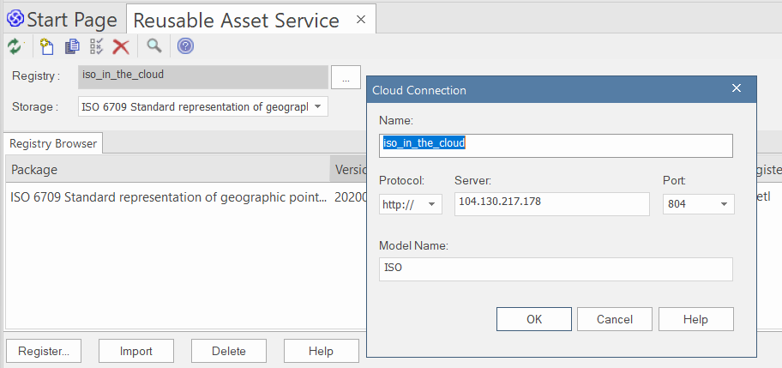

Select the ISO 19156 under ‘Storage’ and Click ‘Import’ > ‘Package’. One storage is created for each main standard number, containing all parts and editions.

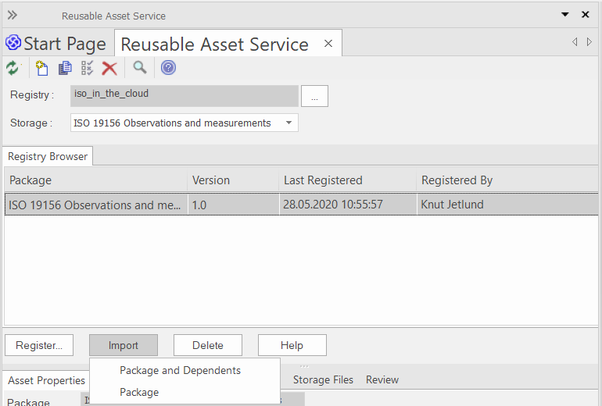

Verify that the following models are present in EA in addition to the ISO 19156 model, or import them if they aren’t.

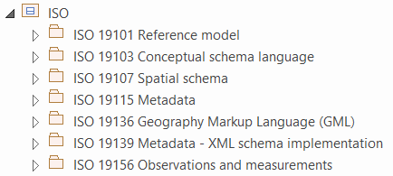

## Import the METCE model

In EA, highlight ‘METCE’ and navigate to ‘Publish’ > ‘Import XML’ > ‘Import Package from XMI’. Import the ‘wmo-metce.xml’ file as shown in the pop-up below.

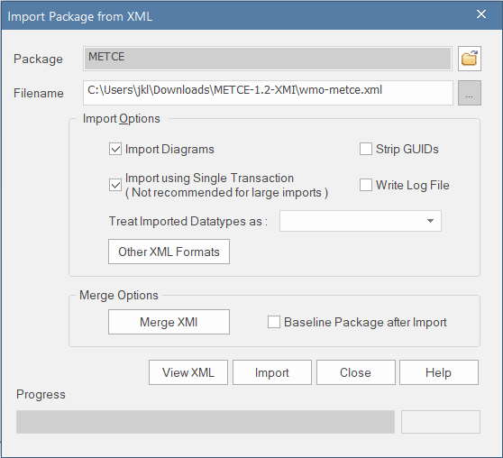

## Import the WMDR model

In EA, highlight the root model ‘Model’ and navigate to ‘Publish’ > ‘Import XML’.

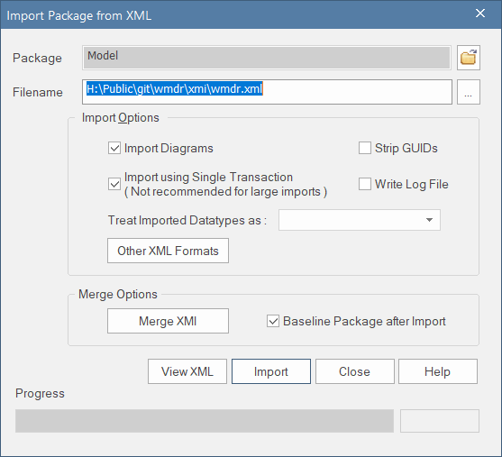

Click ‘Import’, then select ‘No’ when prompted to place the model at the root level.

## Package Control

Enterprise Architect does not support integration with Git for Version Control[6]. We therefore use the 'Controlled Packages' function of Enterprise Architect without explicit Version Control integration. This allows us to pre-set the path for saving and loading the XMI for the WMDR package. The XMI file is located in the Git working directory and can thus be version-controlled using Git outside Enterprise Architect.

Follow the steps provided in the ‘Configure Packages’ help page[7] to control the WMDR package. Basically, highlight the package, then press <Ctrl>+>Alt>+P and complete the pop-up dialogue as shown below.

**NB.** The ISO and METCE packages are not version-controlled, because we don’t change them. However, they should be updated as part of the Model development process, so that the latest versions are used.

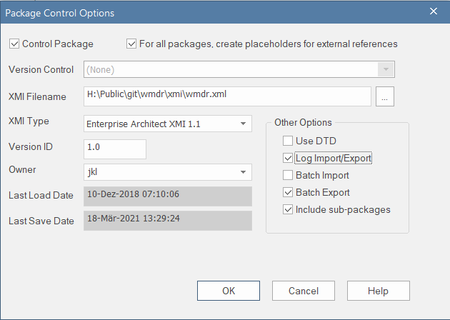

# Generate WMDR GML Application Schema

Enterprise Architect can automatically generate the WMDR GML[8] Application Schema[9]. http://www.opengeospatial.org/standards/gml

To do so, highlight the ‘<<Application Schema>> WMDR’ package, select ‘Specialize’ > > ‘Generate GML Application Schema’ and fill in the form as shown. If you wish, double-click on the Filename to choose another name for the .xsd file.

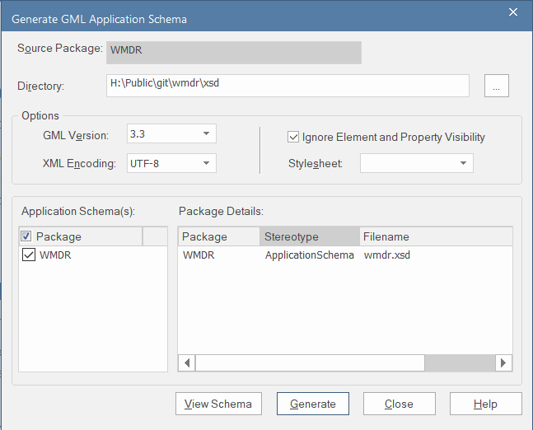

# Final setup steps

The EA project files can get relatively large. To check integrity and reduce file size, select ‘Configure’ > ‘Integrity’ > ‘Manage .EAPX/.EAP File’ > ‘Compact .EAPX/.EAP File’.

The final model should look something like the following in the Browser.

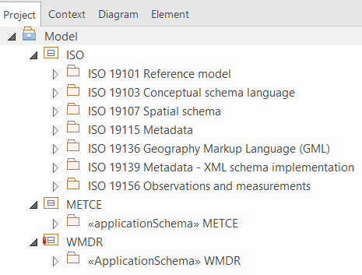

# Model development and schema maintenance

Several steps are involved in updating the model and the GML schema, while maintaining version control of the WMDR package:

* Update the local working copy of the model from the Github repository
* Create a new branch
* In EA
  + Merge the wmdr.xml file into the WMDR package
  + Edit the UML model, making sure to also update the version number
  + Regenerate the GML schema
* Commit updates to the GitHub repository and create a Pull request.

## Update the local working copy of the Github repository

The exact procedures depend on your GitHub client, but the normal process involves

* $ git fetch download metadata from remote
* $ git diff …origin display differences between local copy and remote repo
* $ git pull fetch and merge the remote into the local repository

## Create a new branch for model updates

In general, modelling work should be done in a branch. There are a few commands to work with branches as follows.

* $ git branch -av (to list all branches, local and remote)
* $ git checkout -b <my-branch> (create new branch if not exists, switch to it)

## Update the EA model

Open your local **/eamodel/wmdr.eapx** file from within EA.

Merge the latest wmdr.xml into the WMDR package by selecting ‘Publish’ > ‘Import XML’ > ‘Merge Model XMI into Current Package’.

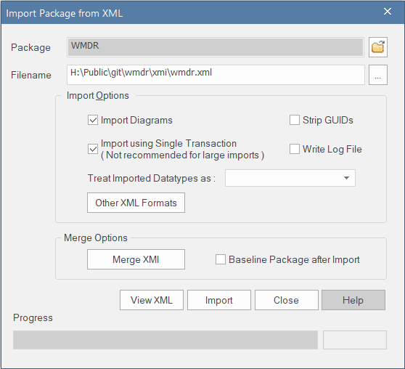

**WMO Guide to Data Modeling**

The WMO Guide to Data Modelling[10] documents certain conventions agreed by the WMO community.

Importantly, every attribute in the model, and every association role target end has a ‘tagged value’ called ‘*sequenceNumber*’. This tagged value controls the order of elements in the schema. It is critical that it is present and that there are no duplicates in a class. Otherwise, the element order in the GML application schema will change. This may create parsing issues down-stream and must be avoided.

To add a new attribute to a class:

* Add the attribute
* Select its type from the appropriate model – e.g. CharacterString is in ISO 19103. Don’t just type CharacterString – you have to select it from the model or the XML schema generation may not work.
* Add a tagged value to the attribute called ‘sequenceNumber’. Give it the next sequence number in the list. E.g. if the class has 5 attributes, call this ‘6’. If you wish to place it earlier in sequence you will need to modify the other sequence numbers accordingly for that class.
* Note that associations from classes also have sequence numbers – these have typically been set higher e.g. 10, 20, 30. However care must be taken not to clash with these numbers also – modify if needed.

Cardinality changes can be made simply by changing the cardinality.

Name changes can be made simply by changing the name.

For more complex changes like adding new classes please consult the WMO Guide to Data Modelling.

## Regenerate the GML Application Schema

See Section 6.

## Export the WMDR package as XMI

In EA, select ‘Publish’ > ‘Export XML’.

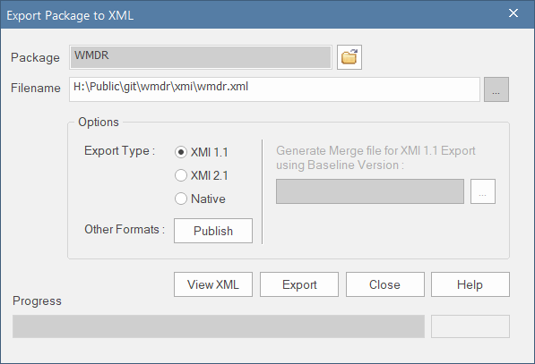

This step is important, because it is the wmdr.xml file that provides the version control and – via the github repository – enables the sharing of the most recent version of the model.

## Generate the HTML documentation

In EA, select ‘Publish’ > ‘HTML’.

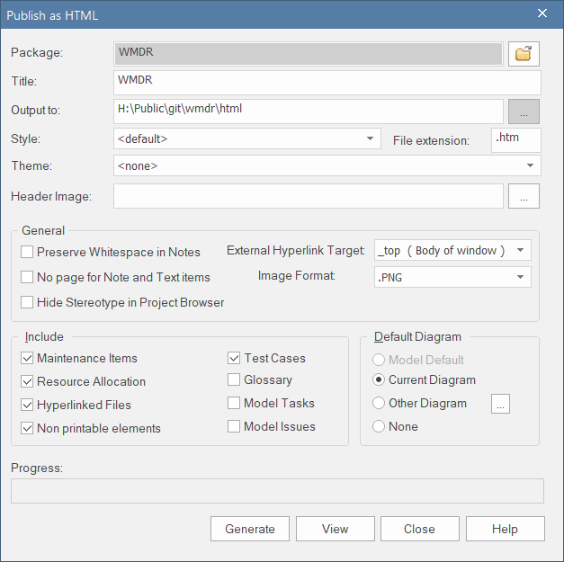

## Test the examples

A series of examples of XML files are included in the WMDR github repository. These examples should be validated against the updated wmdr.xsd. For the validation, Notepad++ with the ‘XML Tools’ add-on[11] can be recommended as a free tool. Other, specialized, tools like XMLSpy or Oxygen are also available.

**NB.** For the validation of the example files against the local wmdr.xsd, the location of the wmdr.xsd must be set to the local path.

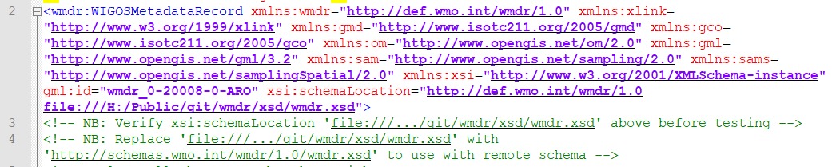

## Update any other documentation as needed

tbd

## Compress EA model and export WMDR package

Once all editing work is completed,

* In EA,
  + Compress the model (cf. Section 7),
  + Export the WMDR package using ‘Publish’ > ‘Export-XML’ > ‘Export Package to XML’  
    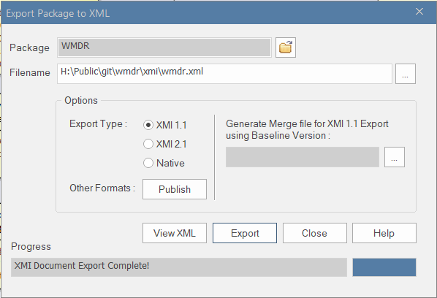
  + Quit EA.

## Commit changes and create pull request

Navigate to your local GitHub repository, stage all changed files and commit your changes.

* $ git add .
* $ git commit –m “commit message”

Push your local changes to the remote GitHub repository (=pull request).

* $ git push

# Release Procedure

The maintainer(s) of the remote repository will decide if the branch can be merged into Master and delete <my-branch> eventually. The maintainer(s) will also create a ‘release’ by tagging the Master branch once ready.

# Recreating earlier versions of the EA model

## Release 1.0RC9

Extract the xmi/wmdr.xml file to a local place from the GitHub release 1.0RC9 and rename it to wmdr-1.0RC9.xml.

Also, extract the xsd/wmdr.xsd file to a local place from the GitHub release 1.0RC9 and rename it to wmdr-1.0RC9.xsd.

Create a root package, then Publish > Import XML with the following settings.

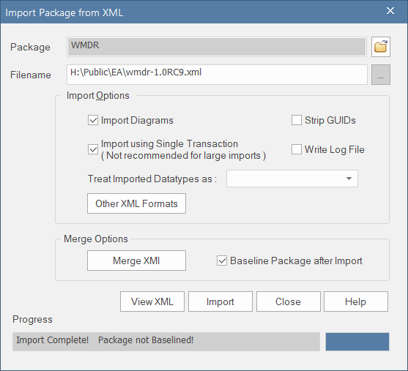

When prompted, create a baseline as follows.

.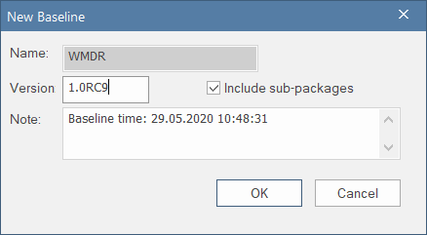

Verify the model by generating the XSD file. In EA, select ‘Specialize’ > > ‘Generate GML Application Schema’. Save the XSD as wmdr-1.0RC9-recreated.xsd.

The wmdr-1.0RC9.xsd and the newly recreated wmdr-1.0RC-recreated.xsd files must be almost the same, the only differences being

* different versions of Enterprise Architect (line is a comment) – Line 2
* the location of the block describing wmdr:description (Lines 79-92 in the schema from release 1.0RC9; Lines 21-34 in the recreated schema)

1. <https://github.com/wmo-im/wmdr>
2. A fully functional 30 day trial can be downloaded from [www.sparxsystems.com.au/products/ea/trial.html](http://www.sparxsystems.com.au/products/ea/trial.html)
3. <https://gitforwindows.org/>
4. <https://tortoisegit.org/download/>
5. <https://sparxsystems.com/enterprise_architect_user_guide/15.0/model_repository/connect_to_asset_service.html>
6. <https://www.sparxsystems.com.au/support/faq/versioncontrolfaq.html>
7. <https://www.sparxsystems.com/enterprise_architect_user_guide/15.1/model_publishing/pkgcontrol.html>
8. <http://www.opengeospatial.org/standards/gml>
9. <https://sparxsystems.com/enterprise_architect_user_guide/15.1/model_domains/generate_gml_application_schem.html>
10. (include reference)
11. <https://notepad-plus-plus.org/>