How-To SportSense

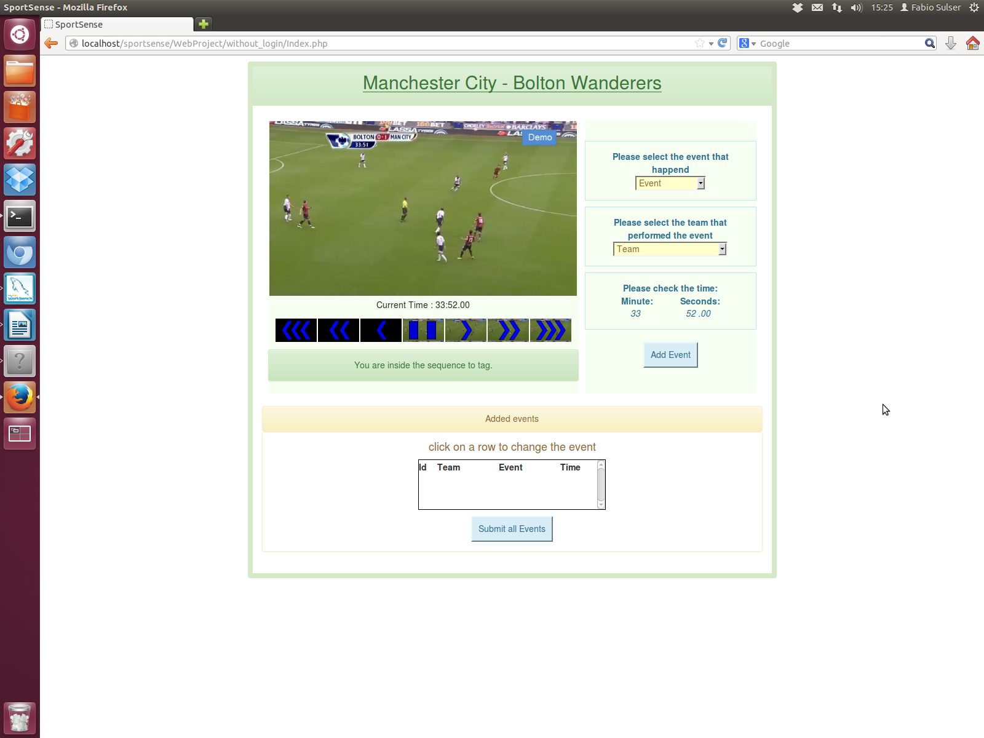
If you accept to do the task, you will see a Webpage looking like the Picture on the right side.

On this Webpage we have three sections.
The red one contains the videoplayer, the green one the input elements and the yellow one your entered data.

$

The Video Player
The Video Player got an extension with which you can play through the video.
The blue break icon indicates your actual position in the movie.
If the background of the break icon is black, your outside your task.

To get to another position of the video click on the images or use the left and right arrows on your keyboard. If you want to play and stop the video use the spacebar of your keybord.
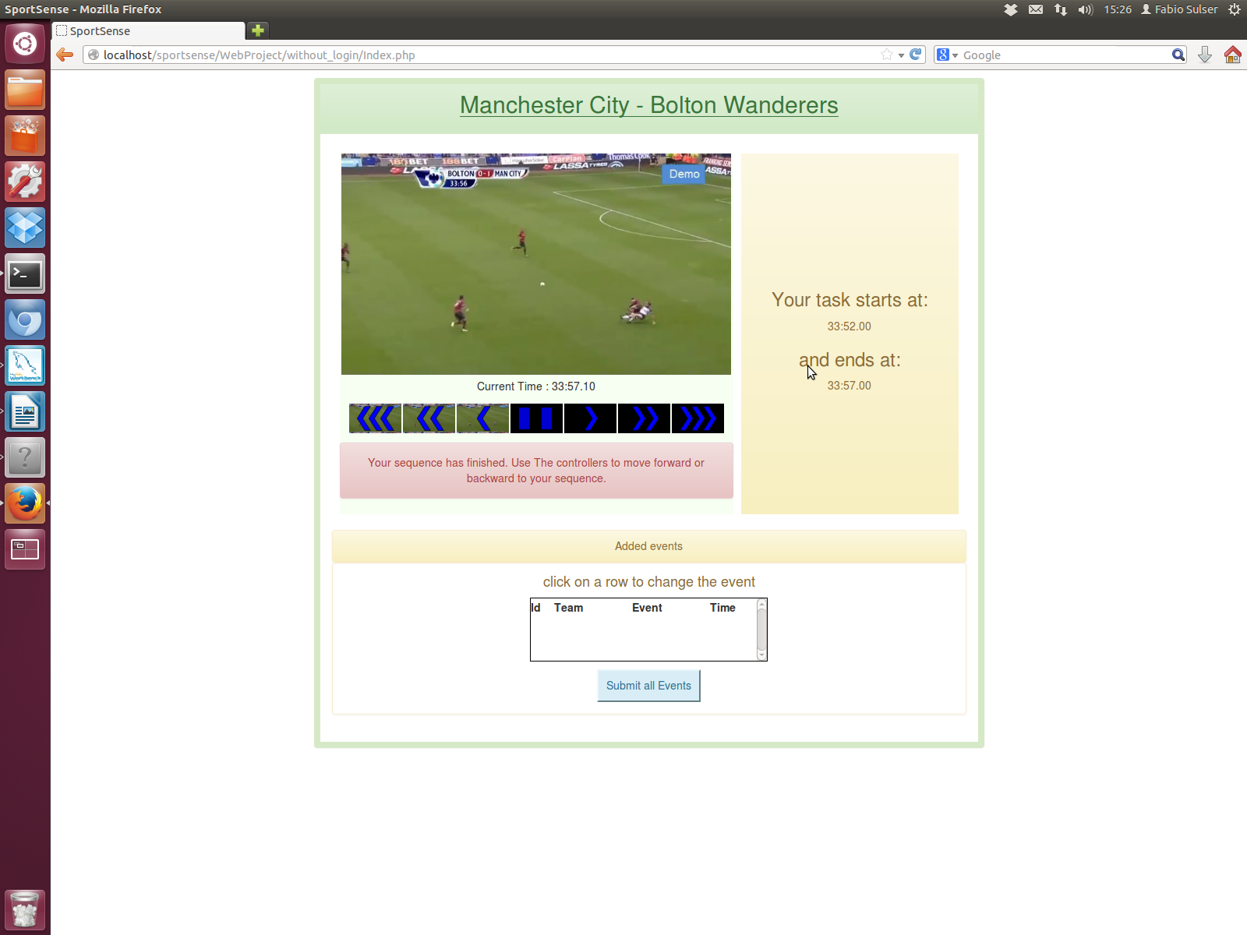
If you are outside your sequence a warning will show up under the player and the events will be replaced with the image on the left side.

The Input Elements

On the right side of the page you've got two things to chose before adding an event. Select first of all the event which is in the action and as second the team that belongs to the action.
Please think about that a foul, goal, offside, out, etc. is only one if the referee blows his whistle.

To get the right time, please set the video at the point where the event happens.
List of Events
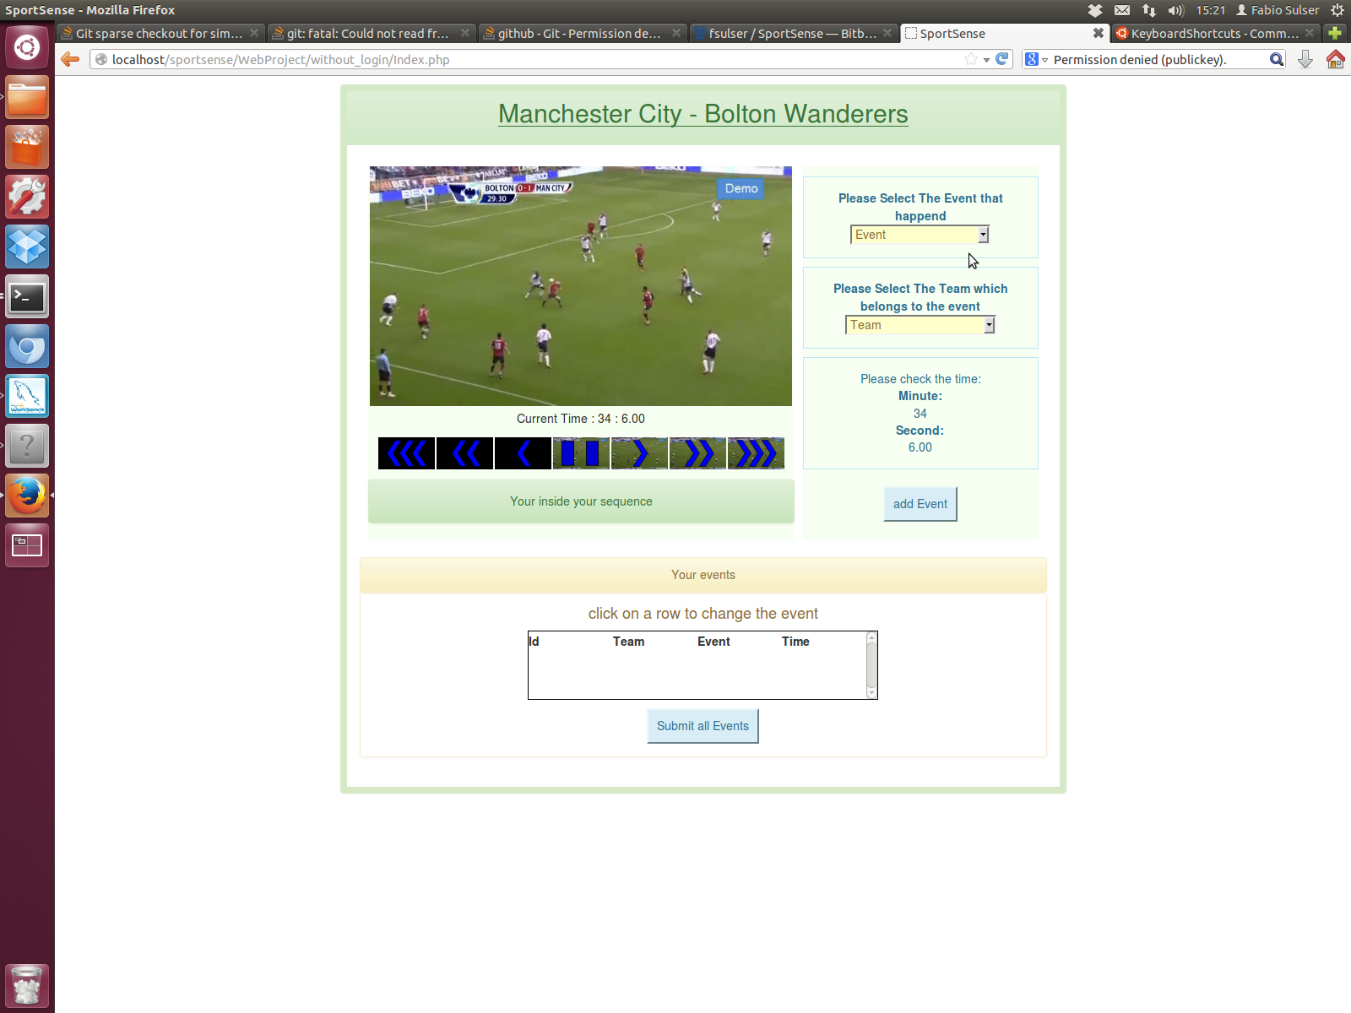
In the last section you will see your captured events. At the beginning there will be an empty list like the image on the right.
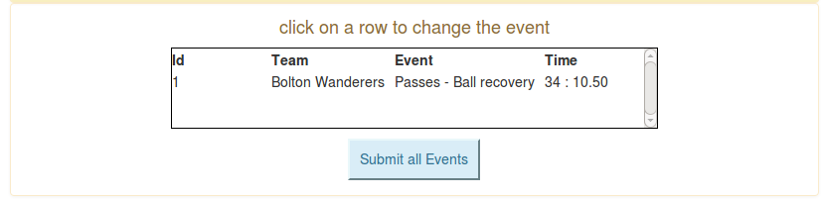
If you have added an Event. You will see it in the list as shown below.

If you think you've added a wrong event you can click on it in the list to change or delete it. The page will change to this:
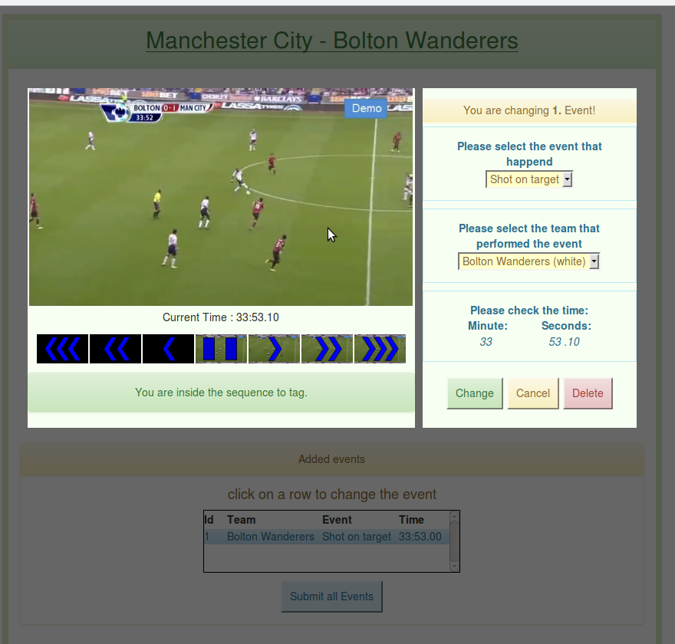

The selected event in the list will be highlighted with blue. Now you can change the event, team or/and time and submit the changes by clicking the “Change” button.
If you want to delete this event click the “Delete” button and if you want to cancel changing click the “cancel” button.

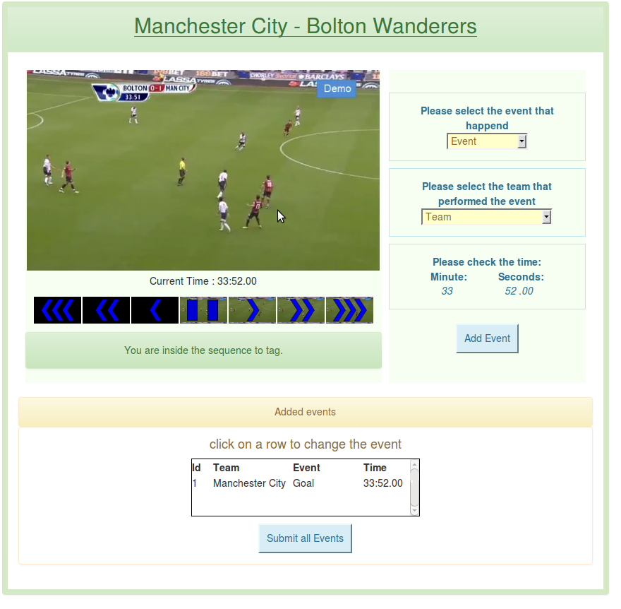
Finishing
If you finished the whole sequence click on the “Submit all events” button which is marked red on the image on the right side.
If there aren't any events in the whole sequence click also the button to receive you're token.

