UML Class Diagram — Filtering Students by Criteria and Developing RuleSet (Backend)

Objective
Produce one compile-ready UML class diagram (PlantUML) that models:
- How a group of students is filtered according to a selected RuleSet—i.e., ordered rule application (Include/Exclude), thresholds on ReadReadySkill subtests, the Inefficient Decoding dependency/Unknown case (when “Word Recognition and Decoding” score is missing), and Grade filtering; scope applies only to students (member.role == Student).
- The assessment domain (members, executions, scores, flags), and a filtering domain (RuleSet/Rule) designed by the candidate on the backend only (no UI).
Use your provided base PlantUML template (editor.plantuml.com compatible).

Scope (backend domain)

Core assessment classes
- OrganizationMember
  - Identifiers: id: UUID, memberid: String, sisId: String, stateId: String
  - Personal: firstName, lastName,
  - Demography: gender:
    - OrganizationMemberGender (Male/Female/X),
    - race, hispanicOrLatino: Boolean,
    - birthDate: Date,
    - englishLanguageLearner: Boolean,
    - individualizedProgram: Boolean,
    - lunchStatus: OrganizationMemberLunchStatus (Free/Paid)
  - Organizational: organization: Organization, grade: OrganizationGrade, role: OrganizationMemberRole (Student, Teacher, School Admin, District Admin), roleChanged: Timestamp, syncEnabled: Boolean, isDeleted: Boolean, addedBy: String

  - Audit: created: Timestamp, changed: Timestamp
  - Utilities: isStudent(), isFaculty(), isAdministrator()
  - Note: In this assignment, we operate only on students (member.role == Student).
- ReadReadyTestExecution
Minimal but real FK target (propose attributes such as id: UUID, executedAt: Timestamp, origin: String, etc.).
- ReadReadySkill (reference catalog, not an enum)
  - id: UUID (or code), name: String
  - Exactly six records:
    - Word Recognition and Decoding
    - Vocabulary
    - Morphology
    - Sentence Processing
    - Reading Efficiency
    - Reading Comprehension
  - Note: Used as a lookup in ReadReadyTestScore.
- ReadReadyMemberInefficientDecoding
  - id: UUID
  - memberId: UUID → OrganizationMember
  - testExecution: ReadReadyTestExecution
  - inefficientDecodingFlag: ReadReadyInefficientDecodingFlag { Unknown, TRUE, FALSE }
  - averageRealWordTime, averagePseudoHomophoneTime, averageNonWordTime: Long (ms)
Domain rule: This indicator is computed based on the “Word Recognition and Decoding” subtest.
If the corresponding ReadReadyTestScore for (memberId, testExecution) with skill = “Word Recognition and Decoding” is missing, then inefficientDecodingFlag = Unknown (timing fields may be ignored/not populated).
- ReadReadyTestScore
  - Identification & links: id: UUID, memberId: UUID → OrganizationMember, execution: ReadReadyTestExecution, skill: ReadReadySkill
  - Scores & stats: scaleScore: BigDecimal, scoreSe: BigDecimal, percentCorrect, percentAnswered, percentile: Integer, numCorrect, numOmit, numAnswered: Integer, averageGrade: Integer,recognitionDifficulty: ReadReadyDifficulty { Low, Medium, High }, rushed: Boolean
  - Algorithm/status: algorithmVersion: String, technicalUpdate: Timestamp, getScoreFlag()/setScoreFlag(TestScoreFlag)
  - Timing: totalTime: Long, operationalTime: Long
  - Audit: created: Timestamp, changed: Timestamp
  - Extras: getRoundedScaleScore(): Integer
  - Note: At the domain level, the combination (memberId, execution, skill) is unique.

Enums
- OrganizationMemberGender { Male, Female, X }
- OrganizationMemberLunchStatus { Free, Paid }
- OrganizationMemberRole { Student, Teacher, School Admin, District Admin } (focus on Student only)
- OrganizationGrade, OrganizationMemberRace (content at your discretion)
- ReadReadyInefficientDecodingFlag { Unknown, TRUE, FALSE }
- ReadReadyDifficulty { Low, Medium, High }
- TestScoreFlag (content at your discretion)

Relationships & constraints (UML/domain)
- OrganizationMember 1..* → ReadReadyTestExecution
Each student has at least one test execution; each execution belongs to exactly one student.
- ReadReadyTestExecution 1..* → ReadReadyTestScore
Each execution has one or more scores (typically per subtest/skill); each score belongs to one execution. Uniqueness: (memberId, execution, skill). Consistency: score.memberId == score.execution.member.id.
- ReadReadyTestExecution 0,1..* → ReadReadyMemberInefficientDecoding
A student can have zero or more inefficiency records; each record is tied to a specific student and typically to a single execution. At most one record per (memberId, testExecution). Dependency: if the ReadReadyTestScore for Word Recognition and Decoding is missing for the same (memberId, testExecution), then inefficientDecodingFlag = Unknown.

- Notes:
  - Domain uniqueness: ReadReadyTestScore(memberId, execution, skill).
  - Domain singularity: ReadReadyMemberInefficientDecoding(memberId, testExecution).
  - All assessment/filtering operations apply only to students.

Candidate-designed: Filtering Rules (backend)
Design RuleSet/Rule to select students using data from ReadReadyTestScore / ReadReadyMemberInefficientDecoding / OrganizationMember.
Must-haves:
- RuleSet contains an ordered collection of Rule; the order of rules is critical (sequential application).
- Support at least these condition types:
  - Thresholds on Scale Score (for one or multiple ReadReadySkill subtests).
  - Inefficient Decoding flag (Unknown/TRUE/FALSE).
  - Filter by Grade.
- Ignore MTSS (do not model it).
You are free to choose the internal structure of Rule, etc., but no UI details.

Diagram requirements
- One PlantUML file (@startuml … @enduml), compilable in editor.plantuml.com.
- Use the base template.
- Show multiplicities, navigability, compositions/aggregations, and the ordered association RuleSet → Rule.
- Add Design Notes (note) explaining:
  - Why RuleSet is ordered and how order affects the outcome.
  - Briefly (2–4 sentences, no DDL): how you would store Rule/RuleSet in PostgreSQL.

Evaluation
- Model quality (40%) — sound abstractions, clear relations, appropriate polymorphism.
- Domain alignment (25%) — solid linkage of rules to scores/flags/grade; student-only focus respected.
- Clarity (20%) — correct multiplicities, compositions, ordered links, informative notes.
- Template/discipline (10%) — diagram compiles, follows the template.
- Rationale (5%) — thoughtful Design Notes (incl. concise PostgreSQL storage idea without DDL).

Submission
- A single .puml (or .txt) with the UML class diagram (backend domain + your RuleSet).
- No UI, no database migrations, no DDL.
- Optional: a short README with assumptions.

Template
Baseline template, see in attachment folder.

Business domain
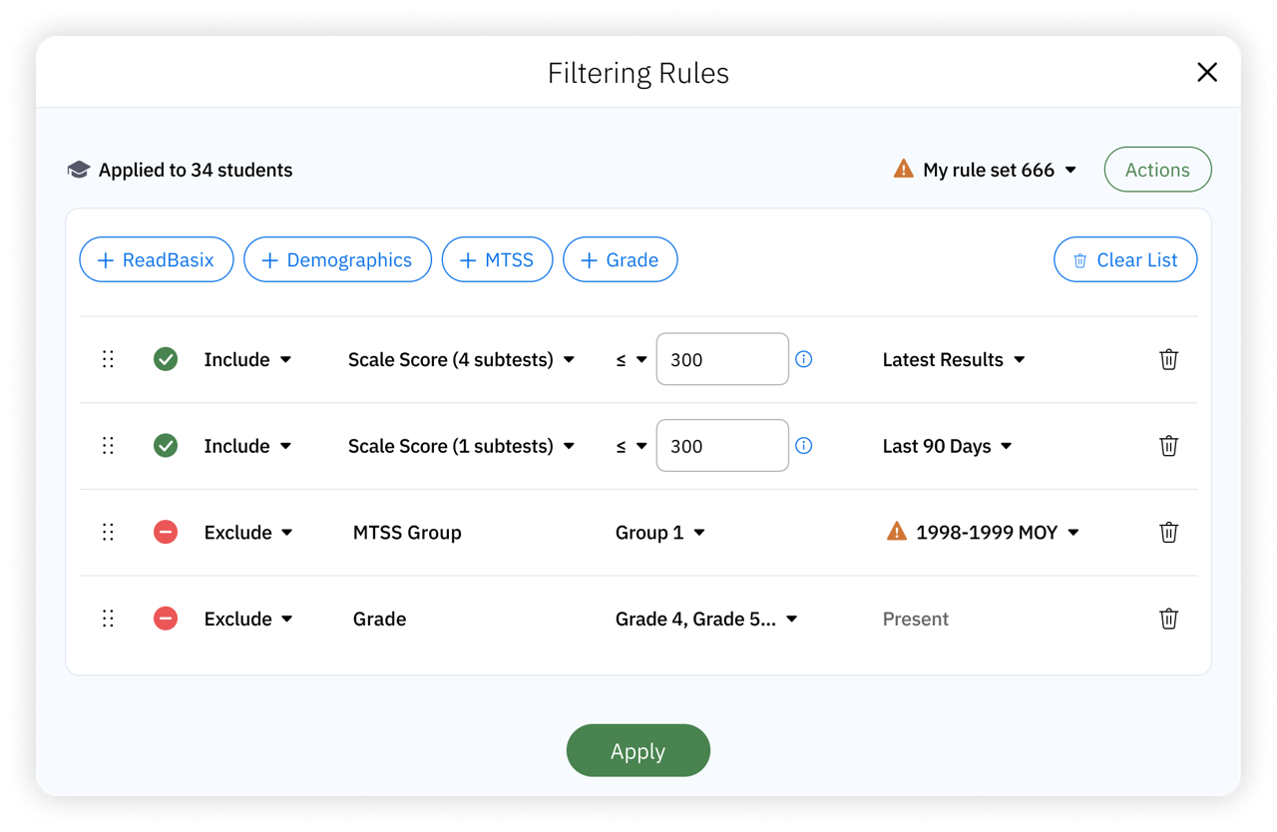

Title: “Filtering Rules”
- Toolbar
- [icon] + “Applies to $X students”
  - $X = number of students in given context, e.g. in group report
- [icon] + Dropdown that opens a popover
  - icon
    - if the rule set was modified since last save, show “edited content” icon
    - else don’t show icon
  - Text in dropdown
    - if nothing selected show “New rule set”,
    - Else show selected rule set name
      - if the rule set was modified since last save, show text in italic.
  - popover design
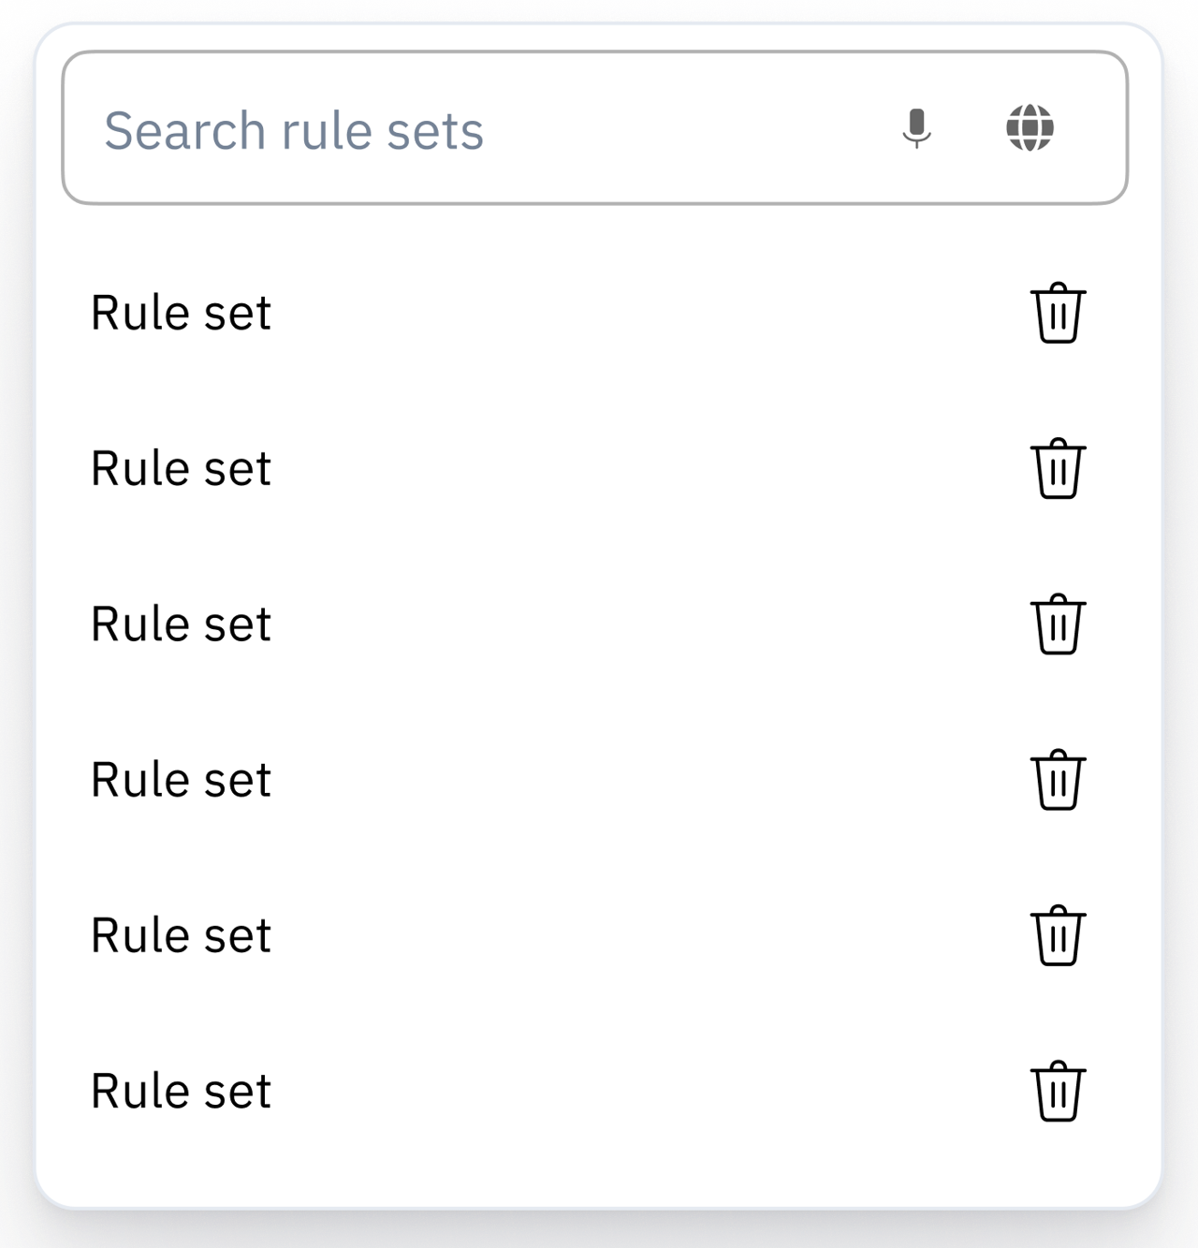

    - Search field “Search rule sets”
      - Searches by rule name
    - [List of saved rule sets, in alphabetical order]
      - “New rule set”
        - Selected by default
      - Item: $RuleSetName + button aria-label=tooltip=”Delete”
        - Title: “Delete Rule Set”
        - Body: “Delete rule set <b>$RuleSetName</b>?”
        - Buttons “Cancel”, “Delete”
          - Delete rule set
          - Update list in popover
          - If deleted currently selected rule set, update dropdown
      - Click to replace rules in the list (below) with the rules from the rule set, and show the selected set name in the dropdown.
      - Selecting again the same rule set that’s already selected should reset the rules in the table to the saved rules (i.e. clear changes)
      - Currently selected rule set (if any) should be selected in the list
- Button “Actions” that opens menu
  - “Save ‘$RuleSetName’”
    - Not visible if no rule set is selected
    - Saves changes to currently selected rule set
    - Same validation as “Apply” button +
      - “Please add at least one rule to the rule set” (rule set must contain at least 1 rule)
  - “Save As…” - opens dialog
    - Title: “Save Rule Set”
    - Textbox “Rule Set Name”
    - Buttons “Cancel”, “Save”
      - Validate before saving:
        - Same validation as “Apply” button +
        - “Please provide rule set name”
        - “Please add at least one rule to the rule set” (rule set must contain at least 1 rule)
  - (separator)
  - “Restore $RuleSetName”
    - Not visible if no rule set is selected
    - Replace rule set in the list with saved rules from the current rule set
  - (separator)
  - “Delete $RuleSetName”
    - Not visible if no rule set is selected
    - Show confirmation dialog (see above), if confirmed
      - Clear rules from list
      - Delete current rule set
      - Update rule set dropdown
- Rectangle with filter
- Toolbar to add and remove rules
  - Button “+ ReadBasix” - open menu with
    - “Scale Score” - add rule, see table below
    - “Inefficient Decoding” - add rule, see table below
    - “Decoding Threshold” - add rule, see table below
  - Button “+ MTSS”
    - add rule, see table below
  - Button “+ Grade”
    - add rule, see table below
    - Visible only to school admin and district admin
  - --- space ---
  - Button “Clear All”
    - clears all rules from the table (no confirmation)
- Rules table with the following columns (no headers)
  - Handle to drag and drop a row to rearrange order.
    - The rules must be applied in the order they are given
  - Inclusion control
    - Dropdown with options
      - [plus icon] + “Include”
        - Default, include all students that pass this rule
      - [minus icon] + “Exclude”
        - Exclude all students that pass this rule.
  - Metric control
    - One of the values from Metric control column
    - If a custom popover is specified then replace label with a dropdown to open the popover
      - By default all options in the popover are checked. For example, if metric is “Scale Score” and all subtests are checked, then all 6 subtests must conform to the Scale Score rule.
      - In the cell show “$MetricName ($SubMetricsChecked)”,
        - If 1 subtest selected then $SubMetricsChecked = subtest name, e.g. “Scale Score (Vocabulary)”
        - Else $SubMetricsChecked = number of selected subtests, e.g. “Scale Score (5)”
  - Value control
    - Show controls specified in the Value control column
    - If selected value(s) no longer exist add an icon to the left of the cell, and show a tooltip over the icon: “Rule Disabled: the selected values are no longer available. Choose a new value to activate the rule.” The wrong values should continue to be displayed until overridden.
  - Time Frame control
    - One of the options selected in Time Frame control column, or “Present” (see spec).
    - If user can select an option, then the default is “Latest Results”
    - If the only value is “Present” then show it in the cell, in disabled style. Not interactive cell.
    - Else, when clicked open the Time Control menu as described in
      - . Fill in selected value from column “Displayed string” in that table.
      - If user selected benchmark or school year option as time frame, the option may be invalid of the corresponding benchmark or time frame have been deleted after the user selected and saved them. In this case, add an icon to the left of the cell, and show a tooltip over the icon: “Rule Disabled: The selected time frame is no longer available. Choose a new time frame to activate the rule.” The broken time frame should be displayed until it is changed.
    - Actions
      - Button aria-label=tooltip = “Delete”
        - Delete the selected rule, no confirmation
- Button “Apply”
  - “One or more selected time frames is no longer available” (in case benchmark or school year were deleted after filter was saved)
  - look at validation rules for each filter
Metric control | Value control | Time Frame control
Grade | Dropdown with  - Checkbox list of grades, in predefined order.  - Button “Save” (no validation)  - Default: no grades selected.  - Cell content  - If no grades selected show placeholder: “No grades selected”  - If 1 grade selected show grade  - If more than 1 grade selected show “$X selected”  - Validation:  - “Please select at least one grade level.” | show “Present”
MTSS Group +   Tooltip for  = “MTSS Groups categorize students based on their literacy needs within a Multi-Tiered System of Support framework.” | Dropdown with  - Checkbox list of MTSS Groups defined in Administrative → MTSS Groups, in predefined order.  - Button “Save” (no validation)  - Default: no groups selected  - Cell content  - If no groups selected show placeholder: “No groups selected”  - If 1 group selected show grade  - If more than 1 group selected show “$X selected”  - Validation:  - “Please select at least one group.”  - ”One or more selected MTSS groups is no longer available.” (if filter was saved with MTSS group that was later removed or disabled) | All options
Dropdown “Scale Score ($NumberOfSubtests subtests)” +   When clicked opens popover  - Header: “READBASIX SUBTESTS”  - [checkbox] [List of 6 subtests]  - Checked by default  - If only 1 is checked, then it should be disabled.  - Button “Save” (no validation)  Tooltip for  = “Filter students based on their scale scores in the selected ReadBasix subtests.” | Dropdown with menu (single choice)  - =  - >  - Selected by default  - <  - ≥  - ≤  Textbox that takes only positive integers,  - Empty by default  - Validation: if value is empty or outside of 290-310 range, show notification “The ReadBasix scale score value must be between 290 and 310.”   icon with tooltip “Enter a ReadBasix scale score as a whole number between 290 and 310.” | All options
Inefficient Decoding +   Tooltip for  = “Inefficient decoding occurs when students spend similar time on unfamiliar words as familiar ones. This may indicate reliance on memorization, signaling potential reading difficulties, and suggests a need for targeted intervention.” | Dropdown with menu (single choice)  - Inefficient Decoder  - Selected by default  - Efficient Decoder | All options
Decoding Threshold +  | Dropdown with menu (single choice)  - Below Decoding Threshold  - Scale score <235  - Selected by default  - Above Decoding Threshold  - Scale score >= 235 | All options

