University of Warsaw
Faculty of Economic Sciences

Filip Szymański, Aleksander Wieliński
Album N°: 427618, 420272

Title

Master thesis degree
Field of study: Data Science and Business Analytics

Thesis written under the supervision of
dr hab. Katarzyna Kopczewska, prof.ucz.
from Chair of Statistics and Econometrics
WNE UW

Warsaw,

Declaration of the supervisor
I declare that the following thesis was written under my supervision and I state that it meets all
criterias to be submitted for the procedure of academic degree award.

Date Signature of the Supervisor

Declaration of the author of the thesis
Aware of the legal responsibility, I declare that I am the sole author of the following thesis and that the thesis is free from any content that constitutes copyright infringement or has been acquired contrary to applicable laws and regulations.

I also declare that the thesis has never been a subject of degree-awarding procedures in any higher education institution.

Moreover, I declare that the attached version of the thesis is identical with the enclosed electronic version.

Date Signature of the Author

Summary

This thesis presents and describes high-tech firm clustering in Poland, Mazowieckie voivodeship. Such tendencies are visualized using a 1x1km grid and DBScan algorithm. This paper further aims at discovering high-tech and knowledge intensive sector characteristics utilizing binary choice, RandomForest and XGBoost models. Fixed radius nearest neighbours as well as assigning county-level data to each observation was used for modelling. The contents of this thesis are aimed at verifying and broadening the understanding of high-tech and knowledge intensive firms’ location factors.

Key words

Field of the thesis (codes according to the Erasmus program)

Thematic classification

The title of the thesis in Polish

Abstract: … Here we show that while there are various potential factors influencing the location decisions of companies, there appears to be a visible distinction between high-tech knowledge-intensive companies and others. We find that such firms are intensively attracted to densely populated areas, mainly big cities, where they form clusters, preferably avoiding locating closely to other groups of companies. Furthermore, our results show a preference towards areas with well-developed cultural facilities (i.e. libraries, museums) as well as areas with well-established amenities chains, including buses available for employees. By presenting a more granulated division of companies by their main business activity sector we hope to expand on the existing literature and shed more light on the high-tech firms on county-level data.

Introduction
The spatial distribution of firms has long been of interest to researchers, with economic theories providing an explanatory framework for the location choices and clustering tendencies observed in various industries. Empirical research and policy considerations often revolve around two main forms of agglomeration economics: location economics and urbanization economics. The former refers to the benefits that firms derive from the coexistence of similar industrial entities in a given geographic region. This proximity facilitates the exchange of knowledge within an industry, reduces the cost of transporting both inputs and outputs, and allows companies to benefit from a more streamlined labor market. The latter addresses the benefits of diversity and companies within a geographic region. It is believed that the variety of industries within a geographic region promotes knowledge externalities and ultimately innovative activity and economic growth (Jofre-Monseny et. al. 2014). There is an ongoing debate among researchers about which theory more accurately describes reality. The fact is that many studies confirm the accuracy of both claims. This is because a lot depends on the sector in which the company operates, the region in which it is located and external factors affecting the location pattern of companies. Also, the approach to researching the problem varies from study to study, leading to ambiguous results. Primarily, it should be noted that companies specializing in different industries value different conveniences. In this article, we build upon the existing discourse surrounding the clustering phenomenon among high-tech firms. It is widely acknowledged in the literature that high-tech companies tend to co-locate in similar areas, such as Silicon Valley in the USA, driven by various factors including access to talent, research institutions, and networking opportunities. Despite extensive research on agglomeration economics, there remains a gap in understanding the determinants driving high-tech firms to form clusters, particularly in regions with emerging high-tech potential such as the Mazovian Voivodeship in Poland (Sitek, 2014). The main purpose of the paper is to find the determinants that drive high-tech companies to form clusters, focusing on a detailed analysis of the location of subsectors belonging to the high-tech family, and also comparing them with other sectors, to spot the differences. To achieve this, we focus our investigation on the Mazovian Voivodeship in Poland, a region that has shown promising potential for high-tech development.
Alfred Marshall is considered the pioneer of location economics theory. As early as 1980, in his book Principles of Economics, he draws attention to three behaviors of firms that can benefit their productivity: labor market pooling - benefiting from the proximity of highly specialized workers, input sharing - collaborative and efficient utilization of resources between firms in close proximity, and knowledge spillovers - unintended diffusion of knowledge resulting from proximity of location. The opposite theory to Marshall's, which assumes benefiting from the diversity of companies in a region, is that of Jacobs (1969). As the author states: “the greater the sheer number of and variety of division of labor, the greater the economy’s inherent capacity for adding still more kinds of goods and services” (Jacobs, 1969, p. 59). In her view, the most relevant source of knowledge for a company is external to the industry in which the company operates. Claiming that the greatest diversity of knowledge sources is concentrated in urban environments, she argues that cities serve as a major source of innovation. This theory underscores the view that the multiplicity of industries coexisting in a geographic region promotes knowledge spillovers, culminating in increased innovation activities and consequent economic growth (Beaudry, Schiffauerova, 2009). In the literature, both theories hold relevance for high-tech industries, but their applicability may vary depending on the specific sub sector in which firms operate. For instance, while location economics may emphasize the importance of proximity to specialized talent and knowledge exchange, urbanization economics may highlight the benefits of diverse knowledge sources and industry interactions. However, despite many studies in this area, an approach that has been underutilized to date is the attempt to more accurately divide companies based on detailed PKD7 codes. Hence, filling a gap in the literature, we will examine the phenomenon of clustering of high-tech companies by applying a granular division of companies, allowing a more accurate study of factors influencing location choice, broken down by specific subsectors in the high-tech industry.
Based on existing theory and empirical evidence, our proposed solution aims to provide a comprehensive understanding of the factors that drive specific subsectors of high-tech companies, namely: high-tech, mid-tech, knowledge-intensive high-tech, to form clusters. Moreover, our approach aims to find out which factors are unique to specific high-tech subsectors, by compiling results for low-tech, mid-tech and other companies. In this article, we will take a two-step approach: in the first step, an exploratory spatial data analysis (ESDA) will be conducted using point data for companies in the Mazowieckie Voivodeship. This will allow us to verify whether the phenomenon of clustering occurs in the study area. Adopting a 1x1 km grid will enable precise analysis and visualization of the distribution of companies in specific locations, offering detailed insights into various subsectors. In the second step, we will take a closer look at the determinants of the location of companies in each high-tech subsector and compare the results with companies in other sectors. To do so, we will estimate a binary choice model by each subsector. In addition, we will complement the econometric analysis with a series of machine learning classification models, specifically a random forest, to find non-linear relationships and visualize the most important factors influencing location choice.
The remainder of the article is as follows: Part 1 includes a review of the literature covering spatial studies of the clustering phenomenon among high-tech companies. Part 2 provides a detailed description of the proposed approach, methodology, and data used in the study of the determinants of clustering among high-tech firms. Then, Part 3 will present an empirical study involving ESDA and 2 series of binary choice models. Finally, Part 4 will conclude with an interpretation of the results and summary.

Literature review
There are a considerable number of articles in the literature discussing the validity of both theories. Authors examine the determinants of firm location using a wide range of approaches, as discussed in detail by Beaudry and Schiffauerov (2009). First of all, we can distinguish the diversity associated with the aggregation of spatial units in the literature. The studies encountered can also be divided with regard to data at the micro and macro-geographic levels. Examining these approaches and their outcomes sheds light on the nuanced perspectives within the field. Kinne and Resch (2017) strongly criticize the utilization of aggregated data for micro-geographic analysis. They argue that reliance on such data at this level introduces systematic prediction errors, particularly in cities characterized by diverse and segregated populations, due to the absence of high-resolution geodata on socio-economic population characteristics. Another heterogeneous approach is the choice of explanatory variables and research methods. Naturally, this is most often due to the fact that authors focus on studying specific industries. However, even when studying seemingly the same industries, one can observe fundamentally different approaches as to the allocation of the studied companies to specific groupings or the granularity of the divisions themselves.
Taking a closer look at the articles on high-tech companies, we can observe certain trends, similarities, as well as differences in the literature. One notable distinction lies in the scale of the study. Specifically, the works of (Ahoura and Hamidi, 2021), (He et al., 2016), (Jofre-Monseny et al., 2014), and (Kinne and Resch, 2017) all utilize data at the state level (equivalent to country level). Furthermore, across these works, there is a consistent observation of a strong tendency among manufacturing firms to cluster in cities and well-communicated areas. This clustering is often driven by several factors including access to cheap raw materials, a wide selection of suppliers, and a common pool of specialized workers. Nevertheless, the trend is not as clear in case of IT and high-knowledge intensive firms. Auora and Hamidi (2021) argues that IT-specialized cells have the weakest relationship to walkability and transit accessibility when compared with other specializations, whereas Kinne and Resch (2017) shows empirical evidence that software firms exhibit a location decision behavior distinct from that of other firm types. They state that lack of significant software industry presence in the densely populated and sizable Ruhr area (around Essen) suggests that high population density alone does not always correlate with a large concentration of software firms. On the contrary, Jofre‐Monseny et. al. (2014) argues that urbanization economies are higher in the knowledge-intensive industries suggesting that industries locate in large cities partly to reap knowledge spillovers. Authors also add that localization effects are higher in industries that employ workers whose skills are more industry specific. Darchen (2015) draws interesting conclusions in a study on the phenomenon of 'creative clusters'. He argues that in Montreal and Vancouver, video game companies form creative clusters, based mainly on cross-fertilization with other creative fields, especially the film industry. However, the researcher points out that this rule applies only to mature industries, showing with the example of Australia that such a phenomenon is practically non-existent, as knowledge sharing there occurs mainly through social media. In another article it is suggested that the formation of creative clusters is largely fostered by strategic location, characterized by low cost of living, low cost of production and standard of living, as knowledge-intensive workers willingly migrate to these areas (Darchen & Tremblay, 2015). Kangmin, et al. (2019) adds that the public service also plays an important role in creating knowledge districts and attracting knowledge workers. His words are confirmed by Florida (2014).
Shifting from a broader examination of location patterns at the national level, several studies delve into a more micro-geographic analysis, looking at specific areas or selected cities. These studies offer deeper insights into the complex dynamics of industrial clusters and location decisions. According to Lopez et. al (2017) high-tech manufacturing firms in the Greater Toronto Area form three main clusters around three central transportation infrastructures: highway, railway station and airport, whereas knowledge-intensive firms specialized mostly in service activities are likely to pay a higher premium for proximity to the central business district, which is in line with standard urban economic theory Fujita (1989). Similar conclusions are drawn by Cissé et. al (2020) adding that knowledge-intensive sectors are much more likely to locate in densely populated areas, compared to less populated areas. They also mention that service sectors show a strong dependence on the intermediate demand and the main regional cities, whereas the manufacturing sector is explained only by specialization and indicates a slight preference for small-sized cities. Kopczewska et al. (2023) posits that population density serves as a significant factor in corporate nesting, surpassing economies of agglomeration in certain contexts. They argue that while economies of density and economies of agglomeration often coexist hierarchically, the determinants of location vary across business sectors. Authors emphasize the absence of a universal theory connecting economies of density and economies of agglomeration, highlighting the sector-specific nature of locational factors. Nonetheless, they underscore the enduring importance of population density as a key consideration across sectors. Goetz and Rupasingha (2002) check the implications of high-tech firm clustering in case of rural areas. They draw two important conclusions: first, rural areas are relatively deterrent to both manufacturing industries, due to the lack of good communications, and knowledge-intensive sectors, due to low population density and lack of opportunities for knowledge spillover. Second, most high-tech firms are supported by regions where the types of firms are diversified except within the same industry. However, they point out sectors like manufacturers of computers and peripheral equipment tend to avoid all kinds of high tech firms in their location decisions. This contradicts Marshall's theory of location economics quite vigorously.
Outlining earlier the broad spectrum of approaches in the literature on studying the spatial distribution of companies, it is worth mentioning the various approaches from quantitative methods. The most popular trend in the literature to date is the use of econometric models to determine the factors that explain the choice of company locations. In the ongoing debate over the appropriateness of the two dominant theories, namely agglomeration vs. localization economies, or in other words Marshall vs. Jacobs, authors in their works often try to find a kind of proxy reflecting the actual factors influencing location choice. There are two most commonly used techniques. One approach employed involves the utilization of a series of logit models as delineated by Ahoura and Hamidi (2021), Lopez et. al (2017), Darchen (2015), and Goetz and Rupasingha (2002). In this methodological framework, each model is structured with a binary dependent variable representing the presence of a high-tech company within a specific sector.
Researchers often choose to utilize count data regression models (Kinne & Resch, 2017; He et al., 2016; Jofre-Monseny et al., 2014; Chin, J. T., 2020) to analyze factors driving the formation of high-tech clusters. These models, such as Poisson, Negative Binomial regression or zero inflated model, are particularly suited for analyzing data representing counts of events or occurrences within defined spatial units. The estimated coefficients from count data models provide evidence on how ceteris paribus variations in an explanatory variable affect the conditional mean of the number of local firm locations Kinne & Resch (2017). However, it is not advisable to deduce causal relationships between the dependent variable and the explanatory variables without having a suitable identification strategy (Greene 2014; Cameron & Trivedi 2009). It is also important to choose the right model for our data. As Kinne & Resch (2017) state, Poisson regression is often suitable for low aggregation levels, while Negative Binomial regression, capable of handling over-dispersed count data, appears more appropriate for higher levels of aggregation.
Beyond the econometric models, researchers have explored a diverse array of spatial analysis techniques that make it possible to visualize the location of clusters, which in turn can support the development of hypotheses for further testing Lopez et. al (2017). Among these, Kernel Density Estimation (KDE) stands out as a commonly employed method for identifying concentrations of high-tech firms within geographical regions. The KDE function can estimate the density around the sampled firms, based on the density of samples within a unit grid, and subsequently, produce a smooth surface. This surface can reflect the hotspot distribution associated with the spatial pattern of firms (Wu, et. al. 2019). Another method widely used is scan statistic. As Lopez et. al (2017) argues, this methodology offers three key advantages: firstly, it allows for the analysis of both microdata and aggregate data, treating space continuously in the point-process sense; secondly, it accurately identifies areas (clusters) of high or low incidence and precisely delineates their locations; and finally, it provides measures of intensity and significance for each identified cluster.

Empirical study

3.1 Data & Methodological Approach
Recent literature developed several approaches to verify the phenomenon of high-tech firms clustering and analyze the determinants of high-tech firms’ location. However, most of the approaches appear somewhat conflicted and show multiple trends depending on the granularity and overall angle of each research. Thus, even though there are many existing solutions, they are not exhaustive and still need to be complemented. In this article we propose a twofold approach for examining the phenomenon of high-tech firm clustering and high-tech firms’ agglomeration determinants (see Figure 1.).
Figure 1. Agglomeration of high-tech firms: clustering and determinants - flowchart
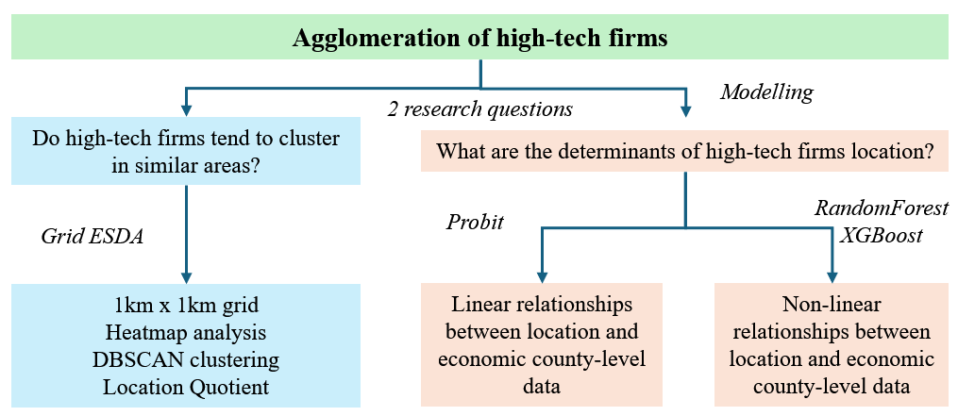
Source: own work
First, we want to verify the existing notion, that among high tech companies there is indeed a clustering mechanism. In our view, the high-tech sector itself is so broad that it is difficult to conclude unequivocally that all companies included in this sector follow the same attraction mechanisms. In our research we utilised data from 2012, retrieved from the official register of polish business entities (REGON). It contains nearly 1 mln geo-localised companies in the Warsaw region in Poland (formally Mazovian NUTS1 voivodeship) and address of each firm. Additionally, each data point contains its assigned PKD 7 - five digit code which describes the major declared activity of a given firm. Thanks to that, we were able to identify 6 sub sectors of interest: High-Tech (HT), Medium High-Tech (MHT), High-Tech Knowledge Intensive Firms (HTKIS), Low-Tech (LT), Medium Low-Tech (MLT), and Other (O) (For more detailed division see Appendix X.). Leveraging a more detailed segmentation, we believe we will be able to more accurately depict the clustering mechanisms for specific high-tech industries, and better differentiate their determinants. The above classification is based on [citation], with minor changes from the subjective opinion of the authors.

3.1.1 Exploratory Spatial Data Analysis
After preprocessing the data and assigning firms to the abovementioned sub sectors, Exploratory Spatial Data Analysis (ESDA) was carried out. In this step we aimed to verify the hypothesis that high-tech companies form clusters. ESDA is a broad approach to exploring geospatial data, utilizing a diverse array of methods for analysis, commonly used in spatial research (Kinne & Resch, 2017). In our approach, we used a 1x1 km grid analysis that allowed us to count the number of companies from each sub sector in each cell. This enabled a detailed, yet easy-to-interpret visualization using heatmap series for each subsector, as well as the calculation of the Location Quotient, which is often used as a measure of local industrial specialization. (Pominova et al., 2022, Artz et al., 2020). In addition to that, we employed a DBSCAN clustering of firms’ location of each sub sector. The selection of a density-based clustering algorithm was pivotal for two primary reasons: Firstly, it enabled us to avoid the manual selection of cluster numbers. Secondly, it was essential to identify both companies within cluster areas and those outside (often termed as noise). This approach facilitated the computation of the ratio between clustered and non-clustered companies, thereby enabling us to draw insightful conclusions about the spatial distribution of subsectors.

3.1.2 Binary choice models & Non-linear models
Apart from the visualized EDA performed on the grid data we deployed a binary choice Probit model to determine linear relations within the dataset as well as complementary RandomForest and XGBoost models to double down on our findings as well as search for non-linear influence on firm location. We propose a division of analysed data into two distinguishable main sets. Geospatial data with a primary focus on describing factors specific to the prime location chosen by companies. This branch allows for research about e.g. pinpointed details about density factors of both population and competition in the direct area of a company. A second set, Territorial data is more descriptive of counties in Mazovian voivodeship. These statistics provide a better overall characteristic of the area and are intended for researching factors which could attract entrepreneurs to the county in the first place. Below can be found a description of the explanatory variables the article is covering.
Peripherals
As the literature suggests, high-tech companies are likely to cluster around developed areas or districts embracing facilitation of businesses while enabling high accessibility and good amenities for the population (Pan et al., 2018). According to the PKD division of firms, we expect to see a strong attraction of low-tech production and land-based companies to the smaller areas. On the contrary, it is expected that especially the highly knowledge intensive sectors and overall high-tech companies prefer developed and accessible locations. The data distinguishes the distance between nearest locations divided by their respective sizes. This approach, as utilized in a paper by Kopczewska et al., (2023) helps prevent misclassification of affinities to either smaller or bigger cities, as it could show an unintentional bias. Thus, the data presented differentiates between distances of 10km, 25km and 50km, and cities of population above 1 mln citizens (core), above 100 k (midsize), 50 k (regional), 30 k (local big) and between 15 to 30 k., allowing for a total of 15 dummy variables.
Population density and urbanisation
As sporadically evidenced in research on business location, population density tends to be a significant factor positively influencing clustering of companies. (Kopczewska et al., 2023) Following the traditional theories of Marshall and modern academic papers, we do not expect any deviation within this trend. Our approach instead focuses on exploring whether a densely populated area will also be a significant factor distinguishing high-tech from low-tech companies. We expect a meaningful positive relation between knowledge intensive sectors, further supporting claims that it is a beneficiary of a dense and competitive environment for highly qualified personnel. Contrary to what is often used in literature, the data concerning population density in this article describes the 500-meter radius around the company (locPdens) instead of basing the information solely on administrative units’ reports.
Additionally, it is expected that a similar relation will be discovered within the sub sectors. Consistently with the density variables, we expect to see a close relationship between service-based and knowledge-intensive sub sectors preferring localizations where similar businesses are already established, whereas sub sectors that center around manufacturing or similar would prefer unexplored territories more, to be a pioneer in development for a particular area. For this reason, we are measuring the 500-meter radius around the firm location, similarly to the population density, to account for the neighboring companies, with an additional focus on firm sectors. (‘group’_neighbor_count variables)
As argued by Deller (2010) and assumed in multiple researches (e.g. Kopczewska, et al. 2023) economic growth stemming from either development of business in the area or high population density in itself is a factor influencing the urbanisation factors. In form of a proxy, we will be checking these using variables measuring the amount of amenities in the area, i.e. stores, buses.
Local competitive environment
To facilitate the research on how different sectors might be drawn to each other we follow a popular motion in the literature to utilize the Herfindahl-Hirsch index (Artz et al., 2020) as well as Location Quotient (Kopczewska et al., 2017, 2023). The former measure allows for defining how diverse the business around a firm is, by calculating the share a company has in the given sector. The below table shows the HH thresholds assumed in the analysis:
Table 1. Herfindahl-Hirsch index - thresholds and interpretation
Herfindahl-Hirsch index | Interpretation
0.15 or lower | highly diversified neighbourhood
between 0.15 and 0.25 | moderately diversified neighbourhood
0.25 or higher | weakly diversified neighbourhood
Source: own work based on (Kopczewska et al., 2017, 2023)
The Location Quotient instead presents how concentrated the sector is in a neighbourhood in relation to the entire region. By dividing the ratio of sector specific firms to firms within a radius, by the ratio of specific firms to all firms in the region we arrive at the Location Quotient. For consistency purposes, the radius measured stays at 500 meters within the modelling part, as with the previous measures including variables in a certain radius. For the interpretation of LQ please refer to section 4.1, where it was explained and calculated on a 1x1 km grid data.
As a last measure for indicating competitiveness of a given area, we utilize a variable locBIG. By measuring the amount of meaningful and well-established companies in the area of a given firm we can determine the willingness to locate in an area already prosperous as opposed to an “underdeveloped” one, showing whether there is a tendency to follow a pattern of successful companies or rather a preference to seek deserted space for business.

Territorial data
The second proposed branch of the data set in our article is territorial data gathered based on counties in Poland, covering the year 2012 respectively. The necessary data was extracted from GUS BDL website, and can be roughly divided into categories as listed below:
Finance
We are inspecting expenditures, income and average salaries per capita based on counties. Additionally, to the general outlook on the economic wellbeing of county residents, we are taking into account the investment power generated in the area. As the literature suggests, high tech firms tend to be located in more promising and rapidly developing areas, as well as to cluster alongside each other with such conditions fulfilled. The expectation is that higher salaries and income stem from high-tech firms being more prevalent in the area and driving the local economy better than other types of enterprises, which in turn attracts more of such firms.
The expectation is that more high-tech firms prefer to locate in counties that exceed others in terms of investments and fixed assets. This could help alleviate a bottleneck problem of successful operating models with weak access to resources. It is also a form of an indicator at how well amenities for citizens are developed, which as proved in literature, helps attract businesses. As an attempt at finding this relation in our data we are using capital investment in enterprises per capita and Financing and co-financing of EU programmes and projects as indicators.
Culture and education
While division between high tech and low and medium tech companies is not crystal clear, we intend to embrace the division between companies focusing on production and knowledge intensive companies. For a detailed description of knowledge-intensive group division please refer to Appendix 1. With this in mind, a prevalent trend in research shows that areas with better access to education and more research resources tend to attract more high-tech companies. We’re measuring this by the number of students and graduates and as a supplement, by the number of books borrowed from local libraries, museums in the area and cinemas. This will hopefully support a thesis that high-tech companies prefer locations more suitable for the growth and education of their employees.
Justice in density factors
As a supplement to data representing population density this article intends to discover whether criminal activity is a factor considered by business owners. Studies have shown that especially in rural areas, the process of economic growth impacts and attracts criminal activity significantly (Deller, 2010). Additionally, with high-tech firms potentially generating more growth to the local economy (Gil, 2019), it is expected that high-tech firms are avoiding areas in which a high crime rate is observed. The crime rate is measured by the confirmed and resolved cases reported within county reports.

Results
This section will present the results of our twofold analysis. In the first step, observations resulting from Exploratory Spatial Data Analysis (ESDA) will be presented. offering a glimpse into the spatial distribution of high-tech companies across the study area. This entails a thorough examination of the tendencies for clustering within each sector. The results of the regression analysis will be presented in the second part of this section. A detailed analysis of the results and discussion follows in Section 5.

4.1 Exploratory Spatial Data Analysis Results
We started by creating a 1x1 km grid and counted the number of companies located in each cell per sub-sector. Table X visualizes the spatial distribution of companies by each group. At first glance, a clear concentration of firms around larger urban agglomerations is noticeable. There is a distinct clustering of firms for all subsectors in the central region, particularly in the capital city of Poland, Warsaw, and its outskirts. In the case of the High-Tech subsector, the presence in other locations is marginal. For Medium High-Tech and High-Tech Knowledge-Intensive firms, a similar pattern is observed, predominantly focusing around the capital city, demonstrating their presence also in areas with higher population densities. Comparing firms from the High-Tech group with Low-Tech firms and others, the former form more distinct clusters. This signals that factors such as population density in the region or distance from larger urban agglomerations may significantly influence the location of High-Tech firms. Such a depiction of firm distribution may also suggest that High-Tech firms prefer to locate in regions where the presence of existing firms from this sector is higher, indicating the applicability of Marshallian theory.

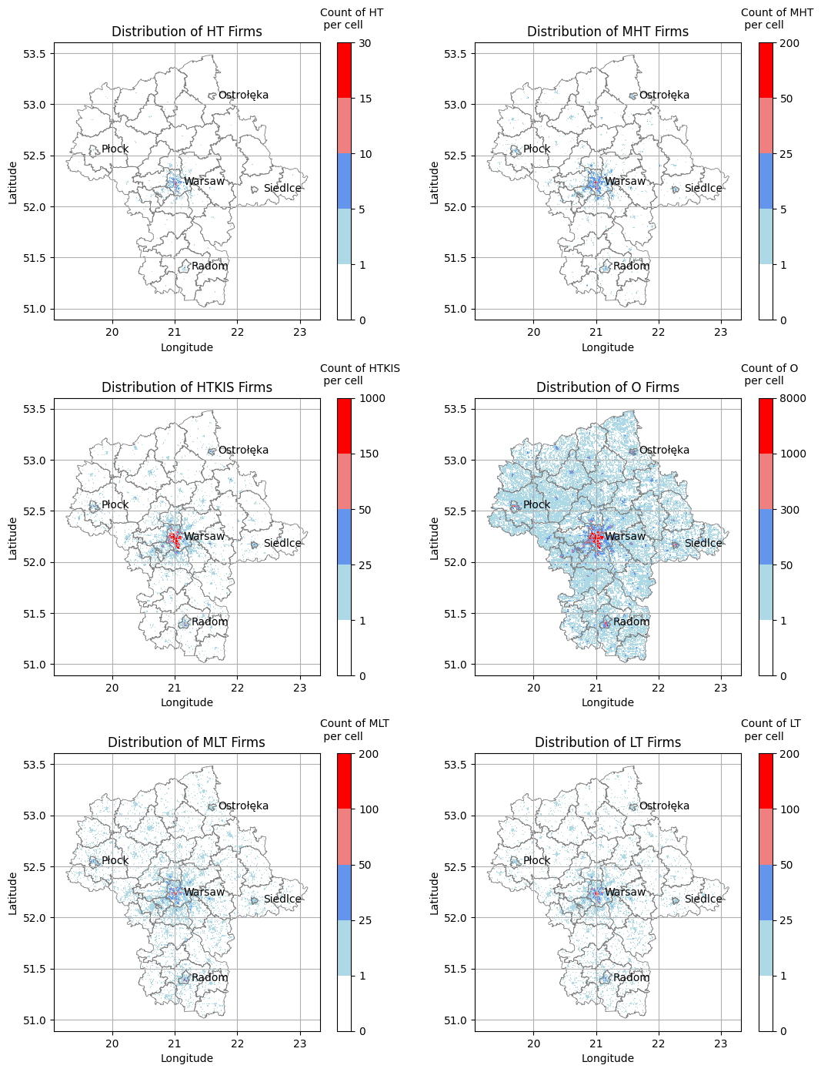
Source: own work
Figure 2. Spatial distribution of firms by sub-sector
Figure 3.

N
The results in Table 2. show descriptive statistics on the distribution of the number of firms on the grid for each subsector. Looking closer, one can see relatively low values of the standard deviation for the High-Tech and Medium High-Tech sub-sectors, indicating low variability across grid cells, which in a way may give hints of companies settling only in selected areas. To verify the aforementioned observations numerically, we calculated the normalized ratios of firm counts for each sub sector within the study area, by using the following formula: cell count per sub sector / total firm count per sub sector (see Table X.)
A higher standard deviation for companies in the High-Tech groups indicates greater variability, suggesting that company ratios show more pronounced fluctuations in the grid cells. Conversely, lower standard deviation values for the other groups indicate a more coherent distribution of companies within each group in the study area. Going further, looking at the max values of the indicator means that for High-Tech companies, the presence of a specific group is most pronounced in relation to the total number of companies in the study area. Higher maximum values suggest areas with concentrated clusters of companies belonging to a specific sub sector, indicating potential hotspots or areas of specialization for those industries.
Table 2: Normalized ratios of firm count for each group
Summary Statistics of the number of firms on the grid for each subsector
 | HT | MHT | HTKIS | O | MLT | LT | TOTAL
conut | 2173 | 7806 | 56774 | 849742 | 37023 | 30191 | 983709
mean | 0,04 | 0,15 | 1,06 | 15,73 | 0,67 | 0,56 | 18,21
std | 0,47 | 1,71 | 11,95 | 104,65 | 3,73 | 3,96 | 124,83
min | 0 | 0 | 0 | 0 | 0 | 0 | 0
max | 28 | 184 | 901 | 7991 | 160 | 230 | 9483
Normalized ratios of firm count for each group
mean | 0,0019% | 0,0019% | 0,0019% | 0,0019% | 0,0019% | 0,0019%
std | 0,0224% | 0,0229% | 0,0219% | 0,0129% | 0,0108% | 0,0138%
max | 1,3404% | 2,4662% | 1,6475% | 0,9880% | 0,4610% | 0,8020%
Having information on the number of companies in each cell for each subsector, we decided to check the composition of business surroundings as well. One way to measure the local industrial specialization, often used in the literature, is the Location Quotient (LQ) (Kopczewska et al., 2017). To calculate LQ based on grid data we used the following approach (see Equation 1.):
Equation 1. Location Quotient equation on a grid data
$${LQ}_{i}= \frac{\frac{∑N_{S, cell}}{∑N_{cell}}}{\frac{∑N_{S, region}}{∑N_{region}}}$$
Source: Kopczewska et al. (2023)
Where subscript S stands for the sub sector, cell for the local neighbourhood, region for the whole territory, and N is the number of firms. High values LQ > 1 indicate a concentration of similar businesses in the surrounding, while low values LQ < 1 suggest sectoral loneliness of the firm. Figure 3. summarises the situation in our data. The relatively small number of cells in which high-tech companies have a high LQ, compared to the much higher scores in the other sectors, confirms our earlier observation that high-tech companies settle only in selected regions, thus forming clusters.
Figure 4. Location Quotient levels for each sub sector
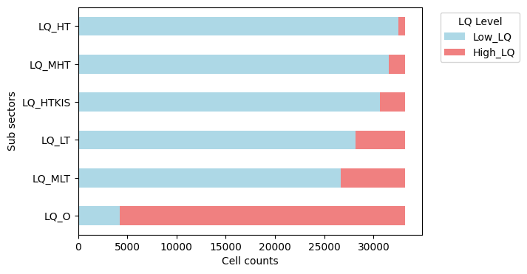Source: own study
Finally, our approach to verifying the clustering phenomenon among high-tech companies involved utilizing the unsupervised machine learning algorithm, DBSCAN. The concept was straightforward: we assessed, for each subsector, the percentage of companies (based on longitude and latitude) assigned to clusters and the percentage labelled as noise. To determine the optimal parameters for the DBSCAN algorithm, we employed the silhouette metric. We adopted a grid search method for each cluster, testing various configurations of the epsilon and min_samples parameters to identify the configuration yielding the highest silhouette score. The results for each sub sector were then summarized in Figure X. Once again, when comparing the results of high-tech sectors with that of other groups, the clustering phenomenon among high-tech companies becomes evident. The chart below clearly shows that high tech companies are more inclined to locate in similar regions than other sectors.
Figure 5. DBSCAN clustering vs noise for each sub sector
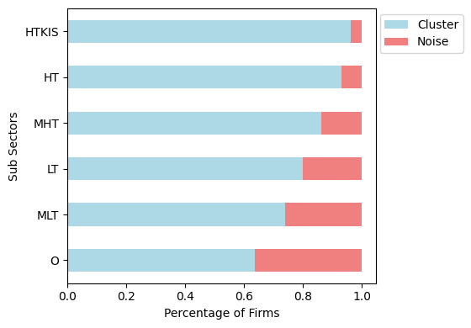
Source: own study

4.2 Probit model, Random Forest and XGBoost
Probit
As a starting point, the probit model was estimated on the scaled variables explained in section 3.1.2 for each of the established groups, with the target variable being the affiliation with a particular group. While the parameters and variables remained unchanged, the division is highly unbalanced.
The result suggests a universal trend for a higher industrial diversity. From the regression alone, It appears that for HT and MHT population density does not significantly impact their location, which cannot be said for HTKIS, MLT, LT and O, where the variable is statistically significant. It appears that while other groups locate in areas with a below average population density, for HTKIS the opposite is strongly preferred. Similarly, both HT and HTKIS display a significant preference for locations in the vicinity of bigger firms. The trend is not so clear for the other groups. Another universally significant variable is the employment size, with a pattern suggesting a positive impact of employment size on location decisions, especially in the HT group, with the contrary occurring for HTKIS. The clustering effect is further highlighted for HTKIS, as there is a preference for a higher LQ value. As indicated in section 4.1., since there are fewer grid cells with high LQ for this group, a positive sign for the variable indicates a clustering tendency and a Jacobian composition. For other groups, a Marshallian agglomeration is preferred. There appears to be a tendency for HT companies to prefer locating in an area around bigger or regional cities, with the trend losing significance in the other groups.
The results of the frnn algorithm further imply the preference for the groups to form clusters and confirm the conclusions drawn from the LQ variable. Each of the groups prefers locating near members of that same group (in case of HTKIS, there is a significant preference to avoid groups other than MLT). This relation is not as significant for the HT group, which could be caused by a small sample size in combination with their inherent preference for bigger cities, which are densely populated by each of the other groups.
HT is the only group without a statistical significance for any of the county-based data in the regression model. Since exploring this aspect is one of the core questions of this paper, this is further explored within the other deployed models, as the relations could be nonlinear and their insignificance caused by a lack of a good sample size. Among those territorial variables, an interesting relation is formed with the average number of museum visitors in the counties most densely populated by each of the groups. While O displays a below average need for museum visitors, the more technologically advanced the group, the more this relation is inverted, peaking for HTKIS. The same can be said for the significance of population per library in the area, which contrary to HTKIS is negative for other groups. This implies a statistical preference towards setting a business in an area more stimulating for intellectual workers. Interestingly, HTKIS shows a preference towards areas where the average income is lesser than average. This could be explained by the fact that knowledge-intensive businesses do not offer a high entry level salary, however, reward their highly experienced employees. Moreover, highly experienced and educated workers are not in the majority of the population in most areas. As expected from the literature, HTKIS, MHT, MLT and LT show a high preference towards buses in the area, highlighting the fact that more advanced business areas require better amenities and enable an easier form of commuting in the city. The opposite can be seen for group 0, as those businesses might not take this into consideration, especially in smaller locations. Similar relation is observed with the amount of purchased apartments, with HTKIS showing the strongest preference. This is further proof that population density is an important aspect of business location. In bigger cities, where as established, HTKIS has a preference to locate, there are a majority of apartments rather than houses, which are more prevalent in smaller cities.
Table 2. Estimation results of probit models for each subsector
Variable | HT | MHT | HTKIS | MLT | LT | O
locHH | -0.765*** | -0.732*** | -0.211*** | -0.604*** | -0.763*** | -0.005***
empl | 0.024*** | 0.029*** | -0.01*** | 0.012*** | 0.029*** | -0.0
locPdens | -0.01 | -0.01 | 0.068*** | -0.119*** | -0.024** | -0.077***
locBIG | 0.029 | 0.046*** | 0.033*** | 0.038*** | 0.003 | -0.093***
locAggTOTAL | -0.002 | -0.109*** | -0.018 | -0.029 | -0.067*** | 0.094***
locHightech | -0.033 | 0.074** | -0.007 | -0.02 | 0.077*** | -0.009
locLQ | -0.163*** | -0.115*** | 0.055*** | -0.214*** | -0.203*** | 0.016***
dist_core_10 | -0.019 | -0.021* | 0.002 | -0.017*** | 0.001 | -0.003
dist_core_25 | 0.139*** | 0.071*** | 0.108*** | 0.049*** | 0.062*** | -0.15***
dist_core_50 | 0.037 | 0.016 | 0.03*** | 0.038*** | 0.019* | -0.041***
dist_midsize_10 | -0.005 | 0.016* | 0.002 | 0.03*** | 0.021*** | -0.009***
dist_midsize_25 | -0.018 | -0.022 | 0.024*** | 0.026*** | 0.013* | -0.022***
dist_midsize_50 | -0.035 | 0.013 | -0.044*** | 0.001 | 0.004 | 0.034***
dist_regional_10 | 0.021* | 0.009 | 0.019*** | 0.014*** | 0.012*** | -0.027***
dist_regional_25 | -0.02 | -0.002 | -0.009* | 0.022*** | 0.006 | 0.009***
dist_regional_50 | -0.014 | -0.006 | 0.01 | -0.015** | -0.008 | -0.004
dist_localbig_10 | 0.009 | 0.002 | -0.008** | 0.02*** | 0.006 | -0.007***
dist_localbig_25 | 0.083* | 0.03 | 0.063*** | 0.023*** | 0.04*** | -0.046***
dist_localbig_50 | -0.01 | 0.021 | 0.006 | 0.007 | -0.004 | -0.005
dist_localsmall_10 | 0.012 | 0.037*** | 0.055*** | 0.031*** | 0.012** | -0.078***
dist_localsmall_25 | 0.017 | 0.003 | 0.014** | 0.011** | -0.005 | -0.002
dist_localsmall_50 | 0.032 | 0.017 | 0.0 | 0.014*** | -0.005 | -0.001
exp_per1 | -0.209 | -0.357 | 0.041 | -0.325*** | 0.05 | 0.277***
inc_per1 | 0.218 | 0.277 | -0.202* | 0.288*** | -0.138 | -0.12*
UE_fin | 0.012 | 0.008 | -0.021** | 0.01 | 0.013 | 0.012**
museums | -0.033 | -0.032 | 0.062 | -0.002 | -0.216 | 0.03
mus_visitors | 0.171 | 0.115* | 0.187*** | 0.151*** | 0.135*** | -0.222***
cinemas_spaces | -0.031 | -0.019 | -0.006 | -0.026*** | -0.023*** | 0.019***
pop_per_1lib | 0.092 | 0.019 | 0.069*** | -0.035** | -0.037* | -0.045***
book_rentals_per1 | -0.005 | -0.004 | -0.005 | -0.0 | -0.005 | 0.003
crime | 0.043 | 1.036 | 0.482 | -0.016 | 1.541*** | -1.01***
crime_per1k | -0.042 | -0.027 | -0.026 | 0.019 | -0.063*** | 0.032***
apts_bought | -0.0 | 0.358 | 1.277*** | 0.658** | 0.631* | -1.518***
unemployment | 0.111* | 0.025 | 0.005 | 0.04*** | 0.039*** | -0.04***
work_accidents | -0.001 | 0.267 | -2.472** | -0.987 | -1.235 | 1.945***
work_accidents_per1k | -0.028 | -0.02 | 0.024** | -0.015* | -0.035*** | 0.001
students | 0.111 | -0.625 | -0.153 | -0.529 | -1.053 | 1.58
graduates | 0.121 | -0.217 | 0.637 | 0.0 | 0.655 | -1.201
avg_salary | 0.11 | 0.014 | -0.004 | -0.035 | 0.041 | 0.004
avg_salary_to_PL | 0.105 | 0.027 | 0.097 | 0.107 | -0.007 | -0.123
hipermarkets | -0.015 | -1.073 | -1.069 | -0.309 | -1.517 | 1.107
supermarkets | 0.032 | 0.14 | 0.397 | -0.036 | 0.667 | -0.434
depos | 0.118 | 0.055 | -0.042 | 0.157 | -0.001 | -0.059
stores | -0.579 | -0.029 | -0.157 | -0.09 | 0.075 | 0.273
all_stores | 0.026 | 0.009 | 0.083 | -0.075 | 0.115 | -0.011
apts_available | 0.002 | -0.069 | 0.187 | 0.393 | -0.019 | -0.01
buses | 0.152 | 0.865* | 1.042*** | 0.793*** | 1.094*** | -1.291***
schools | -0.229 | -0.863* | -0.617*** | -0.227 | -0.959*** | 0.966***
HT_neighbor_count | 0.413*** | 0.018 | -0.029*** | 0.005 | 0.003 | 0.003
HTKIS_neighbor_count | -0.16*** | -0.227*** | 0.357*** | 0.112*** | -0.168*** | -0.269***
LT_neighbor_count | 0.026 | 0.163*** | -0.138*** | -0.028 | 0.731*** | -0.015
MHT_neighbor_count | -0.022 | 0.178*** | -0.059*** | 0.037** | 0.032** | -0.041***
MLT_neighbor_count | 0.007 | 0.094*** | 0.07*** | 0.359*** | -0.058*** | -0.1***
O_neighbor_count | -0.248*** | -0.246*** | -0.222*** | -0.489*** | -0.558*** | 0.419***
Source: own study
Random Forest
Apart from confirming the above assumptions and conclusions on the groups, Random Forest shows a significant relation between the amount of neighbours there are from other groups. It is further implicative of a clustering phenomenon appearing; however it also showcases that there is no clear cut formula for what each group is composed of. Furthermore, there is also a relation shown between the population density, which for HT and MHT was not significant in the Probit regression. Unfortunately, no county-data was identified as significant for any of the groups by Random Forest.
Figure 6. Feature importances for Random Forest Models of each sub sector
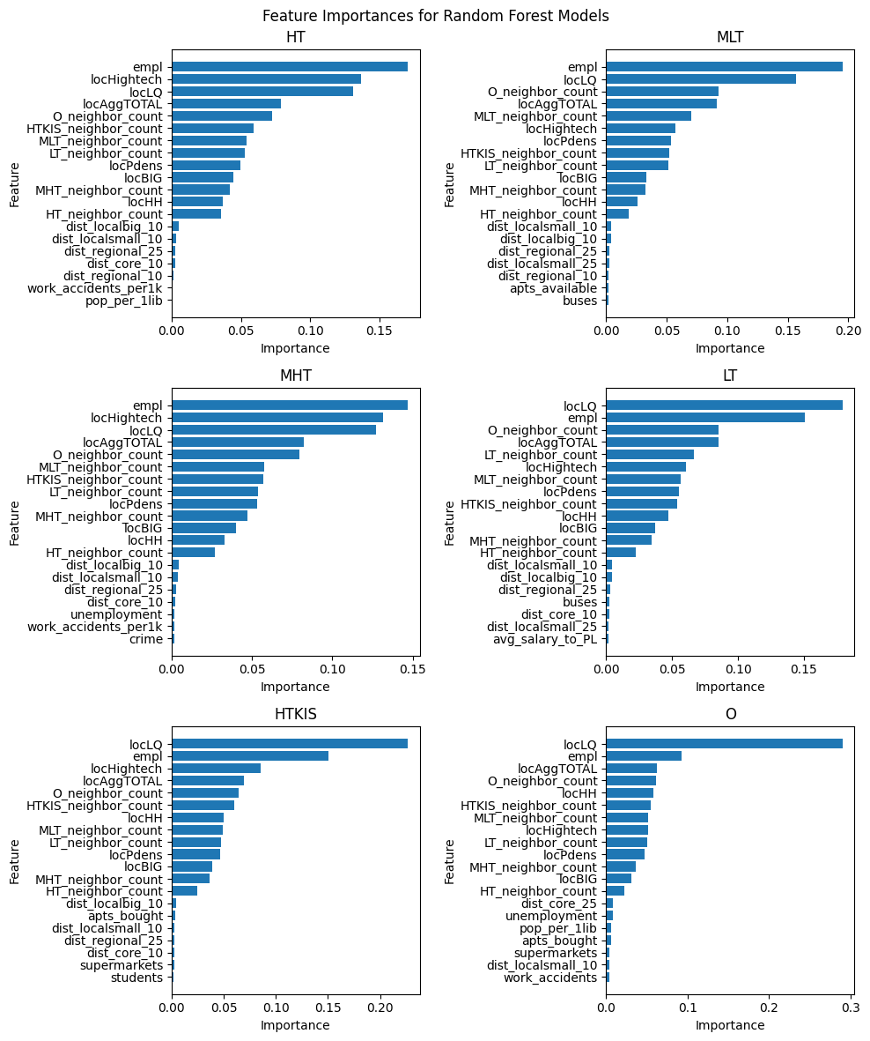Source: own study
XGBoost
Despite the territorial data being county sized and not personalized for each company address, we strongly believe there are more factors that could be explored and for which the relation might be much more complex. Because of this, we deployed an XGBoost model for each group which highlighted factors sometimes unnoticed by the previous models. For HT group XGBoost showed a significant relationship with purchased apartments in the area. As there was a positive relation shown between bigger cities and HT companies locations, this also implies that densely populated areas are more preferred by HT. Although not evident in the Probit or Random Forest models, XGBoost also indicates that there is a relation between HT companies and population per library in the area and average museum visitors. With that we draw a conclusion, that similarly to HTKIS, HT is attracted to areas which could stimulate intellectual workers more. The most apparent relation signified by XGBoost is that of apartments bought and HTKIS. We can also see the important factors being the amount of graduates from an area and the amount of museums. This further confirms the results achieved with the Probit model and . As observed in the literature, there is also a relation with stores established in the area. Although unnoticed by the previous models, we presume this is consistent with the theory that higher tech / knowledge intensive companies care for the amenities available for their employees. The above implies that conclusions similar to those drawn from the Probit model of HTKIS could be drawn for HT, however the current calculations might be strongly influenced by the small sample size. For O group XGBoost indicates the strongest relationship with the 25km distance from core cities as well as with the unemployment rate. It appears that similarly to what was concluded above, most of the “other” companies prefer settling on the outskirts of major cities, where there is a higher unemployment rate, which could in turn make it easier to start a business with a workforce available.
Figure 7. Feature importances for XGBoost Models of each sub sector
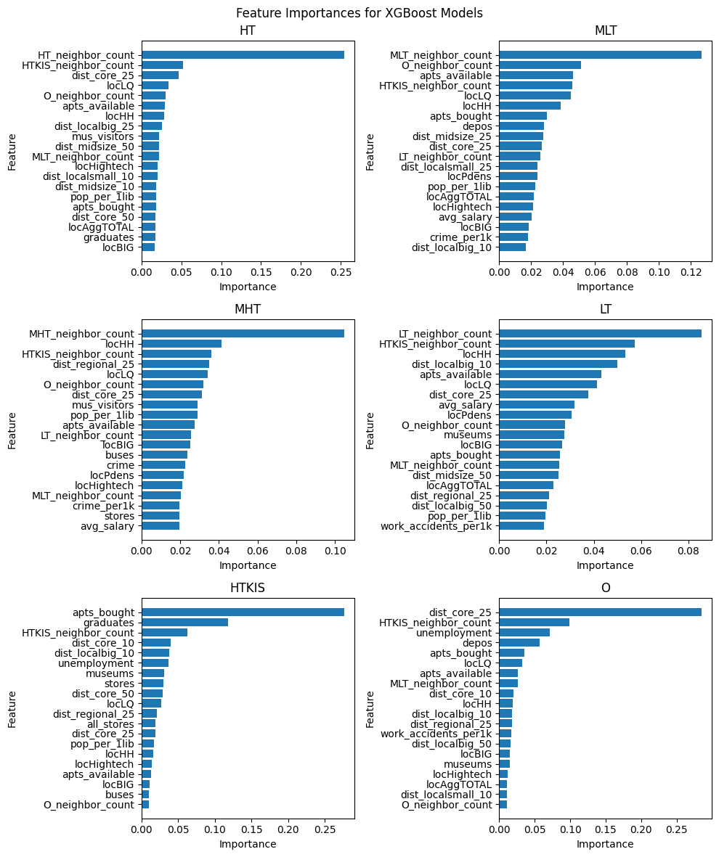Source: own study
Conclusions and final remarks
As the research on company location determinants progresses, there is a high diversity in results depending on the assumed research approach and variables taken into account. The existing literature describes a clustering tendency for companies around densely populated areas (Kopczewska et al., 2023), and points out the differences between sectors, however it is still lacking in a definitive answer to what particularly distinguishes high-tech and knowledge-intensive sectors. While Auora and Hamidi (2021) argue a low impact of transit amenities for high-tech locations, Kangmin, et al. (2019) suggests a visible trend of public service in creation of knowledge districts. Showcasing differences in assumed data scale Kinne and Resch (2017) try to dispute the importance of population density in knowledge-intensive sectors, in opposition to Cissé et. al (2020).
In this paper, a subtle blend of micro-scaled data describing location information with broader county-level data is introduced in order to approach a common ground for research. It is consistently proved with a 1x1km grid approach that companies from high-tech groups form clusters, with the rest containing a noise pattern, in other words locating in a broader range of areas. There is also a clear tendency of a higher industrial specialization, the more high-tech the business is. Secondly, we argue that high-tech knowledge intensive firms follow not only the well-established patterns of locating near densely populated areas and preferring a neighbourhood of similar sectors, but are also significantly impacted by economic factors such as museum visitors in the area, libraries or available public buses. The employed XGBoost model detecting non-linear relationships was useful to showcase the importance of graduates and purchased apartments in knowledge-intensive sectors, proving a high rate of investment present in those areas.
We hope this paper will broaden the perspective on determinants from both location and economic data and as such add to the literature, especially concerning emerging markets like the Mazovian region in Poland.

Bibliography
Arbia, G., Espa, G., Giuliani, D., & Mazzitelli, A. (2012). Clusters of firms in an inhomogeneous space: The high-tech industries in Milan. Economic Modelling, 29(1), 3–11. doi:10.1016/j.econmod.2011.01.012
Artz, G. M., Kim, Y., Orazem, P. F., & Han, P. J. (2021). Which small towns attract start‐ups and why? Twenty years of evidence from Iowa. American Journal of Agricultural Economics, 103(2), 702-720.
Beaudry, C., & Schiffauerova, A. (2009). Who’s right, Marshall or Jacobs? The localization versus urbanization debate. Research Policy, 38(2), 318–337. doi:10.1016/j.respol.2008.11.010
Benbrahim Ansari O. Geo-Marketing Segmentation with Deep Learning. Businesses. 2021; 1(1):51-71. https://doi.org/10.3390/businesses1010005
Cameron, C. & Trivedi, P., 2009. Microeconomics using stata Revised ed., College Station, TX: Stata Press.
Chin, J. T. (2020). Location choice of new business establishments: Understanding the local context and neighborhood conditions in the United States. Sustainability, 12(2), 501.
Cissé, I., Dubé, J., & Brunelle, C. (2020). New business location: how local characteristics influence individual location decision?. The Annals of Regional Science, 64(1), 185-214.
Darchen, S. (2015). “Clusters” or “communities”? Analysing the spatial agglomeration of video game companies in Australia. Urban Geography, 37(2), 202–222. doi:10.1080/02723638.2015.106
Darchen, S., & Tremblay, D.-G. (2014). Policies for Creative Clusters: A Comparison between the Video Game Industries in Melbourne and Montreal. European Planning Studies, 23(2), 311–331. doi:10.1080/09654313.2013.865712
Deller, S. C., & Deller, M. A. (2010). Rural crime and social capital. Growth and Change, 41(2), 221-275.
Florida, Richard. The rise of the creative class--revisited: Revised and expanded. Basic Books (AZ), 2014.
Gil, P. M., Afonso, O., & Brito, P. (2019). Economic growth, the high-tech sector, and the high skilled: Theory and quantitative implications. Structural Change and Economic Dynamics, 51, 89-105.
Greene, W.H., 2014. Econometric Analysis. Seventh edition
Goetz, S. J., & Rupasingha, A. (2002). High-tech firm clustering: Implications for rural areas. American Journal of Agricultural Economics, 84(5), 1229-1236.
He, Zekai, and Michael Romanos. "Spatial agglomeration and location determinants: Evidence from the US communications equipment manufacturing industry." Urban Studies 53.10 (2016): 2154-2174. https://doi.org/10.1177/0042098015586698
Jofre‐Monseny, Jordi, Raquel Marín‐López, and Elisabet Viladecans‐Marsal. "The determinants of localization and urbanization economies: Evidence from the location of new firms in Spain." Journal of Regional Science 54.2 (2014): 313-337. https://doi.org/10.1111/jors.12076
Kinne, Jan and Resch, Bernd, Analysing and Predicting Micro-Location Patterns of Software Firms (2017). ZEW - Centre for European Economic Research Discussion Paper No. 17-063 http://dx.doi.org/10.2139/ssrn.3082822
Kopczewska, K. (2022). Spatial machine learning: new opportunities for regional science. The Annals of Regional Science, 68(3), 713-755.
Katarzyna Kopczewska, Maria Kubara, Mateusz Kopyt, The power of population density in entrepreneurial ecosystems: attracting business to the place (2024)
López, Fernando A., and Antonio Páez. "Spatial clustering of high‐tech manufacturing and knowledge‐intensive service firms in the Greater Toronto Area." The Canadian Geographer/Le Géographe Canadien 61.2 (2017): 240-252. https://doi.org/10.1111/cag.12326
Pominova, M., Gabe, T., & Crawley, A. (2022). The stability of location quotients. Review of Regional Studies, 52(3), 296-320.
Sitek, B. (2014). EUROPEAN POLICY TOWARDS REGIONAL INNOVATION STRATEGY ILLUSTRATED WITH THE EXAMPLE OF THE MAZOVIA (POLAND). Regional Formation and Development Studies, 8(3), 202-210.
Wu, Kangmin, et al. "Relationship between the built environment and the location choice of high-tech firms: Evidence from the Pearl River Delta." Sustainability 11.13 (2019): 3689. https://doi.org/10.3390/su11133689
Zandiatashbar, Ahoura, and Shima Hamidi. "Transportation amenities and high-tech firm location: An empirical study of high-tech clusters." Transportation Research Record 2675.12 (2021): 820-831. https://doi.org/10.1177/03611981211031219

Appendices

Appendix 1: Sub sectors based on NACE Rev. 2 3-digit level
Abbreviation | PKD7 Groups
HT | 21,1; 21,2; 26,1; 26,2; 26,3; 26,4; 26,5; 26,6; 26,7; 26,8; 30,3
HTKIS | 59,1; 59,2; 60,1; 60,2; 61,1; 61,2; 61,3; 61,9; 62; 63,1; 63,9; 71,1*; 71,2*; 72,1*; 74,9*;
LT | 10,1; 10,2; 10,3; 10,4; 10,5; 10,6; 10,7; 10,8; 10,9; 11; 12; 13,1; 13,2; 13,3; 13,9; 14,1; 14,2; 14,3; 15,1; 15,2; 16,1; 16,2; 17,1; 17,2; 18,1; 20,1; 31; 32,1; 32,2; 32,3; 32,4; 32,9
MHT | 18,2; 19,1; 20,2; 20,3; 20,4; 20,5; 20,6; 25,4; 27,1; 27,2; 27,3; 27,4; 27,5; 27,9; 28,1; 28,2; 28,3; 28,4; 28,9; 29,1; 29,2; 29,3; 30,2; 30,4; 30,9; 32,5; 35,1*; 35,2*; 35,3*
MLT | 1,1; 22,1; 22,2; 23,1; 23,2; 23,3; 23,4; 23,5; 23,6; 23,7; 23,9; 24,1; 24,2; 24,3; 24,4; 24,5; 25,1; 25,2; 25,3; 25,5; 25,6; 25,7; 25,9; 30,1; 33,1; 33,2; 45,2*; 45,4*; 95,1*
O | 1,2; 1,3; 1,4; 1,5; 1,6; 1,7; 2,1; 2,2; 2,3; 2,4; 3,1; 3,2; 5,1; 5,2; 6,1; 6,2; 7,1; 7,2; 8,1; 8,9; 9,1; 9,9; 36; 37; 38,1; 38,2; 38,3; 39; 41,1; 41,2; 42,1; 42,2; 42,9; 43,1; 43,2; 43,3; 43,9; 45,1; 45,3; 46,1; 46,2; 46,3; 46,4; 46,5; 46,6; 46,7; 46,9; 47,1; 47,2; 47,3; 47,4; 47,5; 47,6; 47,7; 47,8; 47,9; 49,1; 49,2; 49,3; 49,4; 49,5; 50,1; 50,2; 50,3; 50,4; 51,1; 51,2; 52,1; 52,2; 53,1; 53,2; 55,1; 55,2; 55,3; 55,9; 56,1; 56,2; 56,3; 58,1; 58,2; 64,1; 64,2; 64,3; 64,9; 65,1; 65,2; 65,3; 66,1; 66,2; 66,3; 68,1; 68,2; 68,3; 69,1; 69,2; 70,1; 70,2; 72,2; 73,1; 73,2; 74,1; 74,2; 74,3; 75; 77,1; 77,2; 77,3; 77,4; 78,1; 78,2; 78,3; 79,1; 79,9; 80,1; 80,2; 80,3; 81,1; 81,2; 81,3; 82,1; 82,2; 82,3; 82,9; 84,1; 84,2; 84,3; 85,1; 85,2; 85,3; 85,4; 85,5; 85,6; 86,1; 86,2; 86,9; 87,1; 87,2; 87,3; 87,9; 88,1; 88,9; 991; 92; 93,1; 93,2; 94,1; 94,2; 94,9; 95,2; 96; 97; 98,1; 98,2; 99; 0

The classification was based on NACE rev. 2 classification performed by Eurostat available [here].
High-Tech Knowledge Intensive Firms were assigned based on the PKD classification on top of the already established NACE codes [source].
PKD7 groups marked with ‘*’ have been additionally, based on authors’ subjective opinion assigned to each respective group.

Appendix 2: Variables considered in Probit, RandomForest and XGBoost models
Geospatial data
variables | description
'dist_core_10', 'dist_core_25', 'dist_core_50', 'dist_midsize_10', 'dist_midsize_25', 'dist_midsize_50', 'dist_regional_10', 'dist_regional_25', 'dist_regional_50', 'dist_localbig_10', 'dist_localbig_25', 'dist_localbig_50', 'dist_localsmall_10', 'dist_localsmall_25', 'dist_localsmall_50' | As utilized in Kopczewska, et al. 2023 this is a set of dummy variables denoting the distance of a firm from cities of different sizes.
'locPdens' | Inhabitants of the nearest 500 m radius from each company
'locBIG' | The number of big, well developed companies within a radius of 500 m from each company
'HT_neighbor_count', 'HTKIS_neighbor_count', 'LT_neighbor_count', 'MHT_neighbor_count', 'MLT_neighbor_count', 'O_neighbor_count', 'locAggTOTAL' | A number of firms from a given group, (Appendix X) calculated in a radius of 500 m from each firm, as well as a total amount of neighbors
'locHH' | Herfindahl-Hirsh index calculated in 500 m radius
'locLQ' | Location Quotient calculated in 500 m radius
'empl' | Employment size per company
Territorial data
variables | description
'exp_per1', 'inc_per1', 'UE_fin', 'avg_salary', 'avg_salary_to_PL' | As all the below variables, those are proxy county-level data assigned to each observation by the code of the statistical unit it is located in within the Mazovian region. They correspond to expenditure and income per an inhabitant, as well as EU projects financing and average salary levels.
'museums', 'mus_visitors', 'cinemas_spaces', 'pop_per_1lib', 'book_rentals_per1', 'students', 'graduates', 'schools' | Proxy data corresponding to education levels and cultural development. The variables concern museums in the area, average visitors, spaces in cinemas, inhabitants per 1 library, book rentals per inhabitant as well as students, graduates and schools in the county.
'hipermarkets', 'supermarkets', 'depos', 'stores', 'all_stores', 'buses' | Proxy data highlighting amenities the county is rich in, i.e. stores of varying sizes and public transportation buses.
'apts_bought', 'apts_available' | Proxy data describing apartments bought and available for inhabitants of the county
'crime', 'crime_per1k', 'unemployment', 'work_accidents', 'work_accidents_per1k' | Proxy data monitoring statistical characteristics of the area pertaining to crime (also per 1k inhabitants), unemployment rate and work accidents (also per 1k inhabitants)

PKD7 (Polska Klasyfikacja Działalności - eng. Polish Classification of Business Activity) - A hierarchically structured classification of a set of socio-economic activities, in accordance with NACE rev. 2 classification
Source: https://bdl.stat.gov.pl/bdl

