University of Warsaw
Faculty of Economic Sciences

Filip Szymański, Aleksander Wieliński
Album N°: 427618,

Title

Master thesis degree
Field of study: Data Science and Business Analytics

Thesis written under the supervision of
dr hab. Katarzyna Kopczewska, prof.ucz.
from Chair of Statistics and Econometrics
WNE UW

Warsaw,

Declaration of the supervisor
I declare that the following thesis was written under my supervision and I state that it meets all
criterias to be submitted for the procedure of academic degree award.

Date Signature of the Supervisor

Declaration of the author of the thesis
Aware of the legal responsibility, I declare that I am the sole author of the following thesis and that the thesis is free from any content that constitutes copyright infringement or has been acquired contrary to applicable laws and regulations.

I also declare that the thesis has never been a subject of degree-awarding procedures in any higher education institution.

Moreover, I declare that the attached version of the thesis is identical with the enclosed electronic version.

Date Signature of the Author

Summary

Key words

Field of the thesis (codes according to the Erasmus program)

Thematic classification

The title of the thesis in Polish

Data

Exploratory Spatial Data Analysis
The subsequent analysis begins by examining what percentage of mid/high-tech companies belong to each area defined as dist_(core, midsize, regional, localbig, localsmall)_(10, 25, 50), and to the COREfirms, COREpopul clusters. We created a crosstab that counted the number of mid/high-tech companies that matched the results of the selected variables, and divided the number of matched observations by the total number of mid/high-tech companies (see Table 1).
Table 1. Crosstab results
Variable | Percentage  matching  (high-tech) | Percentage  matching  (non-high-tech) | High-tech  (0) | High-tech  (1) | Non-high-tech (0) | Non-high-tech (1)
COREfirms | 94.38% | 68,08% | 2379 | 39962 | 300455 | 640923
COREpopul | 96.85% | 74,20% | 1333 | 41008 | 242915 | 698463
dist_core_10 | 56.54% | 32,36% | 18402 | 23939 | 636719 | 304659
dist_core_25 | 84.41% | 51,42% | 6601 | 35740 | 457343 | 484035
dist_core_50 | 90.43% | 63,25% | 4050 | 38291 | 345968 | 595410
dist_midsize_10 | 1.72% | 3,18% | 41611 | 730 | 911483 | 29895
dist_midsize_25 | 3.60% | 8,72% | 40816 | 1525 | 859260 | 82118
dist_midsize_50 | 5.04% | 16,37% | 40205 | 2136 | 787247 | 154131
dist_regional_10 | 7.88% | 7,85% | 39005 | 3336 | 867489 | 73889
dist_regional_25 | 72.07% | 52,06% | 11824 | 30517 | 451294 | 490084
dist_regional_50 | 94.11% | 79,01% | 2494 | 39847 | 197607 | 743771
dist_localbig_10 | 45.17% | 33,20% | 23216 | 19125 | 628852 | 312526
dist_localbig_25 | 90.83% | 65,21% | 3884 | 38457 | 327510 | 613868
dist_localbig_50 | 94.97% | 80,99% | 2128 | 40213 | 178933 | 762445
dist_localsmall_10 | 77.72% | 53,33% | 9434 | 32907 | 439298 | 502080
dist_localsmall_25 | 95.88% | 83,37% | 1746 | 40595 | 156567 | 784811
dist_localsmall_50 | 99.90% | 98,88% | 42 | 42299 | 10550 | 930828

To begin with, consider the disparity between the results for the COREfirms and COREpopul variables. A relative comparison of the results indicates a much higher concentration of high-tech companies around densely populated areas and areas with a large number of companies. Results close to 95% for both variables for high-tech companies clearly indicate that the location of these companies is not random, and it is necessary to focus on a deeper analysis of this phenomenon and take this fact into account when formulating the research hypothesis.
A comparison of the results for the dist_core and dist_midsize variables also shows a certain regional dependence. Assuming that the dist_core_10 variable corresponds to areas less than or equal to the area of Warsaw's inner city, and the dist_core_25 variable also covers its outskirts, the results of 56.64% and 85.41%, respectively, indicate a very high concentration of high-tech companies just in the vicinity of Warsaw. In comparison, non-high-tech companies falling into the dist_core_25 area account for only half of all non-high-tech companies in the Mazovian region. Moreover, for the variables dist_midsize_(10,25,50), which correspond to the location around Radom and Plock, (also dist_regional, which corresponds to cities with a population of 50k+) the results are very low. This indicates the overwhelming dominance of large cities in terms of locating high-tech companies.
Figure 1. Spatial distribution of mid/high-tech firms
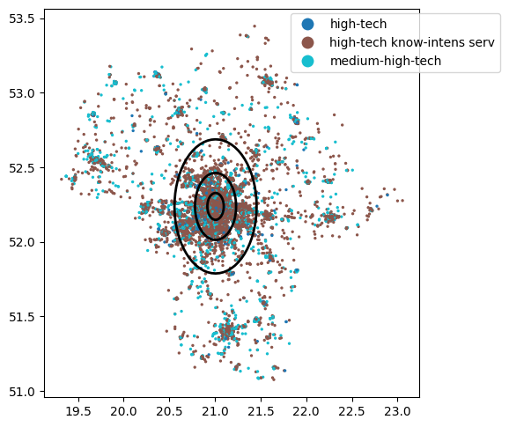
The insights from the above analysis can be visualized in the graph (see Figure 1). The chart shows the point distribution of high-tech companies in the Mazovian Voivodeship. It clearly shows the concentration of companies around larger agglomerations characterized by higher population density, as well as the huge density in the very center of Warsaw and its suburbs. The chart has been plotted with 3 circles corresponding to areas with a radius of 10, 25 and 50 kilometers from the center of Warsaw. Based on the results from the crosstab analysis, 56.54%, 84.41% and 90.43% of all high-tech companies are located in these areas, respectively.
The next step from the preliminary analysis was to visualize and plot three variables: locPdens - the number of residents in the direct neighborhood of 500m from a given company, locAggTotal - the number of companies in the direct neighborhood of 500m from a given company, and locBIG - the number of companies classified as large in the direct neighborhood of 500m from a given company (see Figure 2). Cross-referencing the graph of the locPdens variable with the graph for high-tech companies, one can clearly see clusters forming around larger urban areas, where population density is higher. This coincides with the conclusions of the crosstab analysis and also, such tendency can be found in the literature (Kopczewska et. al. 2023). The same is true for the variable locAggTotal, where we also see a tendency for high-tech companies to locate in areas with more companies. However, the trend is not as clear-cut as in the case of population. The chart shows that the areas to the east and northeast of Warsaw do not overlap in all places when compared with the density of mid/high-tech companies. Nevertheless, looking at the graph for the locBIG variable at the same time, we can see that there are relatively more companies classified as large in these areas, which may influence the lack of bright shades shown in the graph for the locAggTotal variable.
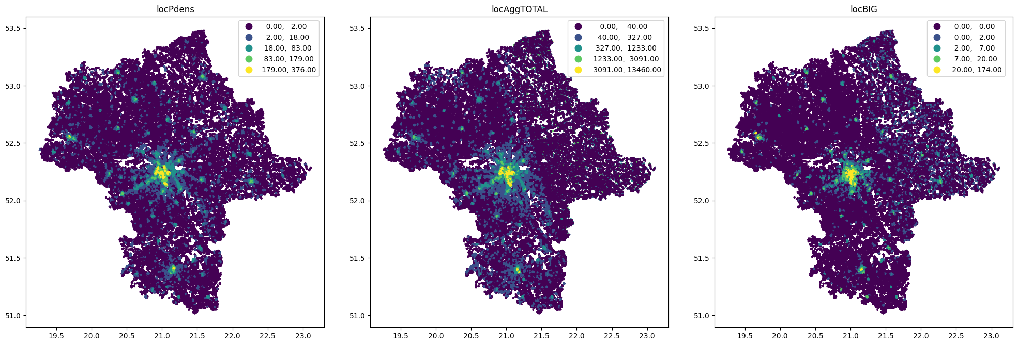

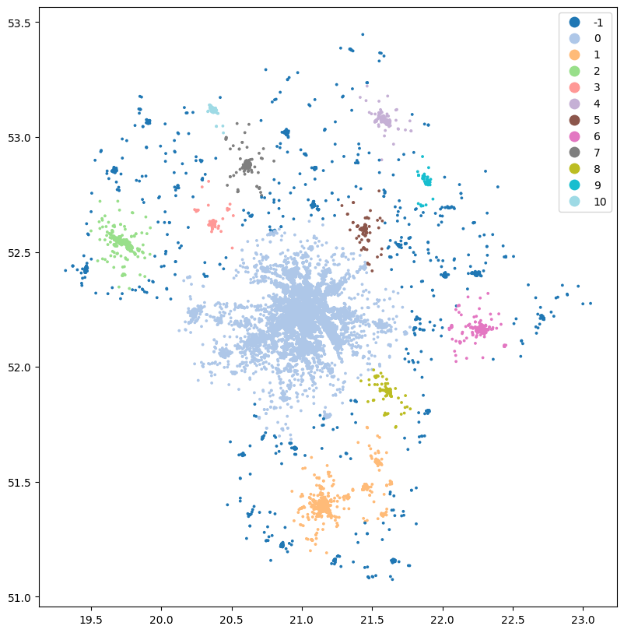

Literature Review
While studying spatial data, one of the fundamental steps is to examine the spatial distribution of our variables. Geo-located points, irrespective of assigned features, are distinguished by their longitude and latitude (x, y) coordinates on a projection. Using this data, it is possible to gather observations into spatial clusters that exhibit spatial continuity, encompassing all points under analysis (Kopczewska, 2021). There are many unsupervised machine learning techniques for clustering, which are differentiated primarily by the method of measuring distance, e.g. Euclidean, Manhattan, Minkowski etc., how the assignment to a given cluster is decided, and how the center point in a given cluster is formed. K-means is one of the most popular and simplest unsupervised learning technique employed for clustering data. It divides a set of n observations into k clusters, assigning each observation to the cluster with the closest mean. The primary goal of this algorithm is to minimize a specific objective function, which in this context is a squared error function. (Ansari, 2021). For relatively modest sample sizes (n), the k-means algorithm can be effectively applied, however, its suitability diminishes as n grows due to the need for calculating a resource-intensive n × n mutual distance matrix (Kopczewska, 2021). As Ansari (2021) states, in case of B2B market segmentation analysis k-mean algorithm could not find any useful clusters out of the data set. Instead, the unsupervised Self-Organizing Map (SOM) has demonstrated its proficiency in identifying both geographically uniform and geographically diverse areas across the United States.
There are two main problems with the K-means algorithm. One is that the user has to determine the number of clusters a priori, either based on intuition or simply by guess. The second is that the algorithm does not detect noise observations, creating clusters using all the data provided, also taking into account observations that do not contribute to the formation of clusters. Recognizing these challenges, another approach known as the DBSCAN (Density-Based Spatial Clustering of Applications with Noise) algorithm was developed to address some of the limitations of the K-means method. Unlike K-means, DBSCAN doesn't require you to preset the number of clusters. It works by identifying clusters based on the density of points within a specified radius, rather than relying on a predetermined number. Central to the DBSCAN algorithm are the concepts of "core points," "border points," and "noise." Core points require a certain number of neighboring points within a defined distance, border points exist near core points but lack the required density, and noise points are too distant from core points to be grouped into clusters.

Dalsze kroki i metodyka badawcza
- Podzielenie firm na sektory względem kodu PKD7 (tak jak to zostało zrobione w Pani pracy) i próba sklastrowania ich. Wstępnie zbadaliśmy korelację zmiennych w bazie, jednak nie otrzymaliśmy obiecujących wyników, co z naszych podejrzeń może być związane ze zbyt granulowanym podziałem kodów PKD.
- ESDA dla firm finansowych i produkcyjnych podobna jak dla firm high-tech
- Zastanowienie się nad dodatkowym czynnikiem związanym z lokalizacją, który może mieć istotny wpływ na nasze predykcje. W literaturze przewijały się pomysły w których autorzy tworzyli zmienną np. odpowiadającą odległości firmy od najbliższej autostrady/drogi szybkiego ruchu. Być może w naszym przypadku mogłyby inwestycje w nieruchomości / dostępność biur pod wynajem?
- Eksperymentowanie z różnymi technikami predykcji lokalizacji. W starszej literaturze dotyczącej lokalizacji firm dominuje podejście ekonometryczne z wykorzystaniem naprzemiennie estymacji GWR, SAR i SEM. W nowszych pracach z zakresu modelowania przestrzennego (niekoniecznie dotyczących lokalizacji firm) coraz częściej autorzy korzystają z technik uczenia maszynowego takich jak lasy losowe czy uczenia głębokiego korzystając z sieci neuronowych.

