Diva 'Wifi' Management Web Page

The Management Web page can be reached at http://127.0.0.1:8002 if the checkbox is enabled.

For other users, it will be http://DomainName:8002, where DomainName is your Public, Internet-facing IP or DNS name.

The features of Wifi are:

- Account creation, optionally controlled by the administrator
- Configurable default avatars for new accounts
- Account updates by both users and administrator
- Account deletion by administrator
- Password recovery via email
- Simple user inventory management

You can change some of the parameters of Wifi in this panel:

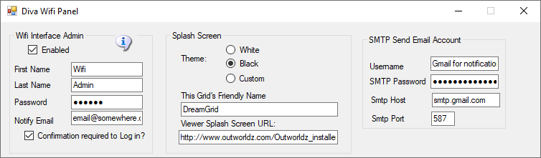

There are three sections that can be modified:

- Wifi Admin account: A super-user that administers the system
- Splash Screen: Things that affect the page that shows to new users
- SMPT Email: Settings to send email for things like password changes

Wifi Admin account

The system automatically makes several accounts the first time it is booted. Once of these is "Wifi Admin'. This user has special rights in the web panel. It can administer all other accounts, delete them, and approve them.

A random password is chosen at startup. You may change it. Since the Hypergrid exposes this login page to the Internet, please choose a strong password.

You must have a user with levels set to 200 or higher in order to change the name from Wifi Admin.

Confirmation Required to Log In:

If this box is checked, users must wait for approval from you before they can log in. You should first make sure the email system works so you get notified. When you are notified, you must log in as Wifi Admin to allow users to join the grid. If unchecked, any person can create an account and log on.

Splash Screen

Themes:
There are three possible theme colors, Black on White, White on Black, and Custom. These themes are copied by Dreamgrid into the real WIFIPages folder from one of these two sets of folders:

White theme:
Outworldzfiles\Opensim\WifiPages-White
Outworldzfiles\Opensim\bin\WifiPages-White

Black theme:
Outworldzfiles\Opensim\WifiPages-Black
Outworldzfiles\Opensim\bin\WifiPages-Black

If you want to use a custom theme, first copy both of the Black or White folders to the WifiPages-Custom folder next to them. Each set of files goes in two places: the Opensim/WifiPages/ opensim/bin/ folders

The updater will never overwrite these custom pages. If you make changes to the custom pages, they will be set into the Wifi page on startup.

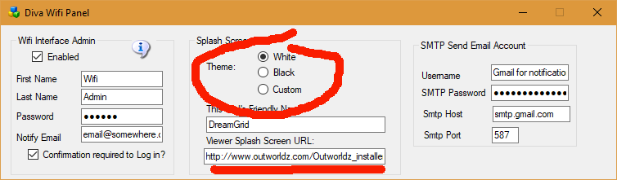
The Splash Screen URL is underlined in Red.
For the BLACK theme, do the following:
Copy the folder \OutworldzFiles\Opensim\bin\WifiPages-Black to \OutworldzFiles\Opensim\bin\WifiPages-Custom
Copy the folder \OutworldzFiles\Opensim\WifiPages-Black to \OutworldzFiles\Opensim\WifiPages-Custom
Save the image as a JPG file in \OutworldzFiles\Opensim\bin\WifiPages-Custom\images\orange-planets-background.jpg
Go to Settings->Web Control Panel. Click the box and change it from Black to Custom. This will copy the files from -Custom to the working folder, bin/WifiPages.
Go back to Dreamgrid, and navigate to Help-View Web Interface or press Alt-W. You should see your new image.
For the WHITE theme, do the following:
The new image goes in \bin\WifiPages-Custom\images\header.png. You must first make the folder
Copy the folder \OutworldzFiles\Opensim\bin\WifiPages-White to \OutworldzFiles\Opensim\bin\WifiPages-Custom
Copy the folder \OutworldzFiles\Opensim\WifiPages-White to \OutworldzFiles\Opensim\WifiPages-Custom
Then click the Theme setting for White. This will copy the files from custom to the WifiPages folder.
Go back to Dreamgrid, and navigate to Help-View Web Interface or press Alt-W. You should see your new image.

Friendly Name

The friendly name appears on the login screen at the top. It is broadcast to viewers as the grid name in the grid Selector Pulldown.

Viewer Splash Screen URL:

The Splash screen URL appears on the login screen as a web page. You can use any web page. If you change this URL, you must delete the grid setting in your viewer, and re-add it to get it updated.

It is recommended to set this to http: (URL of your grid):8002 so they can see the Diva Login Page. This entry is underlined in Red in the image above.

SMTP Email
You may optionally set up Simple Mail Transport Protocol to send email for events such as password changes.

If you use Gmail for SMTP, you will need to enable Less-Secure mail settings at Gmail in your account.

You can find information about this at https://support.google.com/accounts/answer/6010255

