Cache Deletion

Opensimulator has many caches of data to improve performance. You may optionally clear these caches. The system will refresh them on the next startup. This will slow your system down dramatically on the next boot as it must re-fetch all assets the next time it starts.
Opensim must be stopped to clear script and bake caches.
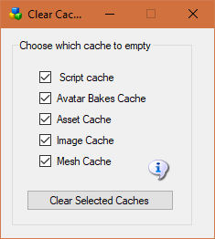
Script cache: Clearing the script cache is only necessary after a update to Opensim binaries. Dreamgrid will not delete the “.STATE” files so your virtual pets will not die.
Avatars bakes cache: this folder holds the various baked skin layers.
Asset cache: holds the assets (mesh, prims, textures) and is typically very large. It automatically flushes itself every 48 hours.
Image cache: holds the images and is typically very large.
Mesh cache: is typically not used

