Region Files
Open the Region Panel with Ctrl-R, or go to Setting-Region.

There will be anywhere from one to many Region.INI files in your system. These show up in this panel. The default is an island called "Welcome".

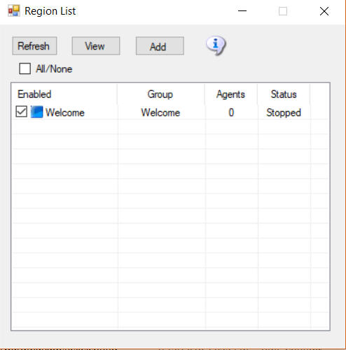

Refresh button

Click Refresh to rescan the system status and update this panel.

Add Regions

Click the Add button to make a new region. You only need to give it a name and save it.

View button

There are three views.

List View: The List view can be sorted by Name, Group, Agents or Status by clicking the column name.

Icon View: The second view is a small icon-only view for larger grids

Map view: The third view only appears if Maps are enabled before the stem boots. It has zoomable map images.

Moving Region Files from Older systems

You may move old region.ini files from other Opensim systems into Dreamgrid using a special drag and drop mechanism.

Use the windows explorer and navigate to the original Dreamworld location on your disk. Look in Opensim\bin\Regions for any region INI files.

Left click each region, one at a time, and drag and drop it onto the Regions panel.

This message will appear:

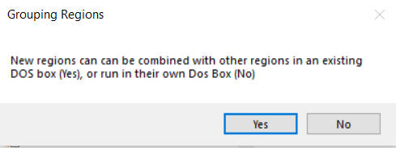

Yes: If you answer Yes, a Chooser dialog will appear. You must chose which region you want to combine your new region with. This places both regions into a single DOS box. When you first start out, your only choice will be Welcome, as you only had one region. If you want a new box, select No.

No: If you answer No, you will get a different DOS box when this region starts.

You should limit the number of DOS boxes by combining your regions into logical groups. A typical system will run 4 to 8 such groups. You can run more, but you will pay a penalty in RAM use for each box.

File Folder Arrangement

Dreamgrid uses a slightly different folder setting than stock Opensim. You cannot just copy them over in a file explorer unless you make a special pattern of folders, with an extra set of folders inside it.

The format is:

Opensim\bin\Regions\DOS Box Name\Region\RegionName.ini

Dreamgrid has several simple rules for *.INI files that differ slightly from stock Opensim.

- The INI file name must match the [Region Name] inside it. This example region [Region Name] must be saved as “Region Name.ini”.

- Only one [Region Name] is allowed in an INI file.

- All contents of a Region file are made by Dreamgrid and will be overwritten. See the Region Control Panel to change the settings.

