Regions
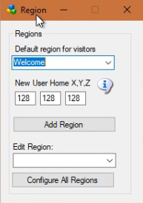
Default region for visitors: Hypergrid visitors get sent to the Default region for visitors.
New User Home X,Y,Z: Users that create accounts on the web page will land at this spot on your Welcome region with their home set here so they can hypergrid back home.
Default: 128,128,24
Add a Region: will bring up a dialog form for adding a new region.
Edit Region: will bring up a dialog form to edit the selected region.
Configure All Regions: will open all regions for editing.

