This screen controls the background wallpaper and the chatty fairy inside the Dreamworld.

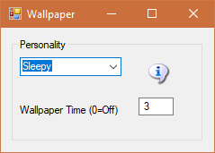

If text = "Sleepy" Then ChatTime = 1.5 seconds delay
If text = "Awake" Then ChatTime = 1 second
If text = "After Coffee" Then ChatTime = ½ seconds
If text = "Too much Coffee" Then ChatTime = 0 delay

Wallpaper time is set in seconds. Set to 0 = no Gifs will play.
Default = 60 seconds to cycle a random GIF.

