Physics Engine
The Physics selection box lets you set very basic physics, where the only collidable object is a box shape. It supports the original Open Dynamic Engine physics. The ubODE engine, by Ubit Umarov, is an advanced version of ODE that is closer to Second Life compatibility with vehicles. Bullet is an award winning physics engine. Running Bullet in a separate thread is the default.
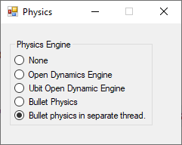
- None effectively does not model physics at all, making all objects phantom.
- OpenDynamicsEngine was the previous default physics engine in OpenSimulator 0.7.6.1 and before. It continues to provide a workable physics implementation. It does not currently support varregions.
- UBODE is closer to Second Life in vehicle performance.
- BulletSim and UBODE support varregions.
- BulletSim is the default physics engine. It provides the best performance and most functionality.
- When run in a separate thread, it cannot crash the Region if it dies.

LInks:

http://www.ode.org/
https://en.wikipedia.org/wiki/Bullet_(software)

