Port Settings and UpNP

Multiple TCP ad UDP Ports are used in Opensim. The defaults are shown below.
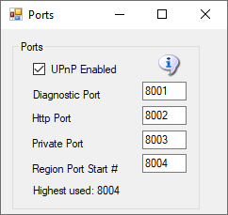
The defaults are 8001 (Diagnostic), 8002 (Public) , 8003 (Private) and 8004 (Starting Region). If you have manually added more regions, their region ports also needs to be open. Each region that is used takes up one port. They start at 8004 and count up by one.
UPnP Enabled: The Outworldz program uses Universal Plug and Play (uPnP) to automatically allow data to come from the Internet to your computer. This is called "Port Forwarding". uPnP capability may be disabled in your router, or it may not support it.
If UpnP is enabled and your router supports it, Dreamgrid will automjatically open the correct ports. This can be slow and timeconsuming, so you may prefer to disable UPnP and set your ports manually
Do you have Plug and Play (uPnP) issues? The Dreamgrid help menu has a useful tool to look at uPnP in your router:
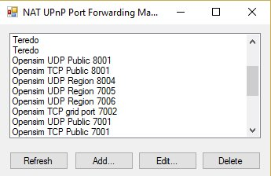
Upnp (Universal Plug and Play) Tool for Windows
You can add, delete and modify the settings without a password, assuming you have uPnP enabled. This tool is avilable in Dreamworld and Dreamgrid in the Help menu.

