Publish Grid

Publish Grid sends shows your grid in the list at Hyperica.com.

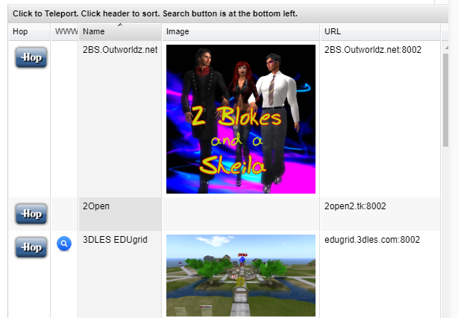

Photos:

Click the Green box to load PNG image and it will appear in your listing.

Publish Items Marked for Search:

Setting this switch will store any prims or regions you set for "Show In Search" into a database at Outworldz that shows the data in any Outworldz grid in your viewer in Search.

