Maps
Opensim has many different maps settings. Dreamgrid has 4 easy-to-use combinations.
Opensimulator has several Map tile makers. It can take a very long time to boot when using the Better and Best maps. These maps using the Warp3D engine must load all prims, mesh and textures, so any bad textures will cause harmless errors to appear on your console.
I recommend you run all maps at Best setting once, then set Maps to None. You can remake maps when enough changes have been made.
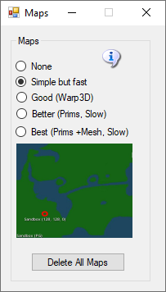
- None: No maps will be made. This is a good setting as the regions will boot very quickly. Any existing maps are not deleted.
- Simple but Fast: MapImageModule is used with just Land showing
- Good: Uses Warp3D module with just Land showing
- Better: Uses Warp3D module with Land, Prims, and land Textures showing
- Best: Uses Warp3D module with Land, Prims, Mesh, Sculpts, and all Textures including prims showing.
- Delete All Maps: If you delete a region, the map will remain. Click this to clear out all maps. You will need to regenerate all maps again by choosing a setting and restarting all regions.

Manual regeneration
Normally, one would generate maptiles at startup. You can also manually force maptile regeneration with the console command
# generate map

