Hypergrid and Domain Name Setup
Hypergrid requires a DNS name or a Public IP be entered here. You can register your own domain,or use your routers public IP, or use the Outworldz free Dynamic DNS system (DYN DNS).
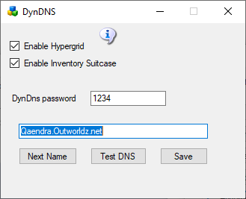
Enable Hypergrid: If off, the Hypergrid will not be available. The grid will be only a Private Grid, with access possible only by logging into the grid directly.
Enable My Suitcase: If on, Hypergrid travel uses a viewer suitcase. The purpose of the Suitcase is to prevent a foreign "rogue" grid from stealing your inventory while you are visiting. However, any items in your suitcase are exposed to other grids. you can only rez or give items in other grids that are already in your suitcase.
The My Suitcase folder is special: it is the folder tree that receives objects you collect while you are visiting other grids. But now it is even more special: it is the only folder tree that is accessible to you (and therefore to the rest of the Internet) while you are traveling. Period.
If you disable the suitcase by unchcking this box, as OsGrid does, you will be able to rez and give items while on other grids from anywaher in your inventory. Items you take or are given will still end up in your suitcase.
DynDNS Password: This is a random number that may be used to keep your DNS Name from being used by others. It's first come, first-served. Your password must be copied from one installation to another to use the same DYN DNS name.
Dns Name: If blank, the PC's LAN address will be used. Hypergrid will not be available.
When there is no Network connection , use localhost, or 127.0.0.1,.
For domain names, the letters and numbers a-z and 0-9 and a dash (-) are the only allowed characters.
Next Name: to use the free Outworldz Dynamic DNS, click "Next Name" to get a name. The Dreamgrid Dynamic DNS system will automatically register your PC's ever-changing IP address and keep your sim running.
Test DNS: Will register the DNS name and chack that it is resolvable. The result should be the Public IP address ofyour router.

links:
http://www.canyouseeme.org

