Database Settings
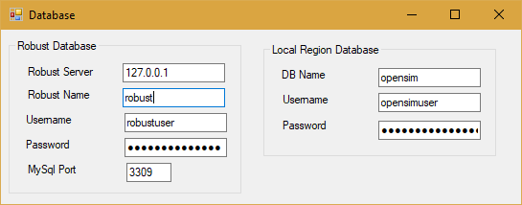
Do not change any of these settings without knowing what you are doing! Any change here must match complicated hand-made changes in MySQL! See thebottom of this help section for more details.
There are two database in Dreamgrid: Robust is the login and inventory database. Each region also uses a separate Opensim database for storing what is in region.
Robust Database:
- Robust Server: should always be 127.0.0.1. This is the Server that runs Robust (itself). It can be the IP address of a different server running MySQL.
- Robust name: The name of the Robust database. default: robust
- UserName: The login name 'robustuser'@localhost'. default: robustuser
- Password : The password for Robust. default = robustpassword
- MySQL Port: The TCP/IP port that both databases use. Default = 3309 to not interfere with the normal Mysql Port of 3306
Local Region Database:
- DB name: The name of the region database. default: opensim
- UserName: The login name 'opensimuser'@localhost'. default: opensimuser
- Password : The password for opensim region datbase. default = opensimpassword
If you want to change the password to either database, you musat add a user account to MySQL first in a DOS box.
cd Outworldzfiles\mysql\bin
mysql -u root
use opensim;
create user 'anewopensimuser'@'localhost' identified by 'opensimpassword';
grant all on opensim.* to 'anewopensimuser'@'localhost';
use robust;
create user 'anewrobustuser'@'localhost' identified by 'robustpassword';
grant all on robust.* to 'anewrobustuser'@'localhost';
quit;

