V1.70 General release

V1.67 beta Bug fixes for 0.9.0 crash when switching back and forth

V1.63 General release

V1.62 UDP probes to 8.8.8.8 to detect local IP. If you still have issues with DNS, change your DNS Settings in your PC network adapter to 8.8.8.8. and 8.8.4.4 ( Google's Public DNS)

V1.55 Adds some cosmetic changes - some machines squished the screen and made it hard to read, removes some checks for DNS names, and added a test button to see if your DNS system is working.

V1.53 has a better method of detecting the LAN Ip if the router ports are blocked, by probing Googles DNS system. This may allow LAN use by more than one PC in situations with multiple LAN adapters.

V1.52 fixes a subtle but nasty bug in Groups. The URL was set according to the documentation, which is incorrect. This sometimes leads to Groups crashing if you had correctly set the private port to be blocked in the router, for some routers.

V1.51 adds a selectable Default Region to the Advanced Panel. This is the location an avatar goes to when logging in or hypergridding in when there is no sim specified in the HG URL.

These changes went into effect in 1.5:

IMPORTANT ! Multi-Region Support may require you to edit a file

If you have not manually edited or added any region files, this section will not apply to you. If you have edited any "Regions\RegionConfig.ini" files to add more regions, or added more region INI files to the Regions folder, this update may break your world. You can easily fix it by renaming the files, or separating them into different files.

There is a new rule that only one region is allowed in any "\Regions\*.ini" file, and the name of the file must be the same as the region inside it. This allows Outworldz to manipulate them in the GUI and also automatically set and open the ports for any region.

Because of this rule, your old Regionfile.ini was automatically renamed in this version. Because it has the region "[Outworldz]" in it, the system will rename the old RegionsFile.ini file to "Outworldz.ini". And now you can rename it with the GUI.

*** ADD, EDIT and RENAME REGIONS ***

You can now rename your region from the default name of "Outworldz", or add new regions. Click Settings->Advanced, and in the display that appears, click

251658240

You will see one or more Regions that you can now change:

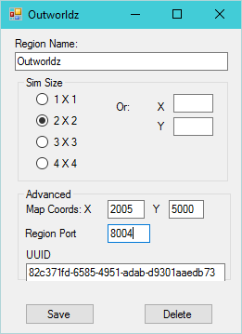

You can choose from various sim sizes, or enter your own sizes. Never put sims of different sizes next to each other. The X,Y sizes should also be a multiple of 256, and both X and Y need to be the same, as most viewers demand that X and Y match. Huge sim sizes such as 4096 X 4096 can be used, such as for flying or car racing.

If you add a new region, it will automatically place the new region 5 regions to the upper right of the highest numbered right-side sim to avoid conflicts. Putting two sims next to each can be done by changing the Map Coords X and Y.

*** NEW DYNAMIC DNS ***

Outworldz now has a free Dynamic DNS system.
I've seeded it with over 25,000 cool names but you can also choose your own grid name at any time. Just click the Advanced panel and click the DNS Name, shown in Red:
251658240
A pop up appears:
251658240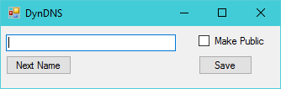
Choose [Next Name] to pick from a very long list of names ready to use, choose one from http://fantasynamegenerators.com/ and enter it, or make up your own name and press Save.
You can now be found on the map, or by friends, and be landmarked by that name + Outworldz.net. If you chose “Fairyland”, you would become this URL:
http://Fairyland.Outworldz.net
Outworldz software already supports IP addresses, DNS name, or noip.com or other Dynamic DNS names, so if you are running a DynDNS system can just type the name in and it will work as expected.

