REACT is new
React is an open-source JavaScript library for building user interfaces, especially for dynamic and responsive single-page applications. It uses a component-based architecture, a virtual DOM for performance optimizat ion, and JSX for declarative syntax. React's one-way data binding simplifies state management, making it widely adopted in web development for its flexibility and efficiency. It is often used with tools like Redux, React Router, Webpack, and Babel

In React, reconciliation and diffing are two crucial processes that help efficiently update the user interface in response to changes in state or props. Let's delve into these concepts:

### Reconciliation Algorithm:

Reconciliation is the process by which React updates the virtual DOM to match the new state or props. The goal is to minimize the number of changes and updates to the actual DOM, making the rendering process more efficient.

React uses a diffing algorithm during the reconciliation process to determine the most efficient way to update the DOM. The primary reconciliation algorithm is based on a tree-diffing strategy, which involves comparing the new virtual DOM tree with the previous one.

### Diffing Algorithm:

1. **Tree Diffing:**
- React compares the new virtual DOM tree with the previous one by recursively traversing both trees.
- It identifies the differences between the two trees.

2. **Component Diffing:**
- React uses heuristics to determine whether it should update a subtree of components or skip it.
- If the type of a component at a certain level has changed, React unmounts the old component and mounts the new one.

3. **Element Diffing:**
- React identifies changes at the element level and determines whether an element should be updated, replaced, or removed.
- It uses keys to track which elements have changed, been added, or been removed.

4. **Keyed vs. Non-Keyed Lists:**
- When rendering lists, providing stable keys to elements helps React efficiently update the DOM.
- For keyed lists, React can reorder elements without recreating them, minimizing DOM manipulations.
- For non-keyed lists, React might have to recreate elements to ensure the correct order.

5. **Updating the DOM:**
- After identifying the differences, React generates a minimal set of changes to update the actual DOM.
- This set of changes is then applied to the DOM using the least amount of manipulation.

By using these diffing and reconciliation strategies, React optimizes the update process, ensuring that only the necessary changes are made to the DOM, leading to better performance.

Understanding these concepts is crucial for React developers to write efficient and responsive applications. It's worth noting that React continues to evolve, and improvements in the reconciliation process may be introduced in future versions.

Component
-Components are independent and reusable bits of code. They serve the same
purpose as JavaScript functions, but work in isolation and return Html
Components come in two types, Class components and Function component
Application
Header
• Body (Content)
• Sidebar

- Create react -app

Npx create-react-app my-app then-> npm start

Folder structure or file structure

public: This directory contains static assets that don't need to go through the build process. The index.html file in this directory is the main HTML file where the React app is mounted. Other assets like images, icons, or manifest files can also be placed here.
src: This is the main source code directory where the React application code resides.
- assets: This directory typically contains static assets like images, fonts, and global styles.
- components: Reusable React components that are used throughout the application. Each component is often organized into its own directory, which includes the component's JavaScript file, CSS file, and other related files.
- pages: Higher-level components that represent different pages or views in your application. Pages may be composed of multiple components.
- App.js: The main component that represents the root of your application. It may include the main layout, routes, and other global configurations.
- index.js: The entry point of the application, where the React app is initialized and the main component is rendered into the DOM.
node_modules: This directory contains the dependencies and libraries required for the project. It is created and managed by npm.
package.json and package-lock.json: These files contain metadata about the project and its dependencies. They are used by npm to manage the project's packages.
.gitignore: This file specifies files and directories that should be ignored by version control systems like Git.
README.md: A documentation file that provides information about the project, how to run it, and any other relevant details.

What is JSX?
JSX stands for JavaScript XML or Extension.
With the help of JSX we can write and add HTML in React.
JSX converts HTML tags into React element.
It's not compulsory to use JSX.
Rules of Writing JSX
Himl code must wrap into one top level element.
Elements must be closed.
Attribute class = className
No if else condition inside jsx but ternary operator is okay.
JS expression in JSX must be wrapped in 0).
Certainly! Here are the key rules for working with JSX in React, summarized:

1. **Wrap in Parentheses:**
Wrap JSX expressions spanning multiple lines in parentheses.

2. **Single Root Element:**
JSX expressions must have a single root element. Use an array or a fragment for multiple elements.

3. **Curly Braces for Expressions:**
Embed JavaScript expressions within JSX using curly braces.

4. **HTML Attributes vs. React Props:**
Use `className` for CSS classes and `htmlFor` instead of `for` in JSX attributes.

5. **Self-Closing Tags:**
Use self-closing tags for elements without children.

6. **Comments in JSX:**
Use curly braces and `/* */` syntax for comments within JSX.
7. **JavaScript Objects for Styles:**
Apply inline styles using JavaScript objects in camelCase.
Remember, JSX is a convenient syntax for React but is not required. It gets transpiled into JavaScript for browser compatibility.

Props in React Js

In React, "props" (short for properties) are a mechanism for passing data from a parent component to a child component. Props are a way to customize or configure child components with specific values or functionalities. They allow for dynamic and flexible rendering of components based on the data they receive
Props are just like a function of js

// ParentComponent.js
import React from 'react';
import ChildComponent from './ChildComponent';

const ParentComponent = () => {
return <ChildComponent name="John" age={25} />;
};

// ChildComponent.js
import React from 'react';

const ChildComponent = (props) => {
return (
<div>
<p>Name: {props.name}</p>
<p>Age: {props.age}</p>
</div>
);
};

export default ChildComponent;

State in react js

In React, "state" is a built-in object that represents the internal mutable state of a component. Unlike props, which are passed from a parent to a child component, state is managed within a component and can be updated over time. State is used to keep track of dynamic data and trigger re-rendering of the component when the state changes
  - State is like a memory for a React component. It's a JavaScript object that holds data and determines how the component renders.
- Setting Up State:
  - You initialize state in a component using this.state (for class components) or useState hook (for functional components).
In React, a "hook" is a special function that allows functional components to have state and use lifecycle features that were previously only available in class components. React Hooks were introduced in React version 16.8 to provide a more concise and readable way to manage state and side effects in functional components.

Here are some common React Hooks:

1. **useState:**
- `useState` allows functional components to manage state. It returns an array with two elements: the current state value and a function to update that value.

```jsx
import React, { useState } from 'react';
const Counter = () => {
const [count, setCount] = useState(0);
return (
<div>
<p>Count: {count}</p>
<button onClick={() => setCount(count + 1)}>Increment</button>
</div>
);
};
```

2. **useEffect:**
- `useEffect` enables functional components to perform side effects (like data fetching or subscriptions) after the component renders.
```jsx
import React, { useState, useEffect } from 'react';
const DataFetcher = () => {
const [data, setData] = useState(null);
useEffect(() => {
// Perform data fetching here
fetchData().then((result) => setData(result));
}, []); // The empty dependency array means it only runs once after initial render
return <div>Data: {data}</div>;
};
```
3. **useContext:**
- `useContext` allows functional components to subscribe to React context without introducing a nested component.

```jsx
import React, { useContext } from 'react';
import MyContext from './MyContext';

const MyComponent = () => {
const contextValue = useContext(MyContext);

return <div>{contextValue}</div>;
};
```

4. **useReducer:**
- `useReducer` is a hook for managing more complex state logic. It is often used as an alternative to `useState` when the state logic is more complex.

```jsx
import React, { useReducer } from 'react';

const initialState = { count: 0 };

const reducer = (state, action) => {
switch (action.type) {
case 'increment':
return { count: state.count + 1 };
default:
return state;
}
};

const Counter = () => {
const [state, dispatch] = useReducer(reducer, initialState);

return (
<div>
<p>Count: {state.count}</p>
<button onClick={() => dispatch({ type: 'increment' })}>Increment</button>
</div>
);
};
```

5. **useMemo and useCallback:**
- `useMemo` and `useCallback` are used to memoize values and functions to avoid unnecessary recalculations or re-rendering.

```jsx
import React, { useMemo, useCallback } from 'react';

const MyComponent = ({ data }) => {
const memoizedValue = useMemo(() => calculateValue(data), [data]);

const handleClick = useCallback(() => {
// handle click
}, []); // Empty dependency array means the function won't change and is memoized

return (
<div>
<p>Memoized Value: {memoizedValue}</p>
<button onClick={handleClick}>Click me</button>
</div>
);
};
```
React Hooks have greatly simplified state management and side effect handling in functional components, making them a powerful and concise alternative to class components. They provide a more consistent way to manage state and side effects across different components.

The useRef hook in React provides a way to create mutable object properties that persist across renders. Unlike useState, changes to a ref object do not trigger a re-render. useRef is commonly used to access and interact with the DOM, manage focus, or persist values between renders without causing re-renders.

import React, { useRef, useState } from 'react';

const MyComponent = () => {
const inputRef = useRef(null);
const [value, setValue] = useState('');

const handleButtonClick = () => {
// Accessing and modifying the input value without triggering a re-render
setValue(inputRef.current.value);
};

return (
<div>
<input ref={inputRef} type="text" />
<button onClick={handleButtonClick}>Get Input Value</button>
<p>Input Value: {value}</p>
</div>
);
};

export default MyComponent;

Props drilling, also known as prop threading or prop passing, refers to the process of passing down props (properties) through multiple layers of nested components in a React application. It occurs when a piece of data needs to be transferred from a higher-level component to a lower-level component in the component tree. While this pattern is common, it can lead to code that is harder to maintain and understand as the application grows.

Challenges with Props Drilling:
- Maintainability:
  - As the application grows, passing props through many intermediate components can become cumbersome and make the code harder to maintain.
- Code Clutter:
  - Components in the middle of the hierarchy may not use the passed props but are required to pass them down, leading to unnecessary code clutter.
- Understanding Component Isolation:
  - The deeply nested components might become less isolated as they depend on data passed through components that don't necessarily use that data themselves.

Solutions:
- Context API:
  - React's Context API allows you to share values, such as state or functions, across the component tree without explicit prop drilling. It's suitable for sharing data that is needed by many components.
- Redux or Recoil (State Management Libraries):
  - State management libraries like Redux or Recoil can help manage global state, making it accessible to any component in the application without prop drilling.
- Higher-Order Components (HOCs):
  - HOCs can be used to wrap components and provide additional props without explicitly passing them through the hierarchy.
- Render Props:
  - The render props pattern involves passing a function as a prop to a component, which that component can then call to render content. This can be used to avoid unnecessary prop drilling.
App.js
To provide that data —>{
Const data=createContext();
Const name=”prince”;
<data.provider value{name}>
}

Export {data};

Child c{
Import data from “app.js”
Data.consumer{
(name)=>{
{name}
}
}
}
It can use only 1 function to return so there for it can create call hell or too complicated

Usecontext
The useContext hook is a part of the React Hooks API, and it allows functional components in a React application to consume values from a React context. useContext makes it easy to access the value provided by a Context.Provider higher up in the component tree without having to pass the value through multiple layers of props.

App.js
To provide that data —>{
Const data=createContext();
Const name=”prince”;
<data.provider value{name}>
}

Export {data,data1};
Const name=useContext(data)
Child c{
<h1>print {data} + {data1}
}

Usememo
The useMemo hook in React is used to memoize the result of a computation or the value of a function, preventing unnecessary recalculations and optimizing performance. It's particularly useful when dealing with computationally expensive operations or when you want to avoid re-rendering a component unless certain dependencies change.
Here's a simple guide on how to use useMemo:

When to Use useMemo:
- Expensive Calculations:
  - Use useMemo when dealing with functions or calculations that are computationally expensive.
- Preventing Unnecessary Renders:
  - Use useMemo to avoid unnecessary re-renders of components when the result of a computation remains the same.
- Optimizing Performance:
  - Consider useMemo in scenarios where performance optimizations are crucial, especially in large or complex applications.

Notes:
- Not Always Necessary:
  - While useMemo can improve performance, it's essential to profile and measure before adding optimizations, as not all computations are necessarily expensive enough to warrant memoization.
- Use Wisely:
  - Use useMemo judiciously, as memoization comes with a trade-off. It adds complexity to the code, and memoizing small or fast computations might not be beneficial.
useMemo is a valuable tool for optimizing React applications by selectively memoizing values and preventing unnecessary recalculations, contributing to improved performance

Usecallback
The useCallback hook in React is used to memoize functions, preventing unnecessary re-creation of the function on each render. This can be particularly useful in scenarios where a function is a dependency for other hooks, preventing those hooks from being called unnecessarily when the function reference changes.

Controlled and uncontrolled components are terms often used in the context of form elements in React. They refer to how the state of a form element is managed and updated.

### Controlled Components:

In a controlled component, the form element's value is controlled by React state. This means that the React component has full control over the form element's value and updates it through state.

Here's an example of a controlled component:

```jsx
import React, { useState } from 'react';

const ControlledComponent = () => {
const [inputValue, setInputValue] = useState('');

const handleInputChange = (e) => {
setInputValue(e.target.value);
};

return (
<input
type="text"
value={inputValue}
onChange={handleInputChange}
/>
);
};
```

In this example, the input element's value is controlled by the `inputValue` state. The `handleInputChange` function updates the state with the new value whenever the input changes.

### Uncontrolled Components:

In an uncontrolled component, the form element's value is not controlled by React state. Instead, the form element holds its own state.

Here's an example of an uncontrolled component:

```jsx
import React, { useRef } from 'react';

const UncontrolledComponent = () => {
const inputRef = useRef(null);

const handleButtonClick = () => {
// Access the current value of the input directly
console.log('Input Value:', inputRef.current.value);
};

return (
<div>
<input type="text" ref={inputRef} />
<button onClick={handleButtonClick}>Get Input Value</button>
</div>
);
};
```

In this example, the input element's value is not controlled by React state. Instead, it is accessed directly using the `inputRef.current.value` when needed. The state of the input is managed by the DOM.

### When to Use Controlled vs. Uncontrolled:

- **Controlled Components:**
- Useful when you need to perform actions or validations on the input value.
- Ideal for forms where the input values need to be synchronized with other parts of the component state.

- **Uncontrolled Components:**
- Can be simpler and more straightforward for simple forms or scenarios where you don't need to track the input value in the component state.
- Useful in situations where you want to work more closely with the DOM or integrate with non-React code.

### Pros and Cons:

- **Controlled Components:**
- **Pros:**
- Full control over the input values.
- Easier to implement validations and modifications.
- **Cons:**
- More code and state management.

- **Uncontrolled Components:**
- **Pros:**
- Simpler and less code.
- Can be useful for integrating with non-React code.
- **Cons:**
- Limited control over input values.
- Harder to implement certain features.

The choice between controlled and uncontrolled components depends on the specific requirements of your application and the level of control you need over the form elements. In many cases, controlled components are preferred for their predictability and ease of integration with React's state management.

In React, a "list" typically refers to rendering a collection of items dynamically. The most common way to achieve this is by using the `map` function to iterate over an array and create React elements for each item. Here's a simple example:

```jsx
import React from 'react';

const MyList = () => {
// Sample array of items
const items = ['Item 1', 'Item 2', 'Item 3'];

return (
<ul>
{items.map((item, index) => (
<li key={index}>{item}</li>
))}
</ul>
);
};

export default MyList;
```

Key Note: When rendering a list in React, it's important to provide a unique `key` prop to each element to help React efficiently update and re-render the components when the list changes.

If your list items have a unique identifier, it's recommended to use that identifier as the `key`. For example:

```jsx
const MyList = () => {
const items = [
{ id: 1, text: 'Item 1' },
{ id: 2, text: 'Item 2' },
{ id: 3, text: 'Item 3' },
];

return (
<ul>
{items.map((item) => (
<li key={item.id}>{item.text}</li>
))}
</ul>
);
};
```

This approach helps React efficiently update the DOM when items are added, removed, or reordered within the list.

In React, you can use the `useState` hook to manage state in functional components. If you want to manage an object as state, you can pass an object as the initial state to `useState`. Additionally, when updating the state, you need to make sure to handle immutability, especially when dealing with objects. Here's an example of using `useState` with an object in React:

```jsx
import React, { useState } from 'react';

const MyComponent = () => {
// Using useState with an object
const [myObject, setMyObject] = useState({
key1: 'value1',
key2: 'value2',
key3: 'value3',
});

// Function to update a specific property of the object
const updateValue = () => {
// Use the spread operator to create a new object with the updated value
setMyObject((prevObject) => ({
...prevObject,
key2: 'newUpdatedValue',
}));
};

return (
<div>
<p>{myObject.key1}</p>
<p>{myObject.key2}</p>
<p>{myObject.key3}</p>

<button onClick={updateValue}>Update Value</button>
</div>
);
};

export default MyComponent;
```

In this example:

- We initialize the state using `useState` with an object containing three key-value pairs.
- We display the values of the object in the JSX.
- We have a button that, when clicked, calls the `updateValue` function, which uses the spread operator (`...`) to create a new object with the updated value for `key2`.

Remember to handle immutability properly when updating the state of an object to ensure that React triggers re-renders appropriately.

Custom Hooks
In React, custom hooks are functions that allow you to extract and reuse stateful logic from components. Custom hooks are a way to share logic between components without using higher-order components or render props.
It’s always starts from use

Here's an example of how you can create a custom hook in React:

```jsx
import { useState, useEffect } from 'react';

// Custom hook for fetching data
function useDataFetcher(url) {
const [data, setData] = useState(null);
const [loading, setLoading] = useState(true);
const [error, setError] = useState(null);

useEffect(() => {
const fetchData = async () => {
try {
const response = await fetch(url);
const result = await response.json();
setData(result);
} catch (error) {
setError(error);
} finally {
setLoading(false);
}
};

fetchData();
}, [url]);

return { data, loading, error };
}

// Example usage of the custom hook
function MyComponent() {
const apiUrl = 'https://api.example.com/data';
const { data, loading, error } = useDataFetcher(apiUrl);

if (loading) {
return <p>Loading...</p>;
}

if (error) {
return <p>Error: {error.message}</p>;
}

// Render component with the fetched data
return (
<div>
<h1>Data:</h1>
<pre>{JSON.stringify(data, null, 2)}</pre>
</div>
);
}
```

In this example, the `useDataFetcher` custom hook encapsulates the logic for fetching data from an API using the `fetch` function. The hook returns an object with `data`, `loading`, and `error` state variables, which can be used in the component that uses this custom hook.

When creating custom hooks, it's a convention to prefix the hook name with "use" to make it clear that it's a hook and to leverage the hook-related rules in the eslint-plugin-react-hooks package.

Axios

Axios is a popular JavaScript library for making HTTP requests. It is often used in React applications to interact with APIs and fetch data. To use Axios in a React component, you'll need to install it first using a package manager like npm or yarn. Here's an example of how you can use Axios in a React component:

Certainly! Axios supports various HTTP methods such as GET, POST, PUT, PATCH, and DELETE. Here's an example of how you can use Axios for editing, updating, and deleting data in a React component:

### Editing (GET request):

```jsx
import React, { useState, useEffect } from 'react';
import axios from 'axios';

function EditComponent({ match }) {
const [data, setData] = useState(null);
const [loading, setLoading] = useState(true);
const [error, setError] = useState(null);

useEffect(() => {
const fetchData = async () => {
try {
const response = await axios.get(`https://api.example.com/data/${match.params.id}`);
setData(response.data);
} catch (error) {
setError(error);
} finally {
setLoading(false);
}
};

fetchData();
}, [match.params.id]);

if (loading) {
return <p>Loading...</p>;
}

if (error) {
return <p>Error: {error.message}</p>;
}

// Render component with the fetched data for editing
return (
<div>
<h1>Edit Data:</h1>
<pre>{JSON.stringify(data, null, 2)}</pre>
{/* Add your form for editing here */}
</div>
);
}

export default EditComponent;
```

### Updating (PUT request):

```jsx
import React, { useState, useEffect } from 'react';
import axios from 'axios';

function UpdateComponent({ match }) {
const [data, setData] = useState(null);
const [loading, setLoading] = useState(true);
const [error, setError] = useState(null);

useEffect(() => {
const fetchData = async () => {
try {
const response = await axios.get(`https://api.example.com/data/${match.params.id}`);
setData(response.data);
} catch (error) {
setError(error);
} finally {
setLoading(false);
}
};

fetchData();
}, [match.params.id]);

const handleUpdate = async () => {
try {
const response = await axios.put(`https://api.example.com/data/${match.params.id}`, updatedData);
setData(response.data);
} catch (error) {
setError(error);
}
};

if (loading) {
return <p>Loading...</p>;
}

if (error) {
return <p>Error: {error.message}</p>;
}

// Render component with the fetched data and form for updating
return (
<div>
<h1>Update Data:</h1>
<pre>{JSON.stringify(data, null, 2)}</pre>
{/* Add your form for updating here */}
<button onClick={handleUpdate}>Update Data</button>
</div>
);
}

export default UpdateComponent;
```

### Deleting (DELETE request):

```jsx
import React, { useState, useEffect } from 'react';
import axios from 'axios';

function DeleteComponent({ match, history }) {
const [data, setData] = useState(null);
const [loading, setLoading] = useState(true);
const [error, setError] = useState(null);

useEffect(() => {
const fetchData = async () => {
try {
const response = await axios.get(`https://api.example.com/data/${match.params.id}`);
setData(response.data);
} catch (error) {
setError(error);
} finally {
setLoading(false);
}
};

fetchData();
}, [match.params.id]);

const handleDelete = async () => {
try {
await axios.delete(`https://api.example.com/data/${match.params.id}`);
history.push('/'); // Redirect to the home page or another appropriate page after deletion
} catch (error) {
setError(error);
}
};

if (loading) {
return <p>Loading...</p>;
}

if (error) {
return <p>Error: {error.message}</p>;
}

// Render component with the fetched data and button for deletion
return (
<div>
<h1>Delete Data:</h1>
<pre>{JSON.stringify(data, null, 2)}</pre>
<button onClick={handleDelete}>Delete Data</button>
</div>
);
}

export default DeleteComponent;
```

Make sure to handle the data and error states appropriately, and adapt the code to fit your specific requirements and API endpoints. Additionally, you may want to add error handling for user inputs in the update and delete components.

Some questions
- Webpack Dev Server: It's a development server that comes with Webpack, providing features like Hot Module Replacement and live reloading. The default port is 8080.
- React with Angular: While technically possible, it's generally not recommended to mix React and Angular in the same project due to differences in their architecture and best practices. It's better to use them independently or consider alternative approaches like separate applications or micro-frontends

React Router is a popular library for handling routing in React applications. It enables the navigation and rendering of different components based on the URL of the application. React Router provides a declarative way to define and manage routes in a React application.

Key components of React Router:

1. **`BrowserRouter`:** A router that uses the HTML5 history API for navigation. It provides a cleaner URL structure without the hash (#).

```jsx
import { BrowserRouter as Router } from 'react-router-dom';
```

2. **`Route`:** A component that renders UI when the path matches the current URL.

```jsx
import { Route } from 'react-router-dom';

// Example: Render Home component when the path is "/"
<Route path="/" component={Home} />
```

3. **`Switch`:** Renders the first child `Route` or `Redirect` that matches the current location. It helps to avoid rendering multiple components for the same URL.

```jsx
import { Switch, Route } from 'react-router-dom';

<Switch>
<Route path="/" component={Home} />
<Route path="/about" component={About} />
</Switch>
```

4. **`Link`:** A component for navigation that renders an anchor (`<a>`) element. It ensures the application doesn't do a full page reload when navigating between routes.

```jsx
import { Link } from 'react-router-dom';

<Link to="/about">About</Link>
```

5. **`NavLink`:** Similar to `Link`, but allows styling based on whether the link is active.

```jsx
import { NavLink } from 'react-router-dom';

<NavLink to="/about" activeClassName="active">About</NavLink>
```

React Router makes it easy to create a single-page application with dynamic navigation and views. It's commonly used in React projects to handle client-side routing and improve the user experience.

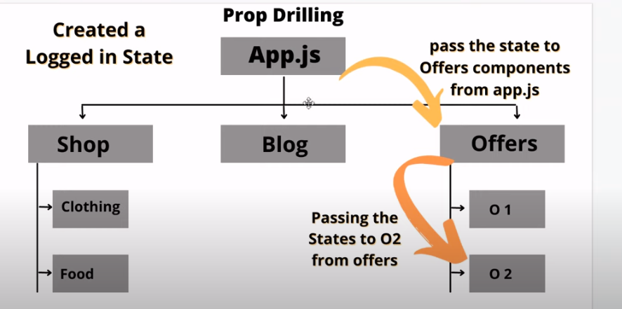

CSS Modules is a popular approach for styling React components. It allows you to write modular and scoped styles for your components, preventing style conflicts in large applications. Here's a basic example of using CSS Modules with React:

React Redux is a library that serves as the official binding for using Redux with React applications. Redux is a state management library for JavaScript applications, and when combined with React, it provides a powerful and predictable state management solution.

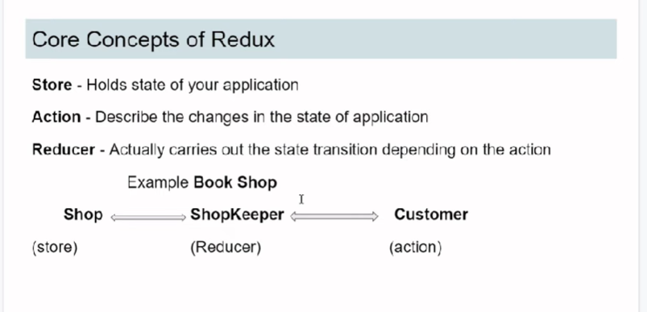

In Redux, the key concepts are Store, Actions, and Reducers. Here's a brief overview of each:

### 1. **Store:**
- **Definition:** The store in Redux is a single source of truth that holds the entire state tree of your application.
- **Responsibility:** It manages the state, allows access to the state, and enables the state to be updated.
- **Creation:** You create the store using the `createStore` function from the Redux library, passing in a root reducer.

```javascript
import { createStore } from 'redux';
import rootReducer from './reducers';

const store = createStore(rootReducer);
```

### 2. **Action:**
- **Definition:** Actions are plain JavaScript objects that represent an intention to change the state.
- **Structure:** An action typically has a `type` property, indicating the type of action, and additional properties containing data associated with the action.

```javascript
// Example action
const incrementAction = {
type: 'INCREMENT',
payload: 1, // Optional data associated with the action
};
```

### 3. **Reducer:**
- **Definition:** Reducers are pure functions that take the current state and an action as arguments and return a new state.
- **Responsibility:** They specify how the state changes in response to actions. Each reducer handles a specific part of the application state.
- **Structure:** Reducers should not modify the existing state but return a new state based on the action type.

```javascript
// Example reducer
const counterReducer = (state = 0, action) => {
switch (action.type) {
case 'INCREMENT':
return state + action.payload;
case 'DECREMENT':
return state - action.payload;
default:
return state;
}
};
```

### Putting it All Together:

1. **Create the Store:**
```javascript
import { createStore } from 'redux';
import rootReducer from './reducers';

const store = createStore(rootReducer);
```

2. **Define Actions:**
```javascript
// Example actions
const incrementAction = { type: 'INCREMENT', payload: 1 };
const decrementAction = { type: 'DECREMENT', payload: 1 };
```

3. **Create Reducers:**
```javascript
// Example reducers
const counterReducer = (state = 0, action) => {
switch (action.type) {
case 'INCREMENT':
return state + action.payload;
case 'DECREMENT':
return state - action.payload;
default:
return state;
}
};
```

4. **Dispatch Actions to Update the Store:**
```javascript
// Dispatch actions to update the store
store.dispatch(incrementAction);
store.dispatch(decrementAction);
```

5. **Access State:**
```javascript
// Access the current state from the store
const currentState = store.getState();
```

In summary, the Redux Store is a centralized container for the state of your application. Actions are dispatched to describe changes, and Reducers specify how the state should change in response to those actions. The Store, Actions, and Reducers work together to manage the state of your application in a predictable and scalable way.

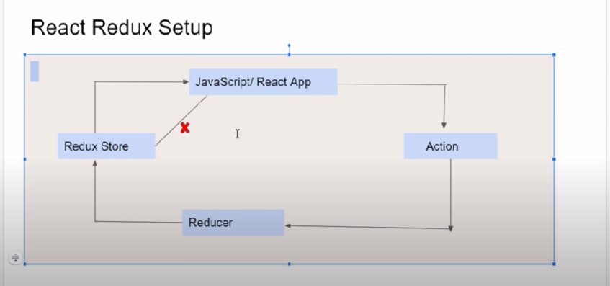

Redux
