Department of Information Technology
Central University of Kashmir
Tullamulla, Ganderbal

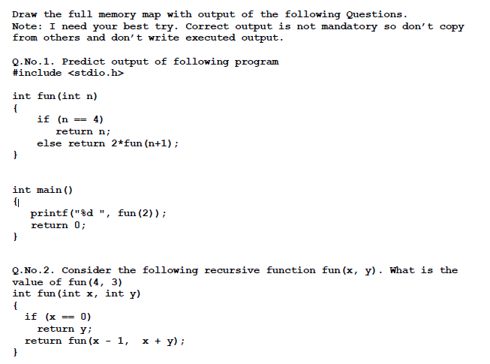
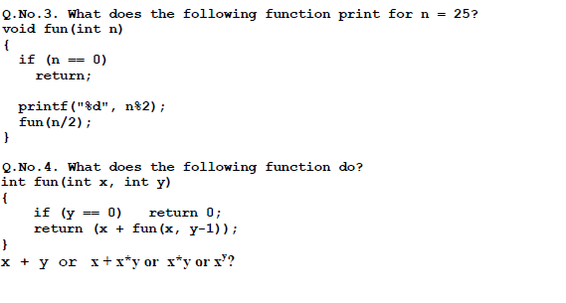
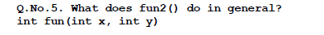
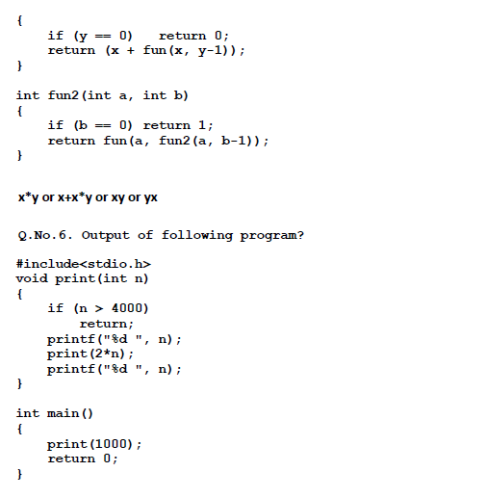
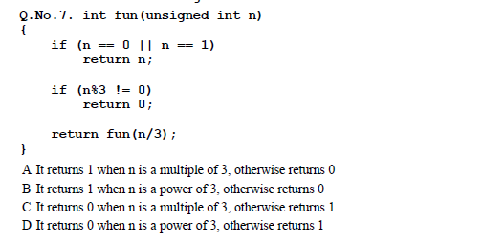
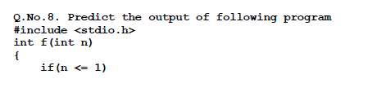
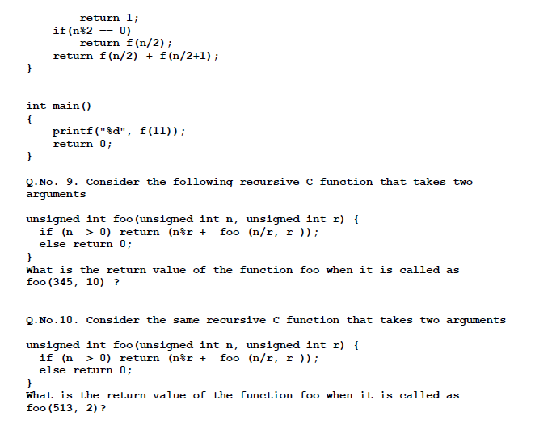
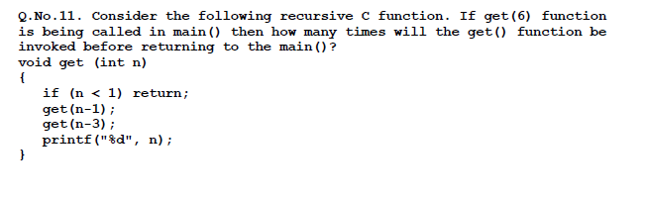
Q.No.12. Write a recursive program which find the sum of N natural numbers
Q.No.13. Write a recursive program to find the decimal equivalent of binary number.
Q.No.14. Write a recursive program to find the power of any number, where number and power are +ve and entered by the user.
Q.No.15. Write a recursive program to print up until nth Fibonacci term.
Q.No.16. Explain the output of following program using stack and Tree for n=4.
#include<stdio.h>
void fun(int);
main()
{
int n;
printf("Enter the number\n");
scanf("%d",&n);
fun(n);
printf("\nwe are back in main()");
}
void fun(int n)
{
if(n>0)
{
printf("%d\n",n);
fun(n-1);
printf("\nwe are in f(%d)",n);
}
}
Q.No.17.Explain the output of following program using stack and Tree for n=4.
#include<stdio.h>
void fun(int);
main()
{
int n;
printf("Enter the number\n");
scanf("%d",&n);
fun(n);
}
void fun(int n)
{
if(n>0)
{
printf("%d\n",n);
fun(n-1);
printf("%d\n",n);
}
}
Q.No.18.Explain the output of following program using stack and Tree for n=4.
#include<stdio.h>
void fun(int);
main()
{
int n;
printf("Enter the number\n");
scanf("%d",&n);
fun(n);
}
void fun(int n)
{
if(n>0)
{
fun(n-1);
printf("%d\n",n);
fun(n-1);
}
}

