1. 以root用户登录
2. 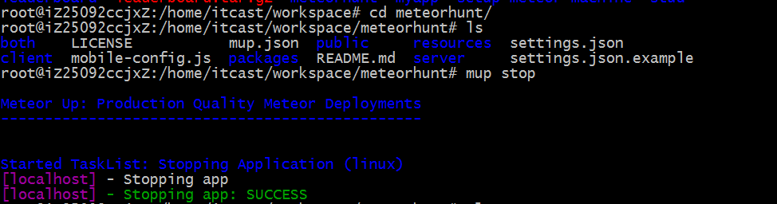

如果服务器上涉及到多项目的部署的测试应该进入到已经部署的项目中,停止部署.

如果不停止已部署的项目,后续无法进行.

1. 上传项目到workspace中
2. Cd workspace
3. 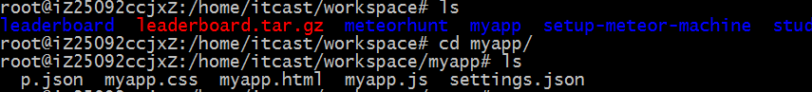
4. 对项目进行初始化,会生成mup.json,setting.json

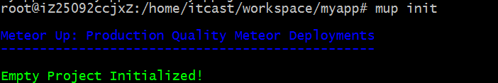

1. 修改mup.json的文件的设置

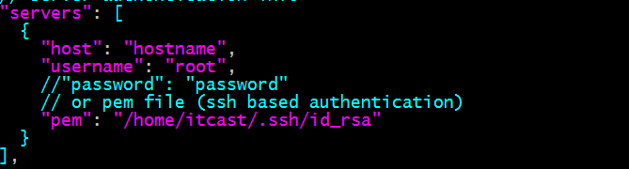

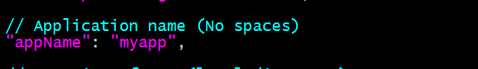

将appName的名字设置为项目的名字

除了这一点其余基本不用修改的部署到itcastcpp

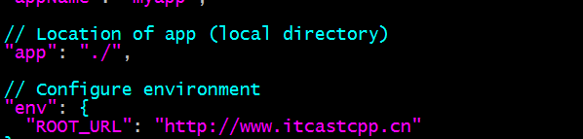

1. root@iZ25092ccjxZ:/home/itcast/workspace/meteorhunt# mup setup

Meteor Up: Production Quality Meteor Deployments

------------------------------------------------

“ Checkout Kadira!

It's the best way to monitor performance of your app.

Visit: https://kadira.io/mup ”

Started TaskList: Setup (linux)

[localhost] - Installing Node.js

[localhost] - Installing Node.js: SUCCESS

[localhost] - Installing PhantomJS

[localhost] - Installing PhantomJS: SUCCESS

[localhost] - Setting up Environment

[localhost] - Setting up Environment: SUCCESS

[localhost] - Copying MongoDB configuration

[localhost] - Copying MongoDB configuration: SUCCESS

[localhost] - Installing MongoDB

[localhost] - Installing MongoDB: SUCCESS

[localhost] - Configuring upstart

[localhost] - Configuring upstart: SUCCESS

1. root@iZ25092ccjxZ:/home/itcast/workspace/meteorhunt# mup deploy

Meteor Up: Production Quality Meteor Deployments

------------------------------------------------

“ Checkout Kadira!

It's the best way to monitor performance of your app.

Visit: https://kadira.io/mup ”

Building Started: ./

The Android platform is not installed; skipping build for it.

The iOS platform is not installed; skipping build for it.

Started TaskList: Deploy app 'hunt' (linux)

[localhost] - Uploading bundle

[localhost] - Uploading bundle: SUCCESS

[localhost] - Setting up Environment Variables

[localhost] - Setting up Environment Variables: SUCCESS

[localhost] - Invoking deployment process

[localhost] - Invoking deployment process: SUCCESS