# Problem Identification and Statement

Design a software to control a system of traffic lights at an intersection. The software should simulate the behavior of traffic lights at an intersection.

Cycle length and traffic flow information must be read from a file. Every specific duration (say 24 hours), the data must be read from the file, the green timings should be updated based on the latest traffic condition, and the control should proceed with the updated green timings.

# Gathering Information

The system has the following components:

1. Traffic semaphores (signal lights): these are standard semaphores with three lights: red, yellow, and green.
2. Traffic sensors that are embedded in each lane near the intersection to record the traffic flow for all roads. The sensors save the traffic rate information into a file. The system is represented in the picture below:

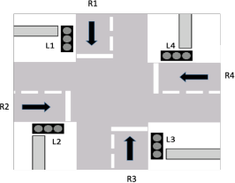

1. the four traffic lights are represented as L1, L2, L3, and L4. The system operates as follows:
   * Traffic light (L1) is green for a duration calculated based on the traffic flow rate in road R1, the other traffic lights (L2, L3, and L4) are red.
   * b. L1 becomes yellow for X seconds (X being a constant value). The Department of Transportation's traffic manual recommends that yellow lights are between 3 and 6 seconds long. Other traffic lights (L2, L3, and L4) remain in red state.
   * c. Then, traffic light L2 becomes green for a duration calculated based on the traffic flow rate in road R2. Meanwhile, L1, L3, and L4 are red.
   * d. Traffic light L2 becomes yellow for X seconds (X being a constant value). Other traffic lights (L1, L3, and L4) remain in red state.
   * e. Then, traffic light L3 becomes green for a duration calculated based on the traffic flow rate in road R3. Meanwhile, traffic lights L1, L2, and L4 are red.
   * f. Traffic light L3 becomes yellow for X seconds (X being a constant value). Other traffic lights (L1, L2, and L4) remain in red state.
   * g. Then, traffic light L4 becomes green for a duration calculated based on the traffic flow rate in road R4. Meanwhile, traffic lights L1, L2, and L3 are red.
   * h. Traffic light L4 becomes yellow for X seconds (X being a constant value). Other traffic lights (L1, L2, and L3) remain in red state.
   * i. The next cycle starts with traffic light L1 becoming green again, and so on.

The green timing for each traffic light is proportional to the traffic flow rate reported for the same road, according to the following equation:

𝑑𝑖

= 𝑄𝑖 × 𝐶

𝑄𝑇

Where 𝑑𝑖 is the green time for the ith traffic light, 𝑄𝑖 represents the traffic flow (number of vehicles per hour) crossing the ith traffic light, 𝑄𝑇 represents the total traffic flow passing through the intersection, and 𝐶 represents the cycle length in seconds.

I/O diagram

Input File name. (File should contain values of C Qt and Qi )

Program

Semaphores ID, state, greentime throughout simulation.

# Step 3: Test Cases and algorithm Test Cases:

The text document Traffic_Information was provided to our program. It contains Cycle Length, Total Traffic Flow, and Traffic Flow values for each trafficlight.

The document Traffic_Information was updated as shown in figure 2 after 60 seconds to test the function updateTiming()

Figure 1: Traffic information dataset 1

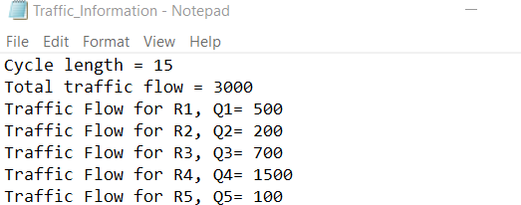

Figure 2: Traffic Information dataset 2



The value of green time for the first semaphore given dataset 1 can be obtained as follows

𝑑1 =

𝑞1

𝑞𝑡

𝐶 =

500

500 + 200 + 700 + 1500 + 100

= 2.5

Similarly, green time values for each semaphore can be calculated. Results are summarized in the table below.

Table 1:

|  |  |  |  |
| --- | --- | --- | --- |
| **SEMAPHORE NUMBER** | **TRAFFIC FLOW Q** | **GREEN TIME D** | **CONSTANTS** |
| **1** | 500 | 2.5 | Cycle Length C |
| **2** | 200 | 1 | 15 |
| **3** | 700 | 3.5 |  |
| **4** | 1500 | 7.5 | Total Traffic Flow Qt |
| **5** | 100 | 0.5 | 3000 |
| **1** | 800 | 5 | Cycle Length C |
| **2** | 200 | 1.25 | 20 |
| **3** | 100 | 0.625 |  |
| **4** | 1700 | 10.625 | Total Traffic Flow Qt |
| **5** | 400 | 2.5 | 3200 |

Expected time for one cycle of simulation given dataset 1 can be found as:

𝑡1 = 𝑑1 + 𝑑2 + 𝑑3 + 𝑑4 + 𝑑5 + 5𝑦𝑡 = 2.5 + 1 + 3.5 + 7.5 + 0.5 + 3 × 5 = 30𝑠

Where 𝑦𝑡 is time semaphore remains yellow: 𝑦𝑡 = 3𝑠

Similarly expected time for one cycle of simulation given dataset 2 can be found as:

𝑡1 = 𝑑1 + 𝑑2 + 𝑑3 + 𝑑4 + 𝑑5+5𝑦𝑡 = 5 + 1.25 + 0.625 + 10.625 + 2.5 + 3 × 5 = 35𝑠

Therefore,

To test run() the state and ID of semaphores are displayed on console three times a cycle for each semaphore. Values of state of semaphores during simulation should change from 3 to 2 to 1, ID values of semaphores should not change during the simulation. The simulation should not end (unless the user exits the program) to properly represent real life situation.

To test readTrafficData(), printLightInfo(), CalculateGreenTime(), UpdateTiming() values of C, Traffic Flow values, green time values will be printed on the console. These values must correspond to values in table 1.

To test AddLight() and getNumOfSemaphores(), 5 semaphores will be added to our Intersection and the number of Semaphores NumOfSemaphores will be printed. We expect NumOfSemaphores to be 5. To test droplight() we will remove one semaphore, we expect NumOfSemaphore to decrease by 1 from 5 to 4.

To test wait() we will make use of a timer. We will time each cycle of the simulation. The time of one cycle of simulation given dataset 1 is expected to be 30s; The time of one cycle of simulation given dataset 2 is expected to be 35s. Values of green time for each semaphore should be updated after 60 seconds

# Pseudocode

Define class TrafficLights Private members

ID as integer State as integer

Greentime as double

TLnumber as integer, global variable

Public members

TrafficLights()

Assign TLnumber to ID Increment TLnumber Assign 1 to state Assign 0 to greentime

getID()

return ID getState()

return state setState(color)

Assign color to state getGreentime()

return greentime setGreentime(GreenTime)

Assign GreenTime to greentime PrintLightInfo()

Print "ID = ", ID, newline

Print "state = ", state, newline

Print "greentime = ", greentime, newline getNumOfTrafficlights()

return TLnumber wait(number_seconds)

Assign clock() to startClock

Assign number_seconds*CLOCKS_PER_SEC to SecondsWaited

while clock() less than startClock + SecondsWaited return

Assign 0 to TLnumber Assign 3 to yellowtime

Assign 60 to updategreentime Assign 10 to tMAX

Define class Intersection Private members

Define trafficlights as array of TrafficLights, and maximum size tMAX Define CycleLength as double

Define TotalTrafficFlow as double

Define TrafficFlows as array of double and maximum size tMAX Define GreenTime as array of double and maximum size tMAX Define TLnumber as Integer

Public members

Intersection()

Assign 0 to TLnumber Assign 0 to CycleLength

Assign 0 to TotalTrafficFlow

For i=0, until i smaller than tMAX, increment i at each iteration

Assign 0 to TrafficFlows[i] Assign 0 to GreenTime[i]

AddLight(aLight as TrafficLights) { if TLnumber less than tMAX)

assign aLight to trafficlights[TLnumber] increment TLnumber

otherwise

Print "Can't add more traffic lights, full capacity", newline dropLight(TLightID as integer) {

Assign false to isFound

For i=0, until i smaller than tMAX, increment i at each iteration if TLightID equals return value when trafficlights[i] calls getID()

Print "The trafficlight to be removed is found", newline

for j = i; j smaller TLnumber; increment j at each iteration

Assign trafficlights[j + 1] to trafficlights[j]

Decrement TLnumber Assign true to isFound

if isFound is negated

Print "Can't find the traffic light to drop" , newline

getNumOfSemaphores()

return TLnumber;

ReadTrafficData()

Define infile as buffer

Infile opens "Traffic_Information.txt" as input file if infile does not open file correctly

Print "error in opening file" Terminate Program and return (-1)

Define trash as string

Store words from infile, into trash, all the words until sign = Assign input value from infile to CycleLength

Print "CycleLength = ", CycleLength, newline

Store words from infile, into trash, all the words until sign = Assign input value from infile to TotalTrafficFlow

Print "TotalTrafficFlow = ",TotalTrafficFlow, newline

for i = 0, i less than TLnumber, increment i at each iteration if infile reaches the end of file

exit loop

Store words from infile, into trash, all the words until sign

=

Assign input value from infile to TrafficFlows[i];

Print "traffic Flow for semaphore", I, " = ", TrafficFlows[i], newline

Infile closes input text file

CalculateGreenTime()

for i = 0, i less than TLnumber, increment i at each iteration Assign (TrafficFlows[i]) * (CycleLength / TotalTrafficFlow) to greentime

Assign greentime to GreenTime[i]

Print "Computed Green Time for semaphore ", i, " = " greentime," s", newline

trafficlights[i] calls setGreentime(GreenTime[i]);

Print "Updated Green Time for semaphore ",i," is now set to = ", trafficlights[i] calls getGreentime(), newline

Print "Updated information of semaphore ", I," as follows:

“,newline

trafficlights[i] calls PrintLightInfo(); Print newline

run()

Assign 0 to TimeSimulation

Print "Simulation starts", newline, newline for 1 equals 1

Assign 0 to start Assign 0 to endCycle

Assign 0 to TimeOneCycle Assign clock() to start

for i = 0, i less than TLnumber, increment i at each iteration Print "Cycle of Semaphore " i, newline, newline trafficlights[i] calls setState(1);

trafficlights[i] calls setState(3);

if return value when trafficlights[i] calls getState() does not equal 3

Continue to next iteration of loop Otherwise

trafficlights[i] calls PrintLightInfo(); trafficlights[i] calls wait(result of trafficlights[i]

calls getGreentime());

trafficlights[i] calls setState(2); trafficlights[i] calls PrintLightInfo(); trafficlights[i] calls wait(yellowtime); trafficlights[i] calls setState(1); trafficlights[i] calls PrintLightInfo();

Print newline Assign clock() to endCycle

Assign endCycle – start to TimeOneCycle

Assign TimeSimulation + TimeOneCycle to TimeSimulation

if TimeSimulation greater than updategreentime x CLOCKS_PER_SEC call UpdateTiming();

Assign 0 to TimeSimulation = 0;

void UpdateTiming()

call ReadTrafficData() call CalculateGreenTime();

Main function

main() returns an integer value

Define Semaphore1, Semaphore2, Semaphore3, Semaphore4, Semaphore5 as TrafficLights Define WashingtonRoad3 as Intersection

WashingtonRoad3 calls AddLight(), giving Semaphore1 as parameter WashingtonRoad3 calls AddLight(), giving Semaphore2 as parameter WashingtonRoad3 calls AddLight(), giving Semaphore3 as parameter WashingtonRoad3 calls AddLight(), giving Semaphore4 as parameter WashingtonRoad3 calls AddLight(), giving Semaphore5 as parameter

Print "number of Semaphores = ", WashingtonRoad3 calls getNumOfSemaphores(), newline

WashingtonRoad3 calls ReadTrafficData(); WashingtonRoad3 calls CalculateGreenTime(); for 1 equals 1 then

WashingtonRoad3 calls run() return 0

Code or implementation

The code is presented in the documents attached: Trotolo_Assignment4.cpp, TrafficLight.h, Intersection.h

# Test and Verification

Figure 1: readTrafficData(); printLightInfo(); CalculateGreenTime(); are tested. Since values of ID,state, Cycle Length, Traffic flow values, green time values correspond to values in table 1 the functions are working correctly. AddLight() and getNumOfSemaphores() are also working since number of semaphore in intersection is 5, and public functions of TrafficLight class are working (which implies semaphores are correctly added to the intersection)

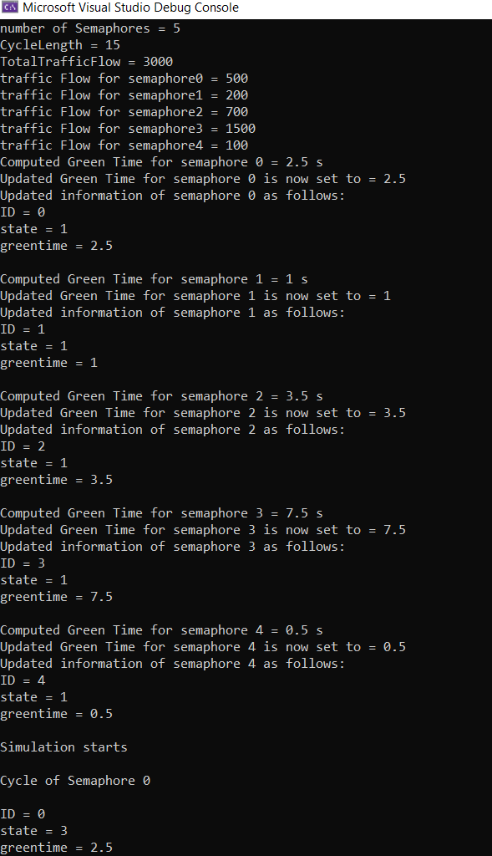

Figures 2 to 5: run() function is tested. Notice that values of state for each semaphore vary as predicted

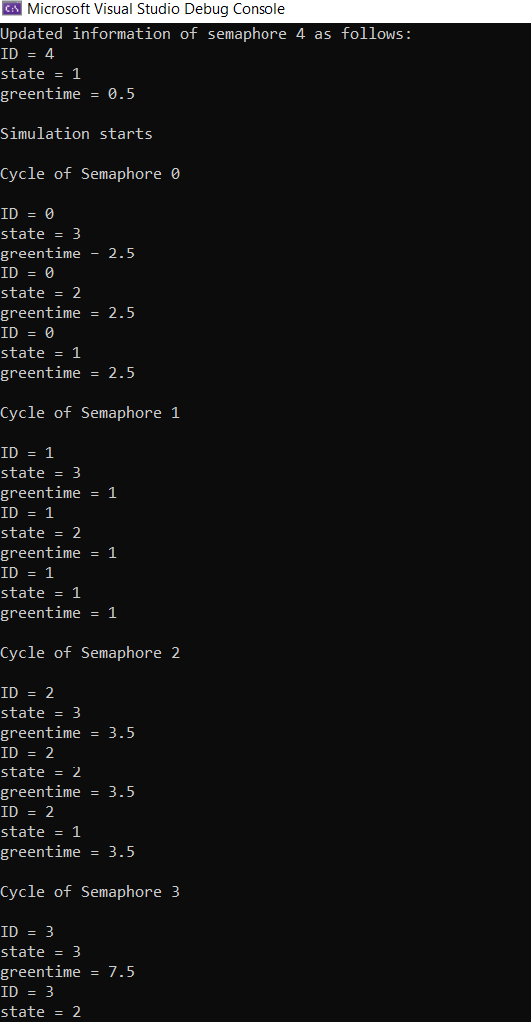

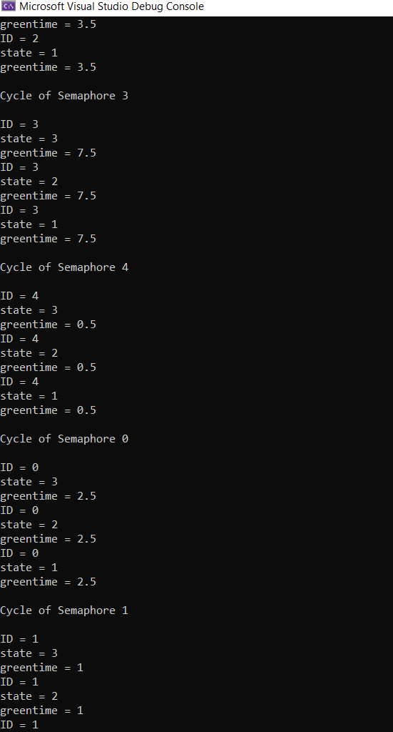

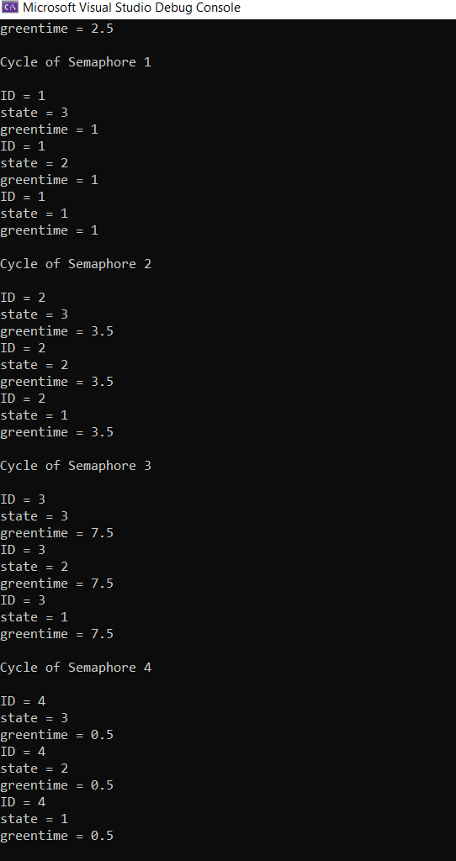

Figure 6: UpdateTiming() is tested. Values of green time of semaphores are updated.

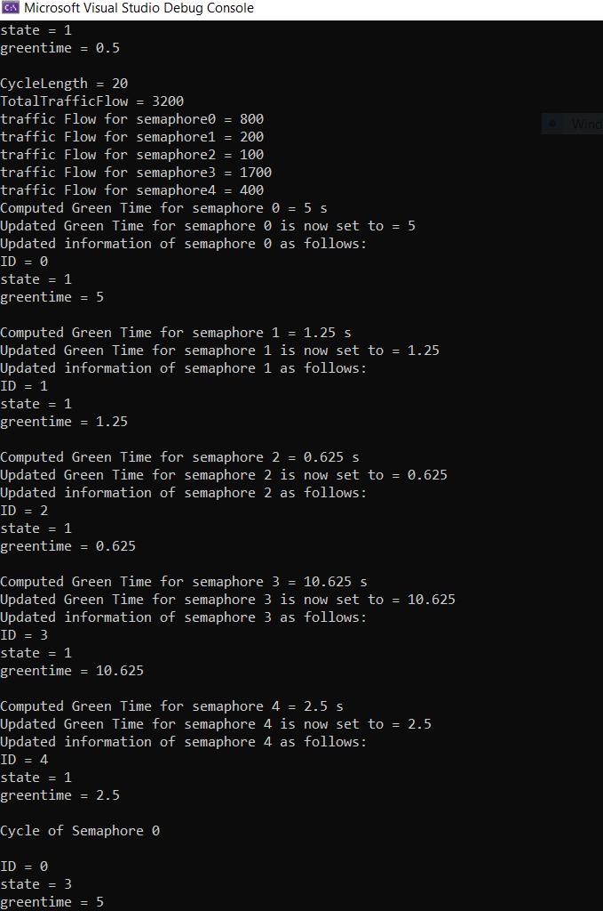

Figures 7 to 10: run () function tested after UpdateTiming() control proceeds with the updated green timings without abnormality

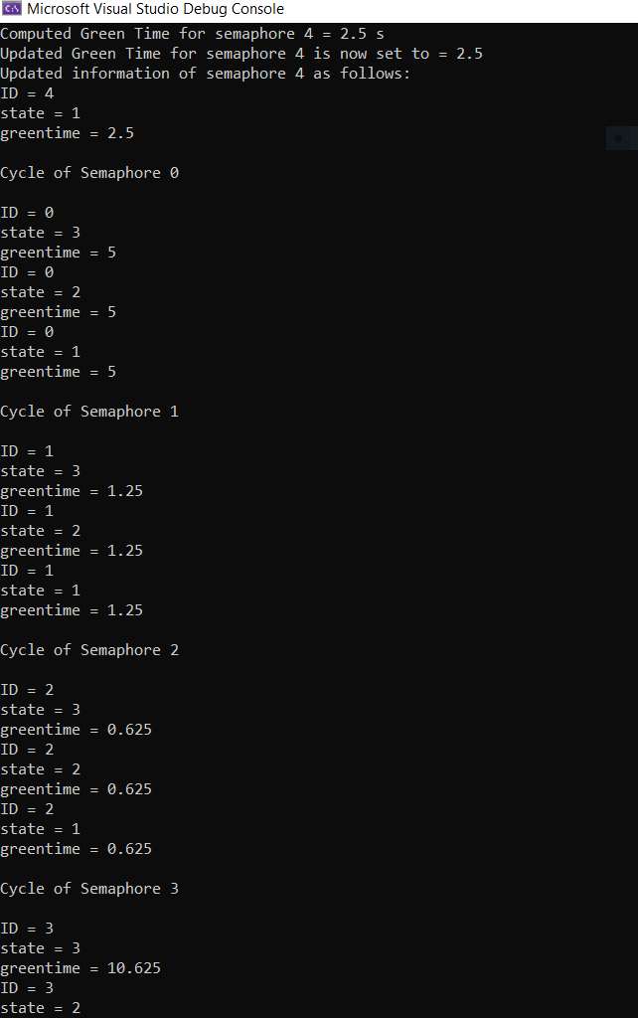

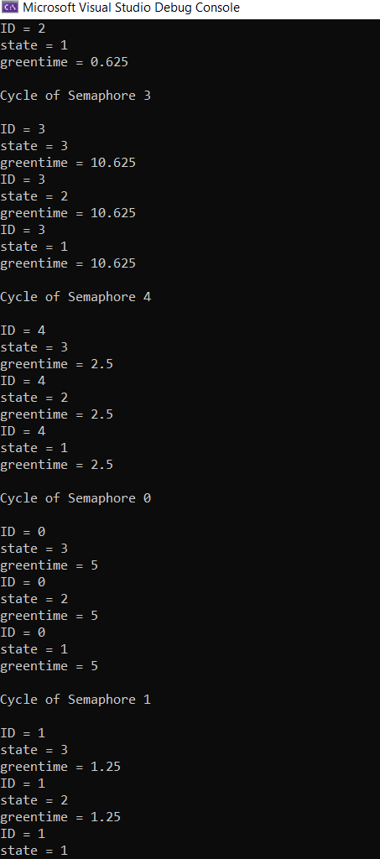

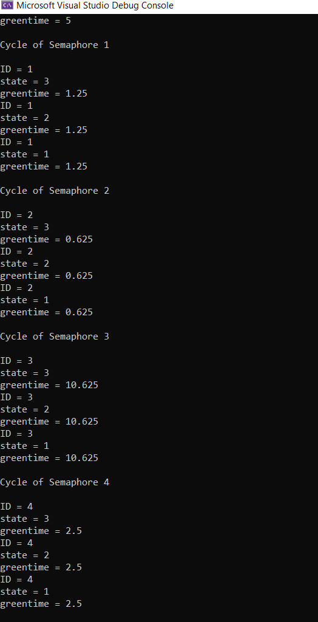

The simulation does never terminate, unless the debugged is stopped by the user. This is what we decided.

Id, State and Green Time of each semaphore are consistent with the predicted values. Time consistency is also respected, which is shown with the help of a timer:

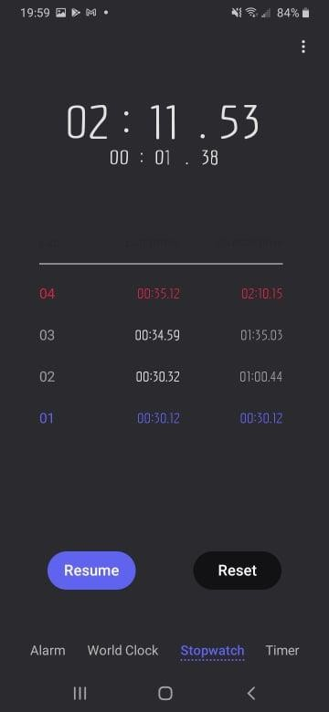

1. is the first cycle of the simulation (30s as expected)
2. is the second cycle of the simulation (30s as expected)

(Green time values updated after 60 s; This corresponds to figure 6.)

1. is the third cycle of the simulation (35s as expected)
2. is the fourth cycle of the simulation (35s as expected)

Hence wait(), UpdateTiming() and run() are working correctly

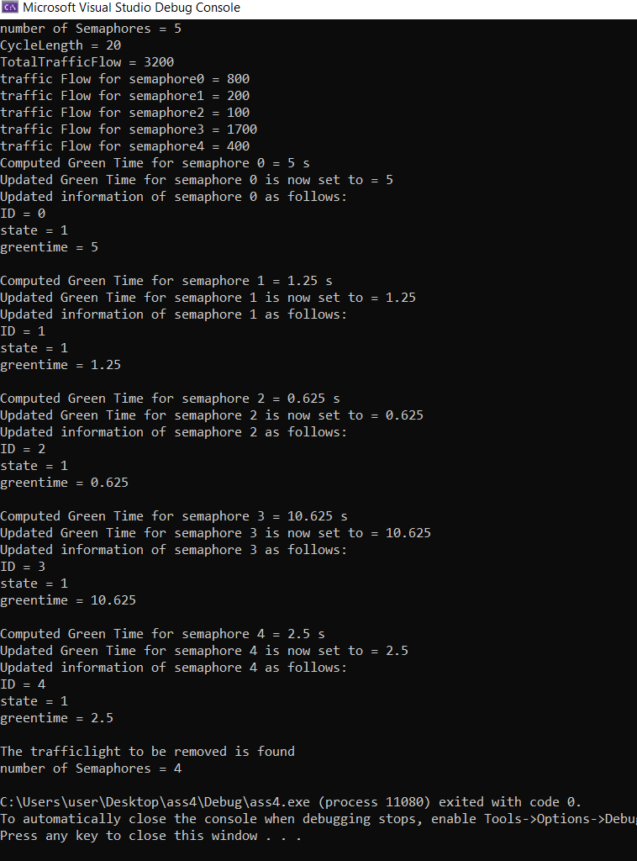Figure

12: droplight() is working properly since the number of traffic lights is reduced from 5 to 4