Mobile phone System Project in Bangalore, India: Supply and Installation Systems for Motorola

KEY INFORMATION
Contacts:
Mr. Fred Tadayyon
Project Director – FTNETS Communications LLC
Phone: +1-847-812-0364
email: Fred@ftnets.com

DATES: January 08, 2011
Proposal Due Date: July 15, 2011

General Information
Country/Region: Bangalore, India
Contract Award: Vodafone
Notice/Contract Number: M2011-6 BST

Project Summary:

Country: | Bangalore, India
Project: | Mobile Phone System Project
Financing: | India Telecom
Abstract: | SUPPLY AND INSTALLATION SYSTEMS FOR MOBILE PHONE
Sector: | Miscellaneous

Work Scope:

Wireless, GPS, GSM and Mobile Communication Projects
- SMS based Device / Home Equipment Control System
- Remote Motor Speed Control using Cell Phones
- GPS Based traffic Monitoring system
- GPS Based Fleet Management System
- Implementation of Mobile / Cell Phone Jamming systems Design
- Intelligent Security System for industrial Surveillance with GSM & Auto Dialer
- GSM Based Remote monitoring system for Electronic Energy meters
- Wireless distributed energy billing system using GSM
- HNet - a Home Networking System with Mobile Communication
- STM1/STM4 and E1/E3 using Tellabs Technology
- Secured Wireless Communication with OFDM
- RF Based Wireless Encryption And Decryption Message Transfer System for Military Applications

Last Project:

KEY INFORMATION
Contacts:
Mr. Fred Tadayyon
Project Director – FTNETS Communications LLC
Phone: +1-847-812-0364
email: Fred@ftnets.com

DATES: February 20, 2010
Proposal Due Date: August 15, 2010

General Information

Country/Region: Cochin, India
Contract Award:
Notice/Contract Number: M2010-8 ICN

Project Summary:

Country: | Cochin, India
Project: | VoIP (Voice Over IP)
Financing: | Private Telecom
Abstract: | SUPPLY AND INSTALLATION
Sector: | Miscellaneous

Location: India / Cochin
VoIP Categories: A-Z Termination, A-Z Termination, Cloud-based Unified Communications Service Provider, did numbers provider, Hardware, Hosted PBX Service Provider, Hosted VoIP billing service provider, Incumbent PTT, International VoIP Wholesale Provider, Internet Telephony Service Provider, Internet VoIP and Video Conferencing Service Provider, Marketing Services, Mobile VoIP, Voip consulting, Voip Termination ISP, Wholesale VoIP Carrier

VoIP Services: Call Relay VoIP Solutions, Call Routing VoIP Solutions, Call shop solution, Data Conferencing, E1 Bulk Wholesaler, E1/E3, H.323 VoIP Gateway, H.323 Wireless/ GSM VoIP Solutions, Hosted PBX, Installation and Support Services, IP devices, Marketing Services, Outsourced Billing, Partnering for Origination and Termination, PC to Phone, PC to Phone, Phone To PC, Phone To Phone, Project Management Services, Termination, Web Call, Web To Phone, Phone To PC, Phone To Phone, Project Management Services, SIP VoIP Gateway, System Integration

VoIP Equipments: 2N, 3CX Phone System, Antek, Blue Lava Prorietary 2 & 4 Port Analog VoIP Gateways, Cisco Systems, Cisco Systems, Huawei VoIP Products, Marketing Services

VoIP Billing Software: 2N, a2billing, AA VoIP Enabler, Accucore billing, Billing system of own development, Custom Open Source Billing Solution, Dialogue Billing, GSM-Central, GT, InfoLink, INPERTEL, Inter-Call.com Billing, IP Phone, IPCB.net, NACT - UNIX Platform, None, Novolink Propietary, VoiceMaster, Voip Switch, voipnow, VPAN

Description: International Wholesale VoIP Provider

KEY INFORMATION
Contacts:
Mr. Fred Tadayyon
Project Director – FTNETS Communications LLC
Phone: +1-847-812-0364
email: Fred@ftnets.com

DATES: March 20, 2006
Proposal Due Date: December 15, 2009

General Information

Country/Region: Overland Park, Kansas
Contract Award:
Notice/Contract Number: UMC006-9 MOT

Project Summary:
Country: | Kansas, USA
Project: | Test Motorola Canopy 5.8 GHz Backhaul Product
Financing: | Sprint
Abstract: | TEST AND SUPPLY
Sector: | Miscellaneous

1 Summary

The purpose of this test plan is to test the Motorola Canopy 5.8 GHz backhaul product to see if it meets the Sprint Nextel needs for IP backhaul.

Layer 2 or MAC layer testing will be conducted at the Sprint Advanced Technology Lab facilities at Burlingame, CA and most of the Radio Frequency (RF) testing will be executed at Motorola ATL facilities in Building 6220 on the Sprint Campus in Overland Park, KS.

FTNETS is aggressively pursuing a technology field trial of broadband wireless backhaul technologies. The chief objective of the trial will be evaluating the equipment under test in a challenging terrain environment in order to validate cost and coverage assumptions associated with a financially viable NLOS solution. Prior to a field trial commitment, the equipment to be tested is expected to meet its minimum stated performance objectives in a laboratory setting. These tests will geared to evaluate MAC performance, minimum RF specifications, scalability and interoperability of the backhaul interface and delay characteristics.

Objectives

The principal objective of the lab test effort is to use the information gathered to confirm the performance to specification of Motorola’s 5.8GHz Canopy PTMP backhaul equipment.

The specific testing goals will be as follows (product specific test plans to be attached as Appendixes to this document):

- Validate RF performance for the Canopy backhaul platform. Compare results to published specifications.
- Evaluate the Mac Layer
- Security of the System
- Application testing

Test Environment Requirements and Assumptions
Unless specified differently, it should be assumed that:

- The system under test (SUT), which includes at least one base station (BTS) has a sufficient number of subscriber stations (CPE) available (typically 2-4). DL/UL ratio is 50/50. BTS and CPE are connected through a variable attenuator and a splitter.
- All the CPE-s have Binary-FSK link with the BTS and are at the same distance from the BTS.
- All the required Service Flows (SFs) are Best Effort (BE) with maximum rate and priority 7. Maximum rate is 14 Mbps for 20 MHz channel bandwidth,. Where applicable, Maximum Latency will be specified to be equal to the wireless frame duration.
- All the base stations in the test can be managed. We are not going to describe details of management connection setup.
- For all the tests using SmartBits, it is assumed that SB port 0 is connected to the BTS, SB port 1 to the CPE1 etc. Mapping of the “logical” SB port N to actual SB module/port will not be specified by default. Logical ports will be referred as SBp0, SBp01, SBp02, etc.
- For all the tests using SmartBits, flows are by default composed of 64 bytes Ethernet frames, unicast with source MAC of the port they are originating from and destination address of the port they are destined to. By default, utilization of the Fast Ethernet port will be 100%. However, when the goal of the test is to verify if certain type of the traffic passes through system or not, and the way to detect it is by

- capturing traffic on the receiving SB port we will send streams with rates of only a couple of frames per second, so captured results at the remote end are easily readable.
- For the test using PC-s, it is assumed that PC0 is connected to the BTS, PC01 to the CPE1 etc. All of the PC-s have installed Ethereal application.
- All the hardware or software listed above is assumed available at all times. For each test that requires additional tools we will add “HW & SW required” section.

Business Requirements and Success Criteria:

Business Requirements

Network Infrastructure Requirements
1. Service Delivery
Port Installation – Less than 20 days
Port Availability – 99.9% or greater
2. Network
Delay – Average 25ms with less than 55ms overall for business line access
Delay – Not more than the differential delay minimum to allow for CDMA soft handoff for PCS T1 backhaul
Packet Loss – 0.10%
Jitter – Less than 2ms
Alarms and Network Management Systems SNMP compatible

Customer Premise Equipment Requirements
- PCS/EVDO Backhaul
Hardened Outdoor Install
Directional Antenna
Non-LOS
Capable of supporting backhaul applications
High Security for Wireless
Redundancy Options
Upgradeable over the air
100bT Ethernet
45 Mbps Sector Throughput

- AN/Backhaul User Mid/Enterprise
Outdoor Install
Capable of supporting backhaul applications
Cable routes need to follow existing entrance openings
Support for IP
High Security for Wireless
Redundancy Options
Upgradeable over the air
100bT Ethernet
Up to 10 Mbps throughput at individual Subscriber stations

- SME Branch Offices
Prefer Non-LOS Indoor Install
Defray from drilling holes for antenna wires
User Self Install- No truck roll required
Optional Integrated WiFi capabilities
Optional VoIP for POTS lines
Autoconfigurable
Battery Backup
Upgradeable over the air
100bT Ethernet
500kbps-6Mbps DS
256Kbps-2Mbps US

- IP Backhaul for 802.16e Trial
Hardened Outdoor Install
Directional Antenna
Non-LOS
Capable of supporting backhaul applications
High Security for Wireless
Redundancy Options
Upgradeable over the air
100bT Ethernet
45 Mbps Sector Throughput
20 Mbps User Throughput Capability

- Content and Applications to Test
Multimedia services
Email
Web Browsing
Video Teleconferencing
Video Phones
Video over IP
VPN services
FTP
Voice over IP

- Financial Requirements (TBD)
CPE Cost
Network Cost per Subscriber
Cost per megabit

- Service Management
Provisioning
Customer Service
Network Management
Control of End User Experience
Authentication

Success Criteria:

For PCS T1 Backhaul Using Interface Device– Meet the differential delay constraint of 8ms for CDMA Soft handoff and backhaul delay of 10ms. Availability should be greater than 99.95%. See table 1.2.2 for exact criteria.
For EVDO Backhaul – Carry all applications currently carried on wireline backhaul
For IP Backhaul- Carry at least 10mbps throughput with less than 10ms of delay
For WiFi/WiMAX Integrated Backhaul- Carry at least 10mbps throughput with less than 10ms of delay
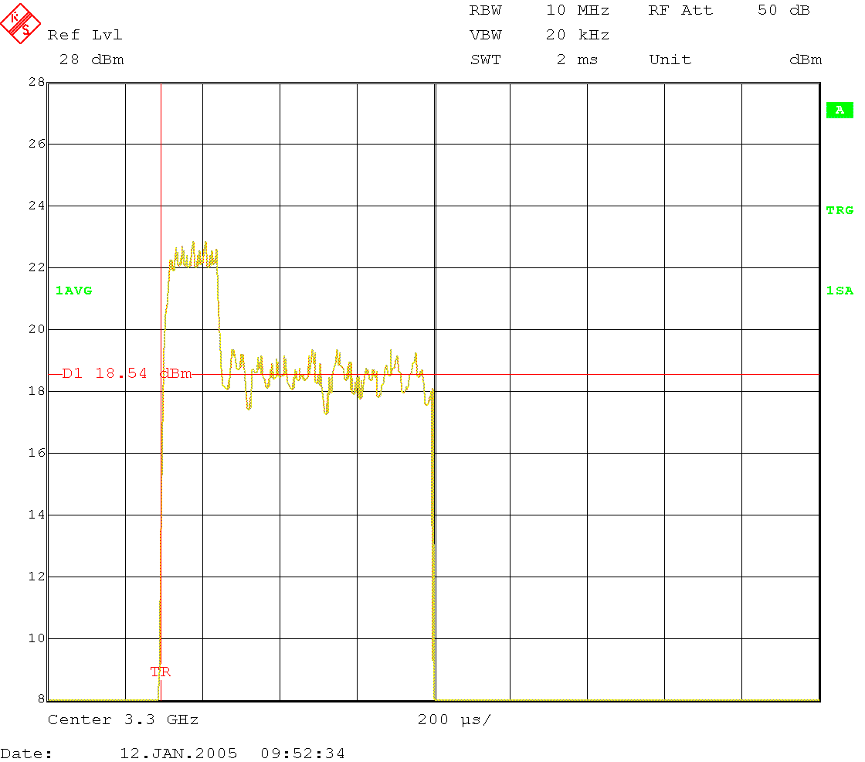

Note that a base station unit will automatically transmit bursts every frame, but a subscriber station unit needs a working link and a certain amount of uplink traffic in order to produce relevant transmit bursts. In this case a splitter should be used for connecting the spectrum analyzer to monitor the transmit power.

  - With the radio under test in Continuous Transmission test mode, record the power envelope at time t1 as defined at 4 above. The Display Line DL2 shall be positioned at the average value of the power envelope corresponding to time t1, as per following figure 2.1.4c:
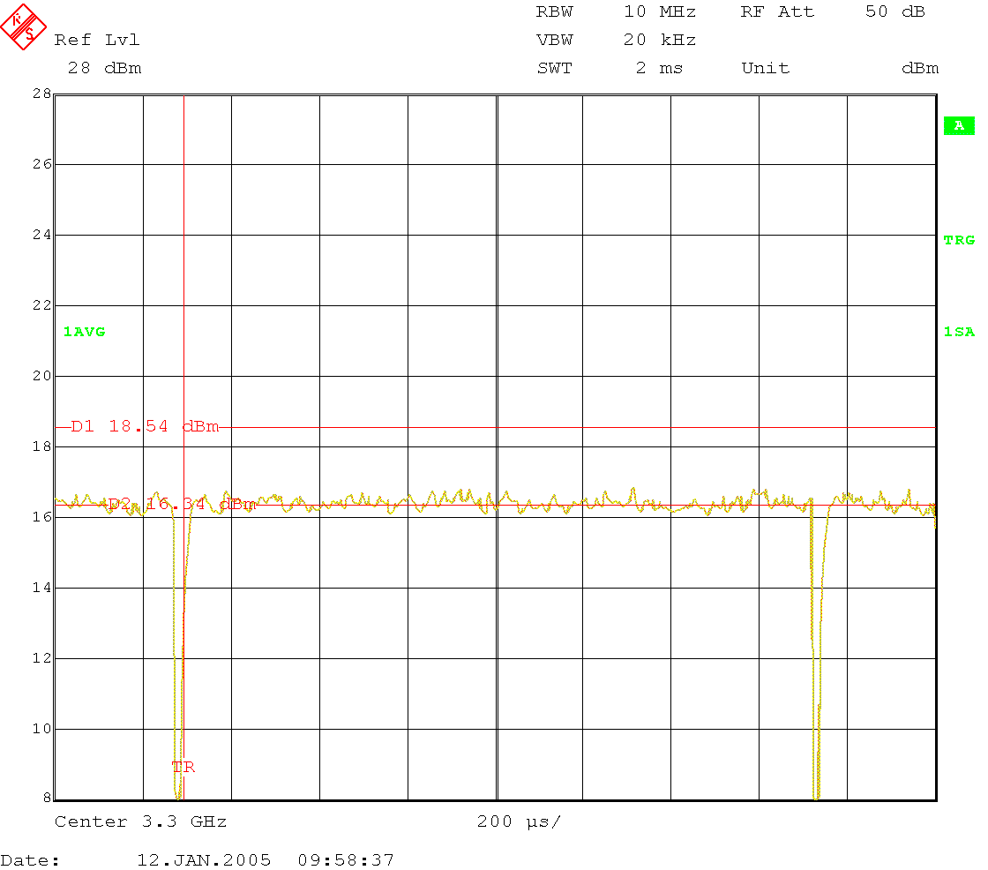

  - Calculate the correction power offset for a measurement taken at time t1 as: Poff(dB) = DL1(dBm)-DL2(dBm)

  - Measure the average power in continuous transmission mode: Pcont, with reading taken at time t1 after the continuous mode was activated. The average transmit power in normal operation (burst mode) is: Pburst(dBm)= Pcont(dBm)+Poff(dB)

Note: Before any continuous transmission, the radio under test should be left at least 20 seconds in normal operation to allow for the temperature compensation mechanism to converge.

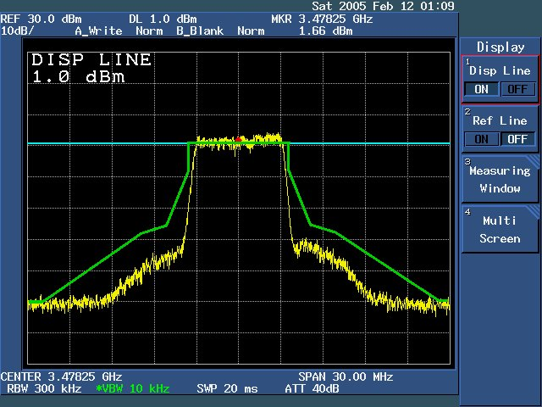

Pass Criteria: The levels stay inside that formed by the spectral mask created in accordance to ETSI EN 301 021 (Fixed Radio Systems Point-to-multipoint equipment; etc).

Configuration: The following general configuration of equipment will be used to perform this test:

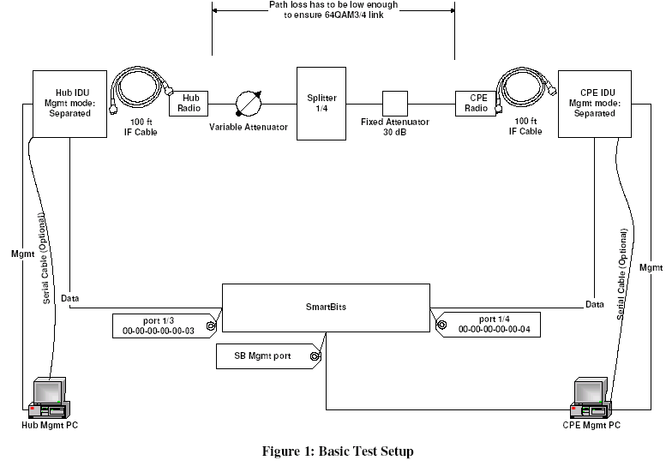

Procedure:
1. Configure SmartBits (SB) ports and CPE IDU for 100-FD.
2. Initiate traffic in both directions (using 100% utilization rate).
3. Repeat steps 1&2 for 100-HD, 10-FD, and 10-HD. Repeat it for BTS and CPE. Repeat it for Mgmt Ethernet port – as we cannot have user traffic through Mgmt port, initiate multiple ping session to BTS and CPE.
4. Configure BTS and CPE to use auto-negotiation.
5. Configure SB ports for auto-negotiation, but they should advertise only 100-FD.
6. Repeat steps 4&5 for 100-HD, 10-FD, and 10-HD. Repeat the test for the management port. As mgmt port has only two LED-s (Link/Act, and 100), ensure that SB ports report correct values.
7. Configure SB streams to send packets sized to 1536 Bytes. Rate does not have to 100% in this case – we can actually use a rate of couple of packets per second. Initiate capture on the SB ports.
8. Connect additional CPE-s to the splitter. Configure SB streams on SBp0 and SBp01 so they utilize 90% of the available bandwidth.
9. Turn on the second CPE.
10. Repeat steps 8&9 by adding more than one CPE. Then start turning CPE-s off. In neither case should traffic between the BTS and CPE-1 be interrupted.
11. Increase attenuation using the variable attenuator to the point of link loss.

Results:
- SB does not report any CRC-s or Ethernet errors.
- Connection between SB ports and SS is 100 FD. 10/100 LED is lit.
- 1536 Byte frames sent at Hub SB port are captured at CPE SB port and vice versa.
- CPE-2 successfully joined the sector. The traffic between BTS and CPE-1 is not affected. BTS reports in the event log addition of the new CPE.
- Both BTS and CPE report in the event log lost link.

