

**Unit test – Assignment**

**Prerequisite:**

1. Knowledge in C# programming language.
2. Or any experience/knowledge in unit testing implementation.

**The Test:**

1. You will require to implement some unit test code for a calculator application.
2. The programing language used is C#.
3. Unit test framework used is NUnit.
4. You are free to access the internet to find reference/example etc, **but** you are required to finish this work on your own.

**Instructions:**

1. Open the folder C#
2. Double click the file MyCalculator.sln
3. From the top menu, choose Build->Build Solution

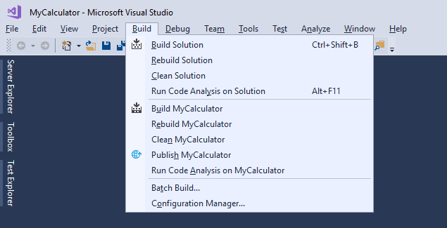

1. Open Test Explorer by choosing from the top menu Test->Window->Test Explorer (**NOT** to be confused with Team Explorer):

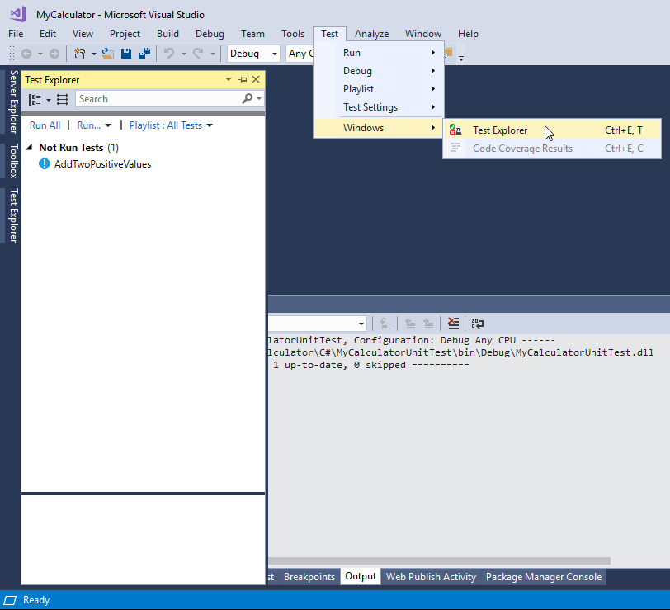

1. On the Test Explorer pane, you can see an example unit test of AddTwoPositiveValues.
2. Choose Run All to run the unit test.
3. The unit test should run successfully and you will see a green checkmark next to the unit test name.
4. You can double click on the unit test name to open the unit test code.
5. Please see the unit test method and all the methods in the Calc class.

**Assignment:**

1. Your assignment is to complete the unit test by adding the following unit tests:
   1. Add method:
      1. Positive number and negative number
      2. Two negative numbers
   2. Subtract method:
      1. Two positive numbers
      2. Positive number and negative number
      3. Two negative numbers
   3. Multiply method:
      1. Two positive numbers
      2. Positive number and negative number
      3. Two negative numbers
   4. Divide method:
      1. Two positive numbers
      2. Positive number and negative number
      3. Two negative numbers
2. Bonus (please complete all the assignment above first!):
   1. Make test arguments not static / test more values using the same methods (Hint: use “TestCaseAttribute”)
   2. Add unit for the divide method with zero as the second argument.
   3. Code quality (eg. DRY – don’t repeat yourself, variable naming, algorithm/code optimization etc).
3. Good luck.