OS Project 3 – Report

File Allocation Table (FAT) Analysis:

Timetable for File Allocation Table (FAT):

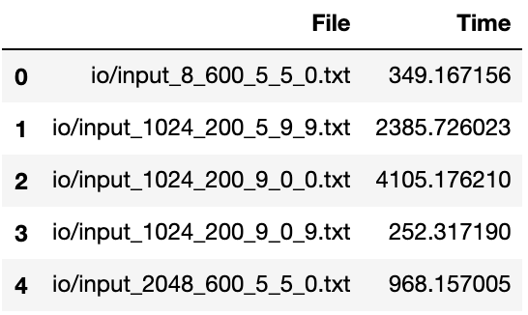

Operations Table for File Allocation Table (FAT):

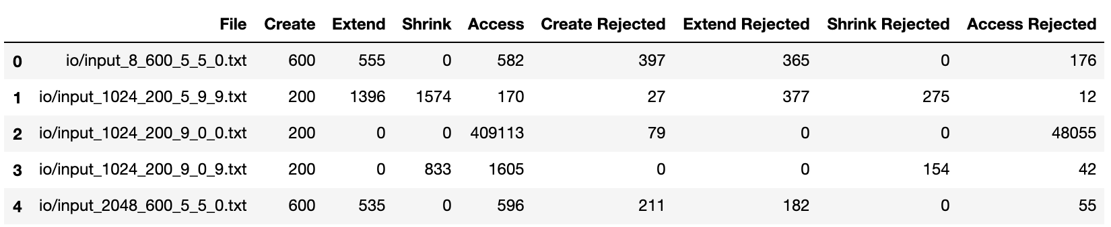

Directory Table (DT) Analysis:

Timetable:
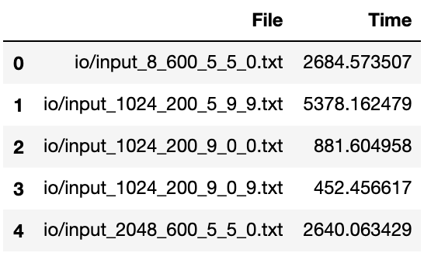

Operations Table:

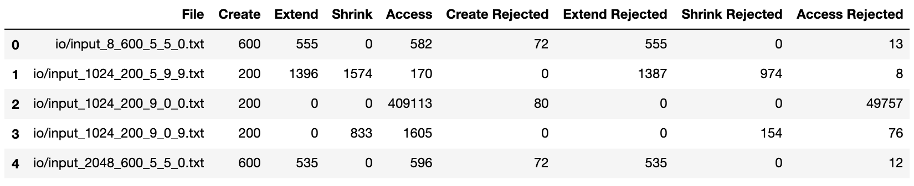

Questions:

1 - With test instances having a block size of 1024, in which cases (inputs) contiguous allocation has a shorter average operation time? Why? What are the dominating operations in these cases? In which linked is better, why?
- Contiguous allocation has shorter average time for “input_1024_200_9_0_0.txt”.
Dominating Operation for “input_1024_200_9_0_9.txt” is Access.
Because Access operations take shorter time for Contiguous allocations, we have shorter average time. Access operations takes shorter time because we know the starting point and because we have contiguous memory space, we can just add offset to starting point to access any part of memory for given file.
- Linked list is better for all input files except “input_1024_200_9_0_0.txt”.

- because it has 200 creation and 409113 access calls. Because contiguous allocation is good at accessing the memory it has shorter average time.

