**Day 1**

**Module Overview**

* Azure Portal and Cloud Shell
* Azure PowerShell and CLI
* Resource Manager
* ARM Templates

**Azure Portal**

1. **Search resources, services, and docs**

* **Manage resources**
* **Create customized dashboards and favorites**
* **Access the Cloud Shell**
* **Receive notifications**

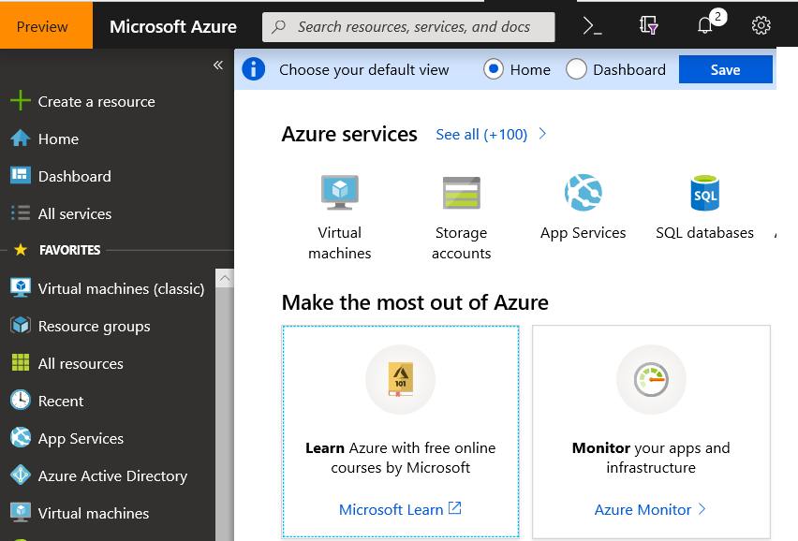

**Reference :** [**https://docs.microsoft.com/en-us/azure/azure-portal**](https://docs.microsoft.com/en-us/azure/azure-portal)



**Azure Cloud Shell**

* Interactive, browser-accessible shell
* Offers either Bash or PowerShell
* Is temporary and provided on a per-session, per-user basis
* Requires a resource group, storage account, and Azure File share
* Authenticates automatically
* Integrated graphical text editor
* Is assigned one machine per user account
* Times out after 20 minutes

Reference : <https://docs.microsoft.com/en-us/azure/cloud-shell/overview>

**PowerShell Cmdlets and Modules**

**Get-Module**

# Output

ModuleType Version Name

---------- ------- ----

Manifest 3.1.0.0 Microsoft.PowerShell.Management

Manifest 3.1.0.0 Microsoft.PowerShell.Utility

Binary 1.0.0.1 PackageManagement

Script 1.0.0.1 PowerShellGet

Script 2.0.0 PSReadline

* Cmdlets follow a verb-noun naming convention; shipped in modules
* Modules are a DLL file with the code to process each cmdlet
* Load cmdlets by loading the module containing them
* Use **Get-Modules** to see a list of loaded modules

**Azure CLI**

**az vm restart -g MyResourceGroup -n MyVm**

* Cross-platform command-line program
* Runs on Linux, macOS, and Windows
* Can be used interactively or through scripts
* Commands are structured in *_groups_* and *_subgroups_*
* Use *find* to locate commands
* Use *--help* for more detailed information

Reference: <https://docs.microsoft.com/en-us/cli/azure/?view=azure-cli-latest>

**Resource Manager Overview**

* Resource Manager
* Terminology
* Resource Group Deployments
* Resource Manager Locks
* Moving Resources
* Removing Resources and Resource Groups
* Demonstration- Resource Groups

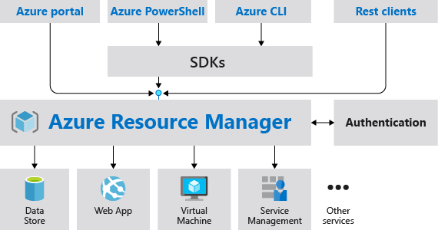

* Provides a consistent management layer
* Enables you to work with the resources in your solution as a group
* Deploy, update, or delete in a single, coordinated operation
* Provides security, auditing, and tagging features
* Choose the tools and APIs that work best for you

**Terminology**

* A **resource** is simply a single service instance in Azure
* A **resource group** is a logical grouping of resources
* An **Azure** **resource manager template** is a JSON file that allows you to declaratively describe a set of resources
* A **declarative syntax** is what a template uses to state what you intend to create
* A **resource provider** is service that supplies the resources you can deploy and manage through Resource Manager

**Resource Groups and Deployments**

* Resources can only exist in one resource group
* Groups cannot be renamed
* Groups can have resources of many different types (services)
* Groups can have resources from many different regions
* Deployments are incremental

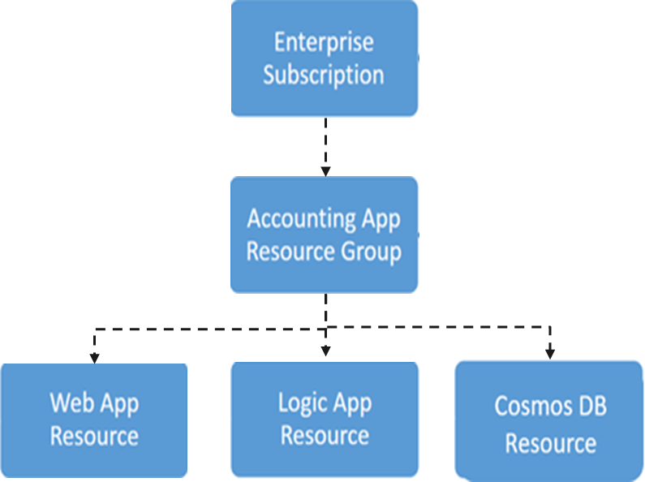

Reference: <https://docs.microsoft.com/en-us/azure/azure-resource-manager/management/overview>

**Resource Manager Locks**

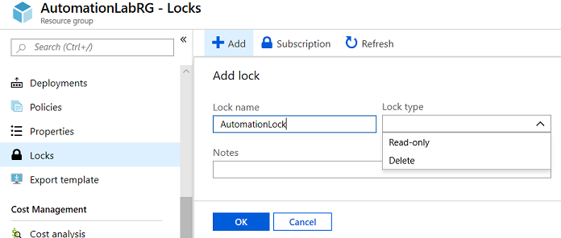

* Associate the lock with a subscription, resource group, or resource
* Locks are inherited by child resources
* Read-Only locks prevent any changes to the resource
* Delete locks prevent deletion

**Moving Resources**

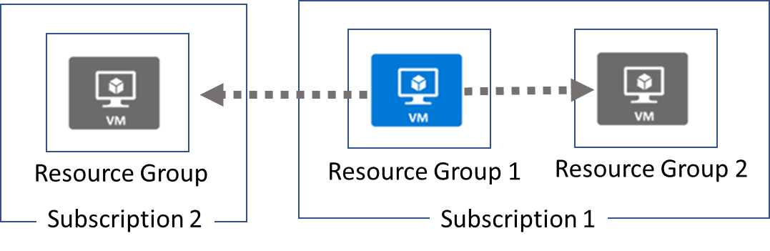

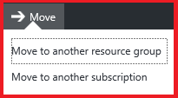

* When moving resources, both the source group and the target group are locked during the operation
* Services that cannot be moved: AD Domain Services, ExpressRoute, and Site Recovery

**ARM Templates**

**ARM Templates Overview**



* Template Advantages
* Template Schema
* Template Parameters
* Template Variables
* QuickStart Templates
* Demonstration – QuickStart Templates
* Demonstration – Run Templates with PowerShell

**Template Advantages**

* Improves consistency
* Express complex deployments
* Reduce manual, error prone tasks
* Express requirements through code
* Promotes reuse
* Modular and can be linked
* Simplifies orchestration

Reference: <https://docs.microsoft.com/en-us/azure/templates>