David Weinstein 2023-12-16

1. Download Android Studio and install it  
   https://developer.android.com/studio

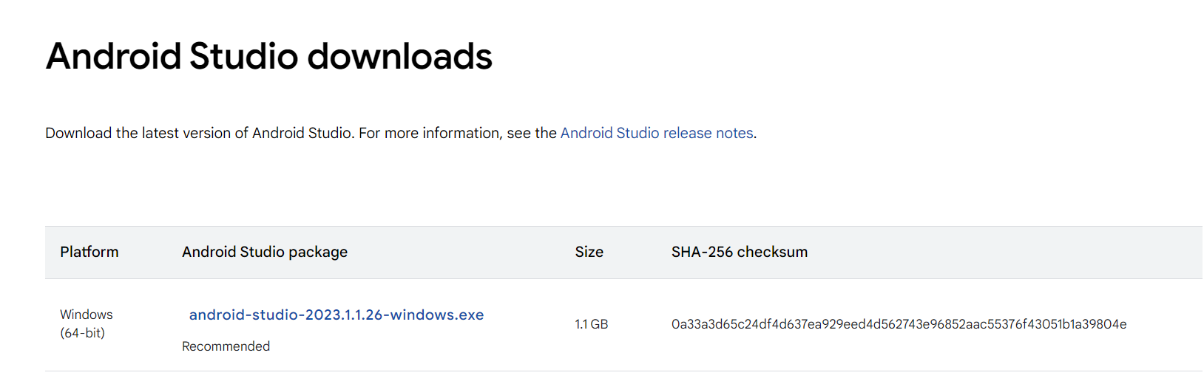

1. Download FTC java SDK from github version v9.01  
   <https://github.com/FIRST-Tech-Challenge/FtcRobotController>

Download ZIP

1. Extract to working place

C:\robotics\FTC-25014

1. Open In Visual Studio

Open the FtcRobotController (The first one)

From C:\FIrst-FTC\FTC-25041-Nof-Harim\FtcRobotController\FtcRobotController\ java\ external.samples  
Select ConceptTelemetry – example to start working without motors

Copy and paste in TeamCode/java/org.firsinspires.ftc.teamcode

Change the name – it will be the class name – pt the 25041_RC in the name

1. REV Hardware Client Overview

<https://docs.revrobotics.com/rev-hardware-client/>

Download and install - REV-Hardware-Client-Setup-1.5.3.exe

This app for controlling the hardware configurations