**Setup Guide for FT900 Amazon AWS IoT demo**

**I. AMAZON AWS IoT Architecture**

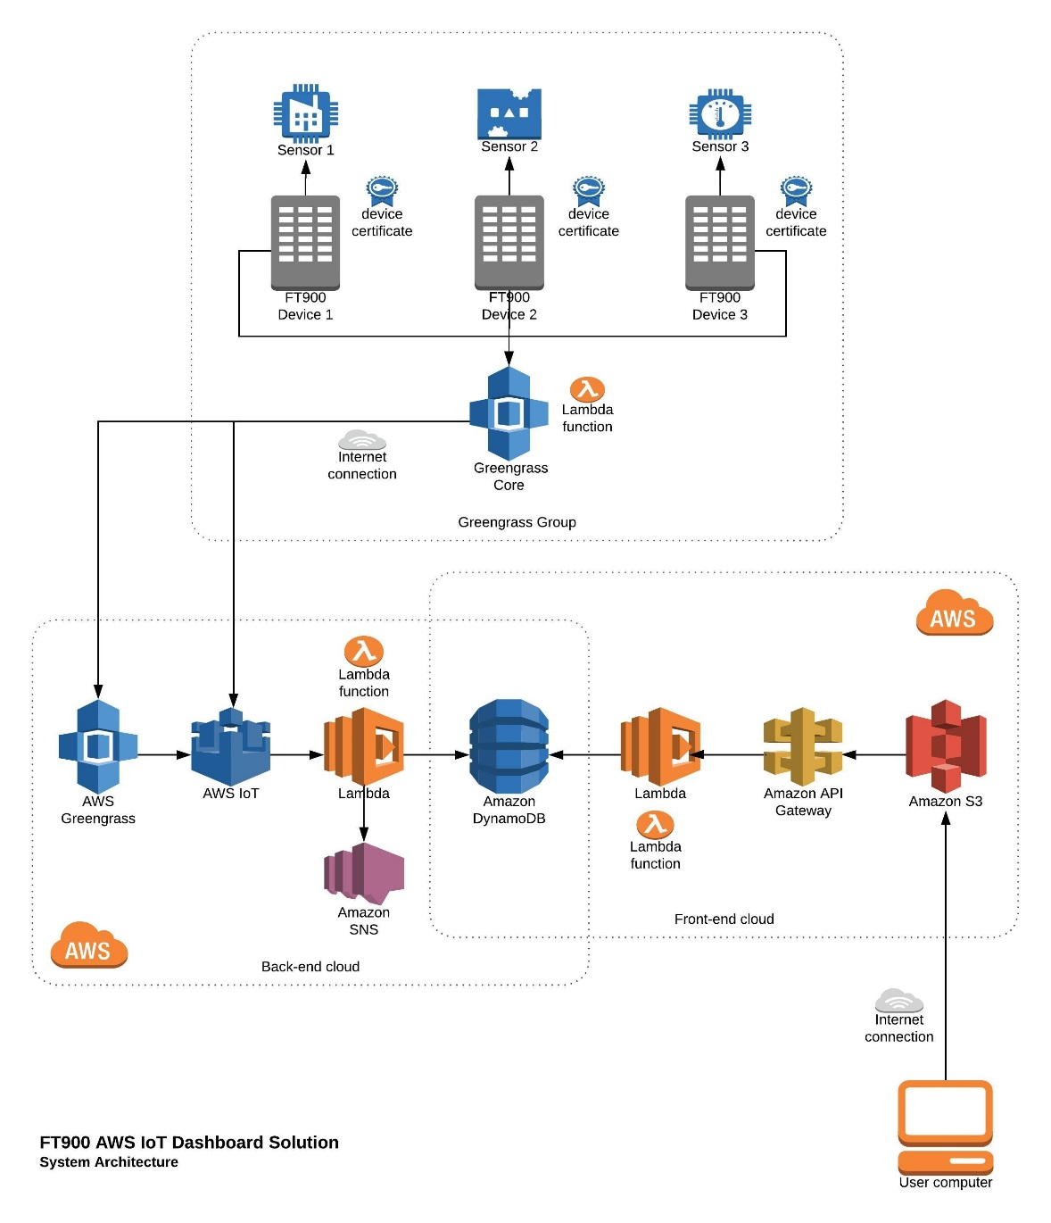

BACK-END: **FT900 -> Greengrass -> IoT Core -> Lambda -> DynamoDB**

FRONT-END: **Browser -> [Dashboard webpage (w/Node) in] S3 -> API Gateway -> DynamoDB**