def vacuum_world():

    goal_state = {'A': '0', 'B': '0'}

    cost = 0

    loc = input("Enter Location of Vacuum: ")

    status = input("Enter status: ")

    otherstatus = input("Enter status of other room: ")

    if status == '1':

        print(f"Location {loc} is Dirty.")

        goal_state[loc] = '0'

        cost += 1

        print(f"Cost for CLEANING {loc} " + str(cost))

    if otherstatus == '1':

        otherloc = 'B' if loc == 'A' else 'A'

        print(f"Location {otherloc} is Dirty.")

        cost += 1

        print("Moving to other Location. Cost for moving " + str(cost))

        goal_state[otherloc] = '0'

        cost += 1

        print(f"Cost for CLEANING {otherloc}: " + str(cost))

    print("GOAL STATE: ")

    print(goal_state)

    print("Performance Measurement: " + str(cost))

vacuum_world()

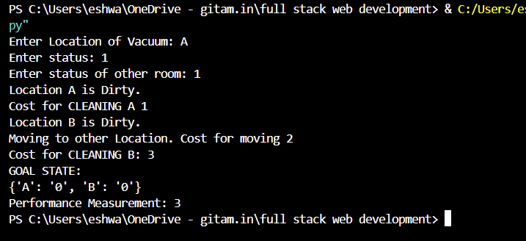

import numpy as np

from itertools import product

def solve(grid, words):

    if not words: return True

    word = words[0]

    for r, c in product(*map(range, grid.shape)):

        for dr, dc in [(0, 1), (1, 0)]:  # Horizontal (0, 1) and vertical (1, 0)

            if all(0 <= r + i * dr < grid.shape[0] and 0 <= c + i * dc < grid.shape[1] and

                   (grid[r + i * dr, c + i * dc] == '-' or grid[r + i * dr, c + i * dc] == word[i])

                   for i in range(len(word))):

                for i in range(len(word)): grid[r + i * dr, c + i * dc] = word[i]

                if solve(grid, words[1:]): return True

                for i in range(len(word)): grid[r + i * dr, c + i * dc] = '-'

    return False

grid = np.array([list("+++++++++-"), list("-++++++++-"), list("-------++-"), list("-++++++++-"),

                 list("-++++++++-"), list("-++++-----"), list("------+++-"), list("-++++++++-"),

                 list("+---------"), list("++++++++++")])

words = ["CIVICS", "HISTORY", "GEOGRAPHY", "CHEMISTRY", "PHYSICS", "MATHS"]

solve(grid, words)

print('\n'.join(map(''.join, grid)))

