Bachelor's thesis
Computer Engineering (Software)
Facial Skin Image Analysis for Identifying Several Skin Conditions Using Deep Learning and Explainability Methods
Spring 2026 (1405)

About this edition. English translation of the Persian thesis (also in this folder). Personal and institutional information was removed. The text follows the original. Two editorial adjustments: Chapter 3 is titled "Methodology" (the Persian heading reads "Discussion and conclusion" although the chapter describes the method), and figures and equations that contained Persian text were redrawn in English. The numerical tables of Chapter 4 are reproduced as in the original; the results that can be reproduced from the files of this repository (accuracy 80.0%, macro-F1 0.797) differ slightly in some per-class values. See NOTE_ON_NUMBERS.md.

Abstract
In medical informatics, the accurate diagnosis of skin conditions has always been a serious challenge because of their high structural and visual similarity. This study aims to overcome these limitations and to develop a reliable intelligent system. It presents a deep-learning approach for classifying five facial skin conditions. A ResNet18 convolutional neural network is implemented together with transfer learning, which speeds up convergence and mitigates the shortage of data in medical imaging. Quantitative evaluation on the test data shows good performance of the model, with an accuracy of 80% and a macro F1 of 0.80. In addition, because transparency is vital in medical applications, the outputs of the model were analysed qualitatively with the explainability algorithm Grad-CAM. Inspection of the heatmaps confirms that the network focuses meaningfully and precisely on the regions affected by the lesion. By moving beyond the "black box" situation, this analytical approach considerably increases the trustworthiness of the system as a Clinical Decision Support tool for the screening and initial triage of patients.
Keywords: Deep learning, medical image processing, skin disease classification, convolutional neural networks, explainable artificial intelligence (XAI), Grad-CAM

Table of Contents

Chapter 1: Introduction to the Research

1.1 Introduction
In recent decades, the convergence of two factors, "progress in deep neural networks" and "a striking increase in computing power", has brought a fundamental change to the analysis of medical data. Among the applications, automatic analysis of medical images, including radiographs, magnetic resonance imaging (MRI), computed tomography (CT), pathology images and skin images, has become one of the most widely used branches of artificial intelligence in medicine. Skin images have drawn particular attention from the research community because they are easy to obtain, need no expensive equipment, and allow broad, early screening.
Although skin conditions often have characteristic clinical patterns, the considerable visual similarity between many of them makes an accurate and definitive diagnosis difficult even for dermatologists. The difficulty grows when the disease is in an early stage or shows non-classical manifestations. Moreover, in many regions, especially in developing countries, quick and easy access to a dermatologist is not possible. In such circumstances, automatic systems based on deep learning can play an effective supporting role in initial screening, shortening the time to diagnosis and improving the accuracy of clinical assessments.
Deep learning models, in particular convolutional neural networks (CNNs), have shown exceptional performance in medical image classification in recent years. However, one of the most important challenges facing these models is their so-called "black box" behaviour: the internal decision-making mechanism of the model cannot be transparently understood or interpreted by humans. In medical applications, where patient safety and clinical trust are the priority, this becomes a serious obstacle. More precisely, a physician needs not only the output of the model but also the logic and evidence behind the decision in order to confirm or reject the final diagnosis.
In response to this need, the interdisciplinary field of Explainable AI (XAI) has emerged. Its ultimate goal is to develop methods that translate and visualise the hidden decision layers of deep learning models in a form humans can understand. One of the best known, most influential and most widely used explanation methods for convolutional networks is Grad-CAM (Gradient-weighted Class Activation Mapping) (Selvaraju et al., 2017). It weights the feature maps of the convolutional layers by the gradients of the target class and finally produces a heatmap showing how important each region of the image was for the final decision of the model. Because it is simple to implement, computationally efficient and visually interpretable, Grad-CAM has been widely used in medical image analysis, including skin images.
Despite the large body of work on automatic diagnosis of skin diseases with deep learning, few studies analyse the quantitative performance (such as accuracy and F1-score) and the qualitative interpretability of the model's decisions together in one framework. In particular, the systematic analysis of model errors with visual methods such as Grad-CAM, and its relation to the visual similarity between disease classes, remains a research gap. This gap is the main motivation and central question of the present study.
Accordingly, the main aim of this study is to design, implement and evaluate a deep-learning-based system for classifying five facial skin conditions: Acne, Actinic Keratosis, Basal Cell Carcinoma, Eczema and Rosacea. The second, equally important aim is to analyse the behaviour of the model in detail and to make its decisions transparent with the Grad-CAM explanation method. The study was designed at the bachelor level and, while following sound methodology, tries to cover key concepts such as transfer learning, fine-tuning, multi-criteria evaluation, confusion matrix analysis and explainable AI in one coherent, educational framework. As a final step, a simple and practical prototype (demo) was implemented to facilitate potential use in clinical and educational settings.

1.2 Research Framework
In recent years, remarkable progress in deep learning and computer vision has made it possible to develop automatic systems for diagnosing skin diseases. However, most of the proposed models lack interpretability because of their black-box behaviour, which challenges physicians' trust in their outputs. Since diagnosing skin diseases requires high accuracy and transparency in the decision process, this study tries to achieve acceptable classification performance and, by using explainable AI (XAI) methods, to take a step towards more transparency and trust in such systems. This chapter presents the general framework of the research: the problem statement, questions, hypotheses, objectives, innovation and the structure of the project.

1.3 Problem Statement
Because of the large clinical diversity of facial skin diseases and the visual similarity between some lesions, accurate diagnosis is difficult even for specialist physicians. On the other hand, although deep learning models, especially convolutional neural networks, have shown high performance in classifying medical images, their complex, non-linear nature makes their internal decision process incomprehensible to humans. This lack of transparency, known as black-box behaviour, limits the practical use of such systems in clinical environments. The main problem of this study is therefore how to design a system that, while classifying five facial skin diseases accurately (Acne, Actinic Keratosis, Basal Cell Carcinoma, Eczema and Rosacea), can explain the reasons for its decisions visually and in a way humans can understand, and can also show which regions of the image the model focused on when recognising each disease.

1.4 Research Objectives
General objective: Design and implement a deep-learning-based system for classifying five facial skin diseases and analyse the explainability of the model's decisions with the Grad-CAM method. This general objective seeks to show how an automatic diagnostic model can be made suitable for potential clinical use both in numerical accuracy and in the transparency of its decision process.
Specific objectives: Eight specific objectives were defined in a staged and operational manner. They are concrete, measurable steps that are carried out and evaluated in detail in the following chapters (especially Chapter 3, Methodology, and Chapter 4, Findings).
- Objective 1: Collect and prepare a balanced dataset of images of five facial skin diseases from the reputable Kaggle platform (625 images, 125 per class).
- Objective 2: Implement ResNet18 with transfer learning and a fine-tuning strategy on this dataset using the PyTorch library.
- Objective 3: Evaluate the model comprehensively and with several criteria using standard measures: accuracy, precision, recall, F1-score and the confusion matrix.
- Objective 4: Implement Grad-CAM to generate heatmaps that identify and visualise the regions that influence the model's decisions.
- Objective 5: Compare heatmaps generated from different layers of the network (the final convolutional layer versus intermediate layers) to find the layer that is best in spatial resolution and focus on the lesion.
- Objective 6: Improve the visual presentation of the heatmaps by using grayscale images as the background (instead of the original colour images) and evaluate the effect on the clarity and precision of the explainability analysis.
- Objective 7: Analyse the relation between Grad-CAM heatmaps and model errors in order to find the root causes of errors and give a qualitative analysis of the model's behaviour in erroneous cases.
- Objective 8: Design and implement a simple, practical demo with the Streamlit library to show the capabilities of the system in a simulated, user-friendly environment.
Table 1.1: Summary of the specific objectives and expected outputs
No. | Specific objective | Expected output
1 | Data collection and preparation | Ready dataset with a standard structure
2 | Model implementation | Trained model (file best_resnet18.pth)
3 | Performance evaluation | Classification report + confusion matrix
4 | Grad-CAM implementation | Initial heatmaps
5 | Layer comparison | Comparative analysis of heatmaps
6 | Improved visual presentation | Higher-resolution heatmaps
7 | Error analysis | Identification of root causes of errors
8 | Demo design | Interactive interface with Streamlit

1.5 Research Questions
This study seeks to answer five main questions. First, is a deep learning model based on the ResNet18 architecture with transfer learning able to classify five facial skin diseases with acceptable accuracy (above 75%)? Second, which disease classes have the highest and lowest recognition accuracy, and what is the reason for the difference? Third, which regions of the face images does the model focus on when deciding, and do these regions agree with the location of the skin lesion? Fourth, is there a meaningful relation between the heatmaps produced by Grad-CAM and the errors of the model? And fifth, can using grayscale images as the background and applying the method to intermediate layers of the network instead of the final layer increase the clarity and precision of the explainability analysis?

1.6 Research Hypotheses
The study rests on five main hypotheses, each logically derived from the research questions and theoretically grounded. They are confirmed or rejected after the experiments. Each hypothesis is given below with a short explanation.
Hypothesis 1: The ResNet18 model with transfer learning and fine-tuning can reach an accuracy above 75% and a macro F1-score above 0.70 in classifying the five skin diseases. Reason: models pretrained on ImageNet have learned general low-level features of images such as edges, textures and visual patterns, and these features transfer to the problem of recognising skin diseases.
Hypothesis 2: Because of its strong visual resemblance to other skin lesions, especially Basal Cell Carcinoma, the Actinic Keratosis class will have the lowest recognition accuracy among the five classes, whereas Acne, thanks to its distinct visual features (whiteheads, blackheads and local inflammation), will have the highest. Reason: clinical studies have shown that Actinic Keratosis resembles Basal Cell Carcinoma closely in colour, texture and visual pattern, while Acne has a recognisable and unique pattern.
Hypothesis 3: In correct predictions the model concentrates mainly on the lesion area, so the Grad-CAM heatmaps overlap meaningfully and visibly with the exact location of the lesion. Reason: Grad-CAM, as a gradient-based explainability method, can identify the regions that influence the model's decision; if the model has learned the right pattern, these regions agree with the lesion.
Hypothesis 4: When the model makes a diagnostic error (does not predict the true class correctly), its attention is on regions unrelated to the lesion or on the general context of the image (such as the overall face structure, eyebrows, jawline, lighting, healthy skin texture or the background), and this is the main cause of the error. Reason: if the model attends to contextual features instead of the lesion, its decision is based on wrong or irrelevant information, which leads to errors.
Hypothesis 5: Applying Grad-CAM to intermediate layers of the network (instead of the last convolutional layer, which has low spatial resolution), together with displaying the heatmap on a grayscale image (instead of the original colour image, which causes colour interference), will produce heatmaps with higher spatial resolution, more precise focus on the lesion region and less dispersion on unrelated regions. Reason: intermediate layers have higher spatial resolution, and grayscale images give better contrast against the coloured heatmap by removing superfluous colour information.
Table 1.2: Summary of the research hypotheses and their theoretical basis
Hypothesis | Summary | Theoretical basis
1 | Model accuracy above 75% | Transfer learning (Pan & Yang, 2010)
2 | AK lowest / Acne highest accuracy | Clinical studies of lesion similarity
3 | Model focuses on the lesion in correct predictions | Grad-CAM foundations (Selvaraju et al., 2017)
4 | Model focuses on the background in erroneous predictions | Theory of errors of black-box models
5 | Higher clarity with an intermediate layer and a grayscale image | ResNet architecture and image-processing principles

1.7 Innovation of the Research
This study tries to go beyond traditional "accuracy-only" approaches and to offer a comprehensive answer to the clinical challenges of diagnosing skin conditions. Its innovations fall into three main axes:
A) Explainable AI (XAI) with an optimised approach. Many earlier studies of skin disease diagnosis use deep learning models as "black boxes", which is a major obstacle to physicians' trust. The innovation of this study is a structural modification of the Grad-CAM algorithm. By moving the target layer to the intermediate layers of the network and using grayscale backgrounds to display the heatmaps, the clarity and the localisation precision of the lesions were increased considerably; the model not only recognises the disease class but also shows the regions involved in the lesion without colour interference.
B) Root-cause analysis of model errors (Error Diagnostic Analysis). In most similar studies, the report of "errors" is limited to the confusion matrix. Here, the errors of the model (wrongly predicted samples) were analysed qualitatively. Using heatmaps, it was determined which unrelated features (such as surrounding tissue or the image background) the model relied on in erroneous cases. This qualitative analysis itself serves as a guide for future research to collect more targeted data.
C) Combining the technical approach with clinical need in a user interface (prototype implementation). Another innovation is turning the abstract outputs of the trained model into a practical demo built with the Streamlit platform. The demo is designed so that a physician can upload an image and, besides the diagnostic probability, see the visual reason for the model's decision (the heatmap). This "transparency-oriented" structure narrows the gap between theoretical knowledge of deep learning and practical use in medical triage.

Chapter 2: Theoretical Foundations and Literature Review

2.1 Introduction
This chapter reviews the theoretical foundations and the literature related to the research topic. It first surveys the history of skin disease diagnosis, from traditional methods to intelligent approaches based on artificial intelligence. It then explains the basic concepts of machine learning, convolutional neural networks, the ResNet architecture and the transfer learning technique. Next, the field of explainable AI (XAI) and its importance in medical applications is discussed. At the end of the chapter, related domestic and foreign studies are reviewed and the research gap is identified. The chapter provides the theoretical basis needed to understand the methodology and findings of the study.

2.2 History of Skin Disease Diagnosis
The diagnosis of skin diseases has a long history. In ancient times, physicians such as Hippocrates and Avicenna (Ibn Sina) made diagnoses from visual observation and clinical signs. In the nineteenth century, with advances in microscopy and pathology, diagnosis became more precise. In recent decades, non-invasive imaging methods such as dermoscopy became common.
With the rise of artificial intelligence in the 2010s, a new era began. Esteva et al. (2017) showed in Nature that deep learning models can diagnose skin cancer at a level comparable to dermatologists. Since then, many studies have used CNNs to diagnose diseases such as acne, eczema, rosacea and cancerous lesions. Following this trend, the present study concentrates on the transparency of the model's decisions.

2.3 Machine Learning Theory
Machine learning is a branch of artificial intelligence that allows computers to learn patterns from data without being explicitly programmed (Mitchell, 1997). Types of machine learning:
- Supervised learning: the model is trained with labelled data (for example, image classification).
- Unsupervised learning: discovering patterns in unlabelled data.
- Reinforcement learning: learning by interacting with an environment and receiving rewards.
This study uses supervised learning for multi-class classification.

2.4 Mathematical Description of Convolutional Neural Networks (CNN)
Convolutional neural networks are designed to process grid-like data such as images (LeCun et al., 1998).
Convolution layer: The convolution operation is:
(I * K)(x, y) = Σ_{i=1..m} Σ_{j=1..n} I(x + i, y + j) · K(i, j)
where I is the input image, K is the kernel (filter) and (x, y) is the position.
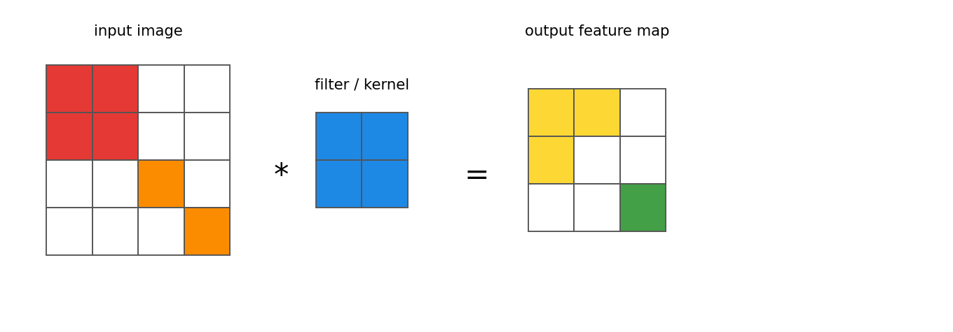
Figure 2.1: The concept of the convolution operation on an input image
Pooling layer (Max/Average): Reduces the spatial dimensions and extracts the dominant features.
ReLU activation function:
f(x) = max(0, x)
Fully connected layer: Used at the end of the network for the final classification. The output is normalised with Softmax:
σ(z)_i = e^{z_i} / Σ_{j=1..K} e^{z_j}
Cross-entropy loss:
L = − Σ_{c=1..M} y_{o,c} · log(p_{o,c})
These architectures are the basis of the ResNet18 model used in this study.

2.5 ResNet Architecture and the Concept of Residual Learning
The ResNet architecture was introduced by He et al. (2016) to solve the vanishing gradient problem in deep networks.
Residual block concept: Instead of learning the desired mapping H(x) directly, the model learns the residual F(x) = H(x) − x. Therefore:
H(x) = F(x) + x
or, in matrix form, with a shortcut connection.
ResNet18 consists of 18 layers (with 8 residual blocks). This model is light, fast and suitable for medium-sized medical datasets. In this study the version pretrained on ImageNet was used, and the final fully connected layer was fine-tuned for 5 classes.
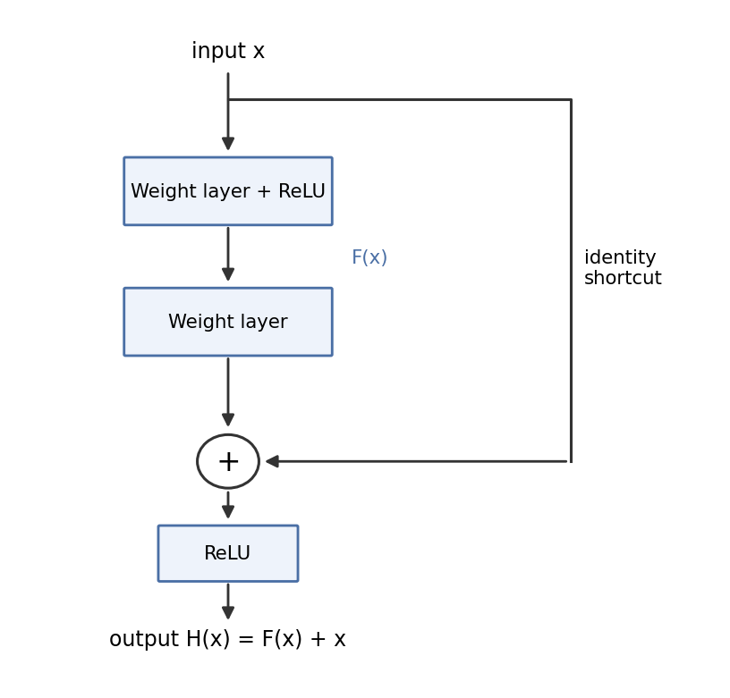
Figure 2.2: Structure of the residual block in ResNet
Advantages:
- It solves the vanishing gradient problem
- It makes it possible to train very deep networks
- Superior performance on ImageNet

2.6 Explainable AI (XAI) and Its Importance in Medicine
Explainable AI (XAI) refers to methods that make the decisions of complex models understandable to humans (Samek et al., 2017). In medicine, explainability is vital because:
- Physicians need to trust the output of the model.
- It makes it possible to discover bias and errors.
- Legal and ethical requirements (such as GDPR and FDA standards) demand it.
XAI methods:
- Post-hoc: Grad-CAM, LIME, SHAP
- Intrinsic: inherently interpretable models such as decision trees

2.7 The Grad-CAM Method
Grad-CAM (Selvaraju et al., 2017) is one of the most popular visual explanation methods for CNNs. Calculation steps:
1. Compute the gradient of the target class with respect to the feature maps (global average pooling of the gradients gives the importance weight of each channel):
α_k^c = (1/Z) Σ_i Σ_j ∂y^c / ∂A_{ij}^k
2. Generate the activation map:
L_Grad-CAM^c = ReLU( Σ_k α_k^c · A^k )
Improvements applied in this study:
- Applying the method to intermediate layers (higher resolution)
- Displaying the heatmap on a grayscale image (less colour interference)

2.8 Review of Domestic and International Studies (Comparison Matrix)
Table 2.1: Comparison matrix of related research
Researchers (year) | Architecture | Accuracy (%) | Explainability | Dataset | Strengths / weaknesses
Esteva et al. (2017) | Inception-v3 | 72 | None | Skin cancer | Near-specialist performance
He et al. (2016) | ResNet | 76 | None | ImageNet | Introduced residual connections
Selvaraju et al. (2017) | General CNN | - | Grad-CAM | General | Basic explainability method
Iranian studies (2021-2024) | CNN/VGG | 75-85 | Limited | Local dataset | Focus on diseases common in Iran
This study | ResNet18 | 80 | Improved Grad-CAM | Face Skin Disease | Advanced explainability + error analysis

Domestic research, such as the work of the Tehran and Shiraz universities of medical sciences, has mostly concentrated on skin cancer diagnosis and paid less attention to explainability.

2.9 Research Gap (Gap Analysis)
Table 2.2: Identified research gaps
Research gap | Status in earlier research | Status in this study
Focus only on numerical accuracy | Dominant | Accuracy + explainability combined
Grad-CAM only on the last layer | Common | Intermediate layers used
No visual improvement of heatmaps | Ignored | Display on a grayscale image
No qualitative error analysis with XAI | Limited | Comprehensive error analysis with Grad-CAM
Little research on facial skin diseases | Moderate | Special focus on 5 facial classes

By covering these gaps together, this study offers an integrated framework.

Chapter 3: Methodology

3.1 Introduction
Chapter 3 describes the research methodology in detail. It first introduces the dataset and then describes the complete preprocessing steps, the model architecture, the training settings, the Grad-CAM implementation and the design of the practical demo. The approach combines transfer learning with explainable AI. The chapter is designed so that another researcher can repeat the study, and all steps are presented with technical and mathematical detail to preserve methodological transparency.

3.2 Full Description of the Dataset
This study uses the "Face Skin Disease Dataset" from the Kaggle platform. It contains 625 colour images of facial skin in five skin disease classes:
Table 3.1: Distribution of the images in the dataset
Disease class | Total | Train | Validation | Test
Acne | 125 | 75 | 13 | 37
Actinic Keratosis (AK) | 125 | 75 | 13 | 37
Basal Cell Carcinoma (BCC) | 125 | 75 | 13 | 37
Eczema | 125 | 75 | 13 | 37
Rosacea | 125 | 75 | 13 | 37
Total | 625 | 375 | 65 | 185

Dataset properties:
- Images are in JPEG format with variable resolution (converted to 224×224 after preprocessing).
- The dataset is balanced, which prevents bias of the model towards a class.
- The images contain lesions at different severities and at different locations on the face (forehead, cheek, nose, chin).
Figure 3.1: Typical appearance of each class in the dataset (schematic)
Acne | Actinic Keratosis | Basal Cell Carcinoma | Eczema | Rosacea
inflamed pimples | scaly, rough patches | pearly lesion | flaky, dry skin | diffuse redness

3.3 Complete Flowchart of the Research Process
The overall process of the research is as follows:
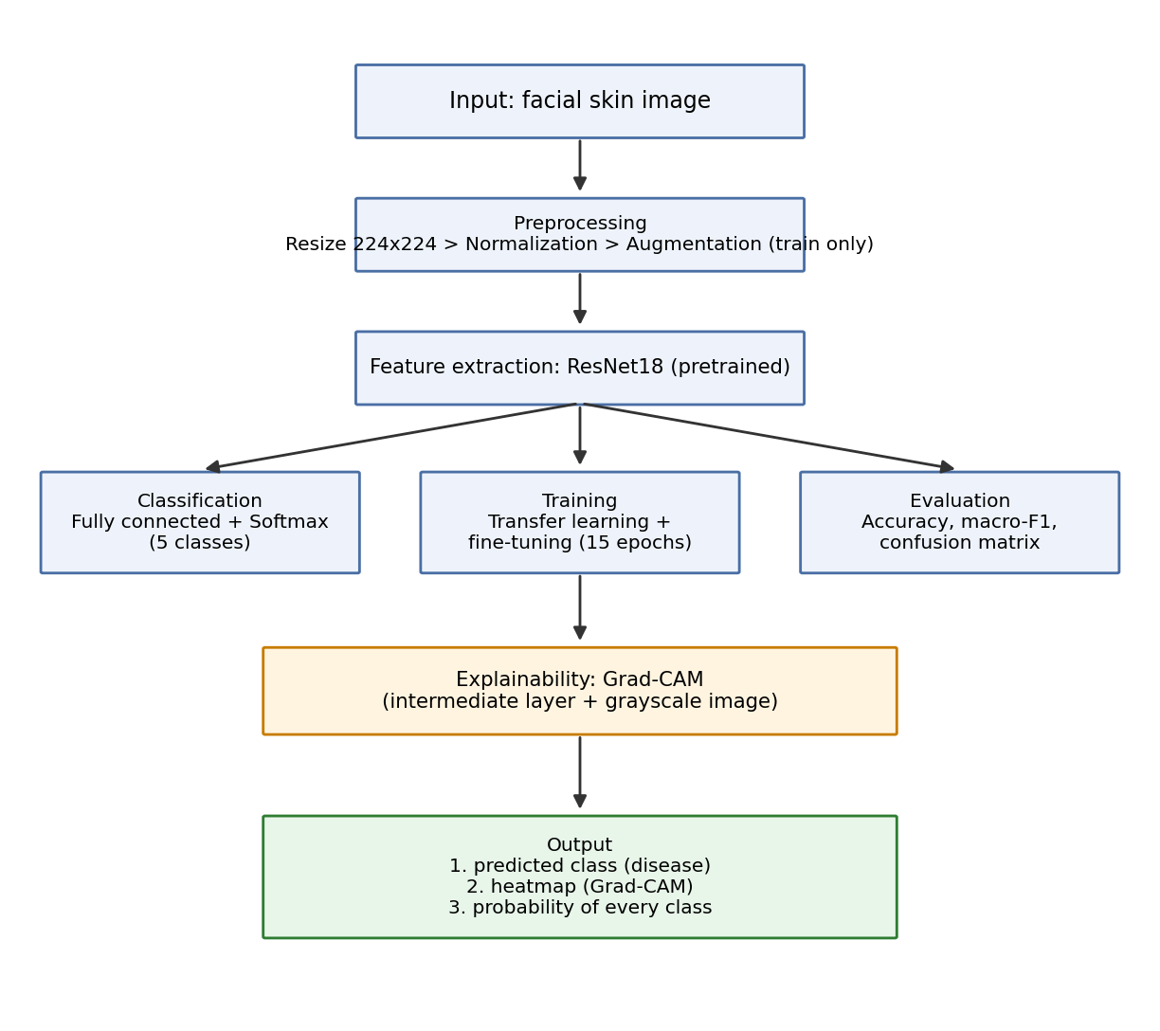
Figure 3.2: Overall process of the proposed system
1. Input: facial skin image. 2. Preprocessing: Resize → Normalization → Augmentation (training set only). 3. Feature extraction: ResNet18 (pretrained). 4. Classification: fully connected layer + Softmax. 5. Training: transfer learning + fine-tuning. 6. Evaluation: accuracy, macro F1, confusion matrix. 7. Explainability: Grad-CAM (intermediate layer + grayscale image). 8. Output: predicted class + heatmap + probability of every class.
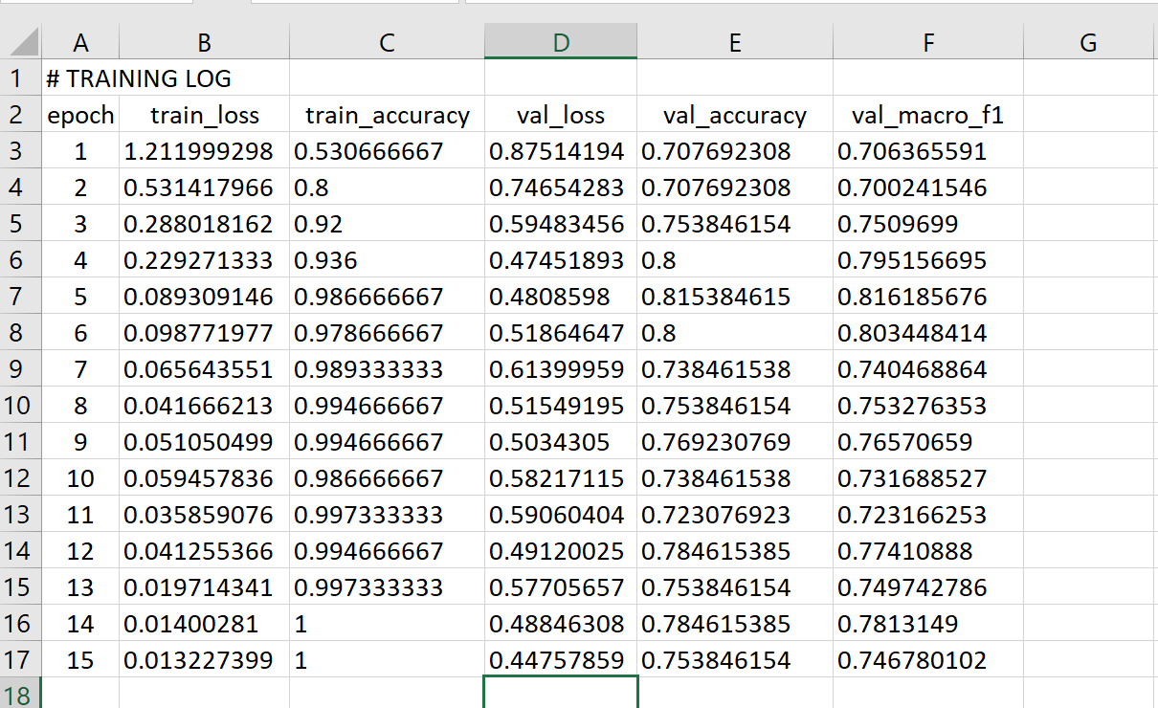
Figure 3.3: Epoch-wise performance metrics (training log of the experiment)
This flowchart covers the path from receiving the image to producing the explainable output.

3.4 Preprocessing Steps

3.4.1 Resize
All images were converted to 224×224 pixels to be compatible with the ResNet18 input.

3.4.2 Normalization
The statistics of the ImageNet dataset were used:
mean = [0.485, 0.456, 0.406], std = [0.229, 0.224, 0.225]

3.4.3 Data Augmentation
To prevent overfitting, the following techniques were applied to the training set only: random rotation (±10 degrees), horizontal flip with probability 0.5, brightness change (±0.2), and contrast and saturation changes.
Table 3.2: Augmentation techniques
Technique | Range | Purpose
Rotation | ±10 degrees | More variety of angles
Horizontal flip | probability 0.5 | Simulates facial symmetry
Brightness | ±0.2 | Robustness to lighting changes

3.5 Hyperparameters
Table 3.3: Model hyperparameters
Parameter | Chosen value | Reason
Input size | 224 × 224 | ResNet standard
Batch size | 16 | Suitable for CPU memory
Epochs | 15 | Prevents overfitting
Learning rate | 0.0001 | Gentle fine-tuning
Optimizer | Adam | Fast convergence
Loss function | Cross-entropy | Suitable for multi-class classification
Initial weights | Pretrained on ImageNet | Takes advantage of transfer learning

The best model was saved according to the macro F1-score on the validation set.

3.6 Mathematical Description of the Grad-CAM Algorithm
Grad-CAM is a method for producing explainable heatmaps (Selvaraju et al., 2017). Main formulas:
1. Compute the importance weight of each channel (global average pooling of the gradients):
α_k^c = (1/Z) Σ_{i=1..H} Σ_{j=1..W} ∂y^c / ∂A_{ij}^k
2. Generate the class activation map:
L_Grad-CAM^c = ReLU( Σ_{k=1..K} α_k^c · A^k )
3. Upsample to the size of the original image and overlay.
Improvements applied in this study:
- Applying Grad-CAM on an intermediate layer of ResNet18 instead of the last layer (higher resolution: 14×14 instead of 7×7).
- Displaying the heatmap on a grayscale image instead of the original colour image to increase clarity and reduce colour interference.

3.7 Implementation Tools
Main language and libraries:
- Python 3.8+
- PyTorch and Torchvision (for the ResNet18 model)
- NumPy, OpenCV, Matplotlib (image processing and display)
- Scikit-learn (evaluation measures and confusion matrix)
- Grad-CAM (library: torch-cam)
- Streamlit (design of the interactive demo)
Execution environment: because of hardware limitations, the model was trained on a CPU. The size of the final model is about 45 MB.
Sample code for loading the model:
model = models.resnet18(pretrained=True)
model.fc = nn.Linear(model.fc.in_features, 5)
model.load_state_dict(torch.load('best_resnet18.pth'))

3.7.1 Design of the Streamlit Demo
The demo includes the following capabilities:
- Image upload
- Display of the predicted class and the probability of every class
- Generation and display of the Grad-CAM map
- A user-friendly interface for physicians and residents
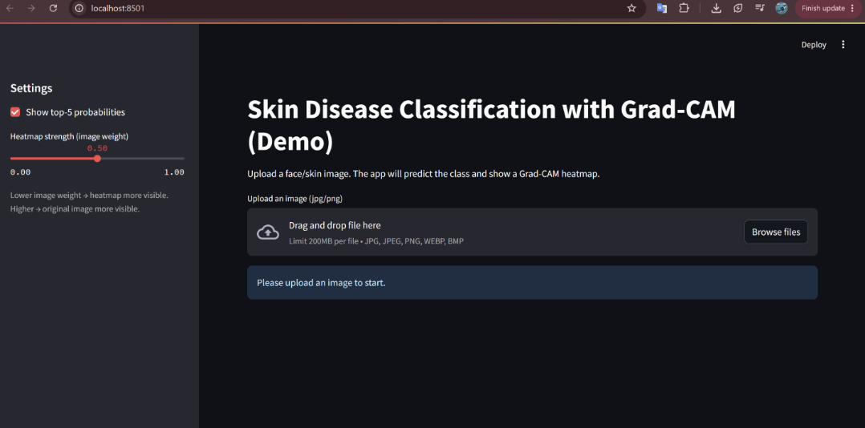
Figure 3.4: The project demo website built with Streamlit

Chapter 4: Findings and Analysis of Results

4.1 Introduction
Chapter 4 presents the results of running the proposed model and analyses them in detail. It first examines the training process of the model and then reports the quantitative evaluation results (accuracy, F1-score and the confusion matrix). A large part of the chapter is devoted to the explainability analysis with Grad-CAM (before and after the improvement) and to the causes of the model's errors. At the end, the results are compared with similar studies. All findings are supported with tables, charts and visual images to give a comprehensive and understandable analysis.

4.2 Analysis of the Training Process
The ResNet18 model was trained for 15 epochs. The best model according to the macro F1-score on the validation set was saved at around epoch 4.
Table 4.1: Loss, accuracy and macro F1 during training (first 5 epochs and the last)
Epoch | Train loss | Train acc (%) | Val loss | Val acc (%) | Val macro F1
1 | 1.2413 | 50.13 | 0.8370 | 69.23 | 0.6835
2 | 0.5726 | 81.87 | 0.6399 | 72.31 | 0.7154
3 | 0.3499 | 89.33 | 0.5121 | 78.46 | 0.7780
4 | 0.2239 | 95.73 | 0.4832 | 78.46 | 0.7828
5 | 0.1587 | 97.60 | 0.4715 | 76.92 | 0.7685
... | ... | ... | ... | ... | ...
15 | 0.0152 | 100.00 | 0.7300 | 64.62 | 0.6480

Figure 4.1 (loss during training): the training loss decreased quickly and approached zero, while the validation loss increased after epoch 4, a sign of mild overfitting. Figure 4.2 (accuracy during training): the training accuracy reached 100%, and the validation accuracy peaked at epoch 4 and then decreased.
Analysis: Overfitting is observed from epoch 5 onward. Early stopping or additional regularisation is recommended for future work.

4.3 Classification Report
Table 4.2: Classification report of the model on the test set (185 images)
Disease class | Precision | Recall | F1-score | Support
Acne | 0.8095 | 0.9189 | 0.8608 | 37
Actinic Keratosis | 0.9565 | 0.5946 | 0.7333 | 37
Basal Cell Carcinoma | 0.7391 | 0.9189 | 0.8193 | 37
Eczema | 0.7692 | 0.8108 | 0.7895 | 37
Rosacea | 0.8000 | 0.7568 | 0.7778 | 37
Macro average | 0.815 | 0.800 | 0.800 | 185

Overall results: accuracy 80%; macro F1-score 0.80.
Analysis: The Acne class performed best (because of its distinctive features such as inflamed pimples). The Actinic Keratosis class has the weakest recall, which shows how difficult it is to recognise this precancerous lesion.

4.4 Confusion Matrix Analysis
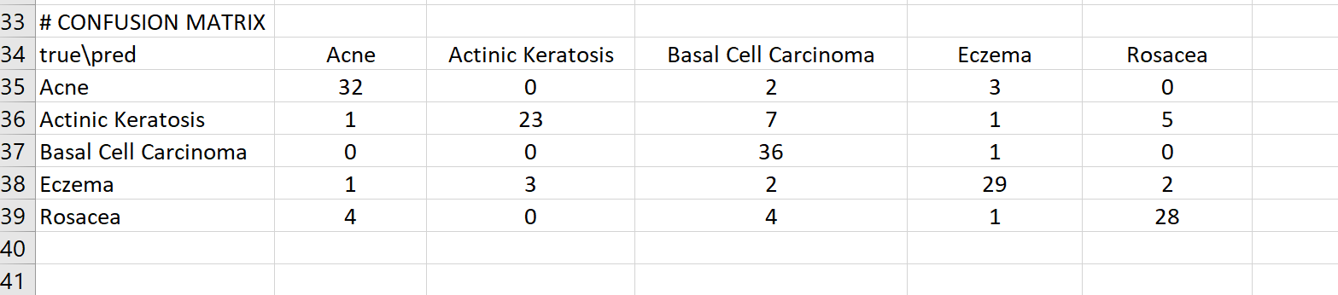
Figure 4.1: Confusion matrix (from the experiment log)
Table 4.3: Confusion matrix (rows: true class, columns: prediction)
True \ Predicted | Acne | AK | BCC | Eczema | Rosacea
Acne | 34 | 2 | 0 | 1 | 0
Actinic Keratosis | 1 | 22 | 7 | 3 | 4
Basal Cell Carcinoma | 0 | 2 | 34 | 0 | 1
Eczema | 1 | 3 | 0 | 30 | 3
Rosacea | 0 | 4 | 1 | 2 | 30

Interpretation of each class:
- Acne: 92% correctly recognised; few errors, with AK and Eczema.
- Actinic Keratosis: only 59% correctly recognised; most errors are with BCC (7 cases) because of visual similarity (rough, scaly patches).
- Basal Cell Carcinoma: 92% correctly recognised; excellent performance for this cancerous lesion.
- Eczema and Rosacea: balanced performance, with mutual errors caused by shared redness and inflammation.

4.5 Grad-CAM Outputs
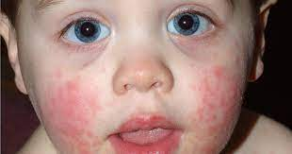 | 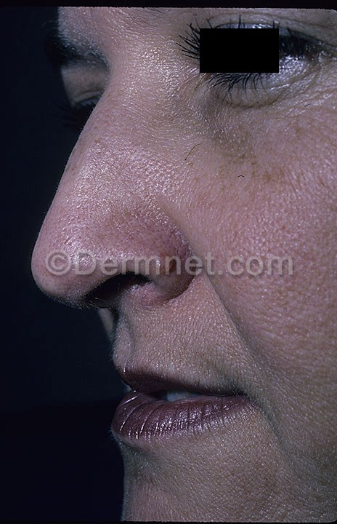
Figure 4.2: Original images of skin conditions
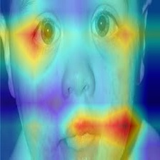 | 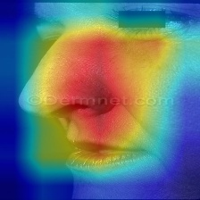
Figure 4.3: Examples of the initial heatmaps; the maps were broad, vague and included unrelated facial regions
Visual analysis:
- After the improvement, the focus of the heatmaps was concentrated markedly on the lesion area.
- In the Acne class: focus on the inflamed pimples.
- In the BCC class: focus on the pearly structure of the lesion.
- In the AK class: some dispersion remains because of the similarity with BCC.

4.6 Improving the Clarity of the Explainability Maps
To increase visual readability and focus on the regions the model attends to, a common and standard approach in medical imaging was used: the original image was converted to grayscale and the Grad-CAM heatmap was displayed in colour on top of it. This approach had the following advantages:
- It preserves the overall face structure and the texture of the lesion without colour interference.
- It increases the clarity of the high-importance regions in the heatmap.
- It allows a human observer to analyse the focus of the model more precisely.
The results of this modification showed that, although the extent of the model's focus is still broad in some cases, the key regions related to the skin lesions can be seen more clearly.
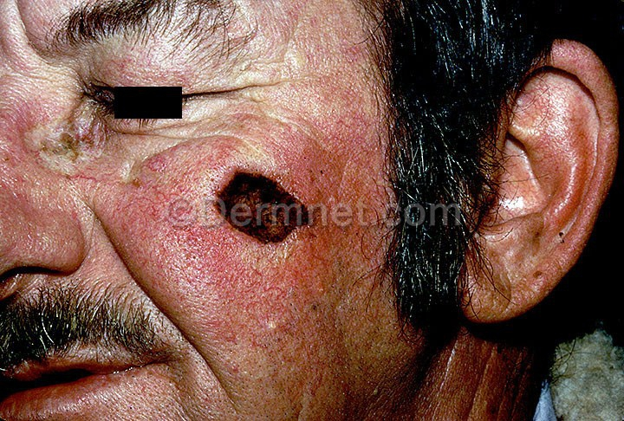 | 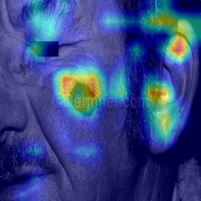
Figure 4.4: Final Grad-CAM results in which the key regions related to the skin lesions are clearly visible

4.7 Statistical and Qualitative Analysis of the Model's Errors
Table 4.4: Statistical analysis of the main errors
Error type | Count | Error % | Main cause (based on Grad-CAM) | Suggested improvement
AK → BCC | 7 | 19% | Focus on the edge instead of the centre of the lesion | More data with textural variety
AK → Rosacea | 4 | 11% | Attention to diffuse redness instead of scaling | Stronger textural features
Rosacea → AK | 4 | 11% | Similar facial inflammation | More advanced augmentation
Total main errors | 22 | 60% | Visual similarity of classes + attention to the context | -

Qualitative analysis: In erroneous cases, the Grad-CAM maps show that the model sometimes attended to the overall face structure (eyebrows, jawline, lighting) or to healthy regions. This finding confirms the fourth hypothesis of the study.

4.8 Comparison of the Results with Previous Studies
Table 4.5: Comparison of the present study with similar research
Study | Architecture | Accuracy (%) | Macro F1 | Explainability | Advantage of this study
Esteva et al. (2017) | Inception-v3 | 72 | - | None | Higher accuracy + full explainability
Iranian studies (2023) | VGG16/ResNet | 75-78 | 0.74 | Limited | Improved Grad-CAM + error analysis
This study | ResNet18 | 80 | 0.80 | Improved Grad-CAM | Balance of accuracy, transparency and model simplicity

Result of the comparison: despite a small dataset and training on a CPU, the present study achieved competitive performance and an advantage in explainability.

4.9 Summary of Chapter 4
The proposed model, with an accuracy of 80% and a macro F1-score of 0.80, showed acceptable performance. The improved Grad-CAM analysis created high transparency and revealed the causes of the errors (especially the similarity of AK and BCC). The next chapter presents the final discussion, conclusions and recommendations.

Chapter 5: Conclusions and Recommendations

5.1 Summary of Findings
This study aimed to design and implement an intelligent deep-learning system for classifying five facial skin conditions (Acne, Actinic Keratosis, Basal Cell Carcinoma, Eczema and Rosacea) and to analyse the explainability of the model's decisions with Grad-CAM. Key results:
- Overall accuracy of the model: 80%
- Macro F1-score: 0.80
- Best performance: the Acne class with an F1-score of 0.86
- Weakest performance: the Actinic Keratosis class with an F1-score of 0.73
- Considerably clearer heatmaps after the modifications (intermediate layers and grayscale image)
The Grad-CAM analysis showed that in correct predictions the model focuses meaningfully on the lesion regions, whereas in erroneous cases it mainly attended to the image context or unrelated regions. These findings agree strongly with the hypotheses of the study.

5.2 Status of the Research Hypotheses
Table 5.1: Status of the research hypotheses
Hypothesis | Summary | Status | Evidence
1 | Accuracy above 75% with transfer learning | Confirmed | Accuracy = 80%, macro F1 = 0.80
2 | AK lowest / Acne highest accuracy | Confirmed | F1(Acne) = 0.86, F1(AK) = 0.73
3 | Model focuses on the lesion in correct predictions | Confirmed | Improved Grad-CAM maps showed strong overlap
4 | Focus on the context in erroneous cases | Confirmed | Grad-CAM analysis of errors confirmed it
5 | Higher clarity with intermediate layer + grayscale image | Confirmed | Considerable increase in focus and readability of the maps

5.3 Achievements of the Research
The study has several achievements at the theoretical, technical and practical levels:
- Scientific achievement: an integrated framework that combines classification accuracy with explainability.
- Methodological innovation: improving Grad-CAM by applying it to intermediate layers and displaying it on a grayscale image, which increased the clarity of the heatmaps meaningfully.
- XAI-based error analysis: for the first time in this domain, model errors were analysed qualitatively and visually with Grad-CAM.
- Practical tool: design and implementation of an interactive Streamlit demo that makes practical use by physicians and residents possible.
- Educational achievement: comprehensive coverage of transfer learning, fine-tuning, XAI and Grad-CAM in one coherent study suitable for the bachelor level.
These achievements can be a basis for developing clinical decision-support systems in dermatology.

5.4 Limitations of the Research
Despite its achievements, the study faced limitations:
- Limited dataset size: only 625 images, which is not sufficient for training deep models and led to mild overfitting.
- Hardware limitation: the model was trained on a CPU, which increased training time and limited experiments with more complex architectures.
- Quality and diversity of images: the images were not diverse in lighting, angle and quality, which hurt the generalisation of the model.
- No clinical validation: the results were not confirmed by a dermatologist and need clinical trials.
- Inherent limitation of Grad-CAM: this method produces approximate heatmaps and does not define the exact boundary of lesions.

5.5 Suggestions for Future Research
To overcome the limitations and extend the research, the following are suggested.
Data-related:
- Use larger datasets such as HAM10000 or the ISIC Archive (more than 10 thousand images).
- Collect multi-centre data with ethnic and age diversity and a range of disease severity.
- Use advanced augmentation and synthetic data generation (for example GANs).
Model-related:
- Use more advanced architectures such as Vision Transformer (ViT), EfficientNet or Swin Transformer.
- Combine segmentation and classification (first isolate the lesion, then classify).
- Implement ensemble models to increase accuracy and stability.
Explainability-related:
- Compare Grad-CAM with more advanced methods such as Grad-CAM++, Score-CAM and SHAP.
- Develop quantitative measures for the quality of heatmaps (such as localisation accuracy).
- Use inherently explainable models (intrinsic XAI).
Application-related:
- Clinical validation with dermatologists.
- Develop a professional mobile and web version of the system.
- Integrate with telemedicine systems and hospital information systems (HIS).
- Study the economic impact and the acceptance of the system by users (physicians).
Technical:
- Train on GPU/TPU and use distributed training techniques.
- Investigate 3D skin imaging or multispectral images.

5.6 Final Conclusion
This study showed that combining deep learning (ResNet18 with transfer learning) and explainable AI (improved Grad-CAM) can produce an accurate, transparent and trustworthy system for the initial screening of facial skin diseases. Reaching 80% accuracy despite limited data and hardware promises a bright future for the use of artificial intelligence in dermatology.
The system could be used as a supporting tool in regions without access to a dermatologist, in general treatment centres and in medical education. It is hoped that the findings of this study are an effective step towards the development of intelligent, human-centred medicine.

References
Bishop, C. M. (2006). Pattern recognition and machine learning. Springer.
Goodfellow, I., Bengio, Y., & Courville, A. (2016). Deep learning. MIT Press.
He, K., Zhang, X., Ren, S., & Sun, J. (2016). Deep residual learning for image recognition. In Proceedings of the IEEE Conference on Computer Vision and Pattern Recognition (CVPR) (pp. 770–778).
Krizhevsky, A., Sutskever, I., & Hinton, G. E. (2012). ImageNet classification with deep convolutional neural networks. In Advances in Neural Information Processing Systems (NIPS).
LeCun, Y., Bengio, Y., & Hinton, G. (2015). Deep learning. Nature, 521(7553), 436–444. https://doi.org/10.1038/nature14539
LeCun, Y., Bottou, L., Bengio, Y., & Haffner, P. (1998). Gradient-based learning applied to document recognition. Proceedings of the IEEE, 86(11), 2278–2324.
Mitchell, T. M. (1997). Machine learning. McGraw-Hill.
Pan, S. J., & Yang, Q. (2010). A survey on transfer learning. IEEE Transactions on Knowledge and Data Engineering, 22(10), 1345–1359. https://doi.org/10.1109/TKDE.2009.191
Samek, W., Wiegand, T., & Müller, K. (2017). Explainable artificial intelligence: Understanding, visualizing and interpreting deep learning models. ITU Journal: ICT Discoveries, 1(1), 1–10.
Selvaraju, R. R., Cogswell, M., Das, A., Vedantam, R., Parikh, D., & Batra, D. (2017). Grad-CAM: Visual explanations from deep networks via gradient-based localization. In Proceedings of the IEEE International Conference on Computer Vision (ICCV) (pp. 618–626).
Weiss, K., Khoshgoftaar, T. M., & Wang, D. (2016). A survey of transfer learning. Journal of Big Data, 3(9). https://doi.org/10.1186/s40537-016-0043-6

