**lssued by: Terapi Media Global L.L.C-FZ** **Date: 05.05.2025**

**To Whom it May Concern,**

This is to confirm that Fethi Göçer, holding identity number [10684223398], has been officially employed by Terapi Media Global L.L.C-FZ as of 05 May 2025. The company is a Limited Liability Company incorporated on 03 May 2025, located at:

Meydan Grandstand, 6th Floor Meydan Road, Nad Al Sheba Dubai, United Arab Emirates

**Employment Details:**

* Position: [Digital Marketing Management]
* Employment Type: Remote
* Start Date: 05 May 2025
* Place of Residence: [Ankara,Turkey]
* Nationality: [Turkish]

The employee performs their duties remotely and is not required to be physically present in Dubai. AII work is coordinated online, and regular communication is maintained through virtual channels.

**Salary and Payment lnformation:**

The employee's salary is processed by Terapi Media Global L.L.C-FZ and is paid in Euro (EUR) or Dollar (USD) to the following bank account provided by the employee:

* Bank Name: [Ziraat Bankası]
* IBAN: [TR73 0001 0007 6057 7177 8050 02]
* Account Holder Name: [Fethi Göçer]
* Country of Account: [Turkey]
* Currency: EUR

AII payments are made in accordance with applicable tax and employment laws in the country of residence of the employee, as well as the regulations of the United Arab Emirates. lf any further information is required, please feel free to contact us.

**Sincerely,**

**Employer**

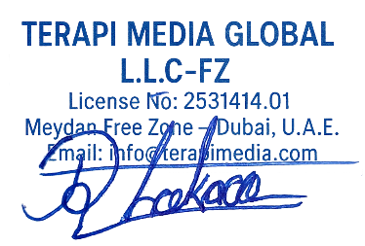

**Employee**

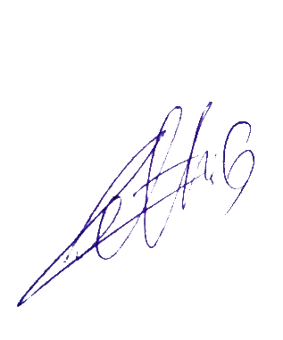[Fethi Göçer]

Position: [Digital Marketing Management]

[[10684223398]