Pride and Prejudice
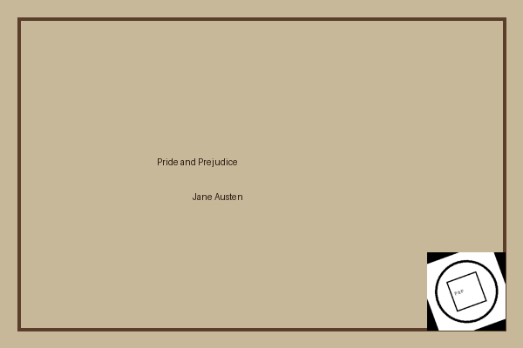
By Jane Austen
Report by: Étudiant

Paragraph length distribution
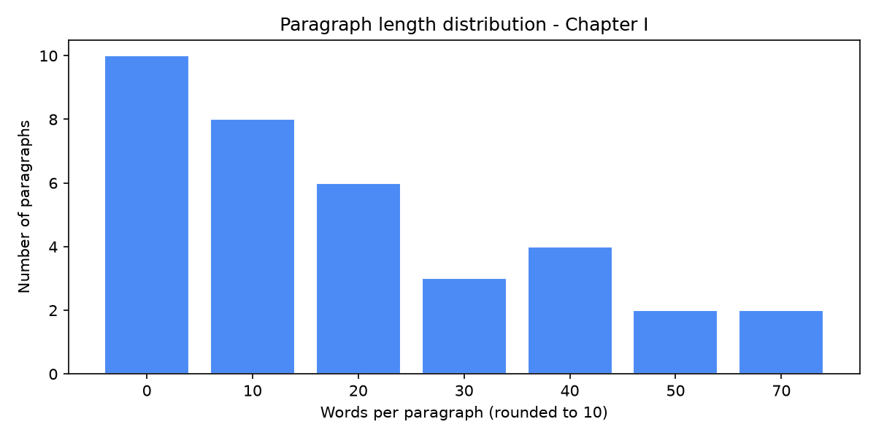

Description
This report analyses the first chapter of 'Pride and Prejudice' by Jane Austen, sourced from Project Gutenberg (https://www.gutenberg.org/files/1342/1342-0.txt).
The chapter contains 35 paragraphs and 846 words in total. The shortest paragraph has 1 words and the longest has 79 words. The average paragraph length is 24.2 words.
Word counts were rounded to the nearest ten for the distribution chart above.

