Digital Fragment matching tool (DFMT)
Test Case 2

April 2020

Table of Contents
1. Introduction 2
2. Scenario 2
3. Tool Installation 2
4. Tutorial Files 2
5. Scenario Execution 3
a. Launch the tool 3
b. Load disk images to be examined 3
c. Query the image database for file fragments 4
d. Use the application output to find sectors of interest 17
e. Repeat the query for the other four files 21

Introduction
This test case assumes that an investigator has one or more intact digital files of interest (e.g., a picture, video, executable, etc.) and one or more disk images. The examiner wishes to know which, if any, of the disk images have some or all of the files of interest on them. For any images with residual fragments of interest, the tool will provide a measure of relative likelihood that the entire file of interest was previously on that disk image. In practice, an examiner may triage based on this score (most likely first) or may triage based on the relevance or interest of a particular matching disk image.
The purpose of this test case is, given one or more intact or partial files of interest, the tool finds matching fragments in disk images and computes a likelihood that the entire input file was previously present on the disk image or images being examined. The typical use case for this tool is to identify post-deletion residual fragments of digital files on digital media. The tool's computational algorithm is designed to eliminate false positives inherent in fragment matching, while retaining true positives and providing a quantitative assessment of original file presence to support triage decisions and maximize the expenditure of examiner time

Scenario
This Test Case takes eight images from 4 different hard drives from four individuals (Charlie, Pat, Jo, and Terry): Four from First Day (FD) and four from Last Day (LD), which was populated for 25 days. The catalogue will be loaded with seven of the eight images. From the eighth image that is not in the database, we will extract some files and query it against the catalogue.

Tool Installation
Copy the dfmt.zip file to the local computer and unzip in any folder which supports program execution by the user. The tool consists of a core executable (dfmt.exe), a configuration file (config.json), and four folders (database, inc, programs, and resources) with supporting files.

Test Case Files
Copy Test-Case2_data.zip to the local computer and unzip in a convenient location. The zip file contains two folders: Test-Case2_files, which contains eleven test files with total size of 2.91MB, and Test-Case2_images, which contains eight disk image files with total size of 127.1 GB.

Scenario Execution

Launch the tool
Run dfmt.exe (double click, Win-R, etc.). Administrator privileges are typically not required. The main dialog window should open.
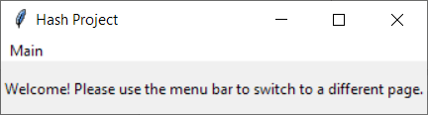

Load disk images to be examined
i. Main -> Load Media
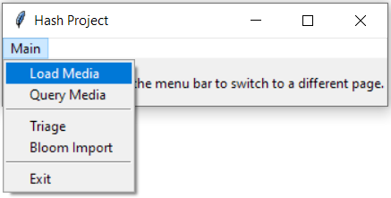
ii. Browse for Media and select image B.001 from the local computer. Provide a name for the database (Test Case 2 in this example) and click Submit.
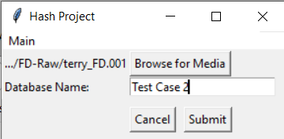

A dialog box will appear when the load is complete.
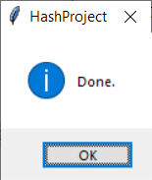
Click OK, then repeat for disk images Charlie_FD, Jo_FD, Pat_FD, Terry_FD and Charlie_LD, Pat_LD, Terry_LD (leave the Database Name the same for all disk images).
NOTE: Don't load image Jo_LD; it contains all of the test files intact and is for reference only.
NOTE: Don't load the same disk image more than once; this will skew the results. If you make a mistake, simply delete the file and folder containing the loaded media (it will be in the database folder, and in this example is a file called Test Case 2 and a folder called Test Case 2) and reload. Alternatively, you can reload the disk images using a different database name. See the FAQ in the user guide for instructions on how to query the hash database for its contents, for example to see which images have been loaded and information on the hashes stored in the database.

Query the image database for file fragments
i. Assume that the investigator wishes to know if the file T1.jpg was on any of the five disk images. From the Main menu, select Query Media. This can be done directly following the load process above (first screenshot below), or the user can select Cancel from the Load Media dialogue window, then select Main -> Query Media (second screenshot below).
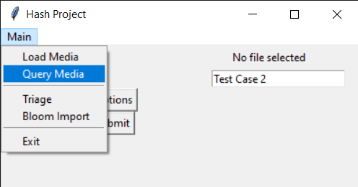
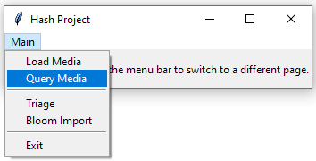
ii. From the Query Media dialogue box, select Browse for Media and select the file patent41.JPG from the TestCase2_files folder. Enter the name of the database from the previous step (Test Case 2 in our example).

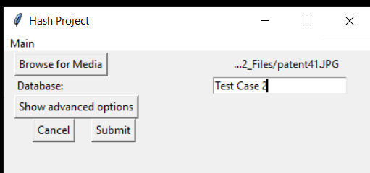

Click on Show advanced options and confirm that the first box is unchecked, and the second box is checked. The checkboxes control which computations are run and output to the user. The second check box runs the more advanced algorithm and produces the most accurate results. When ready, click Submit.

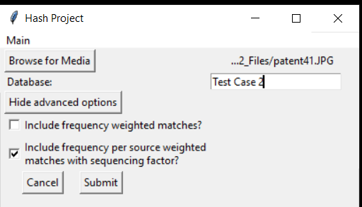

iii. You will be prompted by a Save As dialog box for a location and filename to save the output. In the example below, we created a folder called testCase2_output, navigated to it, then entered testCase2_ patent41.JPG _out as the filename. Click Save when ready.

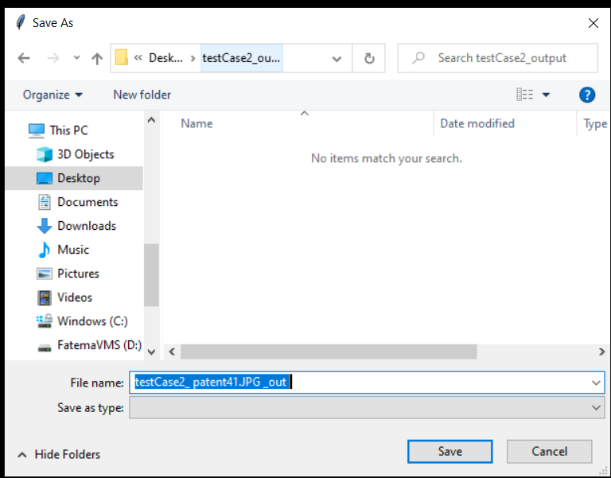

The program will output summary results to a popup window:

Figure: Test Case 2

The output window provides a list of the images containing matching sectors, sorted by score high to low. This data is also stored in the output file created in the previous step. This is a JSON formatted text file and is best viewed with a JSON Viewer (e.g., https://jsonformatter.org/json-viewer, output shown below), although it can also be viewed in a text editor and other applications.

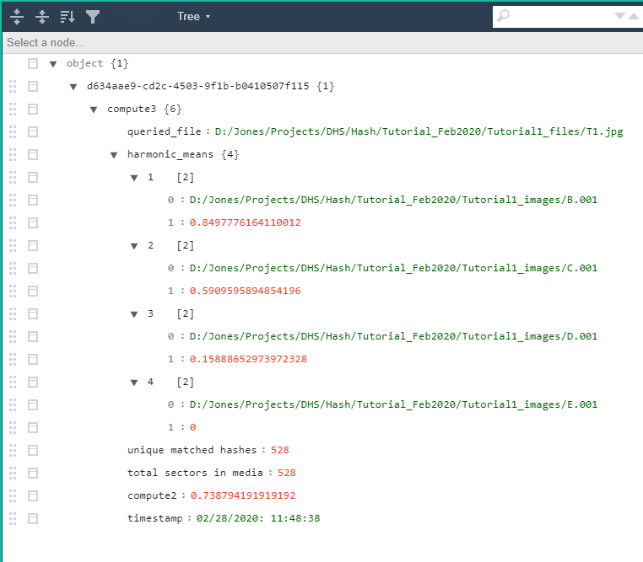

These results indicate that of the five images queried, image B.001 contains the most and/or more significant fragments of the file T1.jpg (the red score, 0.849..., in the JSON output and 0.850 in the popup output). This value may be loosely considered a probability and will always be in the range 0.0-1.0 inclusive. The other images C.001, D.001, and E.001 also contained some fragments of T1.jpg, but either less of them and/or less significant fragments than the image B.001. Image E.001 had the lowest score (0.000) but is included in the output because at least one sector did match (it just wasn't enough to generate a score greater than 0). Image F.001 is not included in the output because no sectors from T1.jpg were found on the image.

iv. The disk image may be manually inspected to confirm the results. Open the test file T1.jpg and the disk image file B.001 in a hex editor (HxD is shown below with decimal offsets).

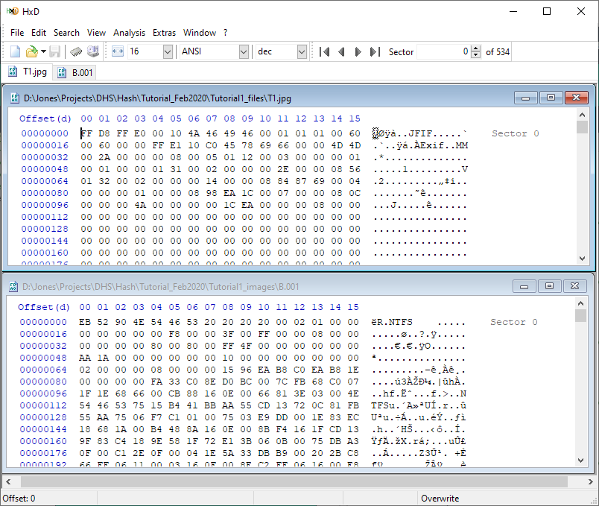
Use the first few bytes of the T1.jpg file to find the first fragment in the disk image B.001 (note: this will only work if the first sector of the file is one of the sectors that survived in the disk image). Copy and paste some bytes (the first 16 in this example) into the Find function, setting the Datatype to Hex-values, then click OK to run the search:

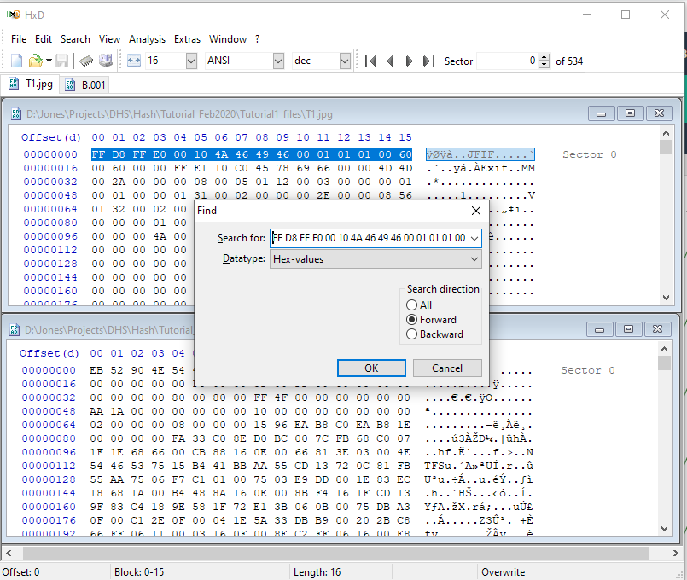

The first match in B.001 should be the start of the residual file fragments at offset 2870784 (decimal).
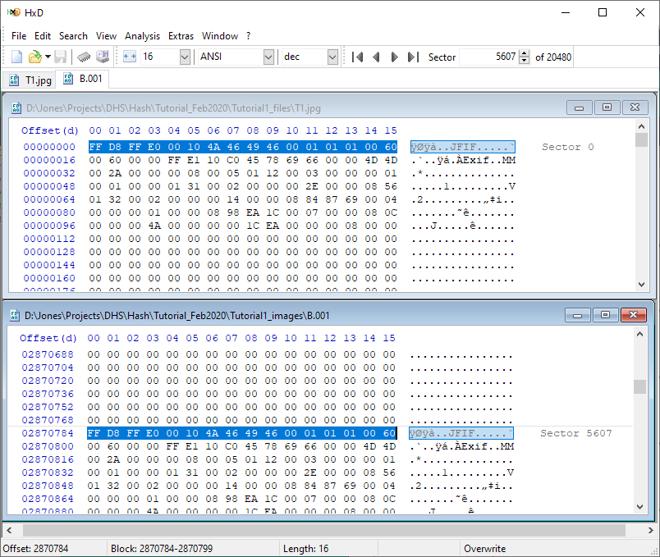

The file T1.jpg has a size of 273,039 bytes, which is 534 512-byte sectors on disk. This means the file would run from sector 5607 to sector 6140 if the entire file survived on the disk image and was stored contiguously. This is the case for this particular file and disk image, which can be confirmed by scrolling through the disk image down to sector 6140 (notice the JPG footer 0xFFD9 at offset 3143821). You'll see content in most of the sectors (some Null sectors are at the beginning of the file on the disk image; there are corresponding Null sectors in the original file). These and some other low-entropy sectors are ignored by the matching algorithm to avoid false positives, and some of the sectors are not unique to this file; this explains why the score is typically not 1.00 for an intact file on a disk image.

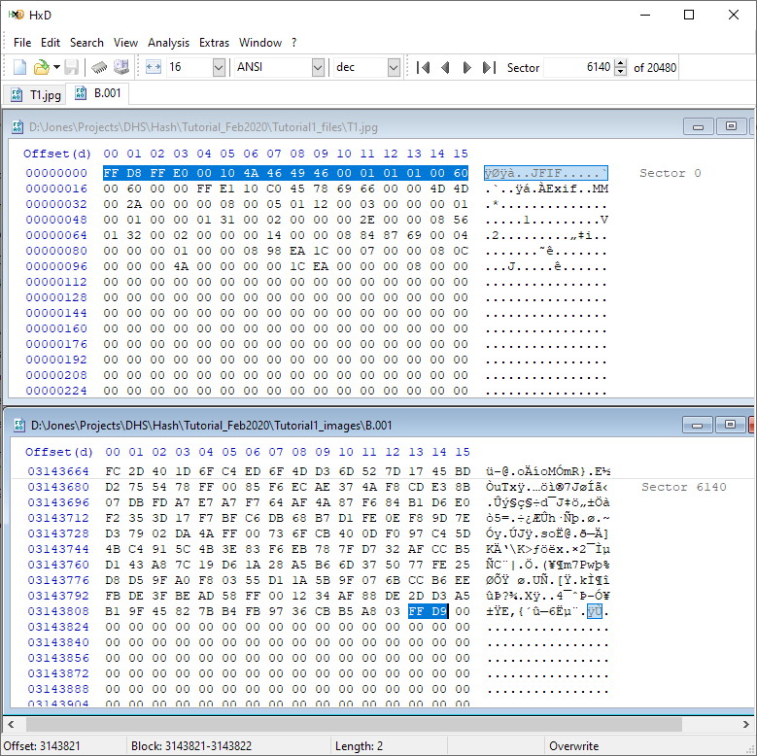

v. Repeat this manual examination for the file T1.jpg and the disk image C.001. Once again, you will find the start of T1.jpg at offset 2870784 (sector 5607) in the disk image C.001.

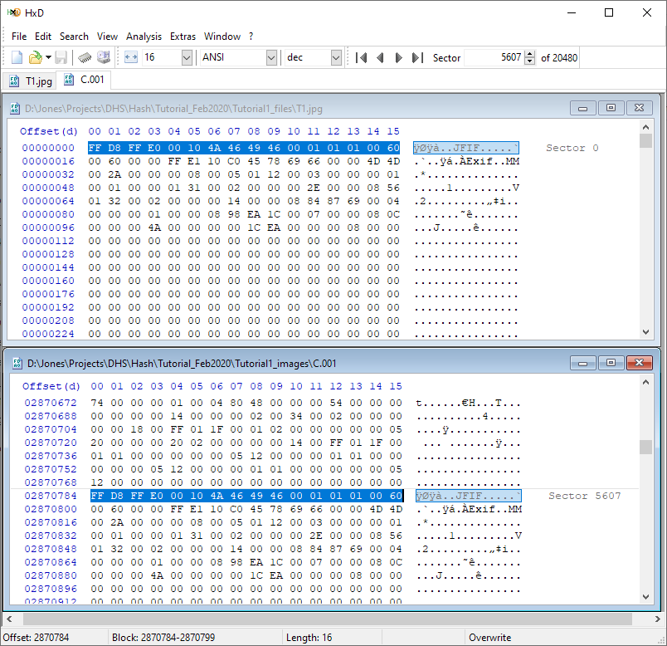

However, this file has been partially overwritten on the disk image C.001. Go to sector 6140 in C.001 (the expected end of the T1.jpg file on the disk image), and you'll find Null bytes.

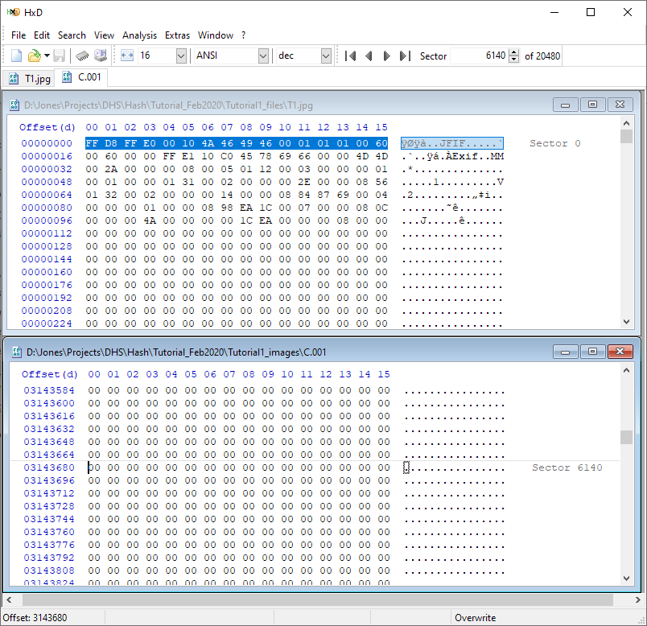

In fact, only the first ~50% of the file survived; overwriting starts at offset 3007304 (in sector 5873).

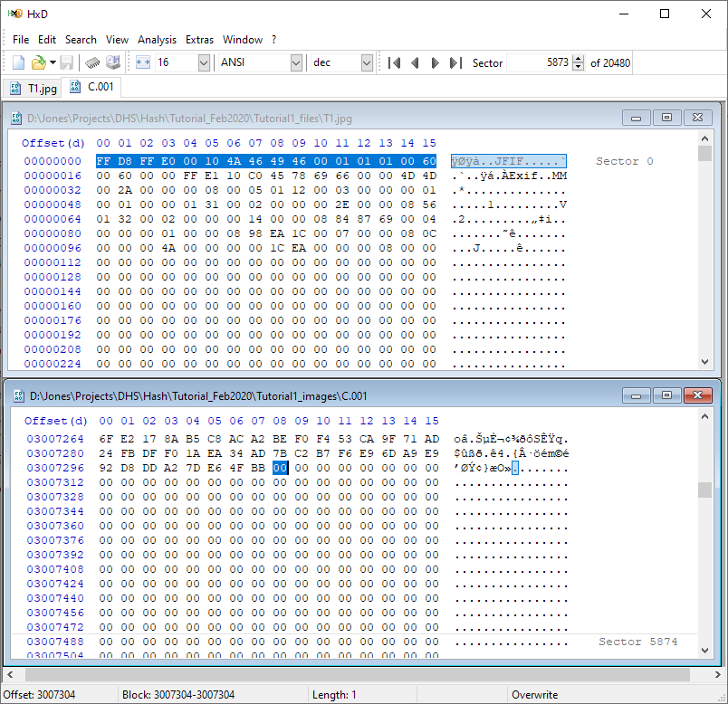

These surviving sectors may be copied into a new file for examination. Highlight sectors 5607 through 5873, right click and select copy, File: New from the menu, then right click and select paste in the new file.

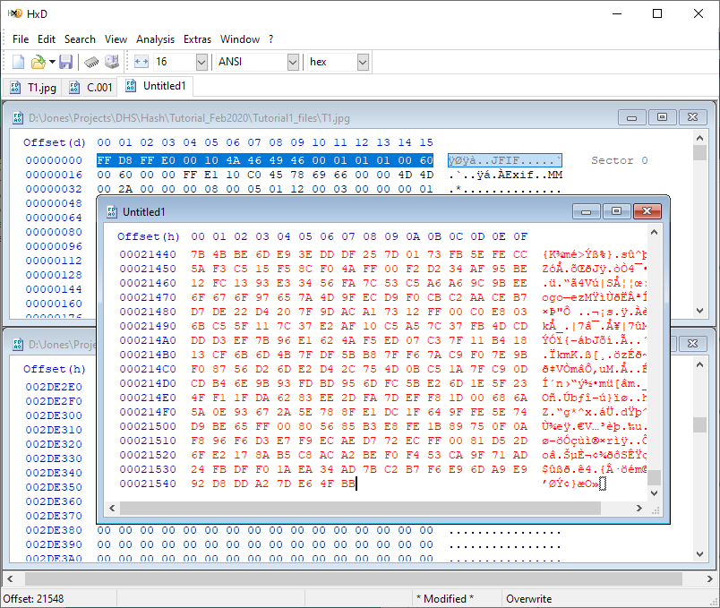

From the menu, select File: Save as, choose a location and name for the file (T1.jpg_C.001_recovered.jpg in this example), and click Save. Using the jpg file extension in this case simply makes rendering with a Windows application simpler, but this is not required.
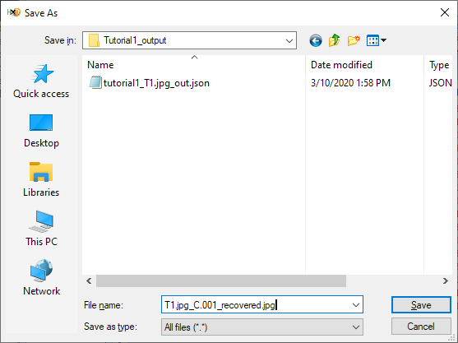

Attempting to view the recovered file in an image viewer will likely generate something like the image below. Not all partial files can be rendered; it depends on the format and the specific fragments which survived (metadata at the start of a file is often critical for rendering), although identification, rendering, and interpretation of partial file fragments remains an area of active research.
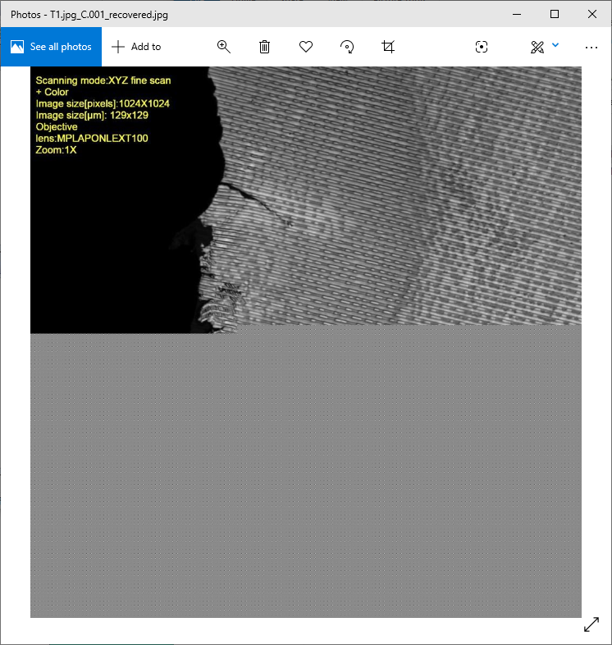

Use the application output to find sectors of interest
In many cases it may be useful to know exactly where in a disk image the matching fragments are located. This information is stored in a temporary file that is kept until the tool is run again, at which point this file is overwritten. The file may be saved and/or renamed between runs of the application.

i. After running a Query Media command, open the file results_hash_digests.txt in the folder where the dfmt.exe file is located (this is a hard-coded default location that will be settable by the user in the future). Open the file with any text editor.

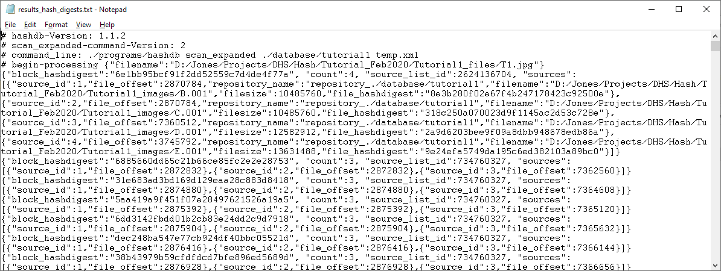

In the screenshot below, the key data is highlighted in red bold and described in the sections that follow.

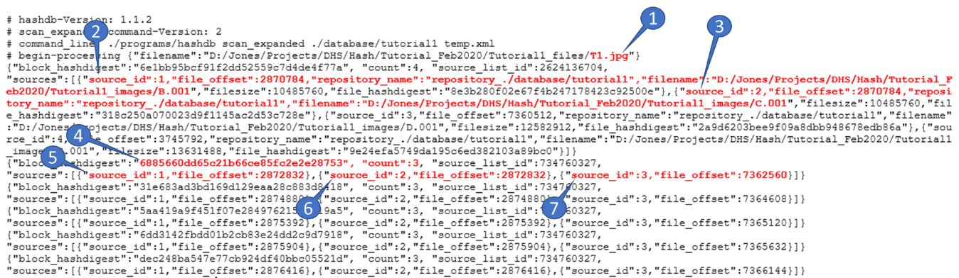

- The input file was T1.jpg
- The database disk image internally called source_id 1 is the file B.001 (see end of this long entry)
- Image C.001 is known internally as source_id 2, etc.
- The sector with hash value 6885... was found 3 times in the image database
- This sector was found on image 1 (B.001) at byte offset 2872832
- This sector was found on image 2 (C.001) at byte offset 2872832
- This sector was found on image 3 (D.001) at byte offset 7362560
The remaining lines in this file are similarly formatted: sector hash followed by image offsets. A future version of DMFT will parse this file for simplified interpretation and visualization.

You can verify the details above by examining the images directly. Open C.001 in HxD, go to byte offset 2872832, highlight the sector (512 bytes), then select Analysis, Checksums, MD5, then OK. The checksum displayed at the bottom of the page (6885...) should match the checksum from the results_hash_digests.txt file.
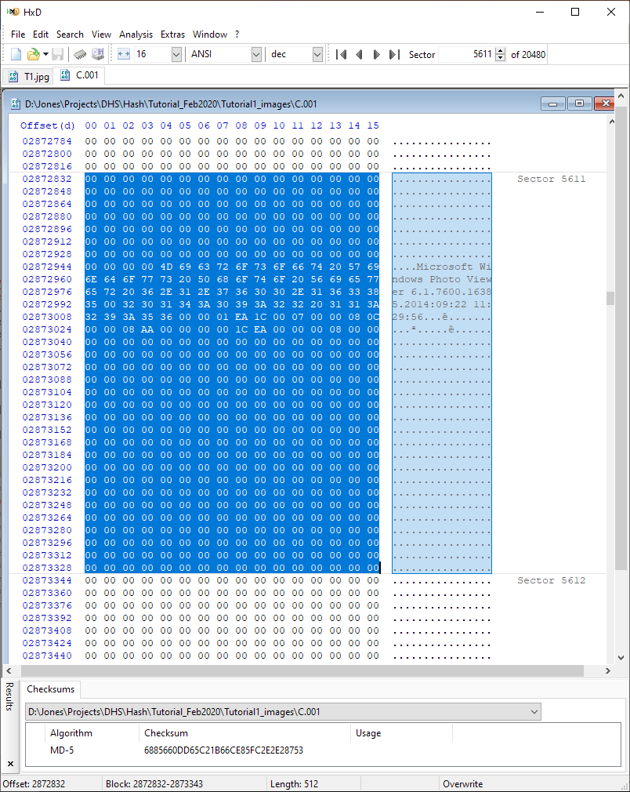

This sector (5611 in the disk image) is part of the T1.jpg file. For now, the easiest way to find that sector in the T1.jpg file is to highlight and copy the 512 bytes from the image file (above), then use the HxD Find function to locate the same bytes in the T1.jpg file.
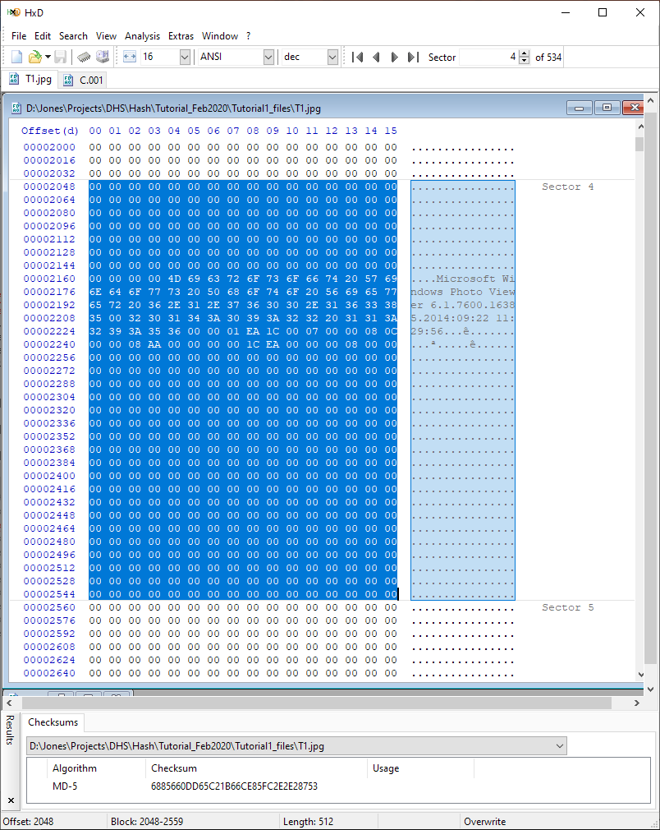

Repeat the query for the other four files
i. Just as background, information for the five test files and the amount of each on the disk images is below.
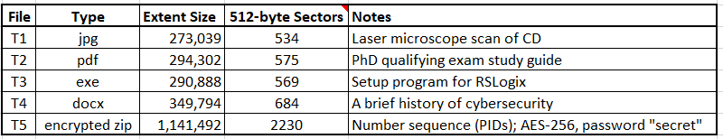

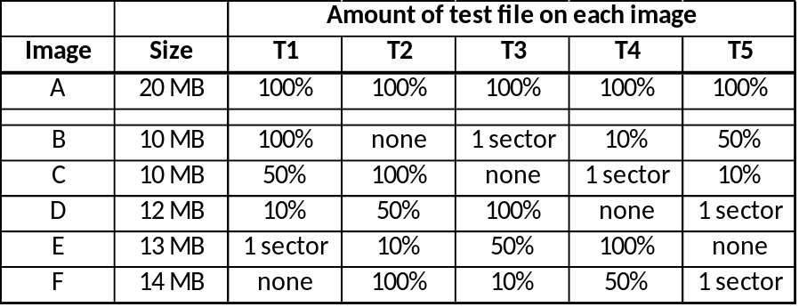

ii. Execute a search for each of the remaining test files (T2 - T5), e.g., use Browse for Media to select another input file, then click Submit.

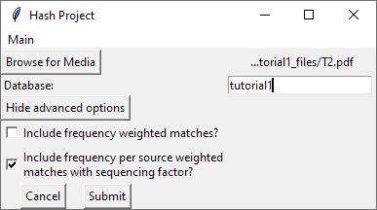

The results should match the table below (recommend using a JSON parser such as https://jsonformatter.org/json-viewer on the output file created when the analysis completes):
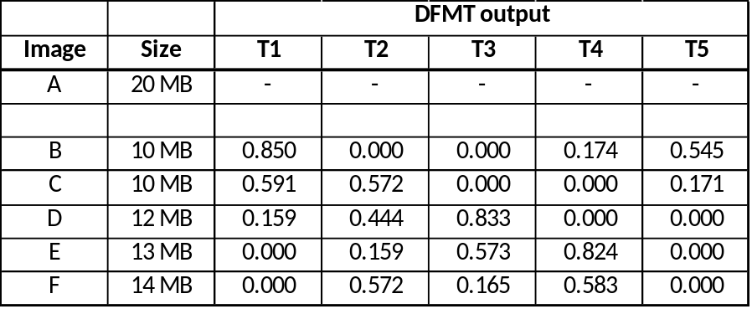

When opening a file in HxD, use Extras (or Tools) -> Open Disk Image (instead of File-> Open) to get the sector boundaries to show (accept the default of 512 byte sector size for this example).
In HxD, offsets are in hexadecimal by default; you can change this to decimal or octal using the menu bar dropdown (change hex to dec) or by left-clicking on the Offset(h) area in the upper left of each file display window.

