How to use kaggle data in colab

1. goto to g-drive and double click on Untitled0.ipynb and choose colab

2. goto <https://www.kaggle.com/zurman/account>

Scroll down to “Create New API Token”

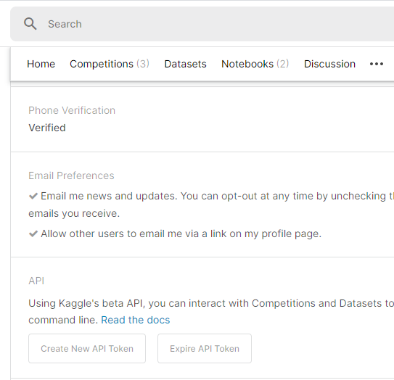

3. generate “kaggle.jos”

4. upload to colab via execution the following code on COLAB:

from google.colab import files

files.upload()

5. do the following

!mkdir -p ~/.kaggle

!cp kaggle.json ~/.kaggle/

# change the permission

!chmod 600 ~/.kaggle/kaggle.json

6. now In kaggle find data set you want, e.g.

!kaggle datasets download -d what0919/intrusion-detection

7. REFRESH Left Tab

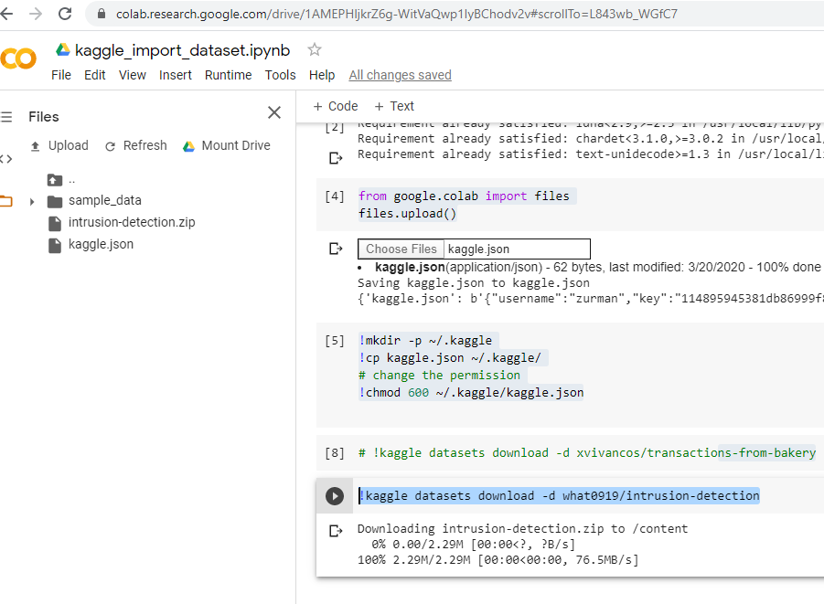

8. run

from zipfile import ZipFile

file_name = "intrusion-detection.zip"

with ZipFile(file_name, 'r') as zip:

  zip.extractall()

  print('Done')

now we have

