**Portugal Presidents user manual**

**Keyboard shortcuts**

|  |  |
| --- | --- |
| **➡️** | Next president |
| **⬅️** | Previous president |
| **SPACE** | Play/Pause video |
| **E** | Apply Edges filter |
| **T** | Apply Texture filter |
| **S** | Search presidents by its properties (name, start date, tags, etc.) |
| **C** | Clear search results |
| **G** | Generate metadata |
|  |  |

**Mouse**

**Mouse wheel (when mouse pointer is on presidents’ carrousel)**

Next President

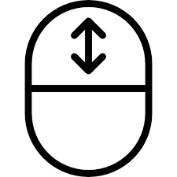

Previous President

**User Interface**

Clicking on a president picture with the left mouse button with switch to that president