Estimated Functions:

𝑦1 = 52.15805x- 189.8661

𝑦2 = 7.0015 x2+9.30386x -239.33403

𝑦3 = 0.820138x3+ 0.26176x2-0.01032x -175.2771

𝑦4 = 0.00598 x4+ 0.75521 x3+ 0.23455x2+1.17636x -175.88028

𝑦5 = 0.00085 x2- 0.0046x2+ 0.7528x2+ 0.5260x2+0.9659x -176.8373

Data Visualization:

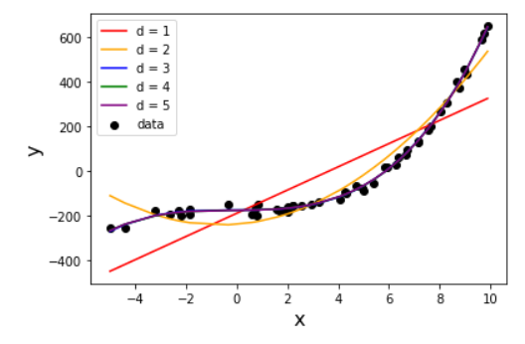

Discussion:

The data seems to best follow 3rd order polynomial 4th and 5th order could overfit the data. 1st order and 2nd order has large error as compared to higher order polynomial