Finding Best Lambda ( test lambda = [1,100] ):

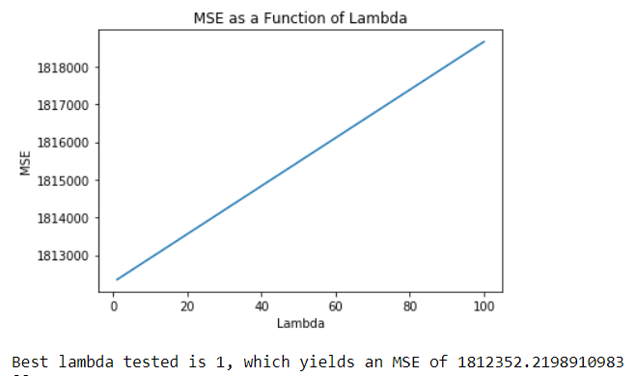

Based on the range of Lambda values tested, the best lambda value is 1 which yield an MSE of 1812352 as shown in plot above

Equation of best fitted model:

𝑦(x) = 5157.1181911 x1 -208.0110813 x2 -207.20822783 x3 -1431.94185492 x4 +237.83046737 x5 -31.50643342 x6 + 500.51745038 x7 +73.91684047 x8

- 460.23360732 x9 + 3928.07687554

predicted price y for a 0.25 carat, 3 cut, 3 color, 5 clarity, 60 depth, 55 table, 4 x, 3 y, 2 z diamond is $6724.2396, which was calculated using above best fitted model.

Finding Best Lambda ( Submission lambda = np.logspace(-1, 2, num=101) ):

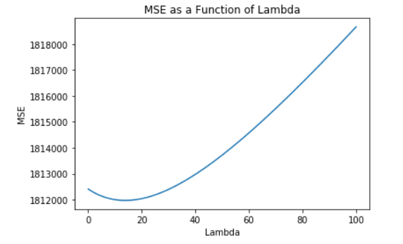

Based on the range of Lambda values tested, the best lambda value is 13.4896, which yields an MSE of 1811976.57 as shown in plot above

Equation of best fitted model:

𝑦(x) = 5115.6513 x1 - 201.49769x2 - 207.15474x3 - 1338.29096x4 + 219.18597 x5 - 66.36405 x6 + 500.90982 x7 +74.30622 x8 -459.07248x9 + 3928.07685

predicted price y for a 0.25 carat, 3 cut, 3 color, 5 clarity, 60 depth, 55 table, 4 x, 3 y, 2 z diamond is $4171.0496 which was calculated using above best fitted model