**Closest pair by Brute Force:**

**1**. Write a program that finds the closest pair of points in a set of 2D points using the brute force approach.

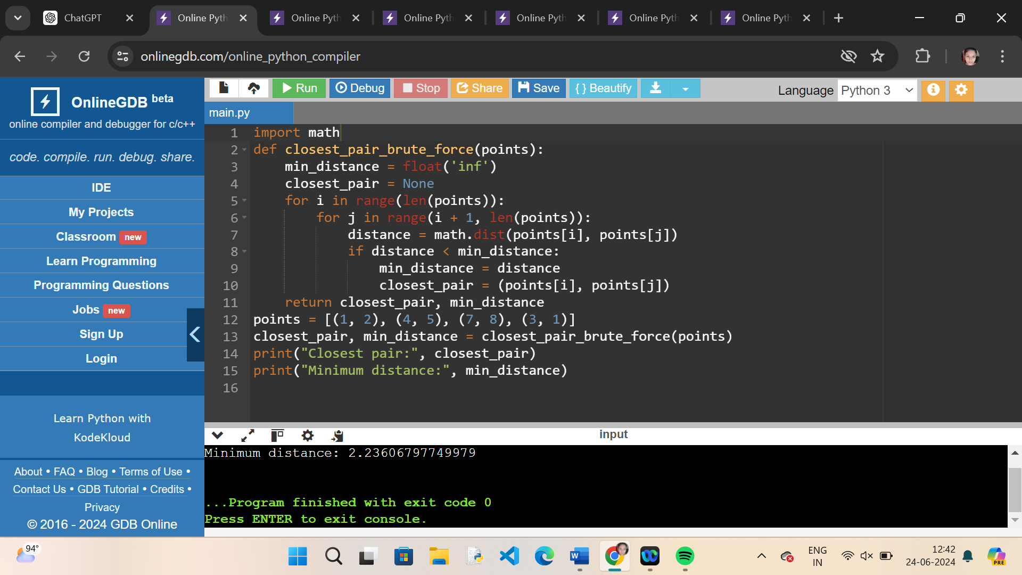

Write a program to find the closest pair of points in a given set using the brute force approach. Analyze the time complexity of your implementation.

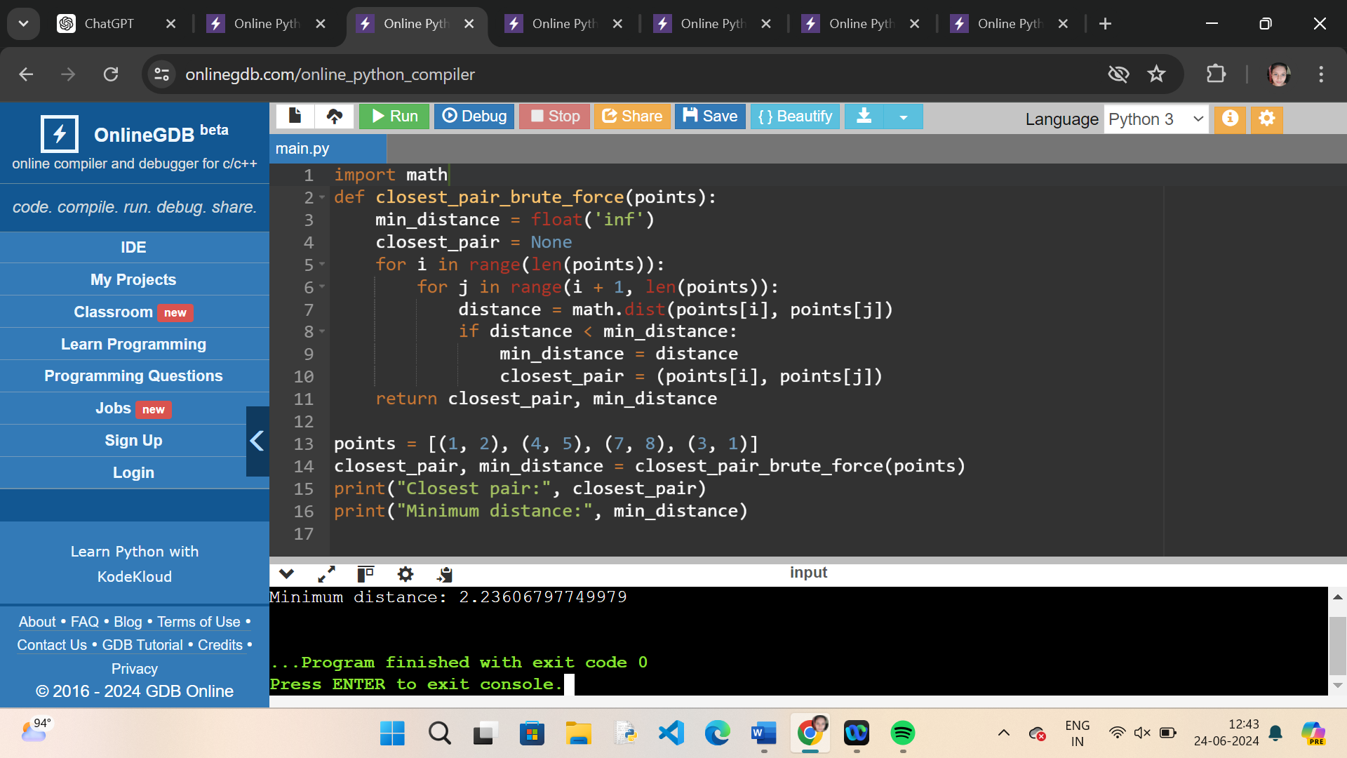

**. Exhaustive search:**

**Traveling Salesman Problem (TSP) with Exhaustive Search**

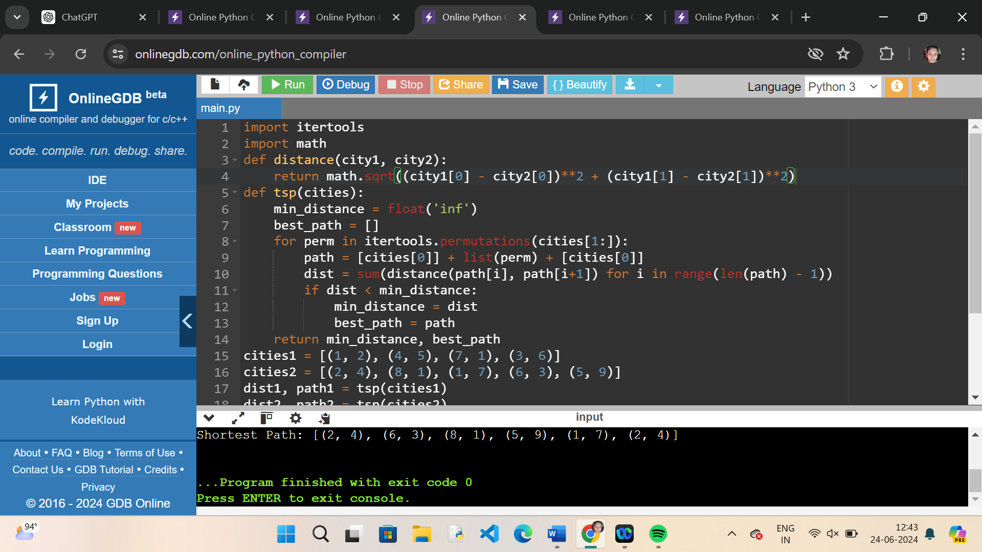

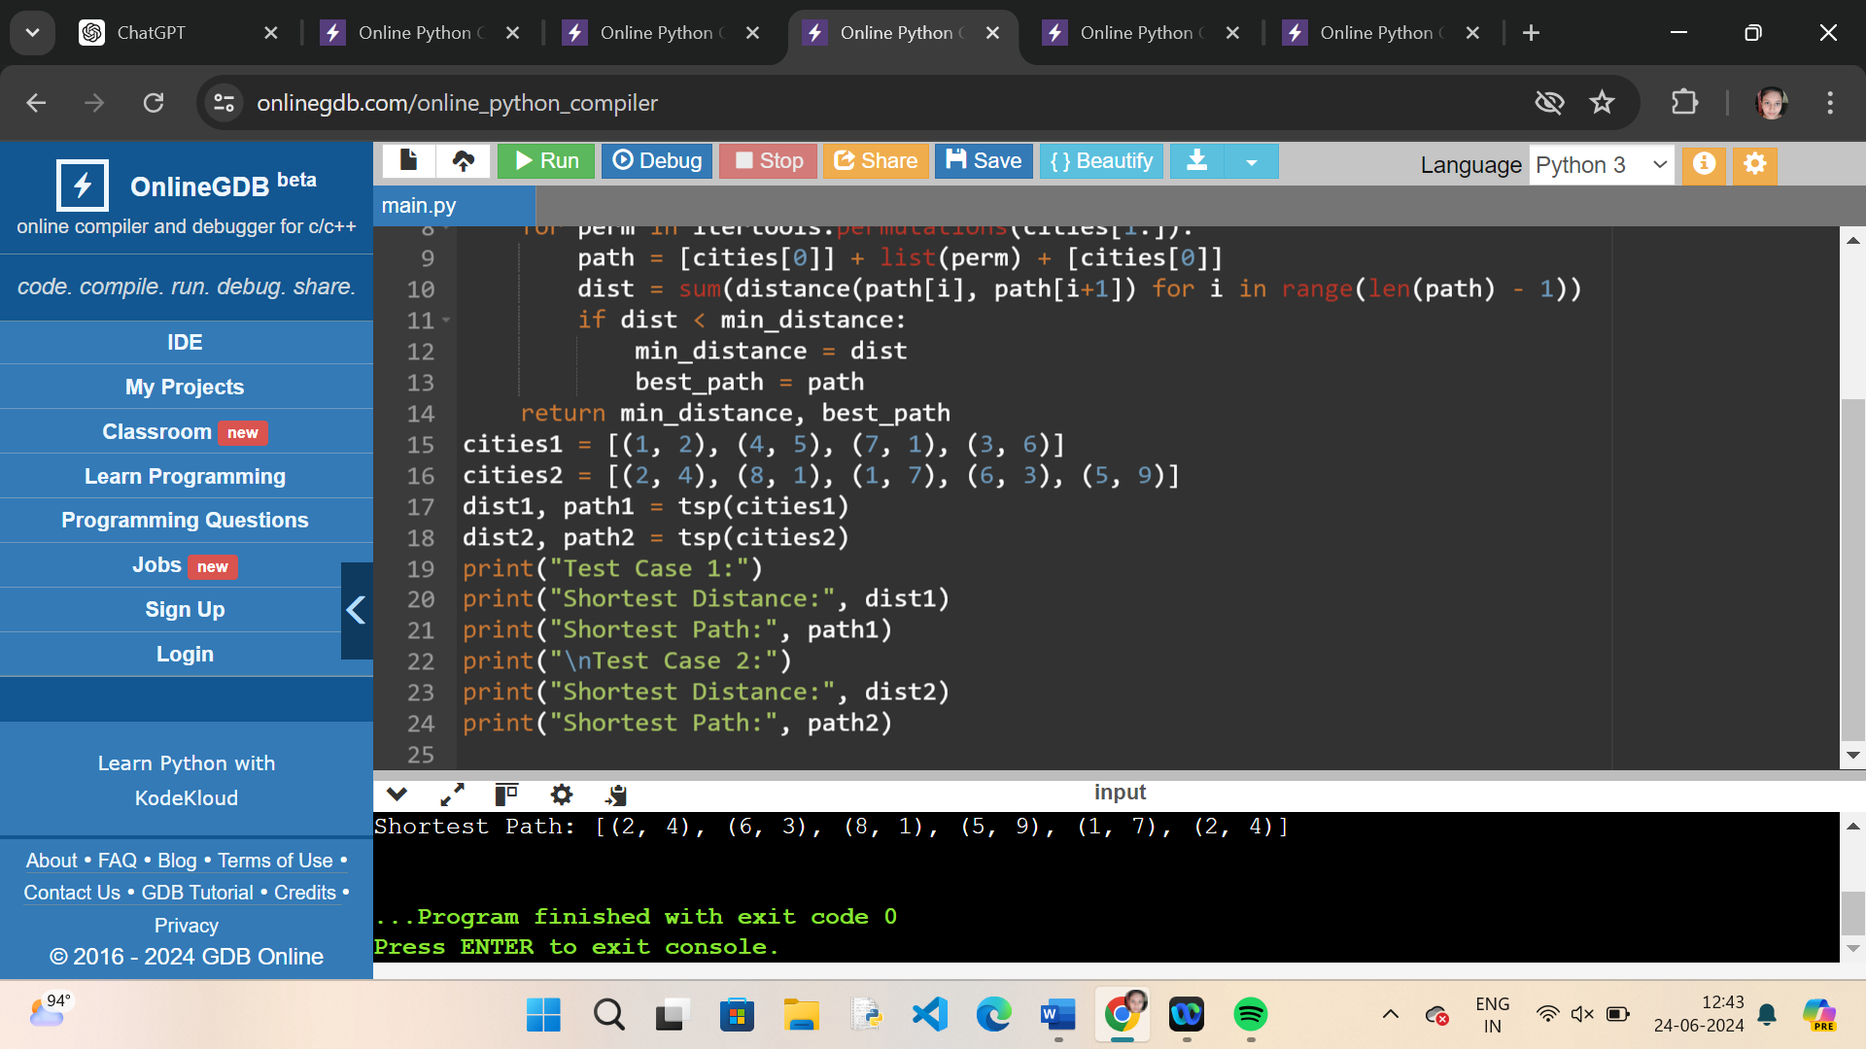

. **Knapsack** **Problem (TSP) with Exhaustive Search**

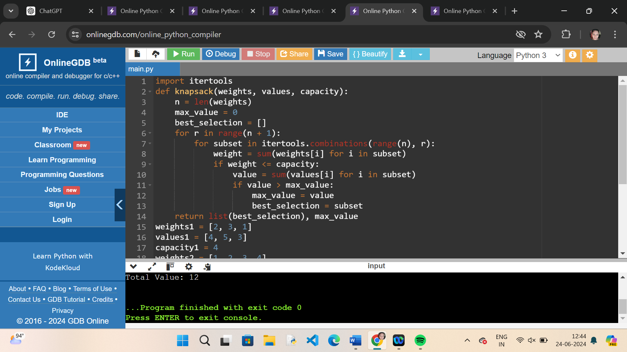

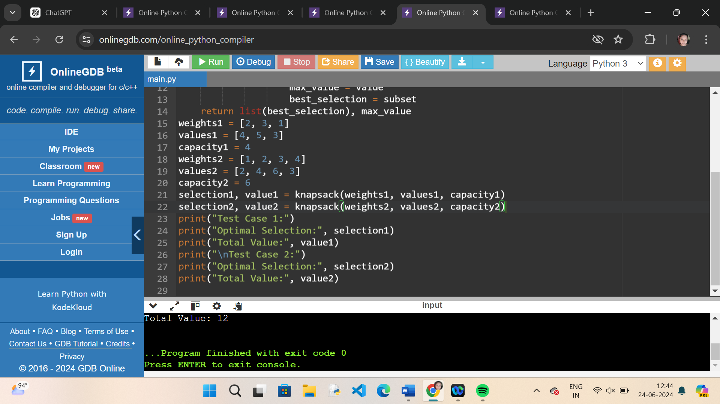

**.Dice throw problem**

You are given the number of sides on a die (num_sides), the number of dice to throw (num_dice), and a target sum (target). Develop a program that utilizes dynamic programming to solve the Dice Throw Problem.

