Design

OpenWCM

Overview
The portal is connected to the UCM to allow the WYSIWIG contribution of content and then the display of that same content back into the Portal. This functionality is called: “In Context Contribution”. This is a strong selling point of Web Content Management, and is a primary functionality desired by MOHE.

Types of Contribution Pages
There are two main types of contribution pages. The first type is a bulleted listing. The second type is a free-form WYSIWIG edit contribution page.

Bulleted List
The bulleted list allows for three different type of items to be contributed.
- A News Story or Announcement
- A document (PDF, DOC, XLS, etc..)
- A link (Internal or External)

Announcement
When a user contributes a news story or announcement, they are prompted to enter a Title, a Description and the Body of the announcement. This then leads to two pages being modified/created. The first page that is modified is the listing page where the user contributed the article. An additional bullet point is added. The bullet point becomes a link to the second page that gets created. This second page is the full announcement, showing the body as well as the other two items.

Documents
Any type of document can also be added. In this case the Title metadata field is used to provide the information that will be on the bulleted list page. When the user clicks on the document, a download dialogue will be displayed where they can choose to download the file.

Links
Links can be internal or external. The title contribution field will be used for the bulleted list.

Searching Contributed Content
For content that is contributed it actually is stored as XML in the content server. A separate page then takes the content and applys a template to it to format it. By default, searching the content server for these pages will simply return the XML pages which don’t make sense as a search result. To deal with this complexity a metadata field: SearchTarget has been created. The portal location where this item should be viewed is stored in this URL. The template to convert from XML to HTML is also specified here.

Contribution Default Metadata
When a contribution area is setup on the portal, we configure default metadata that will get applied to any content that is checked into that region. The default metadatas' that we apply at the moment are:
xSearchTarget
xWFApprover
xWFReviewer
xWFEscalation
Please see the write up on workflow to understand the meaning and purpose of the last three metadata fields.

Glossary
MOHE
Ministry of Higher Education
UCM
Universal Content Management
WYSIWIG
What You See Is What You Get
XML
Extensible Markup Language

Photo Gallery

Overview
The photo gallery is setup to run as a single page. Each time a folder is selected the page reloads passing the folder id as a parameter on the URL. When photos are checked in they will show up in the search results. We provided the ability to specify the content id of the photo on the URL so that when a user clicks on that search result they are taken to the photo gallery folder and image.

Configuration
The photo gallery is deployed as a web application and written as a JPDK portlet. There is one configuration setting in the web.xml where the root photo gallery folder id is specified. There are also configuration entries for specifying the content server to communicate with (port/hostname).
A component: FetchChildFolders was built and is required to be installed on the content server for the Photo Gallery to work as expected. This component defines services to return the folder tree structure.

Security
The security used with the Photo Gallery is the same as with all applications. It simply passes the username, retrieved from the portal context, to the content server through the RIDC java api. All actions: search, get photo, etc, pass the username as a parameter and apply the security of the content server to the action, thereby only returning photos that the user should have access to. As such, all security is delegated and controlled at the data layer level of the Content Server.

Navigation
There is a tree control on the user interface for users to navigate between the folders on the content server. This is a javascript control that is built with the results obtained from the FetchChildFolders component.

Glossary
JPDK
Java Portal Development Kit
RIDC
Remote Intradoc Client
URL
Universal Resource Locator

Workflow

Workflow on the UCM side
This document discusses the Workflow design.

Details
The workflow is setup as a three step workflow. Workflow gets triggered whenever an item is added to the content server and the metadata field: xWorkflow is set to a value of yes. The workflow has three required steps and one exception handling step.

Steps
- Contributor
- Reviewer
- Approver
- Escalation (Exception Step)
The Contributor step is to allow contributors time to work on their content and when they are finally ready to have the reviewer approve it, they release it from that step. This is a system required step.
The second step: Reviewer is specified by the username set in the metadata field: xWFReviewer. If the content item sits in this step for more than three days the item will be moved to the Escalation step. The user who will be required to approve here is identified in the xWFEscalation metadata field.
The third standard step is the: approver step. The user who is required to approve at this step is identified in the xWFApprover metadata field. This step has the same exception conditions as the Reviewer step with a timeout after 3 days.

Exception Flow
If an item goes into the exception step from the Review Step, when it returns it will go into the Approver step. If either the Approver or Reviewer is not specified then their step will be skipped. As such, it is important that at least one of the reviewer/approver fields be set or if both are not set the item will bypass all workflows.

Email Notificaiton
All users will be sent email notifications when a content item falls into their worklist. The email will contain two links. One link will point to the users worklist queue, the other link will point to the item in it’s location on the portal. This way the user can quickly see the item on the portal, then go to their worklist to approve/reject it.

Workflow on the Portal side
The workflow has a custom portlet built that is the task list for a given user. They can approve or reject the item directly from here. This screen will also have a link so they can see the item in the context of the portal, this helps them understand not only what is being approved, but where it will end up after approval. When a user rejects a workflow item it will provide the person rejecting with the opportunity to provide comments as to why the item is being rejected.

Glossary
UCM
Universal Content Management
UCM (Content server 10.1.3.3 patch to 10.1.3.5) install on RH 4.6 32 bit install procedure

NOTE: This instruction is part of the development environment setup and will install UCM on /u01/ucm as STELLENT USER. Please ensure that changes are made appropriately to any configuration depending where and who the install is actually done.

- Pre-req:
  - Files to be on the server:
    - Install file
    - server-linux-shared.zip
  - Files to be on local machine:
    - CS10gR34ContentAccessUpdate-20090505-4.zip
    - ContentAccess-linux.zip (unzip CS10gR34ContentAccessUpdate-20090505-4.zip to get file)
    - sitestudio9.0.0.506.zip
    - DesktopIntegrationSuite.zip
    - FetchChildFolders.zip
    - OracleCaseInsensitiveSearch.zip
  - Package httpd installed on server. If not installed, do the following:

[root@oracleucm u01]# yum install -y httpd
[root@oracleucm u01]# chkconfig --level 345 httpd on
[root@oracleucm u01]# service httpd start
Starting httpd: [ OK ]

Note: httpd is installed using yum (Yellowdog Update Modifier) so that all dependencies for that that package can be resolved easily. Ensure yum is correctly set up to run this command.

- Configuration at DB
  - Log in as Oracle user and run sqlplus as system.
[root@kurau ~]# su – oracle
[oracle@kurau ~]$ sqlplus
  - Create new content server user (idc2_user) and new database tables by running the following sql commands:
create temporary tablespace idc2_temp tempfile '/u01/app/oracle/oradata/orcl/idc2_temp.dbf' SIZE 100M REUSE AUTOEXTEND ON NEXT 5120K MAXSIZE UNLIMITED;

create tablespace idc2_sys datafile '/u01/app/oracle/oradata/orcl/idc2_sys.dbf' size 100M reuse autoextend on next 5120k maxsize unlimited;

create USER idc2_user IDENTIFIED by idc2_user temporary tablespace idc2_temp default tablespace idc2_sys quota unlimited on idc2_sys;

grant connect, resource to idc2_user;

  - Get Oracle instance name (ORACLE_SID)

[oracle@kurau ~]$ cat .bash_profile
# .bash_profile

# Get the aliases and functions
if [ -f ~/.bashrc ]; then
. ~/.bashrc
fi

# User specific environment and startup programs
export ORACLE_BASE=/u01/app/oracle
export ORACLE_HOME=$ORACLE_BASE/product/10.2.0/db_1
PATH=$PATH:$HOME/bin:$ORACLE_HOME/bin
export PATH
unset USERNAME
#Begin
export ORACLE_BASE=/u01/app/oracle
export OWB_ORACLE_HOME=$ORACLE_BASE/product/10.2.0/wb_1
export EDITOR=vi
export ORACLE_SID=MISSION
umask 022
export TNS_ADMIN=$ORACLE_HOME/network/admin
export LD_LIBRARY_PATH=$ORACLE_HOME/lib:/lib:/usr/lib:/usr/local/lib

#End

- UCM Installation
  - Add user (stellent)to install as:
[root@oracleucm u01]# useradd stellent
  - [root@oracleucm u01]# chmod -R 777 /u01
  - Run Installer as stelent user
[stellent@oracleucm ~]$ cd /u02/UCM/V13684-01/UCM/ContentServer/linux/
[stellent@oracleucm linux]$ ./Installer

Please select your locale from the list.
1. Chinese-Simplified
2. Chinese-Traditional
3. Deutsch
*4. English-US
5. English-UK
6. Español
7. Français
8. Italiano
9. Japanese
10. Korean
11. Nederlands
12. Português-Brazil
Choice? 4

Throughout the install, when entering a text value, you can press Enter to accept the default that appears
between square brackets ([]). When selecting from a list, you can select the choice followed by an asterisk
by pressing Enter.

Select installation type from the list.
*1. Install new server
2. Update a server
Choice? 1

Content Server Installation Directory

Please enter the full pathname to the installation directory.
Content Server Core Folder [/oracle/ucm/server]:/u01/ucm

Create Directory
*1. yes
2. no
Choice? 1

Java virtual machine
*1. Sun Java 1.5.0_11 JDK
2. Specify a custom Java virtual machine
Choice? 1
Installing with Java version 1.5.0_11.

Enter the location of the native file repository. This directory contains the native files checked in by
contributors.
Content Server Native Vault Folder [/u01/ucm/vault/]:

Create Directory
*1. yes
2. no
Choice? 1

Enter the location of the web-viewable file repository. This directory contains files that can be accessed
through the web server.
Content Server Weblayout Folder [/u01/ucm/weblayout/]:

Create Directory
*1. yes
2. no
Choice? 1

This server can be configured to manage its own authentication or to allow another master to act as an
authentication proxy.
Configure this server as a master or proxied server.
*1. Configure as a master server.
2. Configure as server proxied by a local master server.
Choice? 1

During installation, an admin server can be installed and configured to manage this server. If there is
already an admin server on this system, you can have the installer configure it to administrate this server
instead.
Select admin server configuration.
*1. Install an admin server to manage this server.
2. Configure an existing admin server to manage this server.
3. Don't configure an admin server.
Choice? 1

Enter the location of an executable to start your web browser. This browser will be used to display the
online help.
Web Browser Path [/usr/bin/konqueror]:/bin/bash

Content Server System locale
1. Chinese-Simplified
2. Chinese-Traditional
3. Deutsch
*4. English-US
5. English-UK
6. Español
7. Français
8. Italiano
9. Japanese
10. Korean
11. Nederlands
12. Português-Brazil
Choice? 4

Please select the region for your timezone from the list.
*1. Use the timezone setting for your operating system
2. Pacific
3. America
4. Atlantic
5. Europe
6. Africa
7. Asia
8. Indian
9. Australia
Choice? 1

Please enter the port number that will be used to connect to the Content Server. This port must be
otherwise unused.
Content Server Port [4444]:

Please enter the port number that will be used to connect to the Admin Server. This port must be otherwise
unused.
Admin Server Port [4440]:

Enter a security filter for the server port. Hosts which are allowed to communicate directly with the
server port may access any resources managed by the server. Insure that hosts which need access are
included in the filter. See the installation guide for more details.
Incoming connection address filter [127.0.0.1]:

*** Content Server URL Prefix

The URL prefix specified here is used when generating HTML pages that refer to the contents of the
weblayout directory within the installation. This prefix must be mapped in the web server Additional
Document Directories section of the Content Management administration menu to the physical location of the
weblayout directory.

For example, "/idc/" would be used in your installation to refer to the URL http://ucm.company.com/idc
which would be mapped in the web server to the physical location /oracle/ucm/server/weblayout.
Web Server Relative Root [/idc/]:

Enter the name of the local mail server. The server will contact this system to deliver email.
Company Mail Server [mail]:

Enter the e-mail address for the system administrator.
Administrator E-Mail Address [sysadmin@mail]:

*** Web Server Address

Many generated HTML pages refer to the web server you are using. The address specified here will be used
when generating those pages. The address should include the host and domain name in most cases. If your
webserver is running on a port other than 80, append a colon and the port number.

Examples: www.company.com, ucm.company.com:90
Web Server HTTP Address [oracleucm.lab.com]:oracleucm

Enter the name for this instance. This name should be unique across your entire enterprise. It may not
contain characters other than letters, numbers, and underscores.
Server Instance Name [idc]:oracleucm

Enter a short label for this instance. This label is used on web pages to identify this instance. It should
be less than 12 characters long.
Server Instance Label [idc]:oracleucm

Enter a long description for this instance.
Server Description [Content Server idc]:

Web Server
*1. Apache
2. Sun ONE
3. Configure manually
Choice? 1

Please select a database from the list below to use with the Content Server.
Content Server Database
*1. Oracle
2. Microsoft SQL Server 2005
3. Microsoft SQL Server 2000
4. Sybase
5. DB2
6. Custom JDBC settings
7. Skip database configuration
Choice? 1

Manually configure JDBC settings for this database
1. yes
*2. no
Choice? 2

Oracle Server Hostname [localhost]:192.168.9.34

Oracle Listener Port Number [1521]:

*** Database User ID

The user name is used to log into the database used by the content server.
Oracle User [user]:idc2_user

*** Database Password

The password is used to log into the database used by the content server.
Oracle Password []:idc2_user

Oracle Instance Name [ORACLE]:MISSION

Configure the JVM to find the JDBC driver in a specific jar file
1. yes
*2. no
Choice? 2

The installer can attempt to create the database tables or you can manually create them. If you choose to
manually create the tables, you should create them now.
Attempt to create database tables
1. yes
*2. no
Choice? 1

Select components to install.
1. ContentFolios: Collect related items in folios
2. Folders_g: Organize content into hierarchical folders
3. LinkManager8: Hypertext link management support
4. OracleTextSearch: External Oracle 11g database as search indexer support
5. ThreadedDiscussions: Threaded discussion management
Enter numbers separated by commas to toggle, 0 to unselect all, F to finish: 1,2,3,4,5

*1. ContentFolios: Collect related items in folios
*2. Folders_g: Organize content into hierarchical folders
*3. LinkManager8: Hypertext link management support
*4. OracleTextSearch: External Oracle 11g database as search indexer support
*5. ThreadedDiscussions: Threaded discussion management
Enter numbers separated by commas to toggle, 0 to unselect all, F to finish: F

Checking configuration. . .

The Oracle database user is missing privileges required by some product features. The script located on
the installation media at UCM/ContentServer/database/oracle/admin/contentserverrole.sql can be used to
grant sufficient privileges or set the install property InstallTablesWithoutFullTextPriv=true to
continue installation without requiring sufficient privileges. See the install documentation for more
information.

The configuration check detected some problems with the current
configuration. It is recommended that you correct the warnings
before proceeding with the install.

Review install settings. . .
Content Server Core Folder: /u01/ucm
Java virtual machine: Sun Java 1.5.0_11 JDK
Content Server Native Vault Folder: /u01/ucm/vault/
Content Server Weblayout Folder: /u01/ucm/weblayout/
Proxy authentication through another server: no
Install admin server: yes
Web Browser Path: /bin/bash
Content Server System locale: English-US
Content Server Port: 4444
Admin Server Port: 4440
Incoming connection address filter: 127.0.0.1
Web Server Relative Root: /idc/
Company Mail Server: mail
Administrator E-Mail Address: sysadmin@mail
Web Server HTTP Address: oracleucm
Server Instance Name: oracleucm
Server Instance Label: oracleucm
Server Description: Content Server idc
Web Server: Apache
Content Server Database: Oracle
Manually configure JDBC settings for this database: false
Oracle Server Hostname: 192.168.9.34
Oracle Listener Port Number: 1521
Oracle User: idc2_user
Oracle Password: S8IfZ6qBKAZjHGyfQWGsIQUiMMHmlggzzS1lRQTTn6s=
Oracle Instance Name: MISSION
Configure the JVM to find the JDBC driver in a specific jar file: false
Attempt to create database tables: yes
Components: ContentFolios,Folders_g,LinkManager8,OracleTextSearch,ThreadedDiscussions

Proceed with install
1. Proceed
*2. Change configuration
3. Recheck the configuration
4. Abort installation
Choice? 1
Finished install type Install at 3/3/10 8:15 PM.

- Post installation configuration
  - Update Apache(httpd) config file:
    - Check version of httpd:
[root@oracleucm ~]# httpd -v
Server version: Apache/2.0.52
Server built: Nov 12 2009 06:54:45
    - Update the config file as root:
If version is 2.0: /u01/ucm/shared/os/linux/lib/IdcApache2Auth.so
If version is 2.2:/u01/ucm/shared/os/linux/lib/IdcApache22Auth.so

[root@ucm1 u01]# vi /etc/httpd/conf/httpd.conf

Append the following :

LoadModule IdcApacheAuth /u01/ucm/shared/os/linux/lib/IdcApache2Auth.so

IdcUserDB idc /u01/ucm/data/users/userdb.txt

Alias /idc /u01/ucm/weblayout

<Location /idc>
DirectoryIndex portal.htm
IdcSecurity idc
Allow from all
</Location>

<Location />
IdcSecurity idc
</Location>

    - Restart httpd so changes take effect:
Stopping httpd: [FAILED]
Starting httpd: [ OK ]

  - Create startup script:

[root@ucm1 etc]# cat > /etc/init.d/stellent
#!/bin/bash
#
#
# chkconfig: 35 80 30
# description: Content Server startup script

# Source function library.

. /etc/rc.d/init.d/functions

STELLENT_OWNER="stellent"
STELLENT_HOME="/u01/ucm/"

start() {
su - $STELLENT_OWNER -c "$STELLENT_HOME/etc/idcserver_start"
su - $STELLENT_OWNER -c "$STELLENT_HOME/admin/etc/idcadmin_start"
}
stop() {
su - $STELLENT_OWNER -c "$STELLENT_HOME/etc/idcserver_stop"
su - $STELLENT_OWNER -c "$STELLENT_HOME/admin/etc/idcadmin_stop"
}
restart() {
stop
start
}
case "$1" in
start)
start
;;
stop)
stop
;;
restart)
restart
;;
*)
echo $"Usage: $0 {start|stop|restart}"
esac

[root@ucm1 init.d]# chmod 750 /etc/init.d/stellent; chkconfig --add stellent --level 0356;

- Patch and Package Install
  - Step 1:
    - Browse to: http://oracleucm/idc/
Login as
Username: sysadmin
Password: idc

    - Go to Administration > Admin Server >Click Oracleucm Button>Component Manage
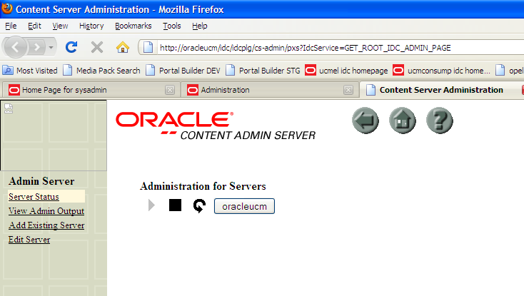
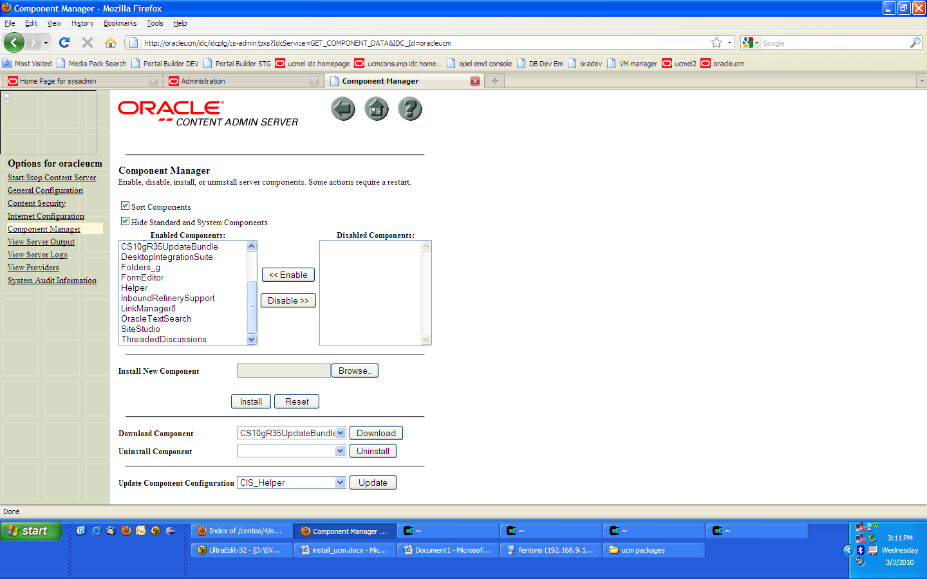

    - Click Browse and select file CS10gR34ContentAccessUpdate-20090505-4.zip (on local machine)
    - Click Install
    - Accept all defaults
    - Choose option to restart server
    - Click circular arrow button (beside stop button)to restart server
    - Do the above steps for the rest of the components:
      - ContentAccess-linux.zip (unzip CS10gR34ContentAccessUpdate-20090505-4.zip to get file)
      - sitestudio9.0.0.506.zip
      - DesktopIntegrationSuite.zip
      - FetchChildFolders.zip
      - OracleCaseInsensitiveSearch.zip

  - Step 2:
    - Stop oracleucm and httpd
[root@oracleucm u01]# service httpd stop
[root@oracleucm u01]# service stellent stop

    - Extract server-linux-shared.zip (on server) into the ucm folder. Answer ALL to replace all file in the directory

[root@oracleucm u01]# su - stellent
[stellent@oracleucm u01]# cd /u01/ucm
[stellent@oracleucm u01]# unzip server-linux-shared.zip
[stellent@oracleucm u01]# chmod -R 755 shared/os
    - Restart oracleucm
[root@oracleucm u01]# service httpd stop
[root@oracleucm u01]# service stellent stop

- Other settings
  - Set default metadata
    - In EM, navigate to Administration > Site Studio Admin > Set Default Project Document Information
    - Click update
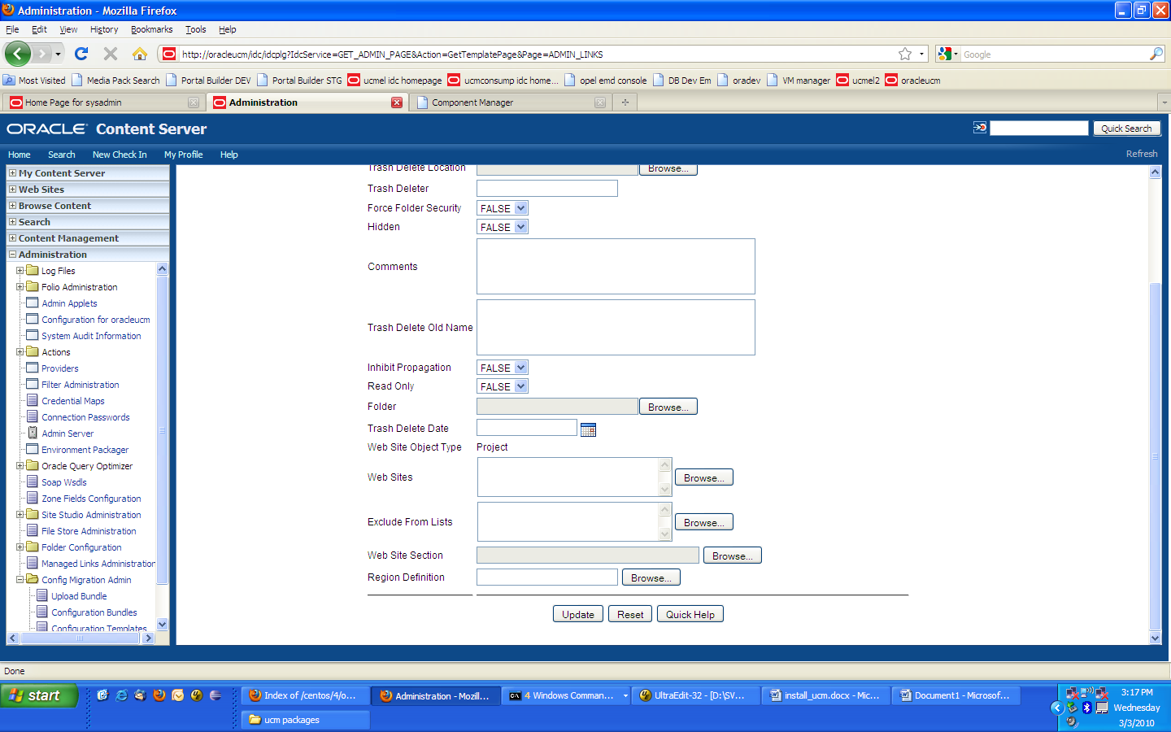

  - Set fields to be indexed
    - In EM, navigate to Administration > Zone fields configuration
    - Move Web Site Object Type and Web Sites from Text Fields table (right) to Zone Text Fields (left)
    - Click Update
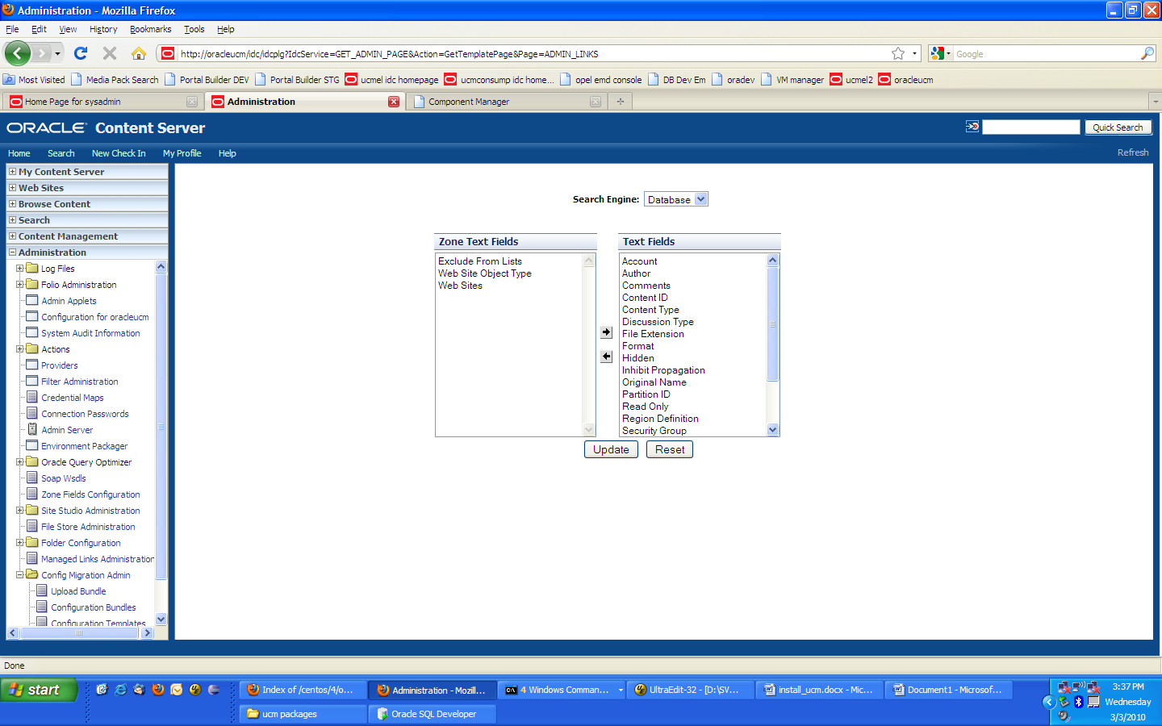

  - Update who connect to content server:

[root@oracleucm u01]# vi /u01/ucm/config/config.cfg

<?cfg jcharset="UTF8"?>
#Content Server System Properties
IDC_Name=oracleucm
IdcProductName=idccs
SystemLocale=English-US
InstanceMenuLabel=oracleucm
InstanceDescription=Content Server idc
SocketHostAddressSecurityFilter=127.0.0.1|*.*.*.*

#Database Variables
IsJdbc=true
JdbcDriver=oracle.jdbc.OracleDriver
JdbcConnectionString=jdbc:oracle:thin:@192.168.9.34:1521:MISSION
JdbcUser=idc2_user
JdbcPassword=S8IfZ6qBKAZjHGyfQWGsIQUiMMHmlggzzS1lRQTTn6s=
JdbcPasswordEncoding=Intradoc
DatabasePreserveCase=true

#Internet Variables
HttpServerAddress=oracleucm
MailServer=mail
SysAdminAddress=sysadmin@mail
HttpRelativeWebRoot=/idc/
CgiFileName=idcplg
UseSSL=
WebProxyAdminServer=true

#General Option Variables

#Additional Variables
DatabaseType=oracle
SearchIndexerEngineName=DATABASE.METADATA
WebServer=apache
IdcAdminServerPort=4440
IntradocServerPort=4444

- Full-Text Search
  - In EM, navigate to Go to Administration > Admin Server >Click Oracleucm Button> General
  - In the Additional Configuration Variables edit box change SearchIndexerEngineName=DATABASE.METADATA to SearchIndexerEngineName=DATABASE.FULLTEXT
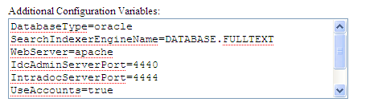
  - Restart oracleucm
  - From oracleucm file system, from directory /u01/ucm/database/oracle/admin/, copy batchsnippets.sql and stellentrole.sql to the database filesystem
  - Login to the database as oracle and run sqlplus as the content server db user (idc2_user). Run batchsnippents.sql

[oracle@kurau ~]$ sqlplus

SQL*Plus: Release 10.2.0.4.0 - Production on Mon Mar 29 11:34:50 2010

Copyright (c) 1982, 2007, Oracle. All Rights Reserved.

Enter user-name: idc2_user
[oracle@kurau ~]$ sqlplus

SQL*Plus: Release 10.2.0.4.0 - Production on Mon Mar 29 11:36:12 2010

Copyright (c) 1982, 2007, Oracle. All Rights Reserved.

Enter user-name: idc2_user
Enter password:

Connected to:
Oracle Database 10g Enterprise Edition Release 10.2.0.4.0 - 64bit Production
With the Partitioning, Oracle Label Security, OLAP, Data Mining Scoring Engine
and Real Application Testing options

SQL> @batchsnippets.sql

  - Run sqlplus as SYSTEM and run stellentrole.sql
[oracle@kurau ~]$ sqlplus

SQL*Plus: Release 10.2.0.4.0 - Production on Mon Mar 29 11:42:34 2010

Copyright (c) 1982, 2007, Oracle. All Rights Reserved.

Enter user-name: system
Enter password:

Connected to:
Oracle Database 10g Enterprise Edition Release 10.2.0.4.0 - 64bit Production
With the Partitioning, Oracle Label Security, OLAP, Data Mining Scoring Engine
and Real Application Testing options

SQL>@ stellentrole.sql
SQL> grant stellent_role to idc2_user;
SQL> grant unlimited tablespace to idc2_user;

  - Go to EM, navigate to Administration > Admin Applets > Repository Manager > Indexer tab
  - In the Collection Rebuild Cycle, click Start to start the indexer. Wait until the Start button is enabled again.
  - Go to option, Exit.

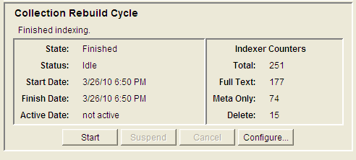

INSTALLATION NOTES:

- DEVELOPMENT
  - Database:
    - Hostname: kurau.htp-mohe
    - IP: 192.168.9.24
    - File system user/password: root/p244w0rd, oracle/oracle
    - DB system password: p244w0rd
    - Content server user/password: idc2_user/idc2_user
    - Table space directory: /u01/app/oracle/oradata/orcl/
    - Oracle Instance Name: MISSION

  - Content Server:
    - Hostname: oracleucm.lab.com
    - IP: 192.168.9.176
    - File system user/password: root/welcome1, stellent/welcome1
    - UCM installed as stellent user
    - Install directory: /u01/ucm
    - EM URL: http://oracleucm/idc
    - Sysadmin password: idc

- STAGING
  - Database:
    - Hostname: ketuka.oas.com.my
    - IP: 10.22.191.159
    - File system user/password: root/pmo123, oracle/oracle
    - DB system password: pmo123
    - Content server user/password: idc4_user/idc4_user
    - Table space directory: /u01/app/oracle/oradata/MISSION/
    - Oracle Instance Name: MISSION

  - Content Server:
    - Hostname: plotan.oas.com.my
    - IP: 10.22.191.157
    - File system user/password: root/welcome1, oracle/oracle
    - UCM installed as oracle user
    - Install directory: /home/oracle/product/10.1.3/ucm_2
    - EM URL: http://ucmstage/idc
    - Sysadmin password: idc
    - NOTE: Since there are no DNS, put entry inside host file:
10.22.191.157 ucmstage

