# OpenWCM & Portal Integration Design

Several parts of the MoHE website will be integrated with OpenWCM. They will take advantage of the in-context contribution features of OpenWCM. This is a three-tier architecture as can be seen in the following diagram.

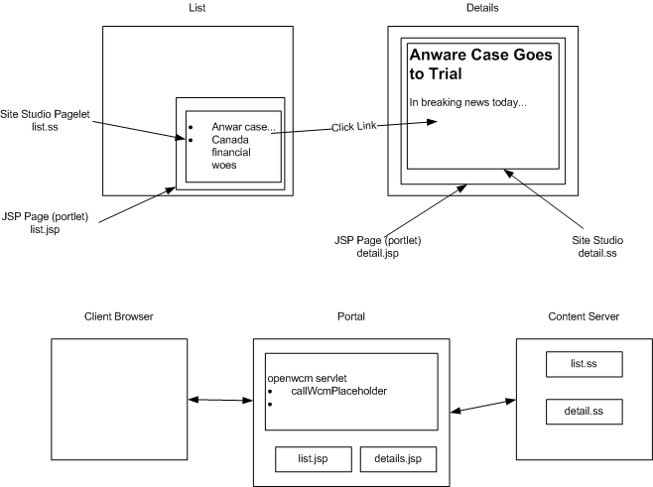

A primary use case where we will be using this functionality is to achieve what we call the Announcements functionality. This is where there is a first page that has a bulleted list of links, we call this the list page. These links then point to a details page that contains the full information associated with the link. We call this the details page.

The way this type of functionality is achieve in WCM has already been developed by the team and won’t be documented here. To bring this functionality into the Portal environment we create two jsp pages, list.jsp and details.jsp. The list.jsp page will include the site studio assets which we just call list.ss but are actually a datafile and placeholder, but this document isn’t the place to go into details to describe exactly what those things are.

The important thing is to construct links in the list.ss that will then target the details portal page and pass in the specific article they are concerned with. The details.jsp page will then accept the article id as a parameter and request that specific resource from the content server.