# System Setup

* Download Fusion Factory (Retriever) ECM 7 VM Image and perform tutorial in the VM.
* Watch the viewlets on the following page for background information:

http://www.oracle.com/technology/products/content-management/ucm/SiteStudio10gR4Tutorials/index.html

# Tutorial Steps:

## Start a new site:

* File > Site > Connection Manager > New > Server CGI Url: http://content.ravenna.com/idc/idcplg > Connect > Site Label - New > ID: <somename, ie:fenton2>> Name: <somename, ie:fenton2>> OK > OK > Done

## Create a Page Template / layout (home page):

* Right Click 'Home'
* Select Home Page

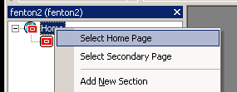

* Create New Template Page >hcsp> OK > Title: <sometitle, ie:fenton2_home_page > Type: WebAsset> Click: 'Assign Info' button > double click on page to edit it.

## Create a wysiwig Element

* Site Assets pull down select Element Definitions

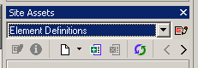

* Choose new Wysiwyg Element Definition > assign metadata and click ‘assign info’

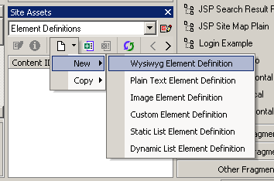

## Create a Region Definition

* Site Assets pull down select Element Definitions > Choose new ‘Region Definition > Assign metadata

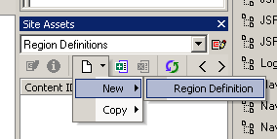

## Add Element to Region Definition

* Double click the newly created region definition in Site Assets window to open it in Designer > Add
* Give the element the new Name, Label, and Info that will appear in Contribution, the element definition created earlier should be available in the Element Definition ID drop down. Select it to make it a part of this Region Definition. Save and click ‘X’ to close Region Definition.

## Create a Region Template and associate it with Region Definition above.

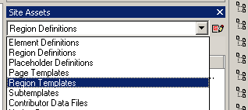

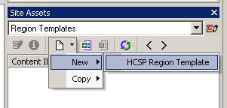

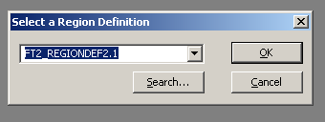

* Choose Region Templates from Site Assets drop down. > New > HCSP Region Template. Associate with Region Definition created above. Assign metadata.
* Double click newly created Region Template to edit it.

## Right click inside the Template and insert the above Element

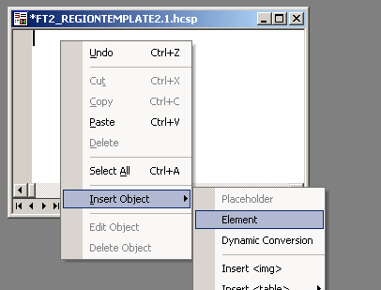

## Create a Placeholder (Definition) and double click to edit.

## Add Region (Definition) to Placeholder

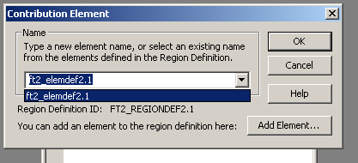

## Add the (Region) Template, save and close.

## Map Placeholder (Definition) to a specific name. Tools menu.

* Tools Menu > Define Placeholder Definitions Mappings > Add > Pick a name and choose the placeholder you created above for both the primary and secondary ID’s > OK

## Now we can put the placeholder into the layout.

* Click ‘Insert Placeholder’ button > Chose the Map Placeholder Definition you created.

## Now a datafile must be created to store the content contributed to the layout page.

* Right click on Home Page (Page Template) layout and select "Assign Content"

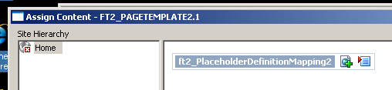

* Click the green plus symbol to add content

C:\Documents and Settings\Administrator\Desktop\docs\FY10 Initiatives\openwcm\pics\Picture 9.png

* Choose New Contributor data file > Next > Assign Metadata > Next > Finish

## Preview web page

* Click on preview button.

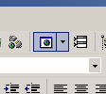

## Add content to the web page

* Ctrl-Shift-F5 to activate contributor mode.
* Select pencil icon to go into contributor mode.

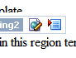

* Muck around and eventually his save/update disk icon.
* Come out of contributor mode: Ctrl-Shift-F5.