**Project report for the course Multisensory Interactive Systems Academic Year: 2010-2020**

**Turning music interaction into a multisensory game-like experience**

**Domenico Sebastiani (mat) – mail**

**Francesco Trebo (198899) – francesco.trebo@studenti.unitn.it**

**Reference possibili**

1. **Lord of the chords**: These guys created a card game for musicians. They proved that turning classical approaches to familiarize with technical concepts into a game experience is interesting for musicians.  
   <https://medium.com/@jonathanng/i-hated-music-theory-how-i-ended-up-creating-a-music-theory-card-game-musicians-love-ee857ea3c16d>  
   -  
   <https://www.lordofthechords.com/>
2. **Dato duo:** “It’s instrument for making electronic music together”  
   Two sides play together: One is a sequencer and the other a synthesizer.
3. **Position of Slowly adapting mechanoreceptors in hands**<https://www.researchgate.net/figure/3-Mechanoreceptors-in-glabrous-skin-vary-in-the-size-and-structure-of-their-receptive_fig2_265246764>  
   <https://www.researchgate.net/publication/265246764_Coding_of_Sensory_Information>
4. **Teenage Engineering**   
   <https://teenage.engineering/products/synthesizers>

**Abstract**

Briefly summarize your project report.

What is the problem you are trying to solve?

What is your solution?

Why is your solution a good one, and why would users want to use it?

What are the key aspects of your solution that will distinguish it from other work that is out there?

What are the main evaluation findings?

1. **Introduction**

What is your project about?

What are you trying to achieve with your project?

What is the context of your project?

What are the motivations for your project?

What are your hypotheses?

Why this area is interesting (e.g., potential applications, open scientific questions)?

What (if any) of the theoretical perspectives on multisensory perception / interactive systems (introduced in class) does your approach build on, question, test?

This project describes the ideas, development and first evaluation of an interactive musical device.

The aim of this project is to understand whether the playful interaction between two people and a particularly devised musical device can help introducing non musician players to basic musical concepts like tempo or sound effects.

When speaking of getting into music playing, having to own an instrument hasn’t been a blocking factor since mass production allowed to have a simple guitar or flute in almost every house, but the learning curve on many of these instruments can be as rewarding as steep. This often leads to difficulties when first starting to play an instrument and the player, especially young ones, can lose interest in the activity.

Our project proposes a game-like music experience, designed to be played by two people. The designed device allows the generation of music through its audio interface and matching visual effects on a screen through its video interface.

The audio interface features a simple step sequencer along with several controls that allow to modify features of the produced sound. The video interface is composed of a game controller and a program that mixes information coming from it and from the audio interface, generating visual effects that can be shown on a screen or a projector.

The game controller features an analog joystick, an accelerometer and a vibrating motor to provide haptic stimuli to the user.

The hypothesis is that non-musician users, through the video interface, will benefit from having to listen actively to music, interact through the controls and receiving haptic stimuli and that the experience recorded can help having a playful and serene interaction with the more complex audio interface.

The area that explores playful music interaction is interesting because it includes a class of possible devices, software programs or instruments that can be educational for non-musicians but also recreational. (todo: expand)

The projects itself is based on the concept of embodied interfaces, interactive sonic experience design and haptic perception (specifically SA-RA mechanoreceptors).

1. **Related work**

What have others done that is similar or related to your project?

What similar interactive systems are there?

What are related approaches? Are they inadequate? i.e., is your proposal an advance over state-of-the art?

Include citations for related work (you can build upon the bibliography cited at the end of each lesson and complement it). You can cite the scientific literature and/or URLs. The citations and URLs should appear in a list of references at the end of the report.

One of the works that inspired part of this project is the Dato Duo music synthesizer by Dato Musical Instruments which is a very accessible “synth-for-two” designed with simplicity in mind and meant to be played by two people. It features a synthesizer side that contains controls that shape the sound produced and a sequencer side which controls act on the rhythm and the melody produced. (TODO: reference)

The proposed device is inspired to the successful two-people approach but diverges on the sensory modalities used, trading off the simplicity of a sound-only experience with a device that provides audio, video and haptic interaction in order to convey more information.

A similar natural graphic approach, even if on a more reasonable scale for a music synthesizer, is used by Teenage Engineering in their OP-1 and Pocket Operator lineup. (TODO: reference)

On the software side there are many games and programs trying to teach music basics to young children but also a good example of how a game-like approach can be effective with music students that need to familiarize with more structured music theory concepts: this refers to “The lord of chords”, a successful card game based on chords that was highly praised by music students and teachers. (TODO: reference)

All this products and projects are partially similar to the proposed device, some in the modalities and some in the motivations, but it seems to us that that our approach has not been used yet and it is worth exploring.

1. **Architecture design**

Present the detailed design of your system.

What key assumptions are you making about your system, its users, and/or the environment in which it will be used?

What justification do you have for those assumptions being reasonable?

What are the components of the architecture, how do they fit together and talk to one another? What tools are you using?

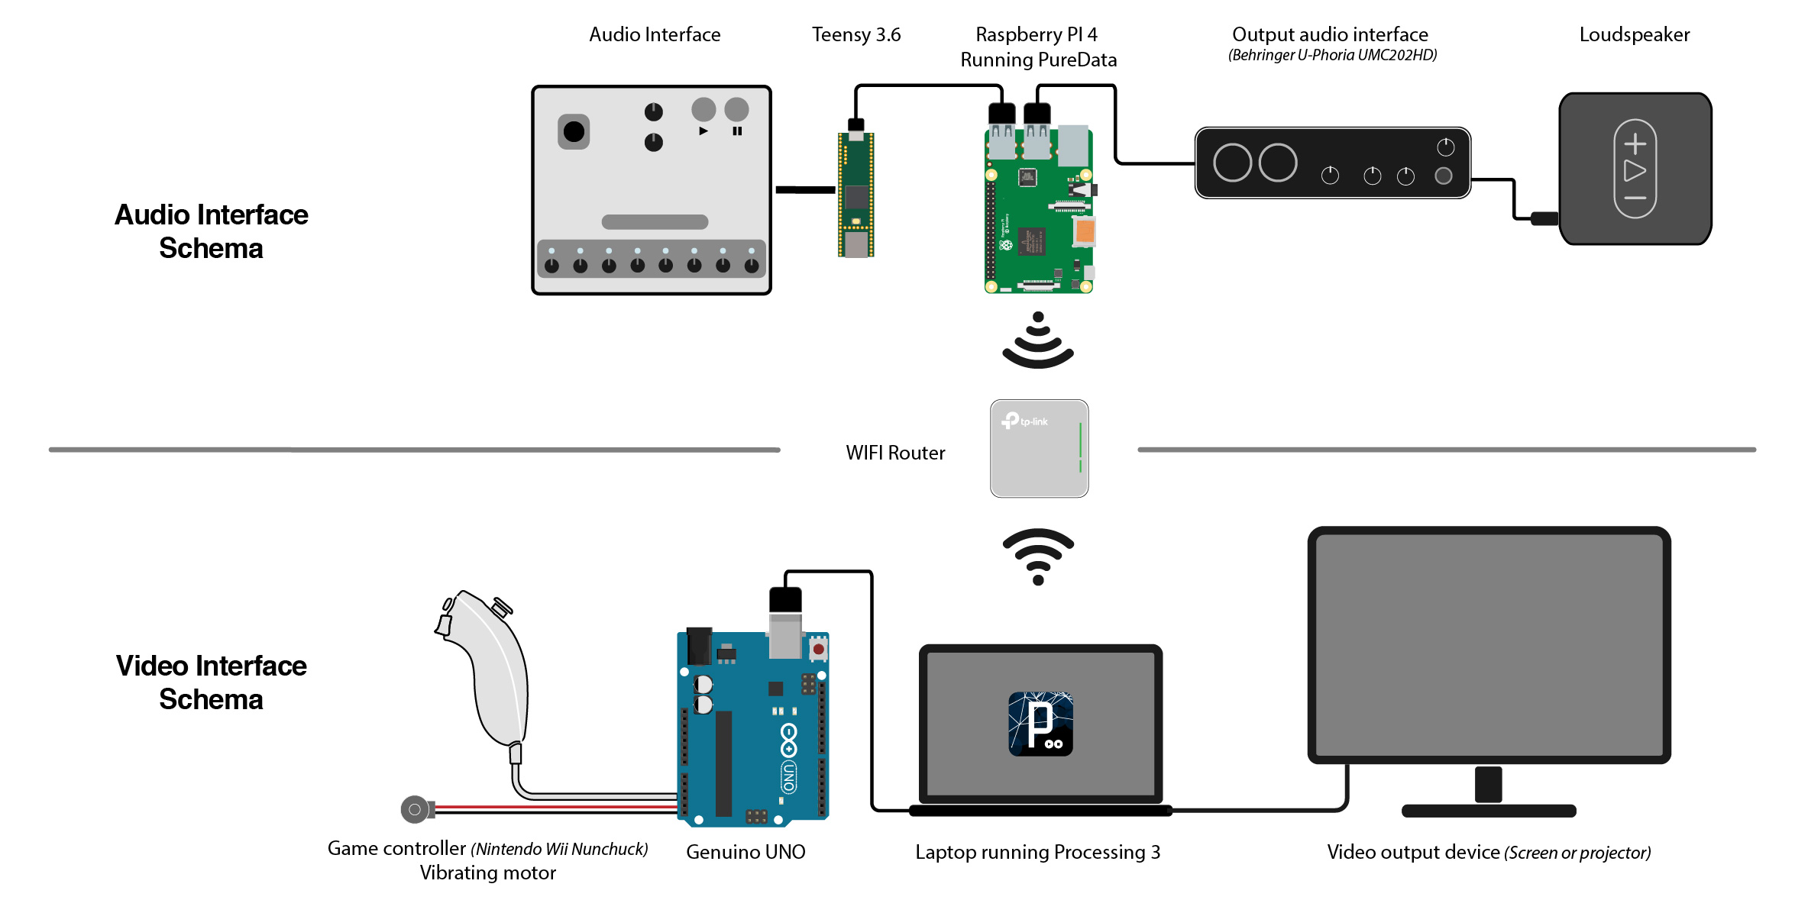

The physical device is divided in an audio and a video section.

**Audio Synthesizer**

The Audio Interface is composed by a control interface with:

* 8 potentiometers for each note of the sequence played.
* 8 LEDs, one for each note potentiometer, indicating the current step of the sequence.
* 1 analog joystick controlling:
  + On the horizontal axis, the amount of detune between two superimposed waveshapes and the amount of delay feedback applied.
  + On the vertical axis, the shape of the sound waveform (morphing from a soft triangle wave to a square wave).
* 1 potentiometer controlling the cutoff frequency of a lowpass filter.
* 1 potentiometer controlling the tempo of the sequence.
* 1 Ribbon sensor controlling the note sustain through an envelope generator.
* 2 Buttons for Play and Pause.

**Video Synthesizer**

The video synthesizer consists in a laptop and a Nintendo Nunchuk Controller that features a three-axis accelerometer for motion-sensing and tilting and an analog joystick, connected through an Arduino UNO board.

The Arduino board converts the movements of the joystick into pulses, whose tempo is compared to the music BPM. A rumble motor, connected to the joystick, provides the user a tactile stimulus of the music tempo.

The laptop runs a Processing3 Script which reads messages from Arduino and from the Audio interface and uses both to control visual effects that are generated on the screen. The laptop can also be connected to a bigger monitor or projector in order to produce a more immersive experience.

The choice of a good spot plays a critical role in the quality of the experience. A quiet room must be chosen in order to allow users to focus their attention on the generated sound. The presence of a big screen or projector could make the experience more immersive.

Users of all ages must be willing to enjoy a game-like experience with the goal of achieving the best result possible, by keeping in mind that, being this the first prototype iteration, the interfaces must be used with particular care.

**3.1 Usage model**

Describe how a user is going to use your system. Think about this as like a user manual. Describe the system from a user’s perspective. For example, the user does not need to know the components of your system and how it works internally, but the user does need to know what sensors to use to do various things. As part of the model, you should describe your user interface design.

The system is meant to be used by two people: one playing with the Audio interface and one with the Video interface.

**Audio interface**

Note that in-depth knowledge of the mapping between sensors and actions performed is not mandatory in order to enjoy the system, however knowing more can help exploring special sound features or effects.

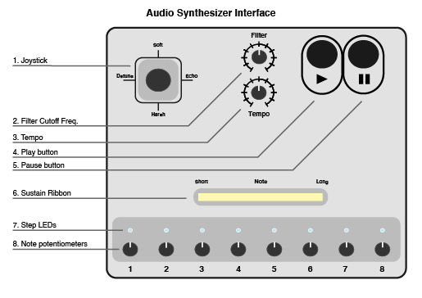

The audio components, as indexed in figure (TODO: add reference) are:

1. Analog Joystick: It can be moved along the vertical and/or horizontal direction and it controls different sound features, namely:
   1. Waveshape - vertical direction: The middle position indicates a 50% balance between 2 oscillators producing a Triangle wave and a Square wave.  
      Moving the stick towards the top position increases gradually the triangle wave (soft) contribution, while moving it toward the bottom increases the contribution of the square wave (harsh)
   2. Detune - Horizontal-Left direction: Moving the stick to the left increases gradually the frequency gap between the main oscillator and a second one (detuned oscillator). This is done at the same time for the two waveshapes (so 2 main oscillators, 2 detuned oscillators).
   3. Delay Feedback - Moving the stick to the right increases the amount of delay feedback added to the sound.
2. Filter Cut-off Frequency knob: It controls the cut-off frequency of a lowpass filter.
3. Tempo knob: It controls the speed of the note sequence.
4. Play button: When pressed, the note sequence starts playing.
5. Pause button: When pressed, the note sequence stops playing.
6. Sustain ribbon/soft-pot: This is used by sliding a finger over the sensitive area (white). Sliding the finger to the left shortens the note sustain while sliding it to the right makes it increase.
7. Step LEDs: The LED turned on indicates the current playing note.
8. Note potentiometers: The 8 potentiometers control the 8 notes of the played sequence, varying the sound from low pitched notes (far left) to high pitched ones (far right). The notes are quantized on a diatonic scale, so that it’s harder to produce dissonant tunes.

All the controls modify the produced sound and some of them affect also visual features generated by the video interface.

**Video Interface**

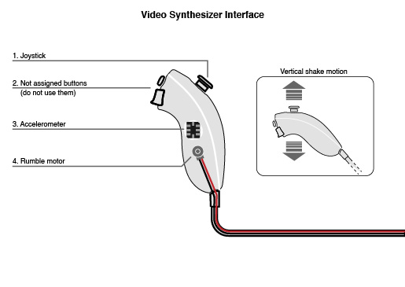

The video interface is composed of a computer, eventually connected to an external monitor or projector, and the game controller.

The controller features:

1. Analog Joystick, which controls some visual effects;
2. 2 Buttons: The buttons are part of the controller, but they are not used for this application. Pressing either buttons has no effect.
3. Accelerometer: it measures the movements of the game controller. Shaking the controller vertically at the rhythm of the beat will improve the amount and the quality of visual effects, colours, etc.
4. Rumble Motor, which vibrates at the rhythm of the beat.

Different combinations of the user actions can produce an increase or decrease of the variety, colourfulness and speed of the visuals.

1. **Implementation**

Which parts of your system are implemented?

How were they implemented?

What tools did you use for doing the implementation?

Which libraries did you use?

What parts of your design were interesting from an implementation perspective?

What kind of optimizations did you do?

You can add references to the code snippets listed in the Appendix.

The system can be subdivided in two main sections.

**Audio Interface**

The audio interface consists in a custom designed desk with several sensors and LEDs, connected to a Teensy 3.6. The board manages sensor reading and sends/receives messages to/from a Single Board Computer (Raspberry PI 4) through serial communication.

The Raspberry PI runs a Miller Puckette’s Pure Data patch, with different functions:

* Audio synthesis
* Serial Communication with the Teensy board
* OSC (Open Sound Control) Communication with the video interface, via a local Wi-Fi network.

The output device is a generic audio interface connected with a loudspeaker.

The Wi-Fi LAN is created using a Tp-Link wireless router and exploits the 5Ghz frequency band when possible, for faster communication.

**Video Interface**

A Nintendo Nunchuk Controller has been connected to an Arduino UNO board via I2C communication. A specific library by G. Bianconi has been used as reference, to decode the information provided by the controller. The Arduino controller has the task to compute the data from the accelerometer converting the movements of the controller into a numerical frequency of pulses. The obtained result in sent via a serial communication to the computer, where a Processing3 sketch is running. Arduino receives from the computer a series of messages that are converted into short physical pulses of the rumble motor, which can be used as tempo reference from the user.

The motor has been strategically placed on the controller in order to touch a particular spot of the user hand. The frequency of the vibration will not exceed 4Hz (240 bpm), so the position of slowly adapting mechanoreceptors has been chosen, on the palm of the hand.

The computer receives the tempo by the audio interface via an OSC communication. By comparing that tempo with the one received by the Arduino, taking in account a given tolerance, it gives the user a reward or a penalty, which consist in an improvement or a decrease of the visual effects quality (colour, quantity, etc.). The program also indicates, by using a visual indicator, if the movement of the user is slower or faster compared to the audio one.

A challenging aspect of the hardware implementation of the visual interface was the number of asynchronous tasks to be performed by both the Arduino and the Processing sketch.

An interesting aspect to be taken into account, is the following: even if the tempo signal emitted by the audio interface has to pass through a series of steps before being converted into vibration (OSC between raspberry and computer, processing sketch, serial between computer and Arduino), the time required is shorter than the latency of the audio DAC, so a delay had to be implemented to synchronize audio with the tactile stimulus.

1. **Evaluation**

-What are your hypotheses?

-What kind of testing have you done to validate your system?

-Describe the experimental procedure: what participants were supposed to do?

/What are your independent, dependent, and control variables?

-Was a within-subjects, between-subjects, or mixed experimental design?

What are your results and are they statistically significant?

With the experiment you should measure:

1. The users’ performance to a task (behavioural response): you need to test various conditions according to your hypothesis
2. The users’ impressions/sensations in interacting with the system (subjective response): e.g., via a questionnaire given at the end of the experiment and/or between various experimental conditions

Consider reporting the results of the pilot study (e.g., if they helped you tuning your system and/or your experimental procedure)

The tested hypothesis is that users can benefit from having to listen actively to music, interact through the controls and receiving haptic stimuli (when using the video interface) and that the recorded experience can help in having a playful and serene interaction with the more complex audio interface. An additional sub-hypothesis is that the impact of this improvement is greater for non-musician participants.

The game-like experience designed is an independent of the evaluation.

The participant selection is controlled by the researchers, thereby the mix of musicians and non-musician users can be defined as an independent variable, while the subjective intuitiveness and overall enjoyment of the experience are dependent variables.

Testing was designed to be organized in sessions with 2 users per session who were both musicians in some cases, both non musicians or one and one in others.

A pilot study was conducted with 4 participants, which where asked to compile an additional questionnaire. As suggested by a participant, we decided to add more visual indicators on the video interface, to facilitate the user improvement.

The experiment was conducted with ten participants, nine males and one female, between 20and 38years of age (mean= 24.5, SD = 4.72). TODO: add values after evaluation

In the case of one musician user and one non-musician, the second one starts by interacting with the audio interface while the other with the video interface. After 5 minutes they swap interface and proceed by playing for 5 minutes more. Then, the two users swap places once more, so that both play at the interface that they started with, in order to record potential improvements in the interaction.

After the experience, participants were asked to complete the following questionnaire.

Q1. Have you ever played a musical instrument?

Q2. Evaluate to what extent music is part of your daily life [1= less than 15 minutes, 5=several hours]

Q3. Evaluate your emotions during the experience [1=sad, 5=happy]

Q4. Evaluate the intensity of emotions proved [1 to 5]

Q5. Evaluate to what extent you felt in control of the experience [1 to 5]

Q3, 4, 5 were repeated after the first and the second interaction of the user with the same interface.

Q6. Describe your experience by drawing a point anywhere between the opposite attributes which can describe it [incomprehensible-intuitive, boring-interesting, unpleasant -enjoyable]

Q7. Evaluate to what extent you think the improvement (if any) in the interaction with the first interface, is due to the practice with the second one. [1 = totally unrelated, 2 = totally related]

Q8. Evaluate to what extent you think the improvement (if any) in the interaction with the first interface, is due to the practice with the same. [1 = totally unrelated, 2 = totally related]

At the end of the questionnaire, participants were asked to leave an open comment about their experience and possible improvements.

Results are illustrated in Figure (TODO: add reference).

1. **Discussion and conclusions**

Discuss the results emerged from the evaluation sessions you performed. Discuss the:

* Limitations: Describe any limitations with your design and implementation of the system.
* Lessons learned: What did you learn? How would you do things differently if you did the project again?
* Future Works: How would you improve the project if you had more time? What would be the further developments?

What can be concluded from the evaluation sessions?

In this experiment, we provide evidence that

There are possible plausible explanations for these results….

In this article, we investigated the […]. Results of the experiment confirmed our original hypotheses by showing that…

The results reported in this study suggest that

**Group members contributions**

Describe the contributions made by each team member to the project. Be specific.

**References**

Provide a list of references cited with complete bibliographic information including URLs where available.

**Code appendix**

Provide a listing of the code for the project. The best way to do this would be to include a few relevant sample snippets as an appendix to the report which you might reference as part of your discussion on the implementation. Then, provide a complete listing of the code as a compressed zip archive which is uploaded to course website as part of your report.

------

NOTE: Together with the report, you need to deliver also your code. You can send a link to an online repository or send a link to a google drive folder (you must provide me with access to such online material).