ASSIGNMENT-1

1. Write a program to Print Fibonacci Series using recursion.

def recur_fibo(n):  
 if n <= 1:  
 return n  
 else:  
 return(recur_fibo(n-1) + recur_fibo(n-2))  
  
nterms = 10  
  
if nterms <= 0:  
 print("Plese enter a positive integer")  
else:  
 print("Fibonacci sequence:")  
 for i in range(nterms):  
 print(recur_fibo(i))

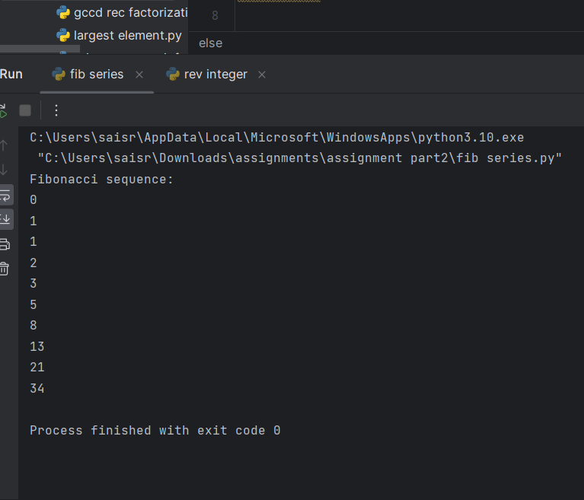

1. Write a program to check the given no is Armstrong or not using recursive function.

def count_digits(n):  
 if n == 0:  
 return 0  
 return 1 + count_digits(n // 10)  
  
def is_armstrong(n, digit_count):  
 if n == 0:  
 return 0  
 return (n % 10) ** digit_count + is_armstrong(n // 10, digit_count)  
  
def check_armstrong(n):  
 digit_count = count_digits(n)  
 sum_of_powers = is_armstrong(n, digit_count)  
 return sum_of_powers == n  
  
# Example usage:  
num = 153  
if check_armstrong(num):  
 print(num, "is an Armstrong number.")  
else:  
 print(num, "is not an Armstrong number.")

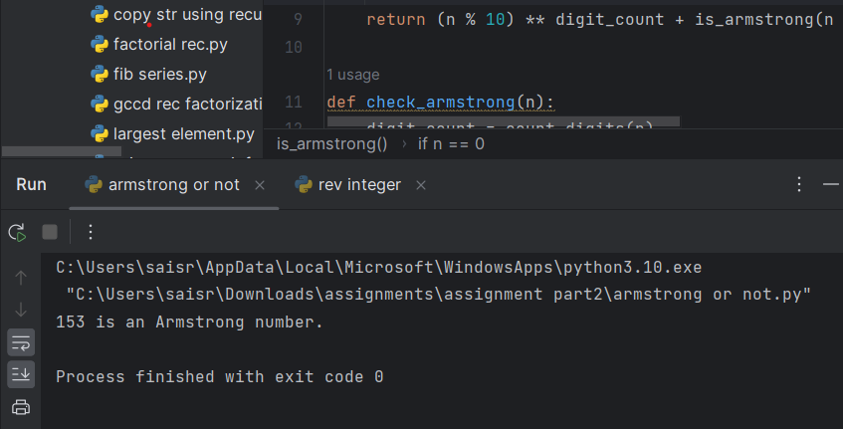

1. Write a program to find the GCD of two numbers using recursive factorization

def prime_factors(n, factor=2):  
 if n <= 1:  
 return []  
 elif n % factor == 0:  
 return [factor] + prime_factors(n // factor, factor)  
 else:  
 return prime_factors(n, factor + 1)  
  
def gcd_recursive(a, b):  
 if b == 0:  
 return a  
 return gcd_recursive(b, a % b)  
  
def gcd(a, b):  
 # Get prime factors of both numbers  
 factors_a = prime_factors(a)  
 factors_b = prime_factors(b)  
  
 # Find common factors  
 common_factors = set(factors_a) & set(factors_b)  
  
 # Calculate GCD by multiplying common factors  
 result = 1  
 for factor in common_factors:  
 result *= factor  
  
 return result  
  
# Example usage:  
num1 = 48  
num2 = 60  
print("GCD of", num1, "and", num2, "is:", gcd(num1, num2)) # Output: 12

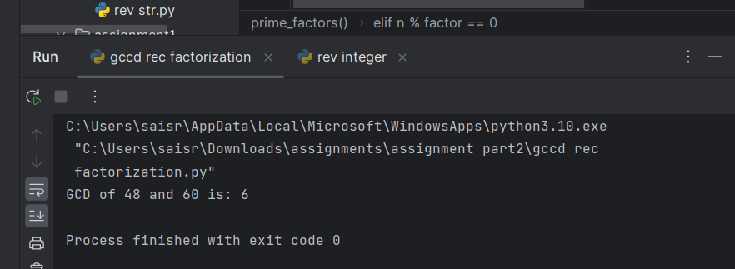

4. Write a program to get the largest element of an array

# Python3 program to find maximum  
# in arr[] of size n  
  
# python function to find maximum  
# in arr[] of size n  
  
  
def largest(arr, n):  
  
 # Initialize maximum element  
 max = arr[0]  
  
 # Traverse array elements from second  
 # and compare every element with  
 # current max  
 for i in range(1, n):  
 if arr[i] > max:  
 max = arr[i]  
 return max  
  
  
# Driver Code  
arr = [10, 324, 45, 90, 9808]  
n = len(arr)  
Ans = largest(arr, n)  
print("Largest in given array ", Ans)

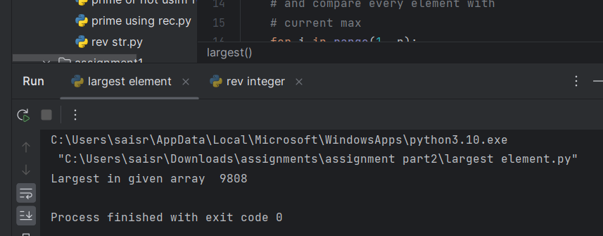

5.Write a program to find the Factorial of a number using recursion.

def recur_factorial(n):  
 if n == 1:  
 return n  
 else:  
 return n*recur_factorial(n-1)  
  
num = 7  
  
# check if the number is negative  
if num < 0:  
 print("Sorry, factorial does not exist for negative numbers")  
elif num == 0:  
 print("The factorial of 0 is 1")  
else:  
 print("The factorial of", num, "is", recur_factorial(num))

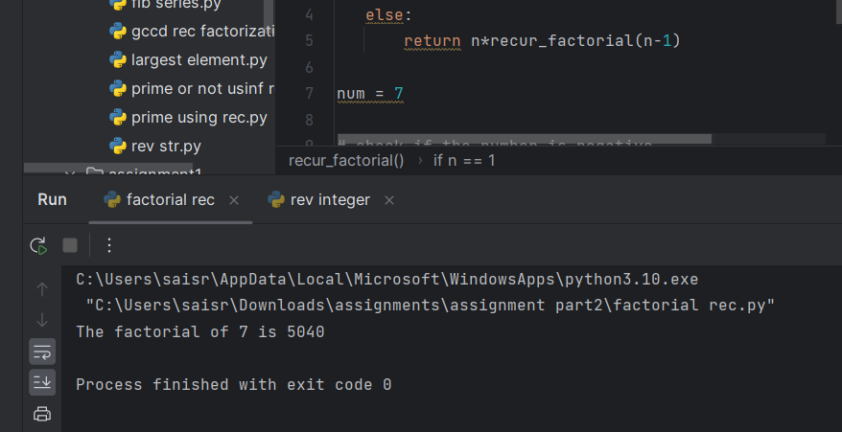

6. Write a program for to copy one string to another using recursion

def copy_string(source, destination, index=0):  
 if index >= len(source):  
 return destination  
  
 destination += source[index]  
  
 return copy_string(source, destination, index + 1)  
  
  
source_string = "Hello, world!"  
destination_string = ""  
copied_string = copy_string(source_string, destination_string)  
print(copied_string)

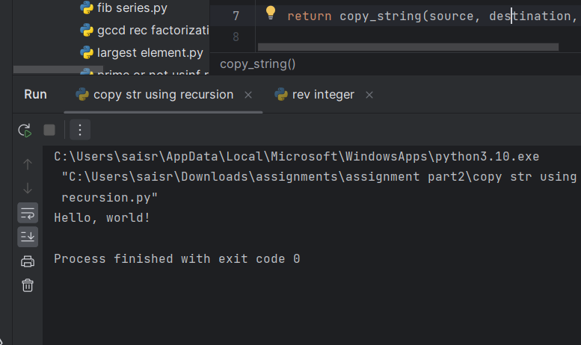

7. Write a program to print the reverse of a string using recursion

def reverse(s):  
 str = ""  
 for i in s:  
 str = i + str  
 return str  
  
  
s = "Geeksforgeeks"  
  
print("The original string is : ", end="")  
print(s)  
  
print("The reversed string(using loops) is : ", end="")  
print(reverse(s))

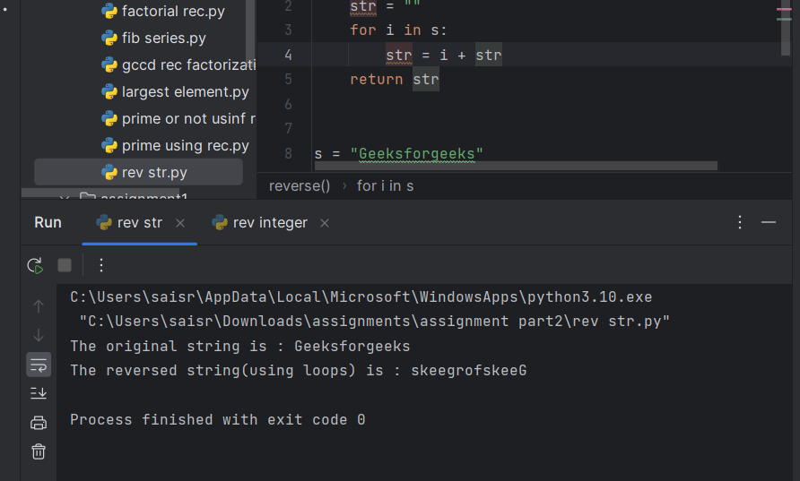

8. Write a program to generate all the prime numbers using recursion

def Prime_Number(n, i=2):  
 if n == i:  
 return True  
 elif n % i == 0:  
 return False  
 return Prime_Number(n, i + 1)  
  
  
n = 971  
if Prime_Number(n):  
 print("Yes,", n, "is Prime")  
else:  
 print("No,", n, "is not a Prime")

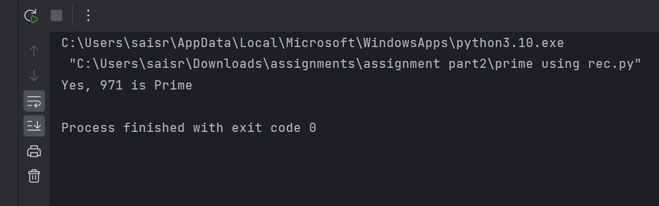

9. Write a program to check a number is a prime number or not using recursion.

def check(n, div = None):  
 if div is None:  
 div = n - 1  
 while div >= 2:  
 if n % div == 0:  
 print("Number not prime")  
 return False  
 else:  
 return check(n, div-1)  
 else:  
 print("Number is prime")  
 return 'True'  
n=int(input("Enter number: "))  
check(n)

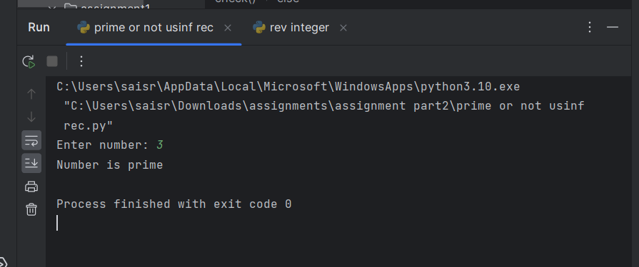

10.Write a program for to check whether a given String is Palindrome or not using recursion

str_1 = input ("Enter the string to check if it is a palindrome: ")  
  
str_1 = str_1.casefold ()  
  
rev_str = reversed (str_1)  
  
if list (str_1) == list (rev_str):  
  
 print ("The string is a palindrome.")  
  
else:  
  
 print ("The string is not a palindrome.")

