16-BIT ADDITION

EXP NO: 5

AIM:To write an assembly language program to implement 16-bit addition using 8085 processor.

ALGORITHM:

1) Start the program by loading a register pair with address of 1st number.

2) Copy the data to another register pair.

3) Load the second number to the first register pair.

4) Add the two register pair contents.

5) Store the result in memory locations.

6) Terminate the program.

PROGRAM:

LHLD 2500

XCHG

LHLD 2502

DAD D

SHLD 2504

HLT

INPUT & OUTPUT

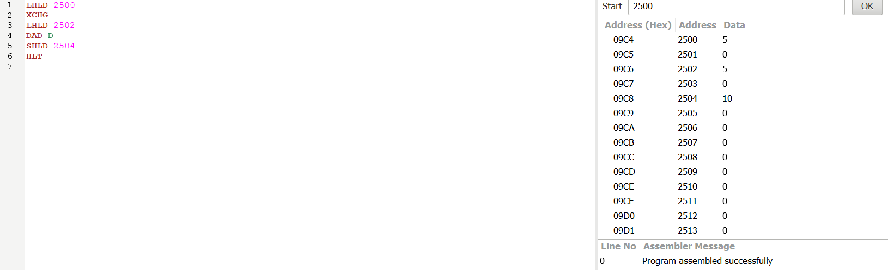

RESULT: Thus the program was executed successfully using 8085 processor simulator.